Detection of Two Mite-Plant-Virus Pathosystems in Florida, Including Field Studies and Chemical Ecology of Induced Plant Defenses on *Phyllocoptes fructiphilus* and *Amblyseius swirskii*

Austin N Fife

Rose Rosette Virus (genus Emaraviridae) is the most devastating disease of roses. Rose Rosette Virus (RRV) creates witches brooms, rosetting, deforms flowers, increases prickle density, elongates shoots, reddens of plant tissues, causes dieback and ultimately plant death. RRV is spread by a microscopic eriophyid mite known as Phyllocoptes fructiphilus Keifer (Trombidiformes: Eriophyidae). Few management options are available: Current mite control is achieved by removing infected roses and frequent pesticide applications. Growers are interested in alternative and less expensive management options to combat P. fructiphilus and RRV. Aggressive pruning was tested for its ability to reduce populations of P. fructiphilus. Mites from the family Phytoseiidae are being investigated as biocontrol agents for the management of P. fructiphilus. A survey of mites on roses was conducted in northern Florida to search for P. fructiphilus, RRD and/or predatory mites. Preliminary data suggest that the phytoseiid mite Amblyseius swirskii Athias-Henriot (Mesostigmata: Phytoseiidae) orients itself towards volatiles of RRV-infected roses. This attraction may have synergistic effects for *P. fructiphilus control. A. swirskii was tested in olfactometer choice tests to identify specific volatile compounds which may cause this behavior. Low levels of Methyl Salicylate found in RRV-infected roses suggest that the virus interferes with the rose’s ability to defend itself against the pathogen. A avoid this negative feedback loop is to induce Systemic Acquired Resistance (SAR) before pathogen introduction, a procedure which could increase the rose’s resistance to RRV. Considering this knowledge, we collaborated with the University of Georgia in to test how SAR-induction might protect roses from P. fructiphilus and/or RRD. Acibenzolar-S-methyl (ASM) is a benzothiadiazole, a SAR-inducing chemical which works like Salicylic Acid to induce plant defenses against viruses, bacteria, and fungal infection. ASM application also has shown chitinase activity in roses, and some studies have shown that the hypersensitive response and SAR interfere with the ability of eriophyoid mites to feed or grow on induced plants. A remaining concern is that SAR-induction may harm predatory mites via direct and indirect effects of SAR-induction. We conducted several field studies from 2018-2021 in order to test the integration of predatory mites with SAR. This research will contribute a biocontrol option for the management of P. fructiphilus in southern Georgia and northern Florida. We describe the first detection of orchid fleck virus (OFV) infecting three unreported hosts: Liriope muscari, cv. ‘Gigantea’ (Decaisne) Bailey, Ophiopogon intermedius Don and Aspidistra elatior Blume (Asparagaceae: Nolinoidaea) in Leon and Alachua Counties, FL. The orchid-infecting subgroup (Orc) of OFV infects over 50 plant species belonging to the plant families Orchidaceae, Asparagaceae (Nolinoidaea), and causes citrus leprosis disease in Citrus (Rutaceae). The only known vectors of OFV-Orc are the flat mites, Brevipalpus californicus (Banks) sensu lato (Trombidiformes: Tenuipalpidae). Florida has various plants in the landscape which Brevipalpus spp. feed on, which are susceptible to infection by OFV-Orc. Chlorotic ringspots and flecking were seen affecting Liriopogons (Liriope and Ophiopogon spp.) in Leon County, FL. Nearby A. elatior also appeared chlorotic. Local diagnostics returned negative for common plant pathogens, therefore new samples were sent to the Florida Department of Agriculture and Consumer Services (FDACS) and USDA-ARS for identification. Two orchid-infecting strains of OFV were detected via combinations of conventional RT-PCR, RT-qPCR, Sanger sequencing and High Throughput Sequencing (HTS). Amplicons shared 98% nucleotide identity with OFV-Orc1 and OFV-Orc2 RNA2 genome sequences available in NCBI GenBank. Coinfections were detected in each county, but single strains of OFV-Orc were detected in L. muscari (Alachua, OFV-Orc2) and A. elatior (Leon, OFV-Orc1). Three potential mite vectors were identified via cryo-scanning electron microscopy (Cryo-SEM): Brevipalpus californicus (Banks) sensu lato, B. obovatus Donnadieu, and B. confusus Baker. In conclusion, OFV orchid strains are present in northern Florida, representing a risk for susceptible plants in the southeastern US.

# 1 LITERATURE REVIEW

## 1.1 A Small Introduction to Some Herbivorous Acari

Mites and ticks belong to a subclass of small arachnids known as the Acari, an incredibly diverse group of arthropods. Despite their ubiquity, mites and invertebrates in general remain understudied relative to other animal fauna (Grodsky et al. 2015, Rosenthal et al. 2017, Titley et al. 2017). Hoy (2011) speculates that our understanding of mite diversity and abundance may be around 50-100 years behind the taxonomy of the Insecta: The small size and cryptic habits of mites make them easy to overlook, and difficult to observe. In addition, their disputed placement in the Arachnida (Giribet 2018) presents a real challenge for taxonomists (Giangrande 2003). Lastly, many mite species have been misclassified, and cryptic species make taxonomic certainty elusive (Bickford et al. 2007). In spite of these impediments, technological improvements, such as Low-Temperature Scanning Electron Microscopy (Achor et al. 2001, Wergin et al. 2006), Confocal Laser Scanning Microscopy (Chetverikov 2012, Chetverikov et al. 2012), X-ray computed tomography (Dunlop et al. 2011, Facchini et al. 2019), and advances in molecular biology–including high-throughput sequencing–(Dasch et al. 2019), have helped to alleviate the difficulty and ambiguity of mite identification via solely morphological characters. The combination of these techniques allows for greater taxonomic certainty (Chetverikov et al. 2012). The most well known species of mites have gained scientific recognition primarily due to their pest status (Savory 1964, Jeppson et al. 1975, Hoy 2011): many acari are parasites of plants and animals, causing disease and economic losses (Jeppson et al. 1975, Hoy 2011, Walter and Proctor 2013). Even so, the majority of mite species are of no economic importance, and are harmless, or even beneficial: many show promise as biological control agents for weeds and arthropod pests (Gerson et al. 2003, Carrillo et al. 2015). Although the majority of arachnids are predatory, mites are unique in that there are species which feed on plants (Savory 1964). Phytophagy arose at least seven times in the Trombidiformes: Parasitengonae, Tetranychoidea, Raphignathoidea, Heterostigmata, Eupodoidea, Tydeoidea and Eriophyoidea all have species which feed on plants (Lindquist 1999). Phytophagy is thought to be a facultative development for the majority of mite taxa outside of the Tetranychoidea and Eriophyoidea; few species of Eupodoidea and Raphignathoidea are obligate herbivores–only *Halotydeus*, *Penthaleus* (Raphignathoidea: Penthaleidae) and *Eustigmaeus* (Raphignathoidea: Stigmaeidae (Gerson 1971))–and the other mite groups have few morphological adaptations associated with plant feeding (Krantz and Lindquist 1979, Lindquist 1999). An important development in the evolution of acarine phytophagy is the reduction of the chelicerae into sharp stylets used for piercing plant tissues (Lillo et al. 2018). These styliform mouthparts are thought to reduce damage to the plant in order to avoid some of the toxic chemistry plants use to defend themselves from arthropod feeding (Mullin 1986). Herbivorous mite damage is dependent on the specific mite-plant interactions for a given plant species or cultivar (Petanović and Kielkiewicz 2010a). Mites generally feed on plant epidermal and mesophyll cells (McCoy and Albrigo 1996, Rancic et al. 2006). High mite populations can reduce the amount of chlorophyll available to the plant (Khederi et al. 2018b), primarily causing bronzing/russetting/silvering by direct feeding, but this damage often spreads to the surrounding tissues as the plant’s immune system responds (Bensoussan et al. 2016). Mite salivary secretions can also cause a condition known as toxemia, which causes plant tissues to become chlorotic or discolor (Oldfield 1996a). Feeding on young tissues often forms distortions and delays plant growth, and some mites–many eriophyoidea and two spp. of Tenuipalpidae–form galls on their host plants (Jeppson et al. 1975, Westphal and Manson 1996, Oldfield 2005). The majority of herbivorous mites do not transmit pathogens (Oldfield and Proeseler 1996), but those which do act as vectors of plant viruses principally from two families from the Prostigmata: Eriophyidae and Tenuipalpidae (Slykhuis 1965). Members of these mite superfamilies are obligate herbivores considered to be some of the more ancient lineages of phytophagous mites (Lindquist 1999). There have been singular reports of spider mites–tetranychidae–associated with viruses (Slykhuis 1965, Robertson and Carroll 1988), but other studies have failed to reproduce similar results (Granillo and Smith 1974). Plant mites are generally considered secondary pests, but often cause significant losses when conditions are optimal, due to the fast reproductive rate of many pest species (Gerson and Cohen 1989, Dutcher 2007).

### 1.1.1 Coevolved plant specialists: the eriophyoidea

The eriophyoidea are the second most economically-important group of herbivorous mites, right behind Tetranychidae. Although eriophyoids may be less damaging than the tetranychoidea, they are one of the most specious groups of plant-feeding mites: It is estimated that the 2,838 species reported in the “Catalog of the Eriophyoidea of the World” represent only about 10% of the total number of species which exist (Amrine and Stasny 1994). Publications of new species descriptions of eriophyids averaged about 70 per year from 1996 to 2007, and have greatly increased since the publication of *Eriophyoid Mites – their Biology, Natural Enemies and Control* (Lindquist et al. 1996), a landmark publication for the field of eriophyoid studies. Eriophyids range in size from 80-500 long (Nuzzaci and Lillo 1996), and seem to have evolved specifically for plant feeding (Krantz and Lindquist 1979, Oldfield and Proeseler 1996, Lindquist 1999, Skoracka and Dabert 2010, Lillo et al. 2018): they have styliform chelicera covered with a protective sheath (Lindquist 1999, Bolton et al. 2018), elongate vermiform bodies, and adult mites have a reduced number of legs from the typical eight to four (Lindquist 1996). The stylets of eriophyids are short, $≤$ 20 (Oldfield and Proeseler 1996), which primarily limits their feeding to epidermal cells, with young/tender meristematic tissues being preferred (Petanović and Kielkiewicz 2010a, 2010b). Feeding is thought to rely on enzymes in their saliva to break down plant cells contents and feed on the resulting soup (Hoy 2011). Eriophyoid mites also have an abbreviated lifecycle, progressing from egg, to larva, followed by nymph, then adult (Manson and Oldfield 1996). Many eriophyoid mites have summer forms (protogynes) which readily proliferate and winter forms (deutogynes), which are able to survive harsher conditions until they can disperse when environmental conditions are moderate (Kassar and Amrine Jr 1990). Eriophyids are not able to disperse very far by walking (Calvet et al. 2020), but are known to disperse aerially (Kuczyński et al. 2020) and passively (Galvão et al. 2012), rarely by phoresy on other animals (Li et al. 2018). Eriophyid lifestyles are generally sorted into leaf vagrants/rust mites and galling/bud forms, with rust mites being fusiform and living on the plant surfaces, while bud and gall mites tend to have more cryptic lifestyles, as suggested by their names (Hoy 2011). The majority of eriophyids studied to date are considered host specific, limited to feeding on a single genus, or one host plant. (Oldfield and Proeseler 1996, Lillo et al. 2018). The few mite species which appear to have a broader host range may be misidentified cryptic species (Navia et al. 2012, Skoracka et al. 2013), a hypothesis strengthened by their limited ability to disperse and close associations with their host plants (Magalhães et al. 2007). These lifestyles and feeding habits of the Eriophyoidea are thought to have shaped both their relationships with their host plants and their ability to transmit pathogens (Mauck et al. 2012, Biere and Bennett 2013): Eriophyid mites represent the majority of mites involved in virus transmission to plants Lillo et al. (2018). In the absence of an infectious agent, most damage from the feeding of vagrant forms of eriophyids is superficial and causes minimal damage to their host plant (Krantz and Lindquist 1979, Oldfield and Proeseler 1996). To date, eriophyids have only been associated with plant viruses (Lillo et al. 2018), which may be explained by the small size of eriophyoid mouths and foreguts, which preclude the acquisition and circulation of large pathogens (Oldfield and Proeseler 1996). Although these developments can be considered an evolutionary advantage for the the Eriophyoidea, it puts the lifestyles of these minute arachnids in direct conflict with the interests of modern agriculture, and motivates the need for management of mite populations.

### 1.1.2 *Phyllocoptes fructiphilus*: the vector of *Rose rosette emaravirus*, the causal agent of Rose Rosette Disease

*Phyllocoptes fructiphilus* Keifer, (Acari: Trombidiformes: Prostigmata: Eriophyoidea: Eriophyidae) is an eriophyoid mite from the Prostigmata group. Like many other eriophyoids, the relationships *P. fructiphilus* has with its host and virus are very specific, and create problems for growers (Krantz and Lindquist 1979, Oldfield and Proeseler 1996): *P. fructiphilus* only feeds on plants in the genus *Rosa* (roses), but it doesn’t create noticeable damage by feeding. Instead, the increased interest in *P. fructiphilus* stems from its relationship with a virus known as Rose Rosette Virus (RRV) Emaraviridae (Allington et al. 1968, Tzanetakis et al. 2006, Laney et al. 2011). *P. fructiphilus* transmits RRV while feeding on the rose epidermis (Allington et al. 1968). A single mite is enough to transmit RRV, and can inoculate a rose in less than an hour (Di Bello et al. 2017). Infection creates the following symptoms: clusters of deformed flowers known as rosettes/witches’ brooms, increased thorniness, elongated shoots, reddened leaves and stems, and increased cane die-back which ultimately kills the rose host (Epstein and Hill 1995). This disease is known as Rose Rosette Disease (RRD) and is the most serious disease of roses, creating millions of dollars of losses for growers (Babu et al. 2014) and threatening the ornamental rose industry Rwahnih et al. (2019). RRD was first described in North America in 1941 from an outbreak in Manitoba, Canada (Conners 1941). *P. fructiphilus* later became recognized as the vector for RRV (Allington et al. 1968, Doudrick et al. 1986, Jesse et al. 2006) and RRV was eventually confirmed to be the casual agent for the RRD (Doudrick et al. 1987, Tzanetakis et al. 2006, Laney et al. 2011, Bello et al. 2015, Dobhal et al. 2016, Di Bello et al. 2017). The mite and virus were generally associated with invasive multiflora rose, *Rosa multiflora* (Thunb) (Amrine Jr 1996, 2002, Otero-Colina et al. 2018) and spread along with the rose throughout the central US (Crowe 1983), and the east (Hindal et al. 1988). Initially the relationship between *R. multiflora* and the pathogen was considered as a type of natural biological control (Epstein and Hill 1999), and some studies even considered artificially spreading viruliferous *P. fructiphilus* to eradicate these pestilent roses (Tipping and Sindermann 2000). The relationship between, *R. multiflora*, mite and virus also has a positive influence on *P. fructiphilus* fecundity: Epstein and Hill (1999) reported a 17-fold increase in the mite population of diseased roses compared to uninfected plants. Like many other species of plant-feeding mites, *P. fructiphilus* reproduce via arrhenotokous parthenogenesis (Oliver 1971), meaning that unfertilized eggs become male, while fertilized eggs become female (Oldfield and Michalska 1996). *P. fructiphilus* grows from egg to adult in 11 days (Kassar and Amrine Jr 1990), which allows a single female to quickly initiate a new colony without being fertilized *a priori* to dispersion (Helle and Wysoki 1996). Together, these factors likely contribute to the dispersal ability of *P. fructiphilus*. Mite and virus spread through the landscape in various ways: RRV can be transmitted by grafting (Doudrick et al. 1987) and the mites can crawl from plant to plant or be blown by the wind over long distances (Zhao and Amrine 1997, Zhao and James 1997, Michalska et al. 2009). Unfortunately, *P. fructiphilus* and RRD have the ability to infest commercial rose cultivars as well (Epstein and Hill 1995, Byrne et al. 2018), and can be spread by humans moving infested plants (Navia et al. 2009). Interceptions of RRD into Florida occurred in 2013, when RRD-infected knockout roses were received from out of state by a nursery in Gadsden county (Babu et al. 2014). No *P. fructiphilus* were detected at the time, and the roses were quarantined and destroyed (Babu et al. 2014). A survey for *P. fructiphilus* and RRD in the southeastern US (Solo 2018, Solo et al. 2020) found both mite and virus to be present in southern Georgia, and *P. fructiphilus* was recently detected in northern Florida (Fife et al. 2020). The presence of *P. fructiphilus* and the possibility of RRD invasion into the southeast emphasizes the need to monitor for and manage RRD to prevent its establishment in these rose growing regions.

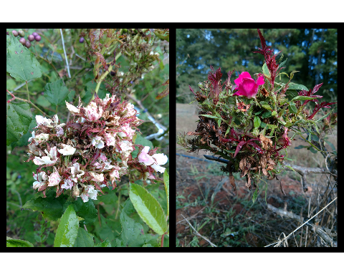

Figure 1.1: Typical symptoms of Rose Rosette Disease (RRD), caused by Rose Rosette Virus: clusters of deformed flowers known as rosettes/witches’ brooms, increased thorniness, elongated shoots, reddened leaves and stems. RRD ultimately kills the rose host.

## 1.2 Integrated Pest Management: Best Practices for Modern Agriculture

Integrated Pest Management (IPM) is a science-informed approach to pest control based on integrating as many different types of control to keep pest populations underneath their economic injury level (EIL) (Stern et al. 1959, Flint and Bosch 1981). The EIL is a breaking point, where the cost of controlling the damage from pests exceeds the costs of crop production (Stern et al. 1959). This EIL is informed by an economic threshold, a point where a specific pest density has been exceeded, and interventions are required to prevent the crop from reaching the EIL (Stern et al. 1959). A useful framework for controlling plant pathogens has been developed in the concept of the disease triangle. For a long time, plant pathologists have recognized the importance of pathogen, environment and host on disease proliferation (Gäumann 1950), and all of these factors must be present in sufficient quantity and quality for disease to occur (McNew 1960, Dimond and Horsfall 1960, Agrios 2004). Extensions of the basic disease triangle have been considered, including adding extra dimensions to account for more variables (Francl 2001), or applying it to different systems (Scholthof 2006), but the basic concept is that removing of one of these main factors of disease gives a point of attack for control efforts: Management may focus on removing a suitable host by crop rotation, or by using cultivars resistant/tolerant to pests and/or pathogens. Pathogens can be excluded from the crop via sanitation measures such as insect screens, tissue culture, seed certification programs, cleaning harvesting equipment, or by growing crops in a greenhouse. Environment can also be manipulated by growing crops in areas where the pest/pathogen isn’t present or can’t survive under normal conditions. The IPM paradigm encourages the combination of as many of these methods as possible for improved pest control. Although there is some overlap in the technologies and terminologies used, pest management traditionally divides pest interventions into four main categories: chemical, mechanical, cultural (environmental), and biological control methods (Bradley and Moore 2018). Chemical controls are an effective way to quickly control pest outbreaks, but pesticides have many drawbacks as well: they pose a risk to the applicator (Alavanja et al. 2004), harm beneficial insects/pollinators, leave residues on crops meant for consumption, and can harm the environment through runoff/drift (Fenner et al. 2013), and polluting surface and groundwater (Driesche et al. 2007, Marquina and Ferre 2010). Pesticides also can create secondary pest outbreaks (Gerson and Cohen 1989) and pest resurgence by killing natural predators in the environment (Driesche et al. 2007), while encouraging pesticide resistance in surviving pest populations (Dutcher 2007, Ciancio and Mukerji 2007). Even so, chemical controls remain useful when used judiciously in an IPM program (Dent 2000, Driesche et al. 2007). Mechanical control is the physical manipulation of plants to prevent pests and pathogens. Mechanical controls include pruning, raking, tilling, removing pests and infected plants (roguing) by hand, creating physical barriers such as raised beds, insect screens, organic or plastic/reflective mulch, solarizing/heating the soil, sticky traps/barriers, etc. (Ciancio and Mukerji 2007, Bradley and Moore 2018). Cultural control has some overlap with mechanical control methods, but cultural controls tend to refer to controlling the environment of your crops to exclude pests. Some examples include: selecting resistant cultivars, cultivating and planting in healthy soil, managing weeds, interplanting/trap cropping, aerating the soil, choosing appropriate planting dates, rotating crops, letting the field lie fallow, and etc. (Ciancio and Mukerji 2007, Bradley and Moore 2018). Biological control in the classical sense relies on reintroducing the various biological entities which keep pest populations in check in their natural/native environments (Heimpel and Mills 2017, Hajek and Eilenberg 2019). This concept is based off of the enemy release hypotheses from invasion ecology, which hypothesizes that introduced pest populations flourish because they have no natural enemies present to control their growth (Liu and Stiling 2006, Heger and Jeschke 2014). The corollary being that biological control agents such as parasitoids, predators, herbivores and pathogens can injure pest populations sufficiently to provide control (Heimpel and Mills 2017, Hajek and Eilenberg 2019). One of the primary benefits of biological control is that these natural enemies can become established in the environment, creating long term control while adapting to fluctuations in pest populations over time (Hajek and Eilenberg 2019). Biological control has found success in a variety of natural and agricultural environments, protecting crops against insect pests and combating invasive weed species (Driesche et al. 2010).

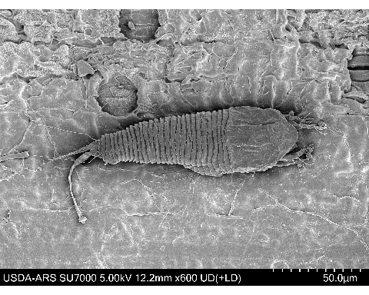

Figure 1.2: Cryo-SEM image of Eriophyid mite infected with unidentified fungus, collected from ., Photo Credit: Dr. Gary R. Bauchan, USDA-ARS, 2020.

### 1.2.1 Current management of Rose Rosette Disease is not effective

Nursery managers have been recommended to manage RRD by removing sick plants and spraying acaracides (Hong et al. 2012, Olson et al. 2017, “Control - rose rosette” 2018). Although eriophyid mites are often controlled via chemical means (Messing and Croft 1996, Leeuwen et al. 2009), a handful of eriophyoid species have developed resistance to some acaricides, including *Phyllocoptruta oleivora* (Ashmead) and *Acalitus vaccinii* (Keifer) becoming resistant to dicofol (Omoto et al. 1994, 1995) while *Aculus cornutus* (Banks) and *Aculops lycopersici* (Tryon) have developed resistance to various organophosphates (Baker 1979, Abou-Awad and El-Banhawy 1985). In addition, to date there is limited information regarding the toxicity and effectiveness of acaricides used to combat *P. fructiphilus*. Pesticide applications are further complicated by the biology of the mite: *P. fructiphilus* are a refuge seeking species of eriophyoids which prefer to feed on the small plant hairs (trichomes) on the sepals, underneath the petals (Amrine and Stasny 1994, Jesse et al. 2006, Lillo et al. 2018, Otero-Colina et al. 2018, Bauchan et al. 2019). The petals, sepals, and trichomes all help shield the mites from conventional pesticide treatments. Furthermore, a single mite is potentially enough to transmit the virus (Di Bello et al. 2017), which can infect a rose in less than an hour, yet plants can remain sick and symptomless for months to years (Amrine Jr 1996, Di Bello et al. 2017). This slow onset of disease symptoms creates an additional challenge for management (Di Bello et al. 2017), because by the time the disease is noticed, the mites may have already spread to the whole garden. Disease detection is also difficult: Symptoms can appear similar to natural plant growth or herbicide damage, making it hard to diagnose in the field (Hong et al. 2012). Molecular methods for testing RRV are becoming readily available Di Bello et al. (2017), and newer technologies, such as Raman spectroscopy (Farber et al. 2019) are being developed to test for RRV, but it remains to be seen if these methods are capable of identifying asymptomatic infections or if these tests are suitable for disease monitoring on larger scales. Host plant resistance is not a viable option for controlling RRD: currently, all roses are known to host *P. fructiphilus*, and few roses show signs of resistance to RRV (Di Bello et al. 2017, Byrne et al. 2018). Mechanical control via pruning and sanitation have not proven to be effective (Olson et al. 2017). The use of windbreaks has been suggested to reduce the number of mites landing on roses (Windham et al. 2014), The lack of management options for mites, as well as the increased cost of rose production due to RRV make it difficult for growers to compete with an increasingly competitive international market. Rose growers need better methods to combat *P. fructiphilus* and RRV.

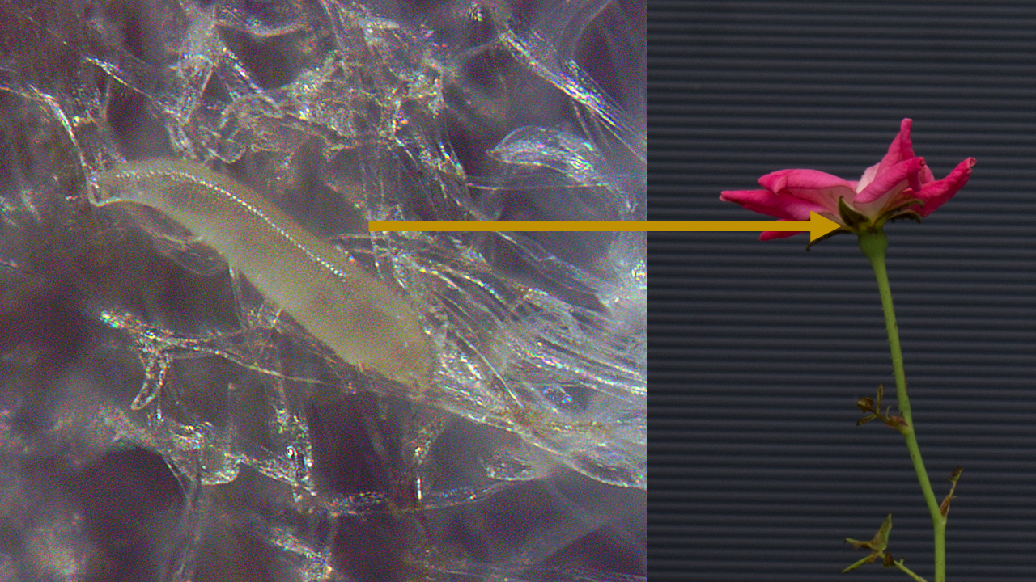

Figure 1.3: Illustration of the typical location of on roses. are difficult to manage with pesticides due to the protection offered by the sepals.

### 1.2.2 Small phytoseiid mites could be an option for biocontrol if discovered

Eriophyoid mites are hard to control via conventional methods (i.e. pesticides) due to their small size and their cryptic habits, so alternative methods of pest control are being investigated. There are currently no known natural enemies associated with *P. fructiphilus*, but surveys of eriophyoid-infested plants sometimes encounter predatory mites which may be suitable for biological control (Lawson-Balagbo et al. 2007b, Picoli et al. 2010, Azevedo et al. 2016). The most well-studied family of predatory is the Phytoseiidae (Gerson et al. 2003, Farragut et al. 2010, Carrillo et al. 2015), which are sometimes released as biological control agents for thrips, whiteflies, spider mites (Tetranychidae), flat mites (Tenuipalpidae), scale insects and other pests (Gerson et al. 2003, Chen et al. 2006, Arthurs et al. 2009, Carrillo et al. 2011a, Carrillo and Peña 2011, Doğramaci et al. 2011, Sarwar 2017, Knapp et al. 2018, Argolo et al. 2020). Phytoseiid mites are generally associated with plants (Farragut et al. 2010), and do not survive well without them (Jung and Croft 2000). Plant structures affect many aspects of a phytoseiid’s life (Cortesero et al. 2000, Schmidt 2013), influencing dispersal (Buitenhuis et al. 2013, Lopez et al. 2016), as well as performance as predators (Cédola et al. 2001, Seelmann et al. 2007, Buitenhuis et al. 2013). Some species such as *Neoseiulus paspalivorus* (De Leon) (Lawson-Balagbo et al. 2007a, Negloh et al. 2011, Lesna et al. 2014) and *Phytoseius intermedius* Evans & MacFarlane (Picoli et al. 2010, Azevedo et al. 2016) are small enough that they can feed on refuge-seeking eriophyid mites hiding in difficult to reach areas, such as in erinea or under plant bracts/perianths (Lawson-Balagbo et al. 2007c, Azevedo et al. 2016, Silva 2016). Studies of predatory mites associated with roses can hopefully encounter a similar mite species able to find its way under the sepals, petioles, and glandular plant hairs (trichomes) to feed on hiding *P. fructiphilus* and provide some control (Howard and Rodriguez 1991, Jesse et al. 2006, Otero-Colina et al. 2018, Bauchan et al. 2019). Prey-seeking on a large plant is a non-trivial task, accordingly, many species of mites learn to find their hosts or prey by relying on Volatile Organic Compounds (VOCs) to guide them released when plants are injured by pests or infected with pathogens, and use these VOCs to locate their prey (Sabelis et al. 1999, Maeda and Takabayashi 2001, Boom et al. 2002, Boer and Dicke 2004a, 2004b, 2005). The chemistry of VOCs varies depending on plant species, and can create many different effects on the arthropods which inhabit the affected plant: VOCs can repel (Moraes et al. 2001, Agut et al. 2018) attract (Nomikou et al. 2005, Gadino et al. 2012, Avellaneda et al. 2019), encourage predation (Kessler and Baldwin 2001, Halitschke et al. 2007), or poison arthropods (Vancanneyt et al. 2001). Manipulating the VOCs which natural enemies or pests may encounter on RRV-infected roses can help inform future research into push-pull strategies for manipulating these natural enemies and predators (Cook et al. 2007).

### 1.2.3 Struggling to stay in roses: chemical ecology of *Amblyseius swirskii* in roses

One of the more popular species of commercially-available predatory mite is *Amblyseius swirskii* Athias-Henriot (Calvo et al. 2014). *A. swirskii* tolerate shipping well (Lopez and Smith 2016) and are often sold packaged in vermiculite or in sachets with wheat bran which allows the mites to slowly release into the environment (Buitenhuis et al. 2014, Calvo et al. 2014). *A. swirskii* are considered a generalist predator, and can be reared on artificial diets (Nguyen et al. 2013), natural or supplemental pollen (Loughner et al. 2011, Park et al. 2011, Delisle et al. 2015, Ghasemzadeh et al. 2017), and/or other arthropods present in the environment even when the pest of concern is absent (Janssen and Sabelis 2015, Kumar et al. 2015). Furthermore, *A. swirskii* have been tested for their compatibility with various combinations of other biocontrol agents, such as predatory mirids, minute pirate bugs, and *Beauveria bassiana* (Chow et al. 2010, Midthassel et al. 2016, Bouagga et al. 2018). Certain modern pesticides and reduced risk-fungicides had relatively low toxicity to *A. swirskii* while other agrichemicals increase mortality or reduce fecundity (Gradish et al. 2010, Fernández et al. 2017, Ersin et al. 2020, Havasi et al. 2021). Agrichemical products should be tested for their compatibility with biocontrol agents before they are utilized in a pest management program. *A. swirskii* has been studied in rose systems in attempts to control thrips, greenhouse whitefly and *T. urticae* (Chow et al. 2010, Hoogerbrugge et al. 2011, Hoogerbrugge et al. 2014, Alipour et al. 2016, 2019, Houten et al. 2016). Schoeller et al. (2020) mentions that growers felt that *A. swirskii* were not effective control of *Scirtothrips dorsalis* Hood (Schoeller et al. 2020). Schoeller et al. (2020) hypothesizes that this reduction in pest control may be due to reduced trichomes on roses. This follows the reports of Loughner et al. (2010a) and Loughner et al. (2010b), who noted that phytoseiids tend to disperse away from plants with few trichomes. Phytoseiids are known to prefer to oviposit on dense patches of trichomes along axillary veins known as ‘domatia’ on the underside of leaves (O’Dowd and Willson 1991, Walter 1992, 1996, Grostal and O’Dowd 1994, Agrawal and Karban 1997), a behavior which is thought to help to avoid predation (Faraji et al. 2002). Another issue with *A. swirskii* control was seen in experiments with *T. urticae*-resistant roses: In order to improve the efficacy of predation on *T. urticae*, *A. swirskii* were released alongside another predatory mite, *Phytoseiulus persimilis* Athias-Henriot (Alipour et al. 2016, 2019). Under these conditions, predation of *T. urticae* was higher (Alipour et al. 2016), but the population growth rate of *A. swirskii* decreased (Alipour et al. 2019). Nomikou et al. (2005) reported that *A. swirskii* locate their prey with VOCs. It may be possible to manipulate *A. swirskii* with VOCs to remain on glabrous plants for longer periods of time, thereby increasing their predation on *T. urticae* or other pests of roses.

## 1.3 Induced Plant Defenses

Plants are primarily sessile organisms which aren’t able to run or hide, therefore undefended plants struggle to grow in the face of the constant threat of herbivory (Kessler et al. 2004). In order to combat being eaten, plants rely heavily on their ability to protect themselves *in-situ*, via a myriad of different physical and chemical defenses (Walling 2000). These defenses are categorized as either constitutive defenses or induced defenses (Farmer 2016). Constitutive defenses are always ‘on’, being produced by the plant constantly, such as tannins and latex, while inducible defenses rely on some sort of signal before the plant will produce them. Physical defenses of herbivory includes spines, prickles, thorns, glandular trichomes, latex, sclereids, epicuticular wax, bark, thick cell walls, and compensatory growth to prevent tissue damage while increasing wear on herbivore mouthparts (Farmer 2016). In addition to these physical barriers to herbivory, plants are also efficient chemical factories which produce a bevy of secondary plant metabolites, including inhibitory proteins, enzymes, and toxins which reduce palatability of plant tissues, prevent uptake of essential amino acids, or kill the herbivore outright (Farmer 2016). It is hypothesized that inducible defenses must have evolved in response to threats that were sporadic in nature, but strong enough to necessitate a response (Edelstein-Keshet and Rausher 1989, Tollrain and Harvell 1999). The idea is that inducible defenses allow plants a type of cost-saving for their limited resources (Optimal Defense Theory, Steppuhn and Baldwin (2008); Adler and Karban (1994)), or to avoid damaging themselves with the compounds used (Steppuhn and Baldwin 2008). Otherwise, the evolution of constitutive defenses would seem to be a better option for plant defense (Karban and Myers 1989, Järemo et al. 1999). A corollary of the optimal defense theory is that inducible defenses should have cues that trigger dependably, accurately and be an effective deterrent once activated, so as to avoid opportunity costs (Berenbaum and Zangerl 1999, Järemo et al. 1999). Induced chemical defenses are thought to have an added benefit of being faster and less costly for plants to produce than other types of defense, such as developing spines or thicker cell walls (Berenbaum and Zangerl 1999, Järemo et al. 1999). Even so, chemical defenses still have drawbacks in allocation costs: plants investing energy into defenses are not using those resources for growth or reproduction (Berenbaum and Zangerl 1999). There are also probably genetic tradeoffs to keep inducible costs active rather than other essential plant functions, and there may be ecological compromises as well: adaptation to one form of defense may preclude the use of another (Berenbaum and Zangerl 1999). Another confounding factor with induced defenses occurs in the presence of specialist herbivores, many of which are especially adapted to overcoming a particular plant defense (Ehrlich and Raven 1964, Schoonhoven et al. 2005, Farmer 2016).

## 1.4 Can Systemic Acquired Resistance Reduce Mite Herbivory?

Järemo et al. (1999) considered the development of systemic responses to be more probable if plant defenses required larger doses for deterrence, and posited that localized responses to herbivory are benefit the plant when small amounts of initial damage are a reliable cues of larger damage to come. This framework readily considers the feeding activities of stylet feeders like mites, whose initial damages are minimal, but quickly accelerate due to mites’ fast population growth rates. Accordingly, plants need to be responsive and accurate when identifying a threat before a defense can be mounted. Plants rely on pattern recognition receptors (PRRs) (Couto and Zipfel 2016), to detect pathogen-associated molecular patterns (PAMPS) (Boller and Felix 2009), and herbivore-associated molecular patterns (HAMPS) (Mithöfer and Boland 2008), molecules released from attacking pathogens and herbivores, respectively. These PRRs are part of innate plant immunity: PAMP-triggered immunity and effector-triggered immunity (ETI) (Chisholm et al. 2006, Jones and Dangl 2006). Plant cell-surface receptors detect common pathogen molecules, such as flagellar proteins, chitin and ergosterol. If activated PTI typically stops further invasion, by depositing callose at the site of infection, releasing reactive oxygen species (ROS), mitogen-activated protein kinases (MAPK, Howe and Jander (2008)), and inducing pathogen-responsive genes. If this first line of defense is surpassed, ETI has evolved to identify the proteins used to overcome PTI, by detecting pathogen effectors with the *R* proteins encoded by the corresponding *R*-genes in the plant (Boller and Felix 2009). One of the most well known effects of activating ETI is the hypersensitive response (HR), rapid localized cell death/necrosis at sites of infection. The HR also activates pathogensis-related (PR) genes and upregulates intercellular Salicylic Acid (SA), which converts to the VOC, Methyl Salicylate (MeSA), a signal which propagates resistance throughout the plant. The increased expression of PR genes primes the plant for long term resistance to future attack, via a process known as systemic acquired resistance (SAR) (Boller and Felix 2009, Vlot et al. 2009, Zhang et al. 2010). HAMPs work in a similar way to PAMPs, but instead of detecting molecular patterns associated with pathogens, they detect molecules associated with herbivores, such as arthropod oral secretions, eggs, pheromones, or other chemicals conserved across a wide range of arthropods (Mithöfer and Boland 2008). Plants respond to triggered HAMPS in similar ways: they also trigger ROS, MAPKs, and Ca $​^{2+}$ influx at the site of injury (Vincent et al. 2017). Another important plant defense is the Jasmonic Acid (JA)-Ethylene (ET) signalling pathways. The JA/ET pathways are activated when JA upregulates in response to wounding and/or arthropod damage, and provides protection from herbivory as well as pathogen damage (Thaler et al. 2001, Farmer et al. 2003, Guo and Ecker 2004, Glazebrook 2005, Howe and Jander 2008). Plants can be primed directly through application of SA, MeSA or even synthetic chemical analogues, such as acibenzolar-S-methyl (ASM) to activate SAR (Conrath et al. 2006, Vlot et al. 2009, Zhang et al. 2010, Jeschke 2015). Bronner et al. (1991a), Bronner et al. (1991b), Westphal et al. (1991), and Westphal et al. (1992) observed that feeding by the gall mite *Aceria cladophthirus* (Nalepa) activated induced defenses, triggering the hypersensitive response in *Solanum dulcamara*. As part of SAR-induction these plants increased their levels of ,3-glucanase and chitinases (Bronner et al. 1991b, Ward et al. 1991, Bhardwaj et al. 2021), enzymes which prevent fungal disease development (Goy et al. 1992, Xue et al. 1998, Narusaka et al. 1999, Suo and Leung 2001, Anguelova-Merhar et al. 2008, Bhardwaj et al. 2021, Rajninec et al. 2021). Experiments by Westphal et al. (1991) also found that *S. dulcamara*’s SAR response to *A. cladophthirus* produced 40-day protection from subsequent colonization by more *A. cladophthirus* or another eriophyid, *Thamnacus solani* Boczek and Michalska, a rust mite. Westphal et al. (1992) continued to demonstrate that these induced responses were not enough not protect the plant from *Tetranychus urticae* Koch, but instead increased their fecundity, possibly due to negative cross-talk between SA and JA that is found in some plant systems (Baldwin et al. 1997, Belliure et al. 2010, Thaler et al. 2012). For example, Warabieda et al. (2020) observed that JA helped increase plant resistance to *T. urticae*, but applying JA and ASM together was less effective than applying JA alone, due to SA interference with JA pathways. Other studies have found opposite effects: Favaro et al. (2019) reported reduced numbers of *T. urticae* on strawberries post SA induction, and Khederi et al. (2018a) found that SA and JA induction was sufficient to control erineum forming *Colomerus vitis* (Pagenstecher). This type of inconsistency is best explained by the results of Kant et al. (2007), which found examples of interspecific variation of *T. urticae*’s ability to induce–and resist–JA defenses. Furthermore, there have been a number of cases where mites have been known to avoid or prevent upregulation of plant defenses entirely: Both *T. urticae* and *Aculops lycopersici* Massee, have been reported to suppress the JA pathways without relying on antagonistic cross-talk between the responses (Sarmento et al. 2011, Alba et al. 2014), instead by suppressing downstream accumulation of JA (Alba et al. 2014, Glas et al. 2014). Glas et al. (2014) observed that *A. lycopersici* would still induces SA defenses, while an inducer species (Kant et al. 2007) of *T. urticae* feeding on tomato (*Solanum lycopersicum*) induces both JA and SA pathways, but when both mites were introduced to the same plant, the JA response plummeted and SA doubled (Glas et al. 2014). This caused *A. lycopersici* populations to suffer while the *T. urticae* populations benefited from *A. lycopersici*’s reduction of JA (Glas et al. 2014). Vectors of plant pathogens create a similar struggle for their host plants by manipulating and suppressing the SA and JA/ET pathways for their mutual benefits (Agrawal and Karban 1999, Belliure et al. 2010). An example can be seen in the interactions of *B. yothersi*, the vector of *Citrus leprosis virus C* (CiLV-C): infection of *Arabidopsis thaliana* and *Citrus* spp. with CiLV-C induces SA and suppresses JA/ET pathways through crosstalk (Arena et al. 2016). A follow-up study of *B. yothersi* feeding on *A. thaliana* was similar in result: mite feeding triggered both SA and JA/ET pathways, but *B. yothersi* reared on mutant *A. thaliana* with no SA response had lower fecundity (Arena et al. 2018), suggesting that *B. yothersi* rely on inducing SA to antagonize JA production. Inducing plant defenses can have negative consequences for the predators as well as the herbivores (Pappas et al. 2017): Ataide et al. (2016) observed that inducing a plant JA pathway reduced *T. urticae* and *T. evansi* mite performance, but also negatively affected ovophagy by *Phytoseiulus longipes*, which ate fewer eggs from mites living on induced plants (Ataide et al. 2016), slowing their reproductive rate. It is also possible that the differences feeding methods between mite species is creating different defense responses, as has been seen in other arthropod groups (Zarate et al. 2006, Zhang et al. 2009, Arimura et al. 2011). In conclusion, this type of interplay between induced defenses is common, and varies by plant species and cultivar (Boom et al. 2004, Anguelova-Merhar et al. 2008), meaning that many plant pathway must be examined mechanistically to better understand the multitrophic cascades at play in each plant-pathogen-arthropod system.

## 1.5 A Second Plant-Mite-Pathosystem: *Brevipalpus californicus* and *Orchid fleck dichorhavirus*

The most important superfamily of herbivorous mites is the Tetranychoidea. The Tetranychoidea are comprised of 2,000 species divided into 5 families (Krantz 2009), two of which have economic significance, Tetranychidae–the spider mites–and Tenuipalpidae. Tenuipalpidae are known colloquially as the false spider mites, or flat mites due to their flattened character and superficial similarity to the Tetranychidae. In contrast to tetranychids, tenuipalpids do not spin webs and are considered to be a pest of reduced severity: Krantz (2009) places them as the ‘third most important family of phytophagous mites’. Flat mites are considered to be a tropical to subtropical group of mites (Gerson 2008), the majority of which are not of economic significance (Hoy 2011). Consequently, tenuipalpids have been studied much less than the Tetranychidae (Jeppson et al. 1975, Childers et al. 2003a, Gerson 2008), but flat mites from the genus *Brevipalpus* have been gaining importance in recent years as vectors of plant viruses (Chagas et al. 2003, Childers et al. 2003c, Childers and Derrick 2003, Kitajima et al. 2003, Rodrigues et al. 2003, Kitajima et al. 2008, 2010, Childers and Rodrigues 2011, Melzer et al. 2013, Rodrigues and Childers 2013, Ramos-González et al. 2017, Chabi-Jesus et al. 2018, Dietzgen et al. 2018a). Another major pest of modern concern is *Raoiella indica* (Hirst), a pest of palms (Arecaceae), ginger (Zingiberaceae), bananas (Musaceae), and bird of paradise plants (Strelitziaceae) (Jeppson et al. 1975, Etienne and Flechtmann 2006, Hoy 2011, Beard et al. 2012), which has been invading the Neotropics since their introduction to the Caribbean (Etienne and Flechtmann 2006, Rodrigues et al. 2007, Roda et al. 2008, Vásquez et al. 2008, Carrillo et al. 2011b, Dowling et al. 2011, Kane et al. 2012, Peña et al. 2012, Alcı́var et al. 2020, Escobar-Garcia and Andrade 2020, Ramı́rez et al. 2020, Rodrigues et al. 2020, Amaro et al. 2021). Flat mites are typically small (200 to 300 ) red or green, and move slowly (Jeppson et al. 1975, Hoy 2011). Tenuipalpids feeding is typically restricted to a few hosts, and mites can usually be found on the underside of leaves, often along leaf veins or the midrib (Jeppson et al. 1975, Hoy 2011). Some species feed on grass, bark, flower heads, leaf sheaths, or form galls (Jeppson et al. 1975, Hoy 2011). Flat mites have egg, larva, protonymph, deutonymph and adult forms over an average of 3-4 weeks (Hoy 2011). A few species have only six legs as adults. Tenuipalpid mites can be difficult to classify correctly with light microscopy, due to distortions during mounting of characters used in species identification (Welbourn et al. 2003). Furthermore, flat mites are thelytokous parthenogenic: Males are seldom encountered, due to infections with the feminizing bacteria *Candidatus* Cardinium (Cytophaga–Flavobacterium–Bacteroides phylum) Chigira and Miura (2005). This has caused some concern that some *Brevipalpus* species are actually isofemale lines specialized on their specific hosts (Groot et al. 2005), an idea which is further complicated by the occurrence of cryptic species in these groups (Navia et al. 2013, Skoracka et al. 2015). Few methods of pest management have been reported from past reviews of tenuipalpids (Jeppson et al. 1975, Gerson 2008, Hoy 2011): a number of different mite predators have been tested for their efficacy, as well as the pathogenic fungi *Hirsutella thompsonii* and *Metarhizium anisopliae* (Rossi-Zalaf and Alves 2006, Gerson 2008). Zheng et al. (2012) tested the ability of water and phytoseiids to reduce populations of *B. obovatus*. *Beauveria bassiana* has been tested to control *R. indica*, and is potentially compatible with the previously-tested phytoseiid species *Amblyseius largoensis* and *Typhlodromus ornatus* (Carrillo and Peña 2011, Freitas et al. 2021). Chemical applications are typically used to control tenuipalpids (Childers 1994), but some species have begun to develop chemical resistance to the more common applications (Campos and Omoto 2002, Rocha et al. 2021).

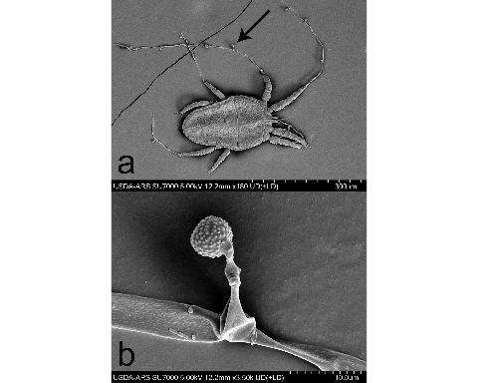

Figure 1.4: a) Cryo-SEM image of Tenuipalpid mite infected with unidentified fungus, collected from b) detail of sporangia. Photo Credit: Dr. Gary R. Bauchan, USDA-ARS, 2020

One of the more cosmopolitan species of tenuipalpid is *Brevipalpus californicus* (Banks). *B. californicus* is a common pest with a large host range of agricultural and ornamental crops, including tea, orchids, citrus, cotton and tobacco (Jeppson et al. 1975, Hoy 2011). *B. californicus* acts as the primary vector for Orchid fleck dichorhavirus (OFV), the type member for the genus *Dichorhavirus*, family *Rhabdoviridae*; a bacilliform, nuclear rhabdoviruses composed of two segments of single-stranded, negative-sense RNA which infects plants (Dietzgen et al. 2014, Walker et al. 2018, Amarasinghe et al. 2019). Dichorhaviruses are only known to be transmitted by mites in the genus *Brevipalpus* (Dietzgen et al. 2014). Other members of this genus are: Citrus chlorotic spot virus, Citrus leprosis virus N, Clerodendrum chlorotic spot virus and Coffee ringspot virus (Dietzgen et al. 2018a). Many orchid genera are able to become infected with OFV (Kondo et al. 2006, 2006), as well as some Asparagaceae (Nolinoidaea) (Dietzgen et al. 2018a), and *Citrus* plants (Rutaceae), where it causes leprosis-like symptoms (Bastianel et al. 2010, Roy et al. 2013, García-Escamilla et al. 2018). Mechanical transmission of OFV is possible under lab conditions to various Chenopodiaceae, Aizoaceae, Fabaceae, and Solanaceae (Chang et al. 1976, Kondo et al. 2003, Peng et al. 2013). *B. californicus* has been collected from OFV-infected Nolinoidaea plants in Australia (Mei et al. 2016, Dietzgen et al. 2018b). *B. californicus* was historically associated with cases of citrus leprosis disease of Florida and Texas prior to 1925, when the disease mysteriously disappeared from the US sometime during the 1960s (Knorr et al. 1968, Childers et al. 2003b). Later studies of herbarium specimens from this time period revealed this disease to be caused by a Dichorhavirus, distantly related to modern OFV strains (Kitajima et al. 2011, Hartung et al. 2015). Maeda (1998) found evidence that *B. californicus* can transmit OFV in a persistent propagative manner, which means that the virus may replicate inside of its mite vector. OFV was first described infecting *Cymbidium* orchids in Japan (Doi et al. 1977). Many countries have reported OFV and OFV-like rhabdoviruses infecting orchids worldwide (Kondo et al. 2003), including Asia: [China (Peng et al. 2017), Korea (Peng et al. 2013)], Africa: [South Africa (Blanchfield et al. 2001, Cook et al. 2019), North America: [The US (Blanchfield et al. 2001), (Bratsch et al. 2015)], South America: [Brazil Kitajima et al. (2001), Colombia (Kubo et al. 2009b), Costa Rica (Freitas-Astúa et al. 2002), Paraguay (Ramos-González et al. 2015), Europe: (Begtrup 1972), Germany (Petzold 1971, Lesemann and Doraiswamy 1975)] and Oceania: (Australia Lesemann and Begtrup 1971, Lesemann and Doraiswamy 1975, Gibbs 2000), Fiji (Pearson et al. 1993), Vanuatu (Pearson et al. 1993)]. The prevalence of OFV and its mite vector is thought to be associated with the importation of infected orchids (Dietzgen et al. 2018a). Orchids infected with OFV develop chlorotic/necrotic flecks on leaves and reduces plant vigor (Peng et al. 2013). Citrus infected with OFV develop chlorotic/necrotic bullseye lesions on leaves, fruits and bark (Roy et al. 2015, Ramos-González et al. 2017). Citrus-infecting strains of OFV have been encountered in Mexico (Roy et al. 2015) and recently in Hawaii (Ocenar 2020, Olmedo-Velarde et al. 2021), introduction of this virus is considered a threat to the billion dollar citriculture industries of the US.

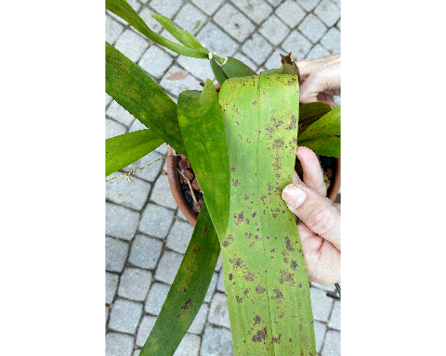

Figure 1.5: orchid infected with Orchid Fleck Virus

# 2 SURVEY AND PHENOLOGY OF NATURAL POPULATIONS OF THE INVASIVE MITE *Phyllocoptes fructiphilus* IN NORTHERN FLORIDA

## 2.1 Introduction

*Phyllocoptes fructiphilus* is a microscopic plant-feeding eriophyid mite. Eriophyoid mites are very host specific (Oldfield 1996b, Skoracka et al. 2009) and *P. fructiphilus* only feeds on plants in the genus *Rosa* (Amrine Jr 1996). *P. fructiphilus* is the vector of Rose Rosette Virus (RRV). RRV infection is commonly associated with the following symptoms: witches’ brooms/rosetting, deformed flowers, increased prickle density, elongated shoots, reddened leaves and stems, and increased die-back which ultimately kills the rose host (Amrine Jr 1996). This disease is known as Rose Rosette Disease (RRD). and is the most serious disease of roses. Florida is the largest producer of roses with a total value exceeding $30 million, and stands to lose millions of dollars if RRD and *P. fructiphilus* become established. There are few options available to control RRD, prevention of disease spread by quarantine and rouging infected roses is key to controlling the spread of this disease into Florida. Rose Rosette Disease and the mite have invaded the southeastern united states as they followed the range expansion of the non-native *Rosa multiflora* (Thunb) towards the coast (Amrine Jr 2002, Otero-Colina et al. 2018). In 2017, a group of researchers conducted a series of surveys for *P. fructiphilus* and RRD in the southeastern United States Solo (2018). RRD has been detected in previously in southern Florida (Babu et al. 2014), but no mites were detected at that time, possibly due to previous application of pesticides before shipping (as commented by Otero-Colina et al. (2018)), or perhaps by grafting of infected rootstock (Doudrick et al. 1987). No RRD or *P. fructiphilius* had been documented in those areas since, but populations of eriphyoid mites are easily overlooked: *P. fructiphilus* are microscopic and cryptic in habits, primarily located under the sepals of rose flowers, near glandular trichomes on the tips of rose canes, making their accidental collection unlikely (Jesse et al. 2006, Bauchan et al. 2019). Previous surveys detected larger populations of *P. fructiphilus* in northern states, with decreasing populations southwards Solo (2018), (*see* *2.1*, *2.2*). Previous surveys were also broader in scope, covering either a broad region (Solo et al. 2020), or select sites known to harbor eriophyoids (Otero-Colina et al. 2018), meaning that the small populations or new introductions would be harder to detect. The data from these previous surveys gave rise to the concept of a ‘southern incidence line’ (*see Solo et al. (**2020**)*), and speculations regarding what may be constraining movement of *P. fructiphilus* and RRD further southwards. Following this line of reasoning, humidity was once hypothesized to be a limiting factor for growth and spread of *P. fructiphilus* populations, but Monterrosa et al. (2021) reported greater mite survival at moderate humidity (60% RH) and increased RRD severity in plants exposed to greater than 20% RH. Furthermore, previous surveys of the southeastern United States did not extend into Florida Solo (2018), (*see* *2.1*, *2.2*). Solo et al. (2020) found small population of *P. fructiphilus* in Thomas County and Lowndes County, GA, less than 20 miles from the northern border of Florida, as well as populations in Dothan, AL (*see* *2.1*, *2.2*), areas with climate trends similar to those of northern Florida (Daly et al. 2012). Therefore, we hypothesized that *P. fructiphilus* (and/or RRV) could be present in northern Florida or other parts of the state if introduced via the plant trade.

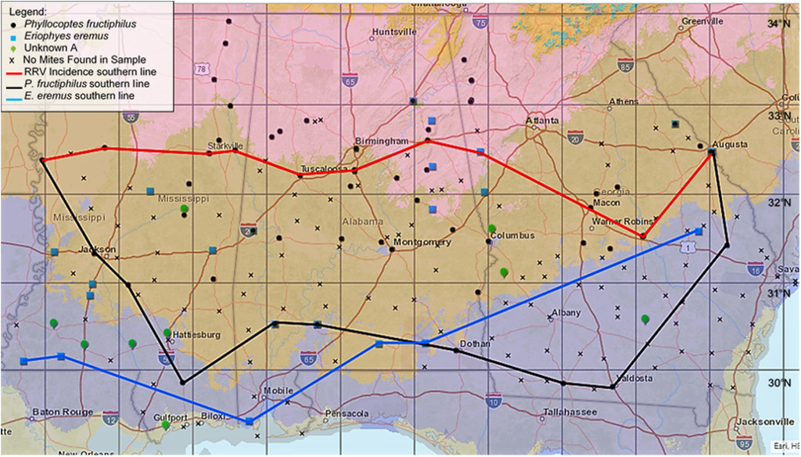

Figure 2.1: ‘Map of the southern incidence line of (RRV) and eriophyid mites in Alabama, Georgia, and Mississippi in 2017. Plant hardiness Zone 7b is in pink, Zone 8a is brown, Zone 8b is blue, and Zone 9a is in gray. Note that there are five locations in which two mite species were found on the same rose sample.’ Citation: HortScience horts 55, 8; 10.21273/HORTSCI14653-20, CC BY-NC-ND 4.0, Unmodified from the original version.

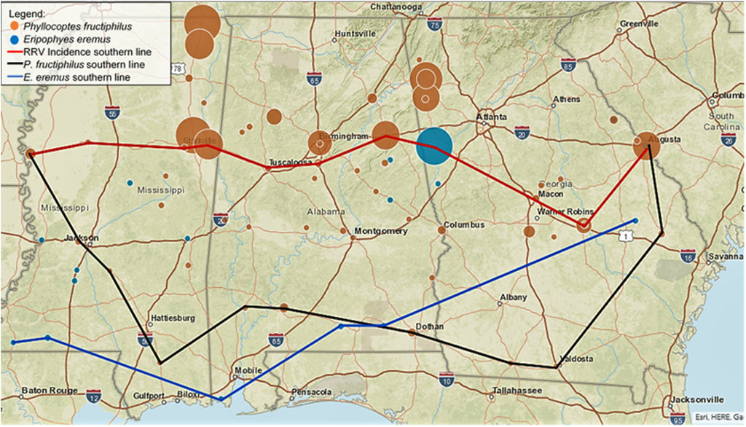

Figure 2.2: ‘Map of the southern incidence line of Rose rosette virus (RRV), southern distribution of and , and the population densities of eriophyid mites found on rose samples in Alabama, Georgia, and Mississippi in 2017. The larger the circle, the more mites found in the sample.’ Citation: HortScience horts 55, 8; 10.21273/HORTSCI14653-20, CC BY-NC-ND 4.0. Unmodified from the original version.

## 2.2 Surveying for *Phyllocoptes fructiphilus*, Rose Rosette Disease and Predatory Mites in Northern Florida

In 2017, the entomology lab at the North Florida Research and Education Center (NFREC) in Quincy, FL, began a series of surveys of roses along the borders of northern Florida and southern Georgia. Our purpose was to estimate the distribution and populations levels of *P. fructiphilus*, as well as recording any RRD incidence in northern Florida. An additional goal of the rose surveys was to detect other predatory mites present on roses: there are many species of predatory phytoseiid mites present in Florida with potential to control agricultural pests such as *P. fructiphilus* (Muma and Denmark 1970). Encountering predatory mites native to the Florida landscape may help in the development of biological control methods for *P. fructiphilus*: native predatory mites sometimes have an advantage for bio-control because native mites have adapted to the environment where they will be released (Gerson 2014). Our results should help identify areas with greater risk for invasion, and help track the movement of *P. fructiphilus* and/or RRD into Florida.

## 2.3 Materials & Methods

A survey of roses in the landscape was conducted following a transect of northern Florida from west to east, Pensacola to Jacksonville. Cities with populations over 1,000 were visited along this route and cuttings were taken from various roses in each city *(see ??)*. Rose cultivar/species, sun exposure and GPS coordinates were recorded to map out sites which had predatory mites, eriophyoid mites, or possibly symptoms of RRD. Rose tissue samples were taken from the periphery of various roses in the landscape; sampling was focused on the flowering tips of roses and included a mixture of flowers, fruits, buds, and short lengths of rose cane. Samples were trimmed with bypass pruners which were routinely sanitized with 70% ethanol between cuts. Samples were stored in 500 Nalgene™ Wide-Mouth Polypropylene Copolymer bottles (ThermoFisher Scientific, Waltham, MA, USA) with ~10 of 95% ethanol. The rose samples then were gently shaken to coat the rose tissues sampled with ethanol. Doing so made sure that the sampled mites were killed and acted to preserve both mites and rose tissues until samples could be processed further and checked for mites. Samples were processed using a washing method derived from Monfreda et al. (2007) used to detect eriophyoid mites such as *P. fructiphilius*: The sampling bottles with ethanol and rose tissues were vigorously shaken to dislodge any mites, then the ethanol in the container was poured over a stack of sieves with decreasing screen sizes: 180 , 53 , and 25 . The bottle and rose pieces were then further rinsed with 95% ethanol over the sieve stack to dislodge any remaining mites. The 53 and 25 sieves were processed separately; the 53 sieve retained larger mites while the 25 sieve retained smaller mites, including *P. fructiphilus*. The sieves were then backwashed from the underside of their screen with a 95% ethanol-filled wash bottle, starting from the highest point of a sieve and working to the bottom to flush any trapped debris and mites into a 50 centrifuge tube for storage and future observations. The ethanol solutions of mites and plant debris were stained with a derivative of McBride’s acid fuchsin stain to enhance contrast (Backus et al. 1988). Solutions were allowed to settle until excess ethanol could be siphoned off, making it possible to then pour this concentrated plant-mite mixture into a thin, small petri dishes or a glass plate for observation under a dissecting microscope. Mites found among the plant debris were counted, then siphoned off with a glass pipette and subsequently stored in micro-centrifuge containers with 95% ethanol as a preservative. 5-10 unstained specimens from each sample were made into prepared microscope slides: Mites were cleared and mounted using the methods of Faraji and Bakker (2008): mites were simultaneously cleared and stained with Faraji and Bakker’s modified clearing solution and heated on a hot plate until the specimens were clear. Subsequently, these mites were moved with an eyelash tool into an iodine-modified Hoyer’s slide mounting media (Hempstead Halide®, Inc., Galveston, Texas, USA), underneath a 12 glass coverslip. The prepared slide was then dried at 90°C before sealing the slide by painting a ring of alkyd insulating enamel (Red Glyptal® 1201, Chelsea, MA, USA) over the edges of the coverslip to seal the slide, to protect it from damage by air incursion and moisture. These slides could then be observed under a compound microscope with phase-contrast objectives to identify the mite families and species if necessary. After mite quantities and species were recorded, a representative sample of eriophyoids putatively identified as *P. fructiphilus* had their identity verified with the acarologist, Dr. Sam Bolton of the Florida Department of Agriculture and Consumer Services, Division of Plant Industry (FDACS-DPI) to ensure accuracy. Roses which appeared to show symptoms of RRD, or which had populations of *P. fructiphilus* present were tested by the Plant Disease Diagnostic Clinic at the NFREC. Plant tissues were tested for RRV by Dr. Fanny Iriarte using the currently accepted molecular methods described in Babu et al. (2016), Babu et al. (2017a), and/or Babu et al. (2017b).

## 2.4 Results

425 samples were taken from 33 sites from an east to west transect along the border northern Florida. Eriophyoid mites were recovered in rose samples from six cities. The first samples of *P. fructiphilus* were first encountered in Tallahassee during 2019; subsequent sampling efforts found in more eriophyoids in Jacksonville, Baldwin, Gainesville and Defuniak Springs in 2020, and Lake City in 2021. Other mites were collected from 68% of the cities visited. The largest populations of *P. fructiphilus* were seen in Tallahassee, with over 8,400 eriophyoid mites from 260 samples collected during 2019-2021 (*see ??*). No evidence of RRD was observed in northern Florida during the surveys, even in areas where abundant *P. fructiphilus* were found. Over 4,600 non-eriophyoid mites were collected from various cities during 2019-2021 *??*. Other non-eriophyoid mites collected primarily belong to the family Tetranychidae, but a small number of phytoseiidae and other predatory mites were recovered as well. These other mites currently await curation and expert identification.

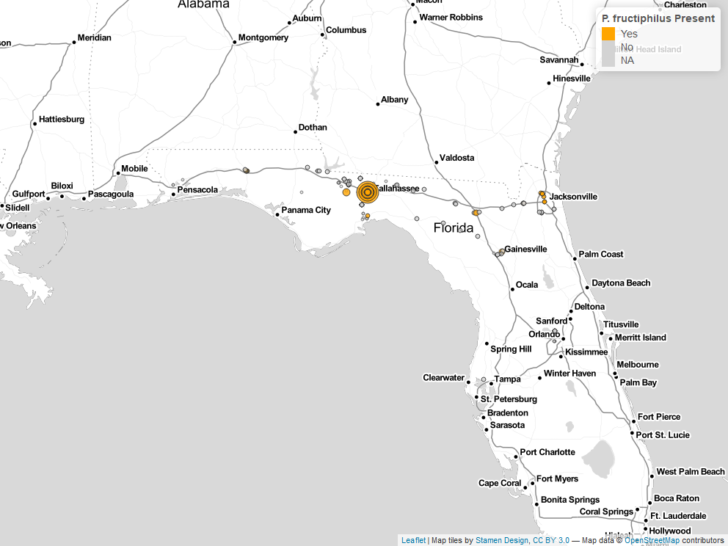

Figure 2.3: mites recovered during surveys of roses in Florida, 2017-2021.

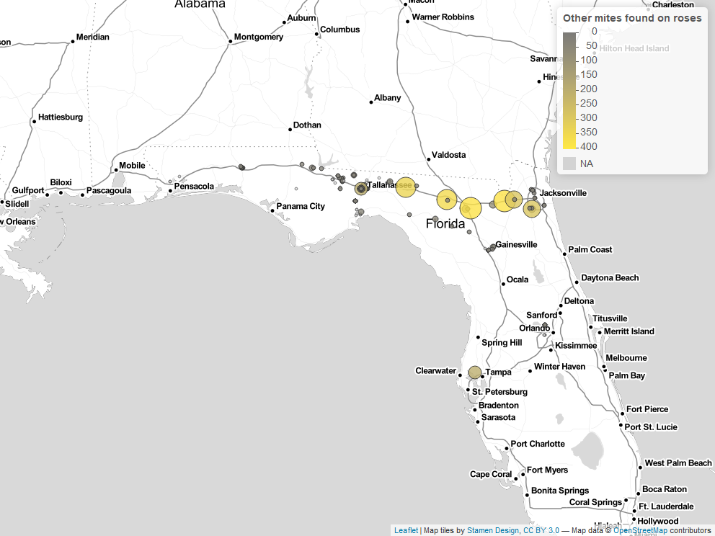

Figure 2.4: Other mites recovered during surveys of roses in Florida, 2017-2021.

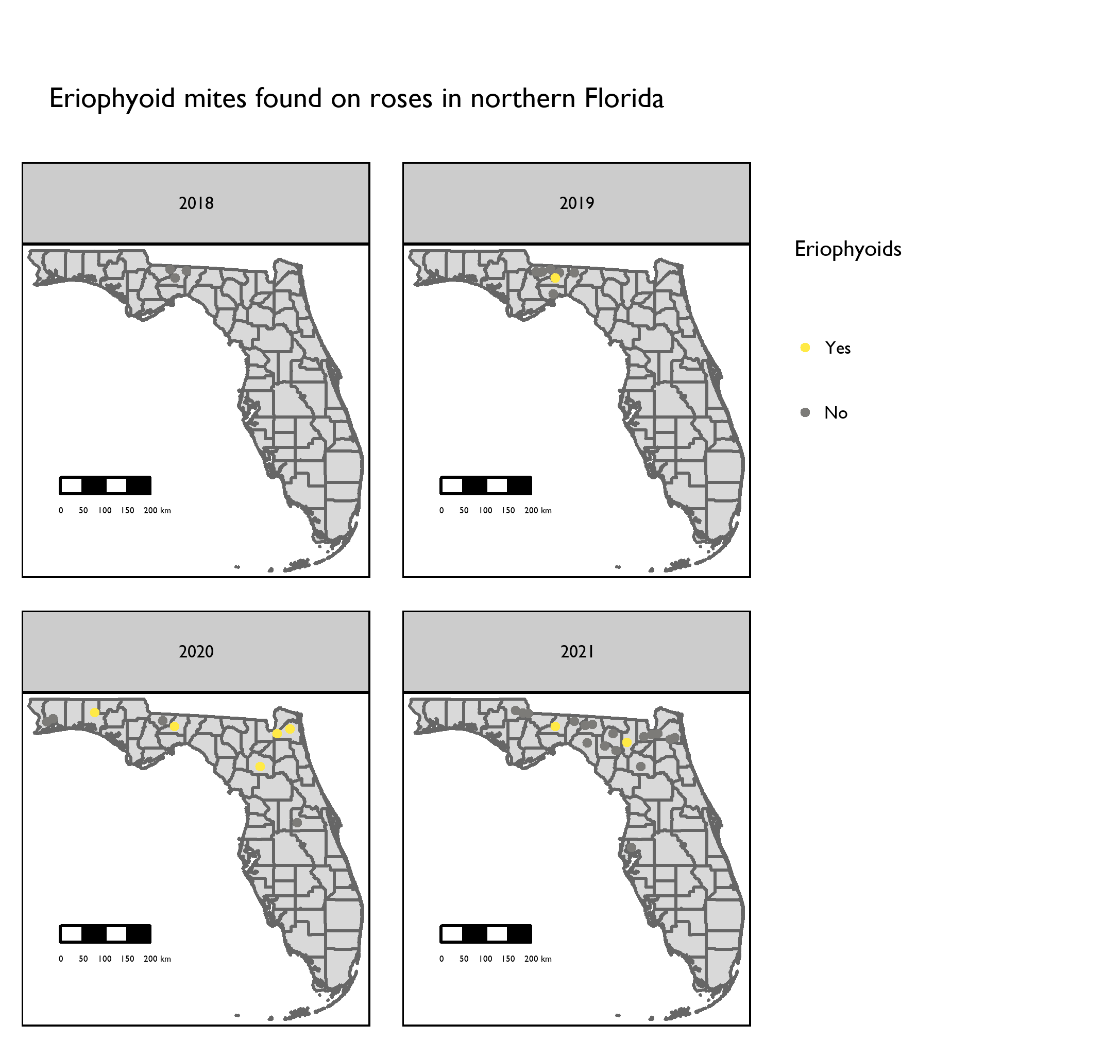

Figure 2.5: Location of populations of eriophyoid mites found on roses in northern Florida 2018-2021.

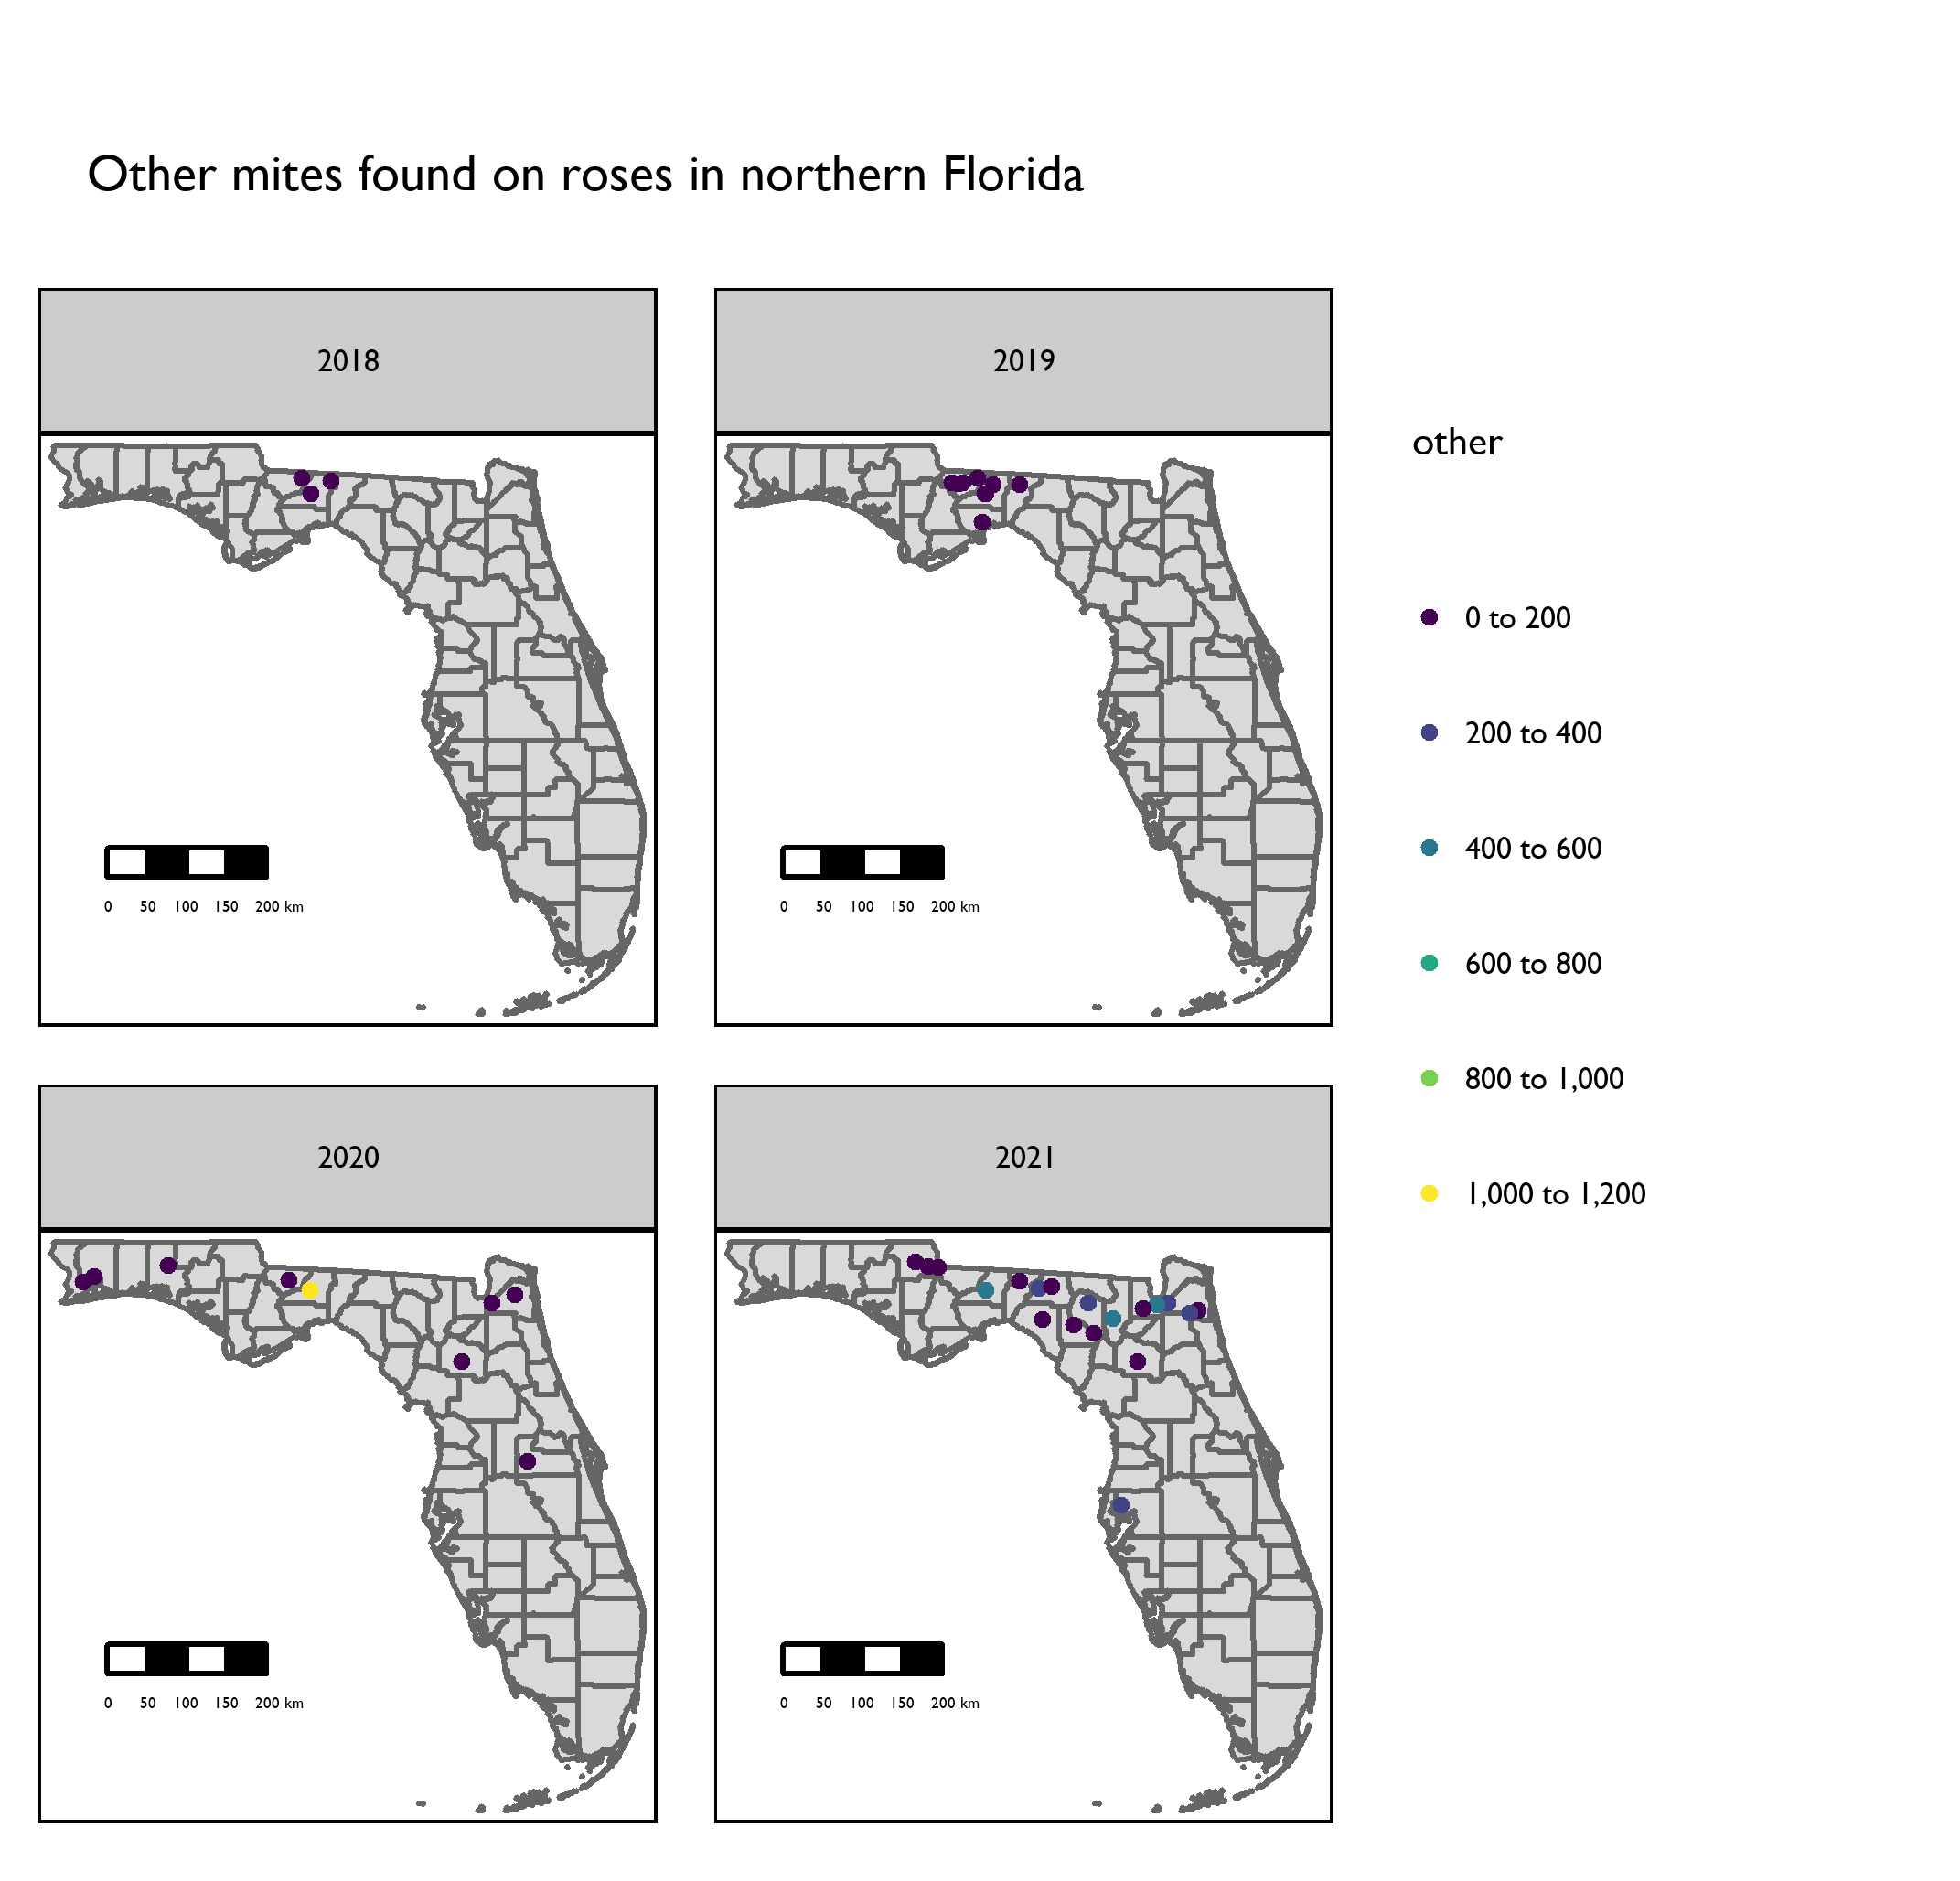

Figure 2.6: Locations of other mites recovered during surveys of roses in Florida, 2018-2021.

## 2.5 Discussion

The presence of *P. fructiphilus* in northern Florida over multiple years and seasons provides evidence against a putative southern limit for the species (Solo et al. 2020). Unfortunately, our survey efforts were severely hampered by the COVID-19 pandemic, which limited opportunities to travel and collect mites. We expect that further investigations of roses in other Florida cities will reveal more *P. fructiphilus*-infested sites. The arrival of a competent vector is not a guarantee that its associated disease will follow suit, but it does provide a necessary component of the disease triangle: if the environmental conditions are suitable, and the rose host is sufficiently abundant, there is potential for disease to occur (Francl 2001). We did not see any signs of RRD in roses in northern Florida, but it is important to note that the delayed onset and difficulty of identifying symptoms makes it likely to miss detection until late stages of the disease. It is not known how *P. fructiphilus* have arrived in northern Florida, or how long they have been here, and unfortunately our observations are not sufficient to describe a mechanism of invasion. Eriophyoid mites may be windblown, transported with infected plants, move on contaminated equipment or clothes, or rarely, are moved through phoresy (Sabelis and Bruin 1996). Previous Florida mite surveys were conducted in 2017 and 2018, along a north-south transect from Florida into Georgia, but *P. fructiphilus* were only detected in recent years. The 2017-2018 Florida surveys were focused on Cherokee roses *Rosa laevigata*, roses which are easiest to find during the spring and early summer, due to their ephemeral blooming cycle. Our recent surveys did not cover the same locations and focused on all species roses present in public or private plantings. In addition, we were unable to sample from Cherokee roses in Florida, due to COVID-19 lockdowns travel restrictions during the blooming season of *R. laevigata*. The sites with the largest populations of *P fructiphilus* in Florida are various plantings around of a college campus, with many landscaping projects, allowing for many potential introductions of *P. fructiphilus* on newly purchased plants. On the other hand, the current invasions of *P. fructiphilus* may have been introduced through their natural means of dispersal over time. The short distances between mite infested roses in Georgia, Alabama and Florida suggest the possibility of multiple routes of introduction, but the mechanisms of dispersal require further investigation for *P. fructiphilus*. In addition, the movements of plant pathogens such as RRD is thought to be partially driven by socioeconomic factors and the movement of plants by people (Nelson and Bone 2015, Katsiani et al. 2020). Inspections and quarantines of mite-infested roses by wholesalers and larger growers is predicted to slow the spread of plant pathogen epidemics (Nelson and Bone 2015). A large number of other non-eriophyoid mites have been collected. Our findings were similar to the results of other surveys (Jesse et al. 2006, Otero-Colina et al. 2018, Solo et al. 2020): we primarily encountered plant-feeding mites, including mites from the families tetranychidae, tenuipalpidae, eriophyoidae, and some predators, including chelytidae and phytoseiidae. We did encounter some tydeidae, but we are not certain of their feeding guild, as many tydeidae are fungivores rather than herbivores. Further examination of collected mites is expected to reveal a variety of species and overlooked individuals. Accurate identification will necessarily require collaboration with individuals better trained in mite taxonomy to avoid misidentifications (Demard et al. 2021). In conclusion, the presence of *P. fructiphilus* in Florida necessitates the development of mite control practices to prevent mite populations from surging, and to hopefully prevent the spread of RRD.

# 3 CHANGES IN HEADSPACE VOLATILES FOR ROSES INFECTED WITH ROSE ROSETTE DISEASE

## 3.1 Introduction

### 3.1.1 Plant defenses and volatiles: why are *Amblyseius swirskii* attracted infected roses?

Rose Rosette Virus (RRV) genus *Emaraviridae* is the the casual agent of Rose Rosette Disease (RRD), the most severe disease of roses (Laney et al. 2011). RRD is thought to have invaded the southeastern United States by the movement of its vector, the eriophyid mite, *Phyllocoptes fructiphilus* Kiefer (Trombidiformes: Eriophyidae), on multiflora rose (*Rosa multiflora* (Thunb)), as these organisms expanded their range from the US northwest, south and east towards the coast (Amrine Jr 2002, Otero-Colina et al. 2018, Solo et al. 2020). RRD is currently present throughout the US, and has been recently detected in Florida (Fife et al. 2020). Infection with RRD creates witches’ brooms, rosetting, deforms flowers, increases prickle density, elongates shoots, reddens of plant tissues, causes die-back and ultimately plant death. Few management options are available to manage *P. fructiphilus*: Current mite control is achieved by removing infected roses and frequent pesticide applications (Hong et al. 2012, Olson et al. 2017, “Control - rose rosette” 2018). Nursery managers are interested in alternative and less expensive management options to combat *P. fructiphilus* and RRD. Predatory mites may have potential to fulfill this need (Gerson et al. 2003, Farragut et al. 2010, Gerson 2014, Carrillo et al. 2015): Many predatory mites species have been successfully integrated into pest management programs along with other biocontrol agents (Chow et al. 2010, Midthassel et al. 2016, Bouagga et al. 2018, Freitas et al. 2021), and certain pesticides (Trumble and Morse 1993, Nicetic et al. 2001, Fernández et al. 2017). Predatory mites from the family phytoseiidae live in close association with their host plants and are effective predators of many pest species (Gerson et al. 2003, Farragut et al. 2010, Carrillo et al. 2015). One of the most popular species of commercially-available phytoseiid mites is *Amblyseius swirskii* Athias-Henriot (Mesostigmata: Phytoseiidae)(Calvo et al. 2014). *A. swirskii* are considered to be a generalist species which feed on a variety of different arthropod pests (McMurtry and Croft 1997), including eriophyoid mites (Park et al. 2010, 2011). *A. swirskii* are able to be purchased in slow release sachets and safely shipped to growers that need them (Buitenhuis et al. 2014, Calvo et al. 2014, Lopez and Smith 2016). They are commonly used in biological control programs (Calvo et al. 2014), partially because of their ability to survive on alternative food sources when pests are not present (Nguyen et al. 2013). They are also able to be released before pests arrive (Kutuk and Yigit 2011), surviving on banker and native plants in the environment until pest populations increase (Xiao et al. 2012). This intimate relation with plants extends into the realm of chemical communications: Phytoseiid like *A. swirskii* have no eyes, instead relying on plant Volatile Organic Compounds (VOCs) to guide them to their prey (Gnanvossou et al. 2003, Boer and Dicke 2004a, Nomikou et al. 2005). Many plant VOCs are released when a plant is attacked by herbivores or pathogens (Shulaev et al. 1997, Sabelis et al. 1999, Halitschke et al. 2007), the composition of which varies, depending on the plant species and type of damage/infection (Sabelis et al. 1999, Boom et al. 2004, Maeda and Liu 2006, Qualley and Dudareva 2008). Methyl Salicylate (MeSA) is a VOC commonly produced under many types of pathogen attack (Park et al. 2007, Arimura et al. 2011). This plant volatile is derived from Salicylic Acid (SA), an important plant hormone involved in activating the hypersensitive response to pathogens (Gaffney et al. 1993, Goodman and Novacky 1994, Park et al. 2007, Vlot et al. 2009). Volatilized MeSA can initiate the the signalling pathway which primes a plant’s immune system against attacks by pathogens (Shulaev et al. 1997, Conrath et al. 2006, Tieman et al. 2010, Gozzo and Faoro 2013). Activation of these plant defenses creates long term resistance against future pathogen attack throughout the plant, through a mechanism known as systemic acquired resistance (SAR) (Boller and Felix 2009, Vlot et al. 2009, Zhang et al. 2010). These same pathways can be induced in a plant by chemical analogues to SA, such as the benzothiadiazoles, including acibenzolar-S-methyl (ASM) (Narusaka et al. 1999, Ziadi et al. 2001, Tripathi et al. 2010, Darolt et al. 2020). Inducing SAR can have various positive effects on disease prevention: SAR induction is often used to combat fungal diseases (Goy et al. 1992, Xue et al. 1998, Narusaka et al. 1999, Suo and Leung 2001), and some studies have found that SAR induction and the hypersensitive response can disrupt the establishment of eriophyoid mites (Bronner et al. 1991a, 1991b, Westphal et al. 1991). Infested plants produced ,3-glucanase and chitinases, which were hypothesized to contribute to defenses against these eriophyoid mites (Bronner et al. 1991b, Ward et al. 1991). Similar increases in ,3-glucanase and chitinase activity was seen in roses treated with ASM, restricting the growth of a fungal pathogen (Suo and Leung 2001). This suggests that SAR-induction in roses may have biological activity against eriophyoid mites, including *P. fructiphilus*. Unfortunately, inducing SAR can have negative effects on herbivores as well as predators (Kant et al. 2015, Ataide et al. 2016, Pappas et al. 2017), which necessitates careful study of all organisms involved to create a successful pest management program. Our study was designed to investigate some of the interactions between plant volatiles and their effects on predatory mites: Preliminary data suggest that *A. swirskii* are attracted towards volatiles of RRD-infected plants. Similarly, MeSA has been reported to attract phytoseiid mites towards their prey to varying degrees of success (Boer and Dicke 2004a, 2004b, James and Price 2004, Gadino et al. 2011, 2012). We hypothesized that infection with RRD was triggering the release of MeSA, creating *A. swirskii*’s attraction to the infected plants. Our studies were designed to investigate differences between RRV-infected and uninfected Pink Double Knock Out® roses and their volatiles, as well as the effects of SAR-induction on rose volatiles. We hypothesized that *A. swirskii* were attracted to infected roses due to increases in defensive volatiles consistent with SAR-induction, such as increases in MeSA. The results will help inform future assays involving predatory mites and their prey-seeking behaviors in relation to rose RRV-infection status and the potential of SAR-inducers for management of eriophyid mites.

## 3.2 Materials & Methods

### 3.2.1 Collection of headspace volatiles from roses

Two methods for collecting headspace volatiles were explored, Volatile Collection Traps (VCT) and Solid Phase Micro Extraction (SPME).

#### 3.2.1.1 Volatile collection trap methodology

The VCT method of collecting VOCs was based on a push-pull volatile collection method as illustrated in *3.1*. Filtered air was provided by a 4-Port Positive Pressure Flow Out/Dual Y-Tubes & Volatile Collection System (Sigma Scientific, Micanopy, FL USA) at 0.2 s/min. Air was blown through a teflon tube into a nylon oven bag (GoBeGreen Turkey Oven Bags, GoBeGreen, Los Angeles, CA, USA.) that had been dried in an over at 50 °C overnight. The bag would be sealed over the end of a flowering rose cane from Pink Double Knock Out® roses. Bags were allowed to inflate in order to detect excessive leaks, if no large leaks were detected, the corner of the bag would be cut and a VCT would be inserted. Traps were 3.5” with 28 ± 5 80/100 mesh with HayeSep® Q adsorbent (Sigma Scientific, Micanopy, FL USA). Headspace volatiles were drawn through the filter by a vacuum line operating at 0.1 /min. Bags were left at positive pressure during volatile collection for 24 hours. The VOCs adsorbed inside the VCT filter were then eluted with 150 of dichloromethane into a glass headspace vial, then 5 of 1 / Nonyl Acetate were added to each solution as an internal standard. A baseline of 53 headspace VOC extractions were collected from 20 mite-free, one-year-old, uninfected Pink Double Knock Out® roses growing in 3 gallon buckets, 16:8 Light:Dark cycles. Extractions were conducted for ~12 hours. 4 extractions were completed from graft-inoculated RRD-positive roses (Doudrick et al. 1987), grown in a quarantine greenhouse under similar parameters. Headspace samples of the RRD-infected roses were taken prior to the quarantine measures requested by federal agencies. Samples were taken at ~20 °C and RH 50-66%.

#### 3.2.1.2 Solid phase micro extraction (SPME) methodology

The Solid Phase Micro Extraction (SPME) field method was created to overcome a specific study limitation: shortly after the detection of *P. fructiphilus* in Florida, NFREC researchers were restricted from working with RRD-infected plants by state agencies to prevent the introduction of the virus to the mites found in the region. In order to obtain VOCs from RRD-infected roses, extractions were taken *in situ* from roses in the landscape of Athens, GA *3.2*. The SPME procedure was similar to the VCT method with a few exceptions: Oven bags were left over rose canes and flowers for an hour before extraction would begin. Filtered air was provided by a Kobalt 24v cordless high-volume inflator (Lowe’s, Mooresville, NC, USA) attached to a inline carbon block filter (Clear $​_{2}$ O® RV and Marine Inline Water Filter - CRV2006, Miramar, FL, USA). Air flow was adjusted to 0.2 /min with a variable flow meter (Sho-Rate™ Series Glass Tube Variable Area Flow Meter, model 1350CB1F, Brooks Instruments, Hatfield, PA, USA) and blown through a teflon tube into an oven bag surrounding the rose flowers and canes to agitate the headspace VOCs. An edge of the oven bag was removed and a disposable air filter/check valve inserted to prevent the oven bag from bursting due to over pressure. Once the bag was in place, an aluminum rod with burette holder/clamps was driven into the ground near the rose to be sampled, and the manual SPME injector (Supelco, Inc, Sigma-Aldrich, Bellefonte, PA, USA) clamped so that the needle of the fiber holder could pierce the inflated bag. Before VOC extraction, 1 of Nonyl Acetate was added to the bag as an internal standard. Extractions were done for 20 minutes. Injections were done using 24 Ga Stableflex SPME fibers with 50/30 DVB/CAR/PDMS coatings (Supelco, Inc, Sigma-Aldrich, Bellefonte, PA, USA). For SPME sampling, headspace VOCs were collected from 11 untreated roses from *P.fructiphilus*-infested roses in the landscape of Tallahassee, FL. 8 roses from the same location were treated with Actigard® 50WG (Syngenta, Greensboro, NC, USA), (ASM) 100 / for 12 weeks before sampling, and 11 RRD-infected roses were sampled from three locations in Athens, GA on May 28th, 2021. Plants were of unknown age, growing in full sun, with symptoms of RRD. The daily temperature of the day of extractions ranged from 24-31 °C, RH 46-74%.

#### 3.2.1.3 Analysis of headspace data

Headspace extractions from VCT and SPME were injected into a paired Gas Chromatography-Mass Spectrometer (GC-MS) (ThermoFisher Trace 1310 Gas Chromatograph and ThermoFisher ISQ QD Single Quadrupole Mass Spectrometer, (ThermoFisher Scientific, Waltham, Massachusetts) and their spectra were analyzed with Chromeleon™ 7 Chromatography Data System software (ThermoFisher Scientific, Waltham, Massachusetts). GC-MS Injections were for 38 mins with 5 °C increase per minute. Volatile collection equipment was cleaned according to manufacturer’s instructions. Compounds were identified by comparisons of mass spectra to spectral databases for confirmation. The ratio of the area under the curve for each chemical peak was then divided by the area of the internal standard (Nonyl Acetate). These values were used for Principal Component Analysis (PCA) with the factoextra package (Kassambara and Mundt 2020), and Uniform Manifold Approximation and Projection (UMAP) (Konopka 2020) in R version 4.1.1 (R Core Team 2021), to visualize any clustering of data and to determine which VOCs are of interest.

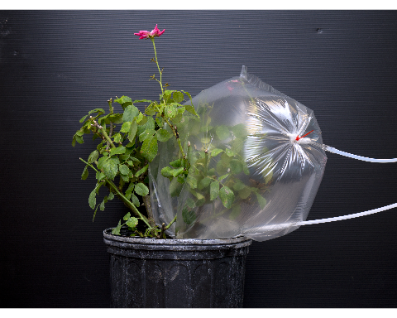

Figure 3.1: Volatile collection trap method for rose headspace sampling. An inert nylon bag is placed around the canes of interest, an air inlet is inserted and sealed at the base with a zip-tie to form a relatively air-tight seal around the base of the rose canes. Once the bag begins to inflate, a small hole is cut in the corner of the bag and a filter inserted and sealed with a zip-tie to form a second seal. The exterior end of the filter is attached to a vacuum airline set to allow for constant static pressure on the bag from inflation. The rose is then left for 24 hours, the filter is eluted with Dichloromethane into a gas chromatography vial, 1 of Nonyl Acetate is added as an internal standard, and then the sample is processed using a coupled Gas Chromatography - Mass Spectrometer (GC-MS) for chemical identification.

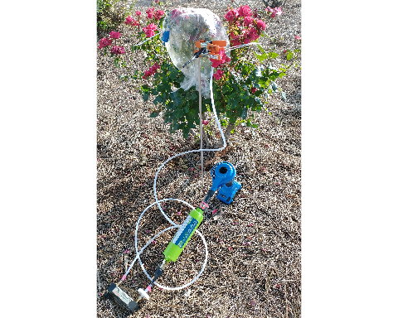

Figure 3.2: Solid phase micro extraction (SPME) method for rose headspace sampling. An inert nylon bag is placed around the canes of interest, an air inlet is inserted and sealed at the base with a zip-tie to form a relatively air-tight seal around the base of the rose canes. Once the bag begins to inflate, a small hole is cut in the corner of the bag and a filter inserted and sealed with a zip-tie to form a second seal. 1 of Nonyl Acetate is added as an internal standard. The needle of a SPME fiber holder is used to puncture the bag, and the fiber is exposed to the headspace for 20 minutes adsorb volatiles to the special coating of the SPME fiber. The fiber is then injected into a coupled GC-MS for chemical identification.

### 3.2.2 Which volatiles are most attractive?: two-arm olfactometer assays

*A. swirskii* mites were purchased online as mini sachets with hooks (Ambly-S, Arbico Organics, Oro Valley, AZ, USA). Sachets would be emptied into a plastic container before assays in order to facilitate finding mites. The mite colony was fed every 2 days with bee/pine pollen. Filtered air was provided by a 4-Port Positive Pressure Flow Out/Dual Y-Tubes & Volatile Collection System (Sigma Scientific, Micanopy, FL USA) at 0.3 s/min for each arm of the Y-tube olfactometer. Air was humidified by passing air through a gas washing bubbler flask filled with water. The bubbler flasks were placed inline before volatile sources and the arms of the Y-tube. The olfactometer was held vertically with a lab stand, and illuminated with a 60 watt household 5000K white LED lightbulb. One arm of the Y-tube would be labelled as the experiment side, and the other arm would be the control chemical. Air lines would be switched after every 5 assays to avoid side bias in the Y-tube. After every 10 assays, the Y-tube was switched for a clean one. Individual *A. swirksii* mites were transferred to the mouth of the Y-tube olfactometer using a fine tipped paintbrush. Assays were recorded for 5 minutes. If a mite entered midway into the arm of an olfactometer, the time and label of the tube would be recorded, the mite removed, and the assay would end. Mites which failed to do so were considered to have made ‘no choice’ and were removed. Assays with roses involved bagging the roses as previously described, but with outlet air lines connected to the inlet of one arm of the Y-tube. In this manner, comparisons were made between an empty bag of air and a healthy rose, as well as uninfected roses to RRD-infected roses. Synthetic volatiles were selected from the top ten chemicals seen in the contributions table from the PCA analysis (*??, ??*). Assays of synthetic volatiles were conducted by a selected VOC with dicholoromethane. The solution was then applied to a 3 dental wick. Dental wicks were placed in otherwise empty inline gas washing bubbler flasks, and left for 5 minutes before beginning an assay. The synthetic VOCs MeSA and DL-Limonene at were tested, at a concentration of 1 /. 100 of dicholoromethane was used as a control.

Responses of *A. swirkii* were compared with $χ^{2}$ tests using R version 4.1.1 (R Core Team 2021).

## 3.3 Results

### 3.3.1 Volatiles differ between RRD-infected, uninfected and induced roses

The top six contributing VOCs for VCT were -Murrolene, -Ocimene, (E,E)--Farnesene, -Caryophyllene, Methyl Salicylate and -Pinene (*??*). The top six contributing chemicals for SPME were -Murrolene, -Caryophyllene 1R--Pinene, Mesitylene, -Pinene and m-Xylene (*??*). Roses infected with RRD were generally similar to uninfected roses for both VCT and SPME methods, (*3.4*, *3.9*, *3.6*, *3.11*), but ASM-treated roses had less chemical variance than either group (*3.9*, *3.11*). For VCT samples, -Murrolene explained most of the variance in uninfected roses, while SPME samples showed the opposite:-Murrolene and -Caryophyllene were primarily found in infected roses.

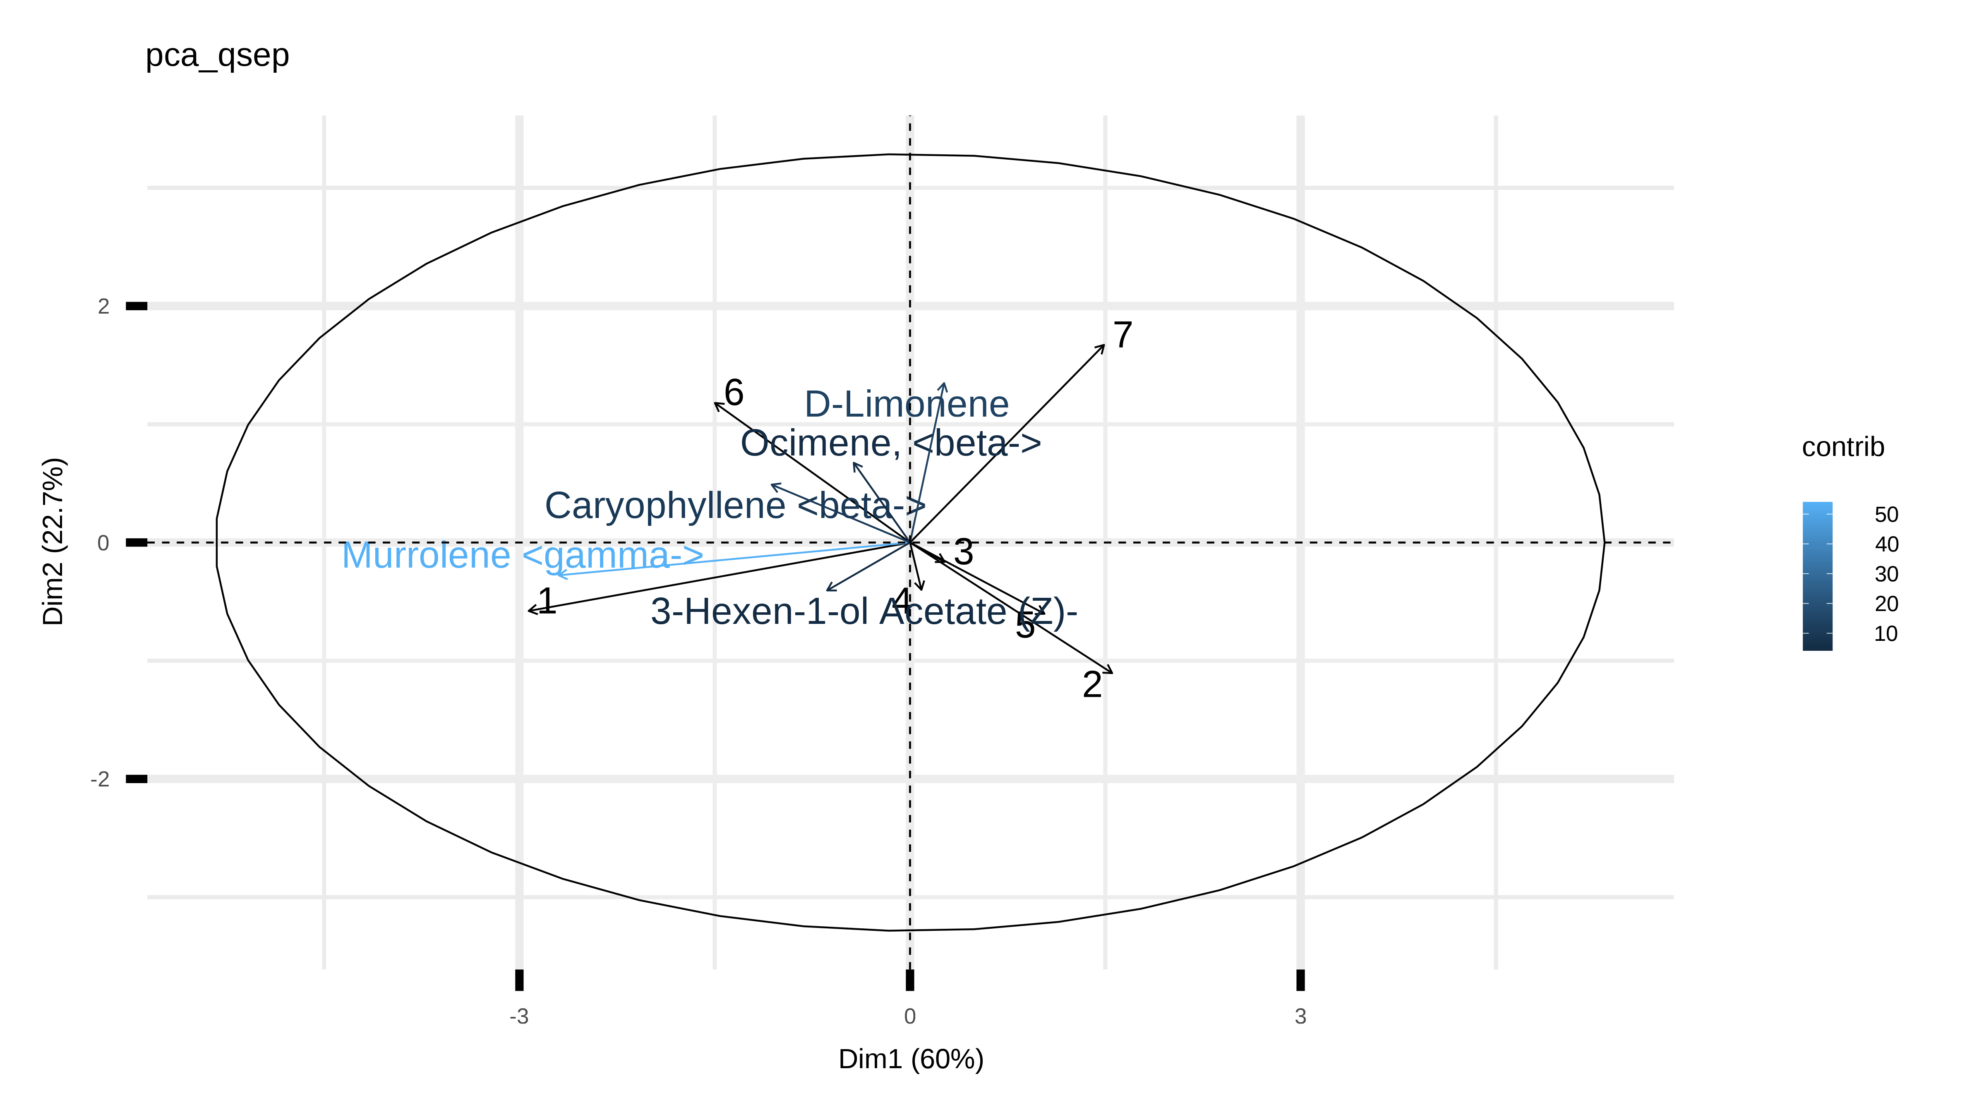

Figure 3.3: Principal component analysis (PCA) biplot of volatiles collected with VCT method.

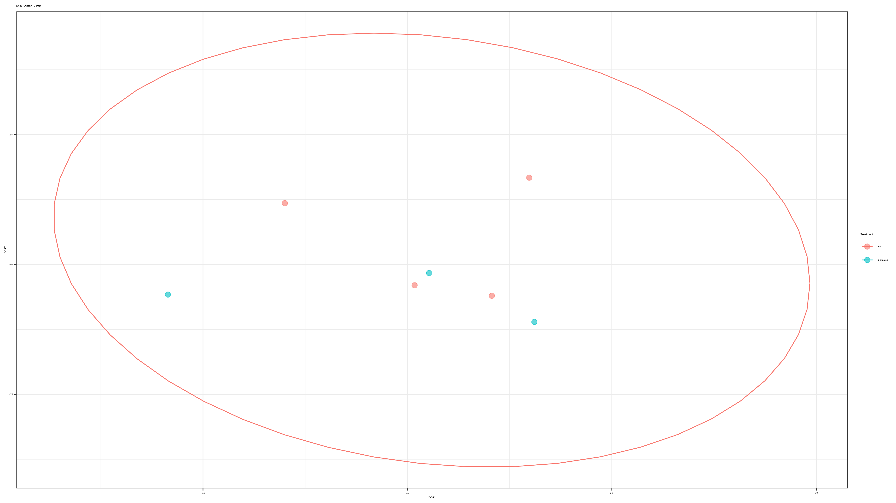

Figure 3.4: Comparison of VCT principal components. Ellipses represent 95% confidence intervals.

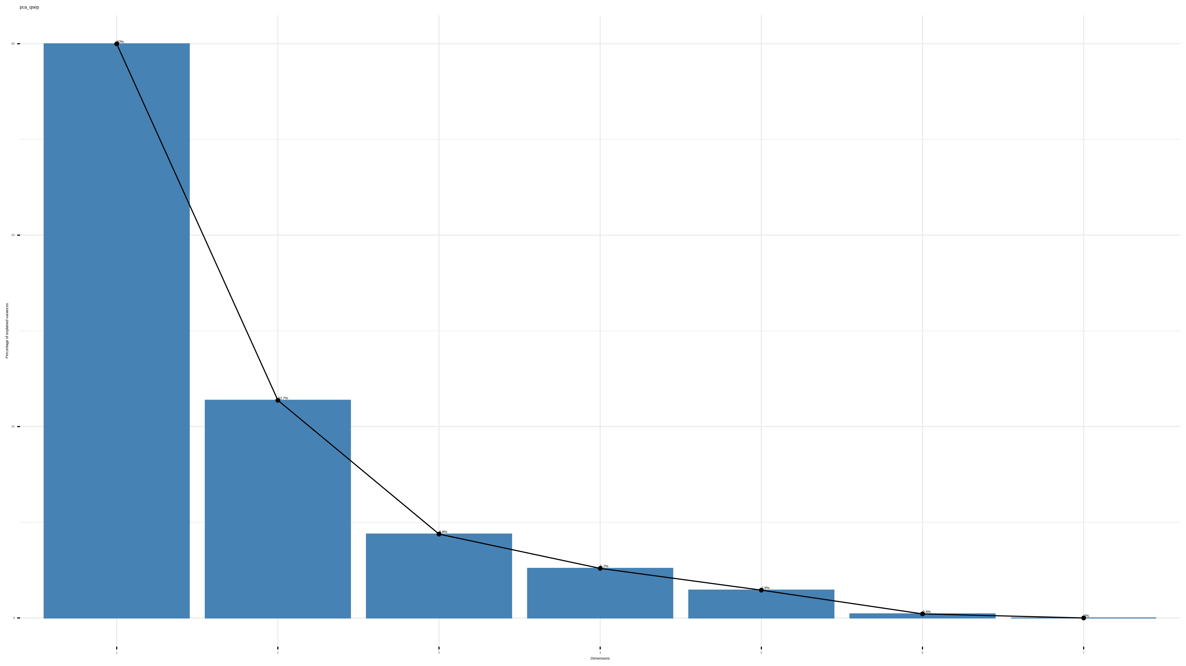

Figure 3.5: Scree plot of VCT principal components.

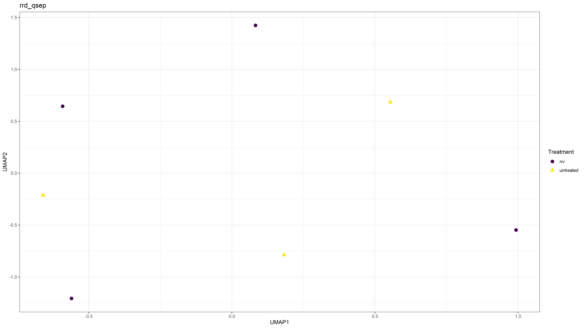

Figure 3.6: Uniform Manifold Approximation and Projection (UMAP) of VCT samples.

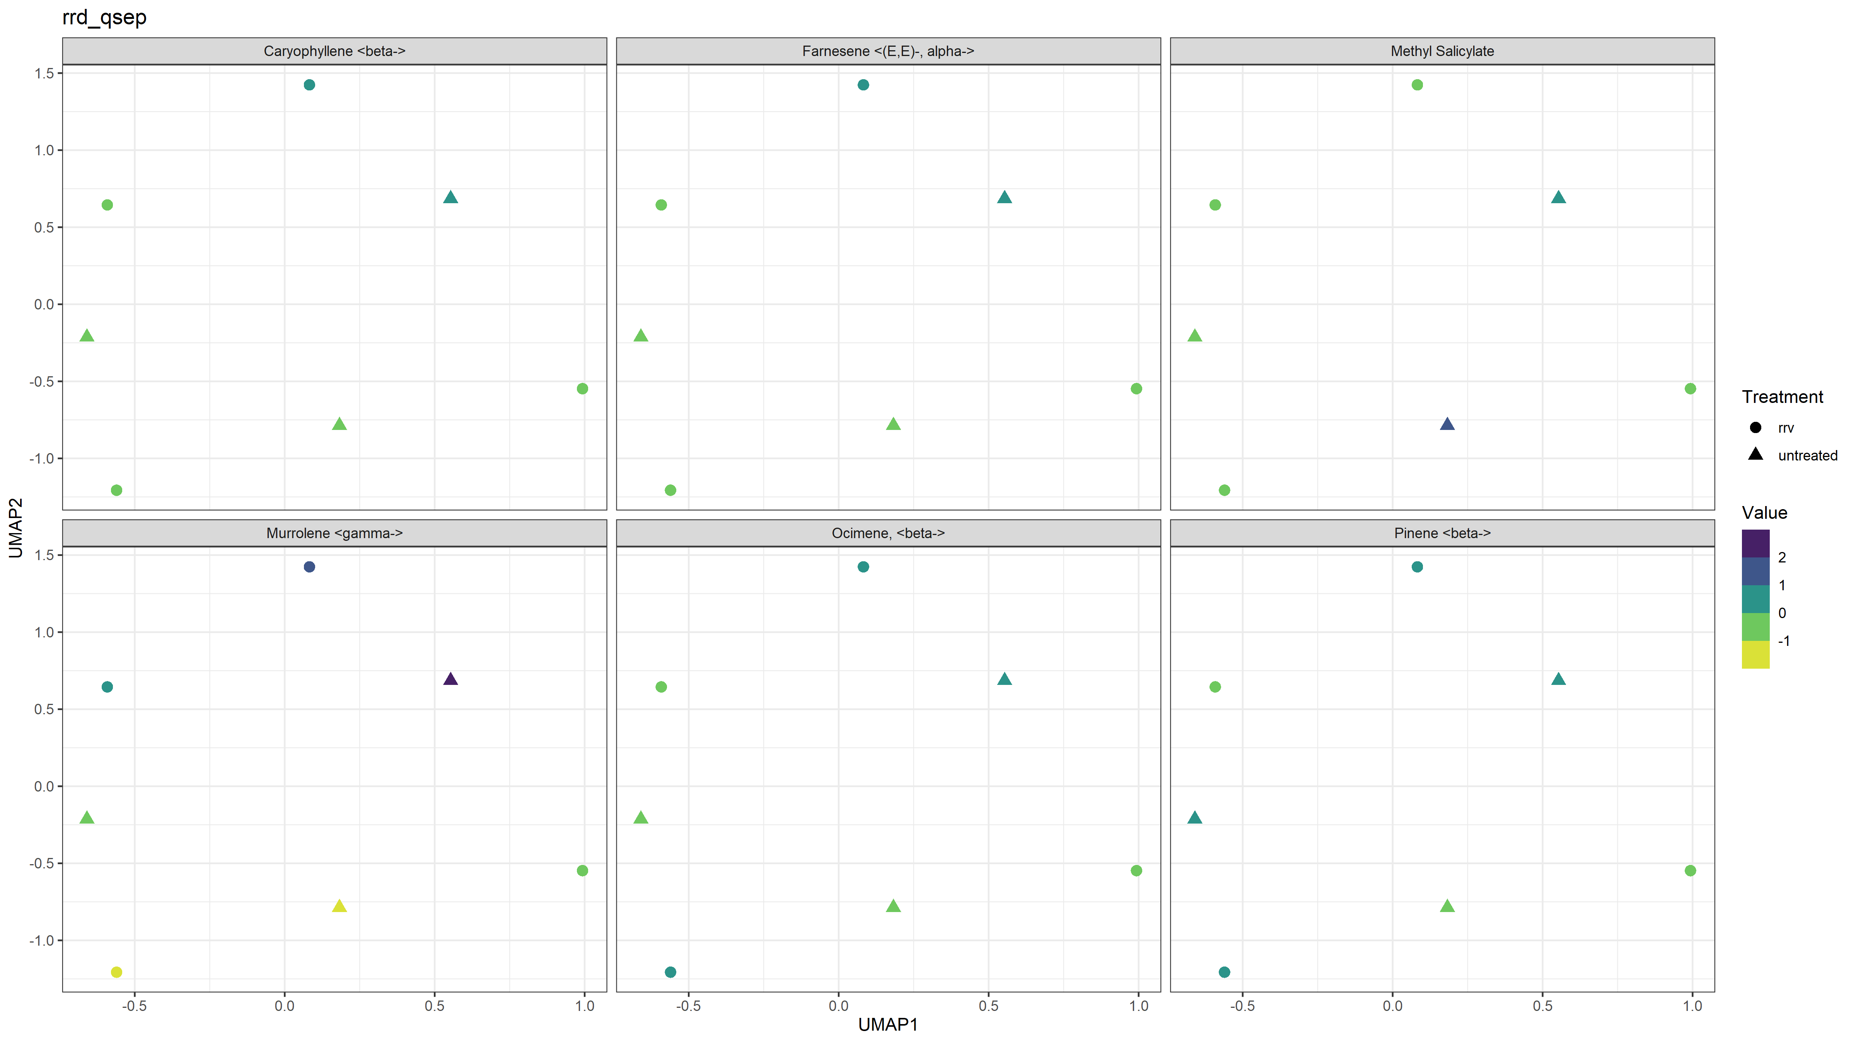

Figure 3.7: UMAP of VCT method’s six largest contributions to volatile compositions.

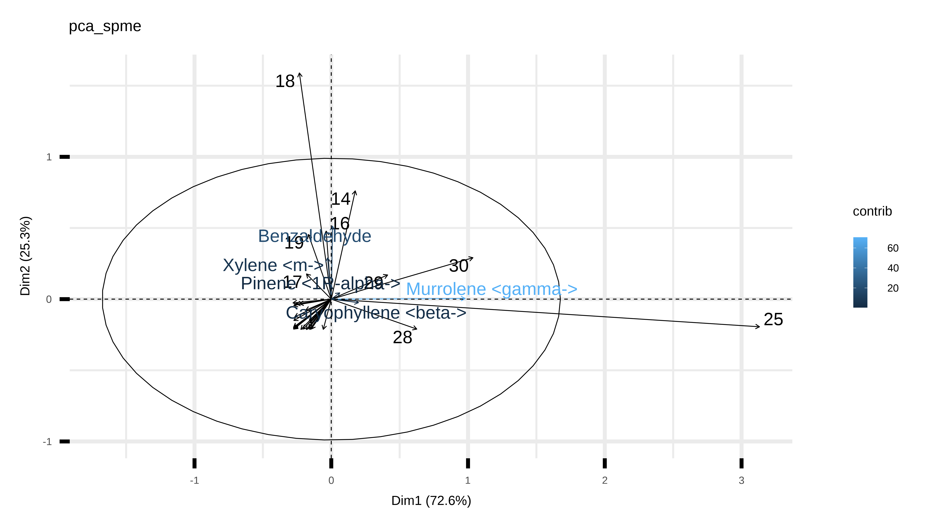

Figure 3.8: PCA biplot of volatiles collected with SPME method.

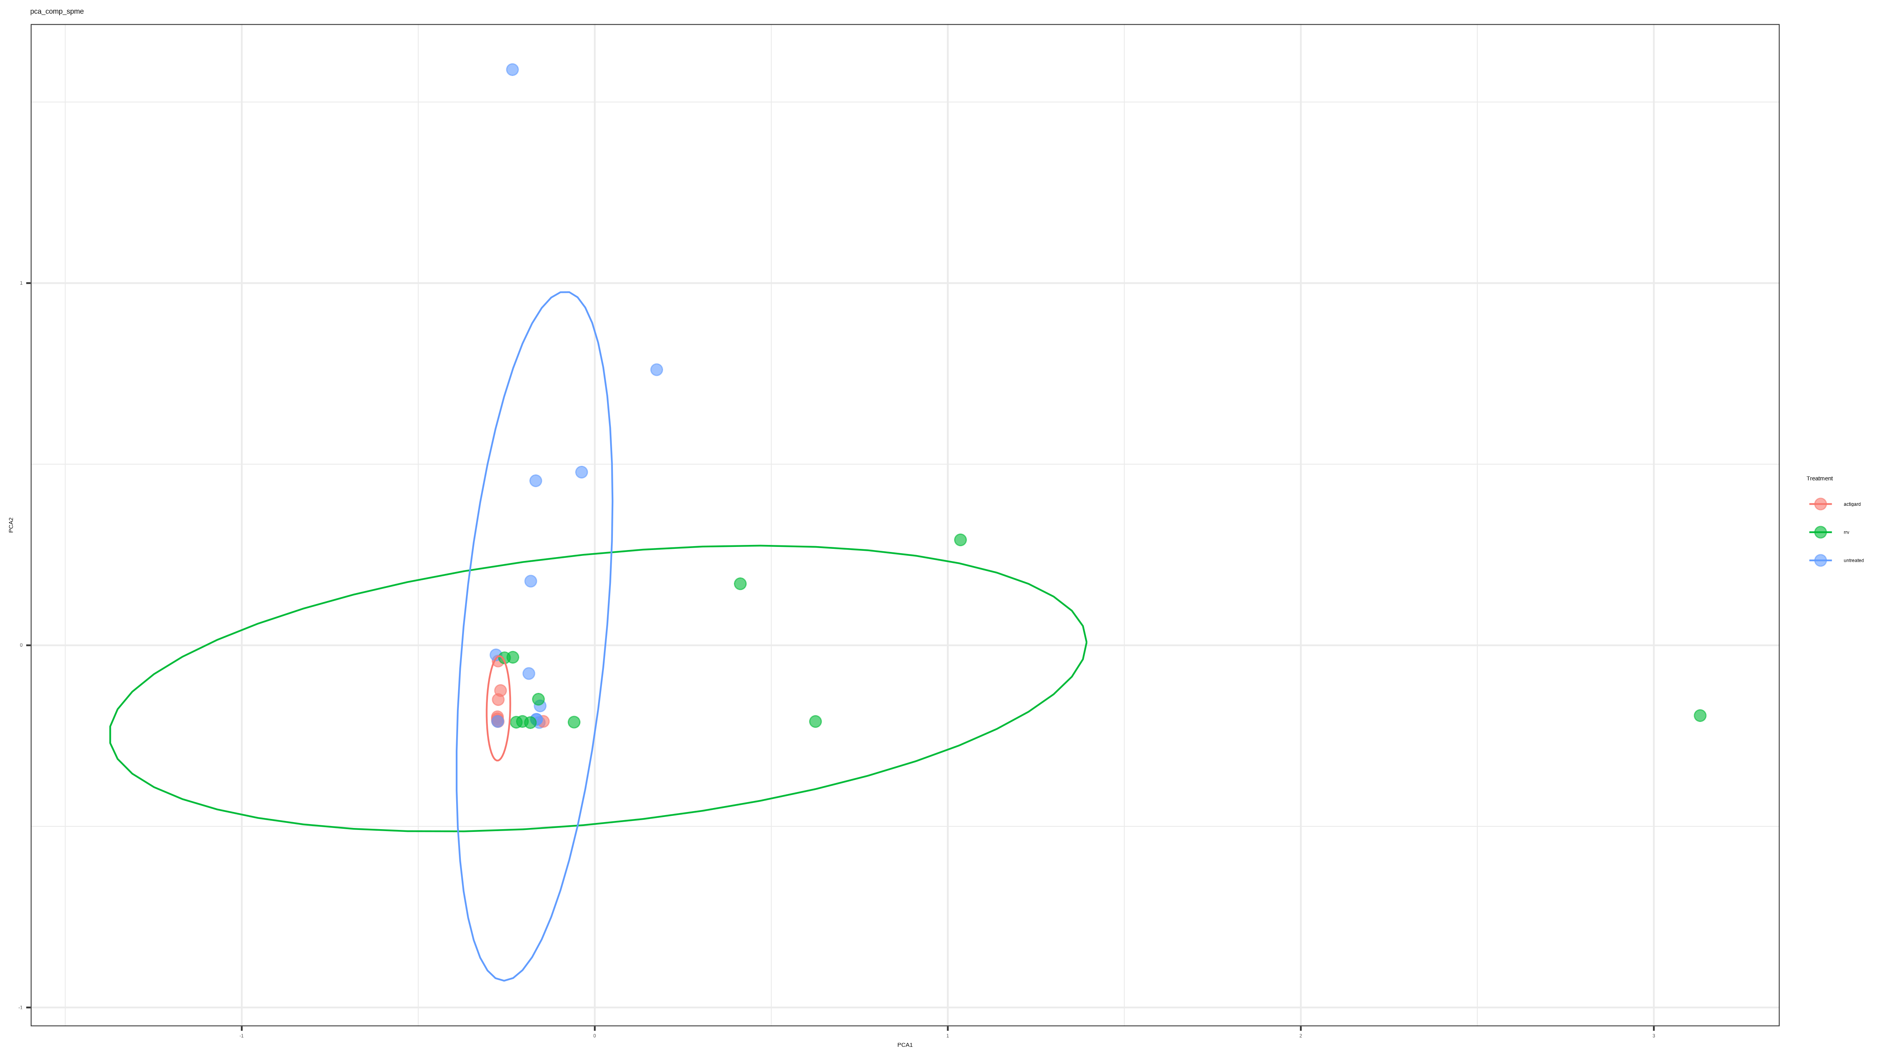

Figure 3.9: Comparison of SPME principal components. Ellipses represent 95% confidence intervals.

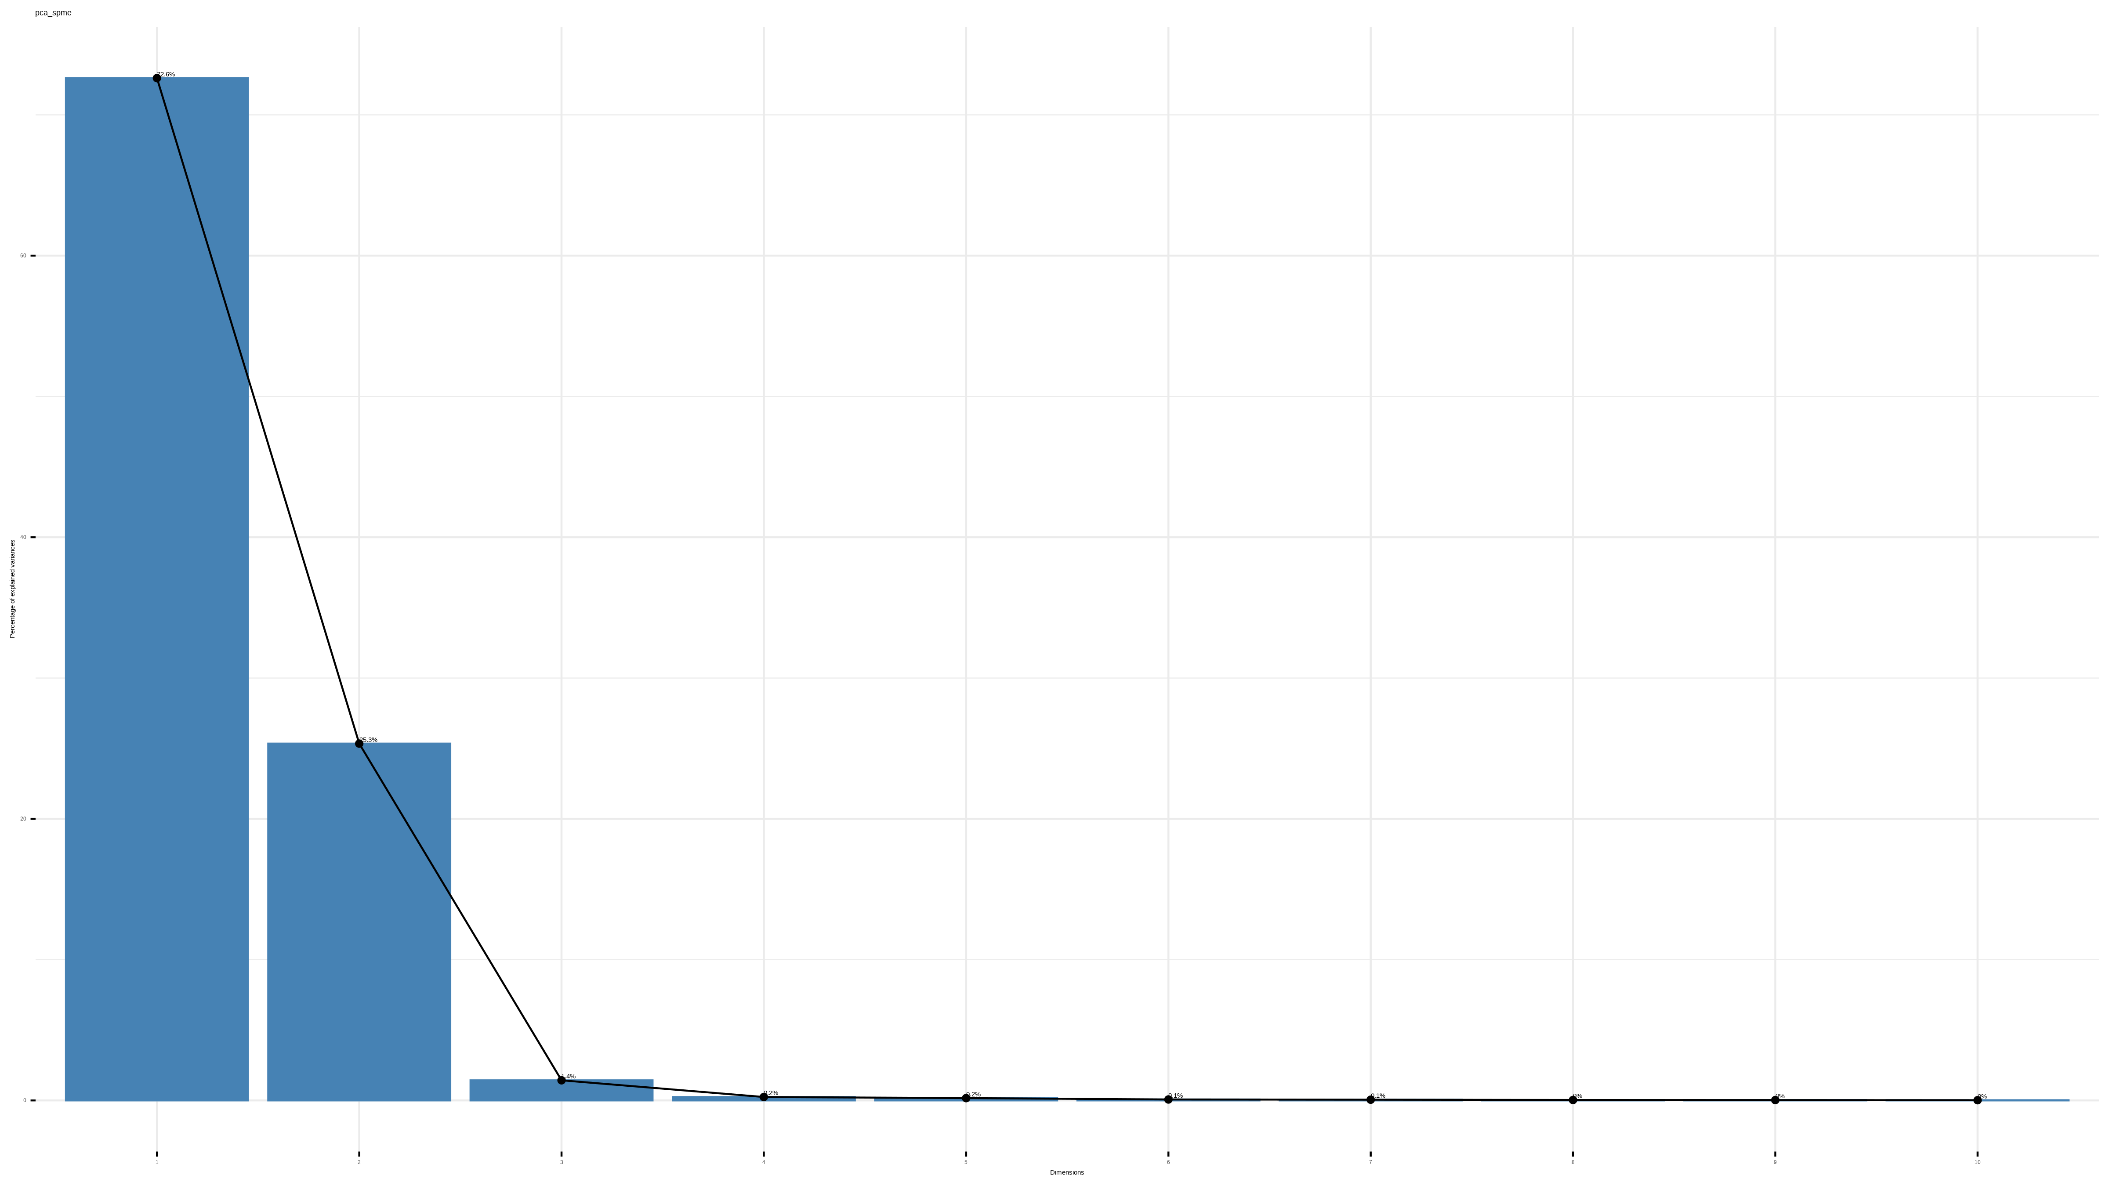

Figure 3.10: Scree plot of SPME principal components

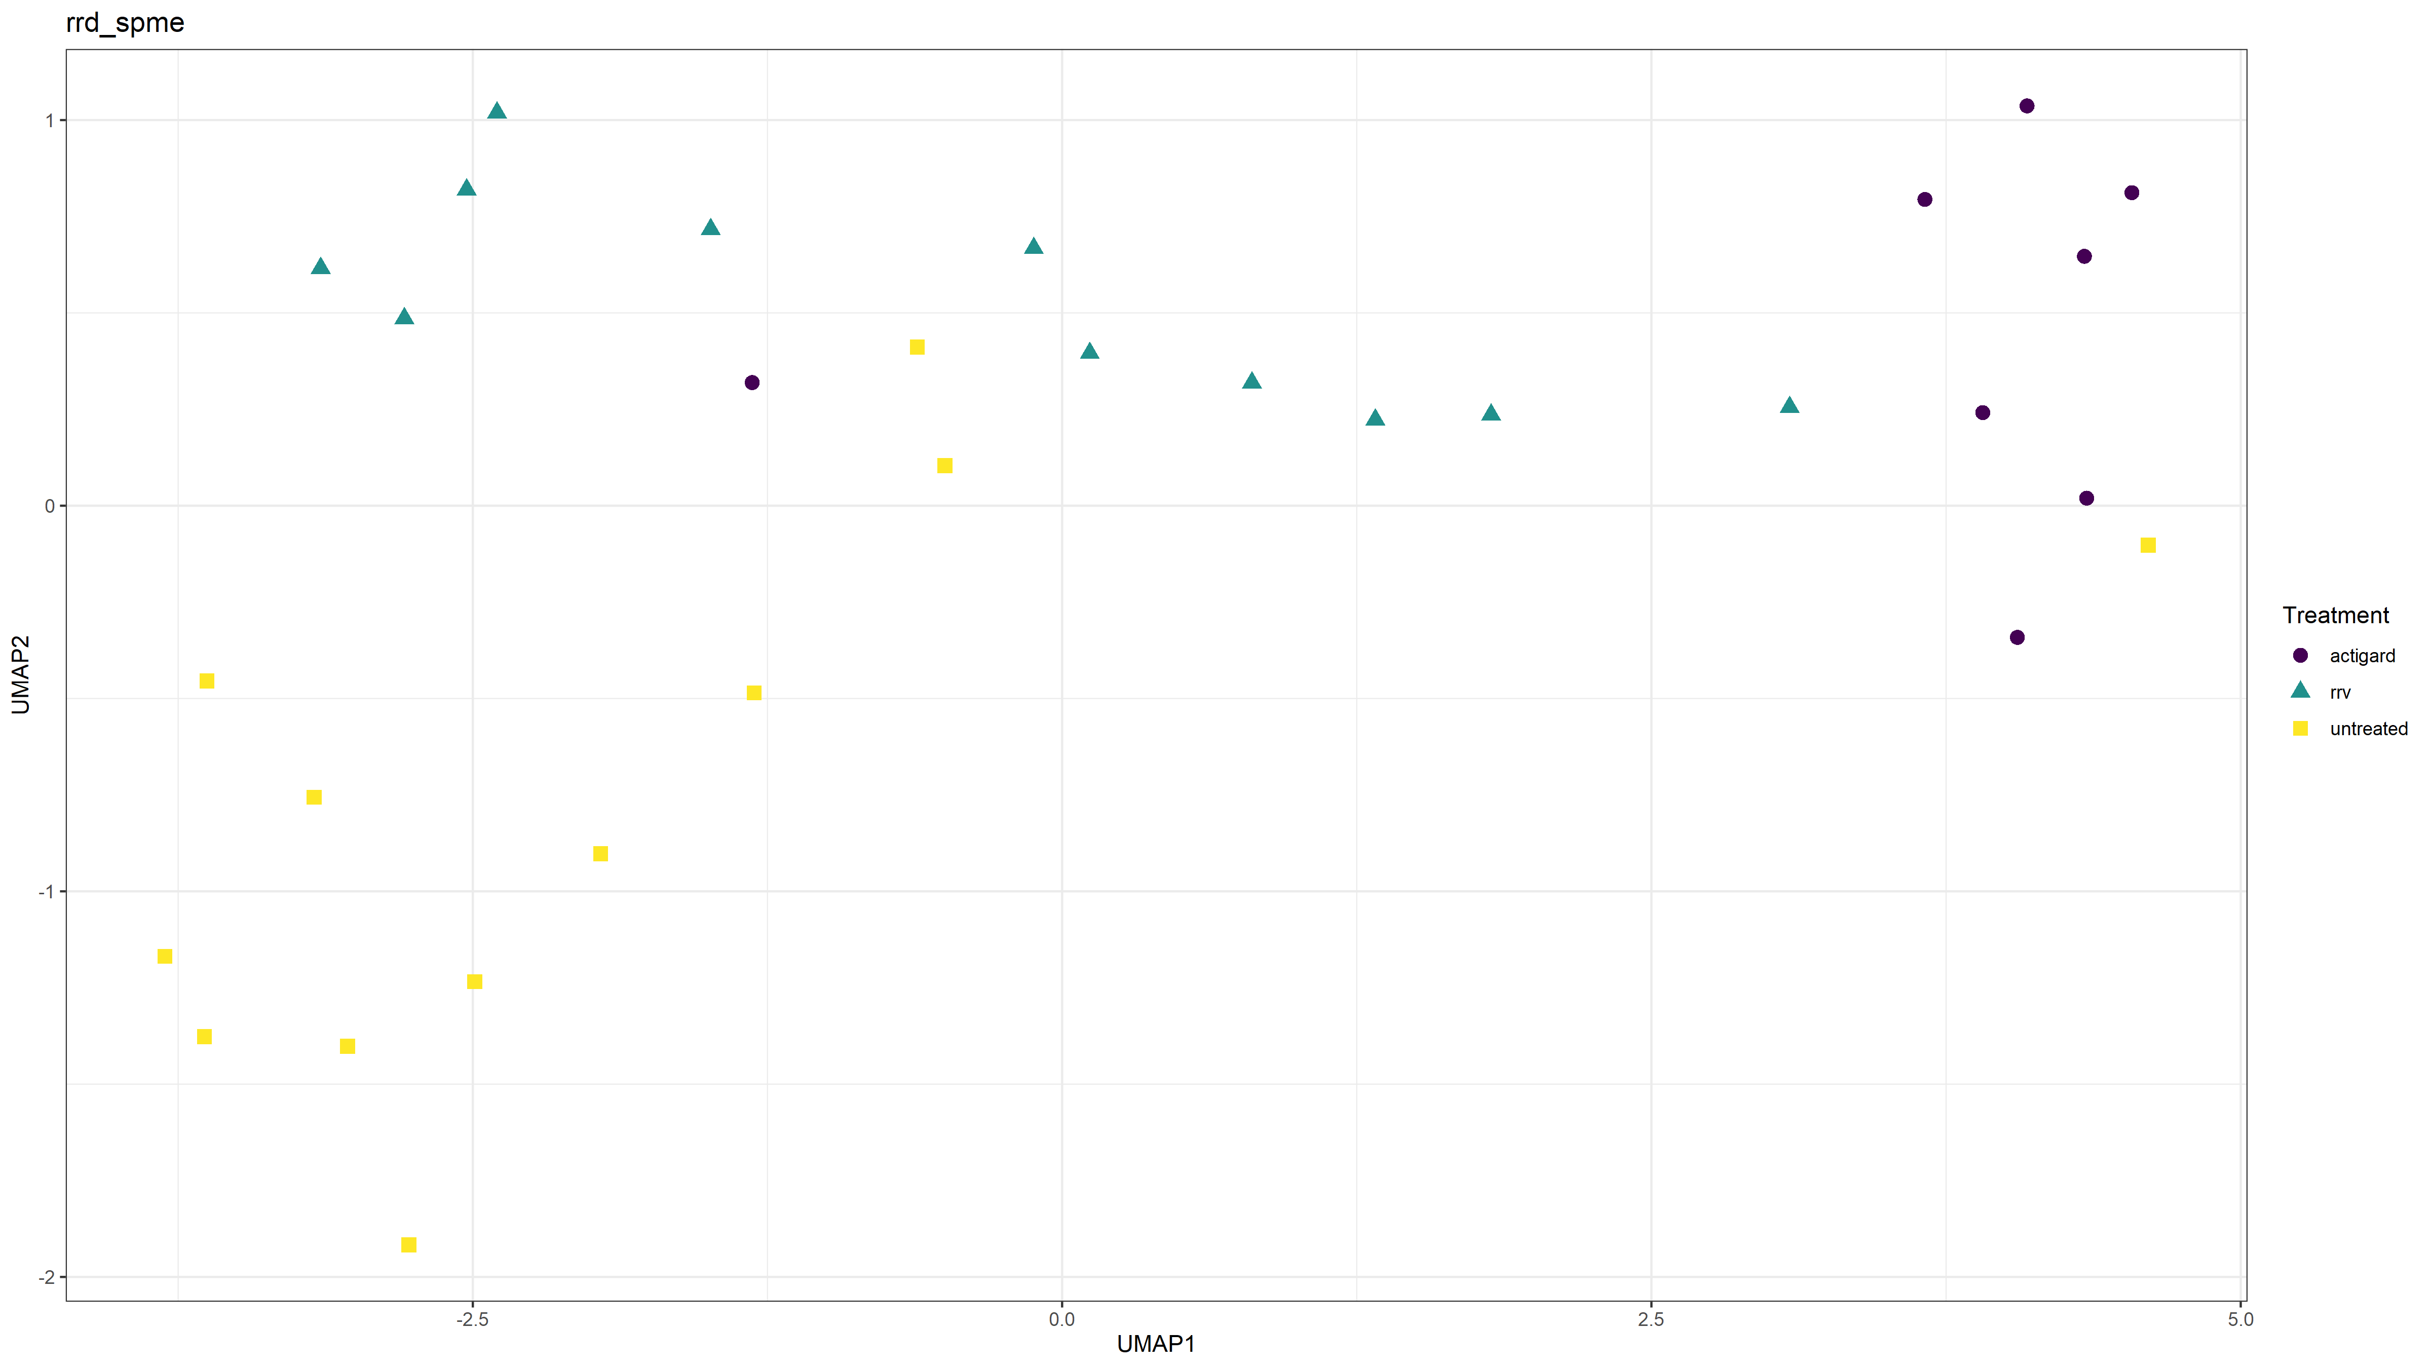

Figure 3.11: UMAP of SPME method volatiles.

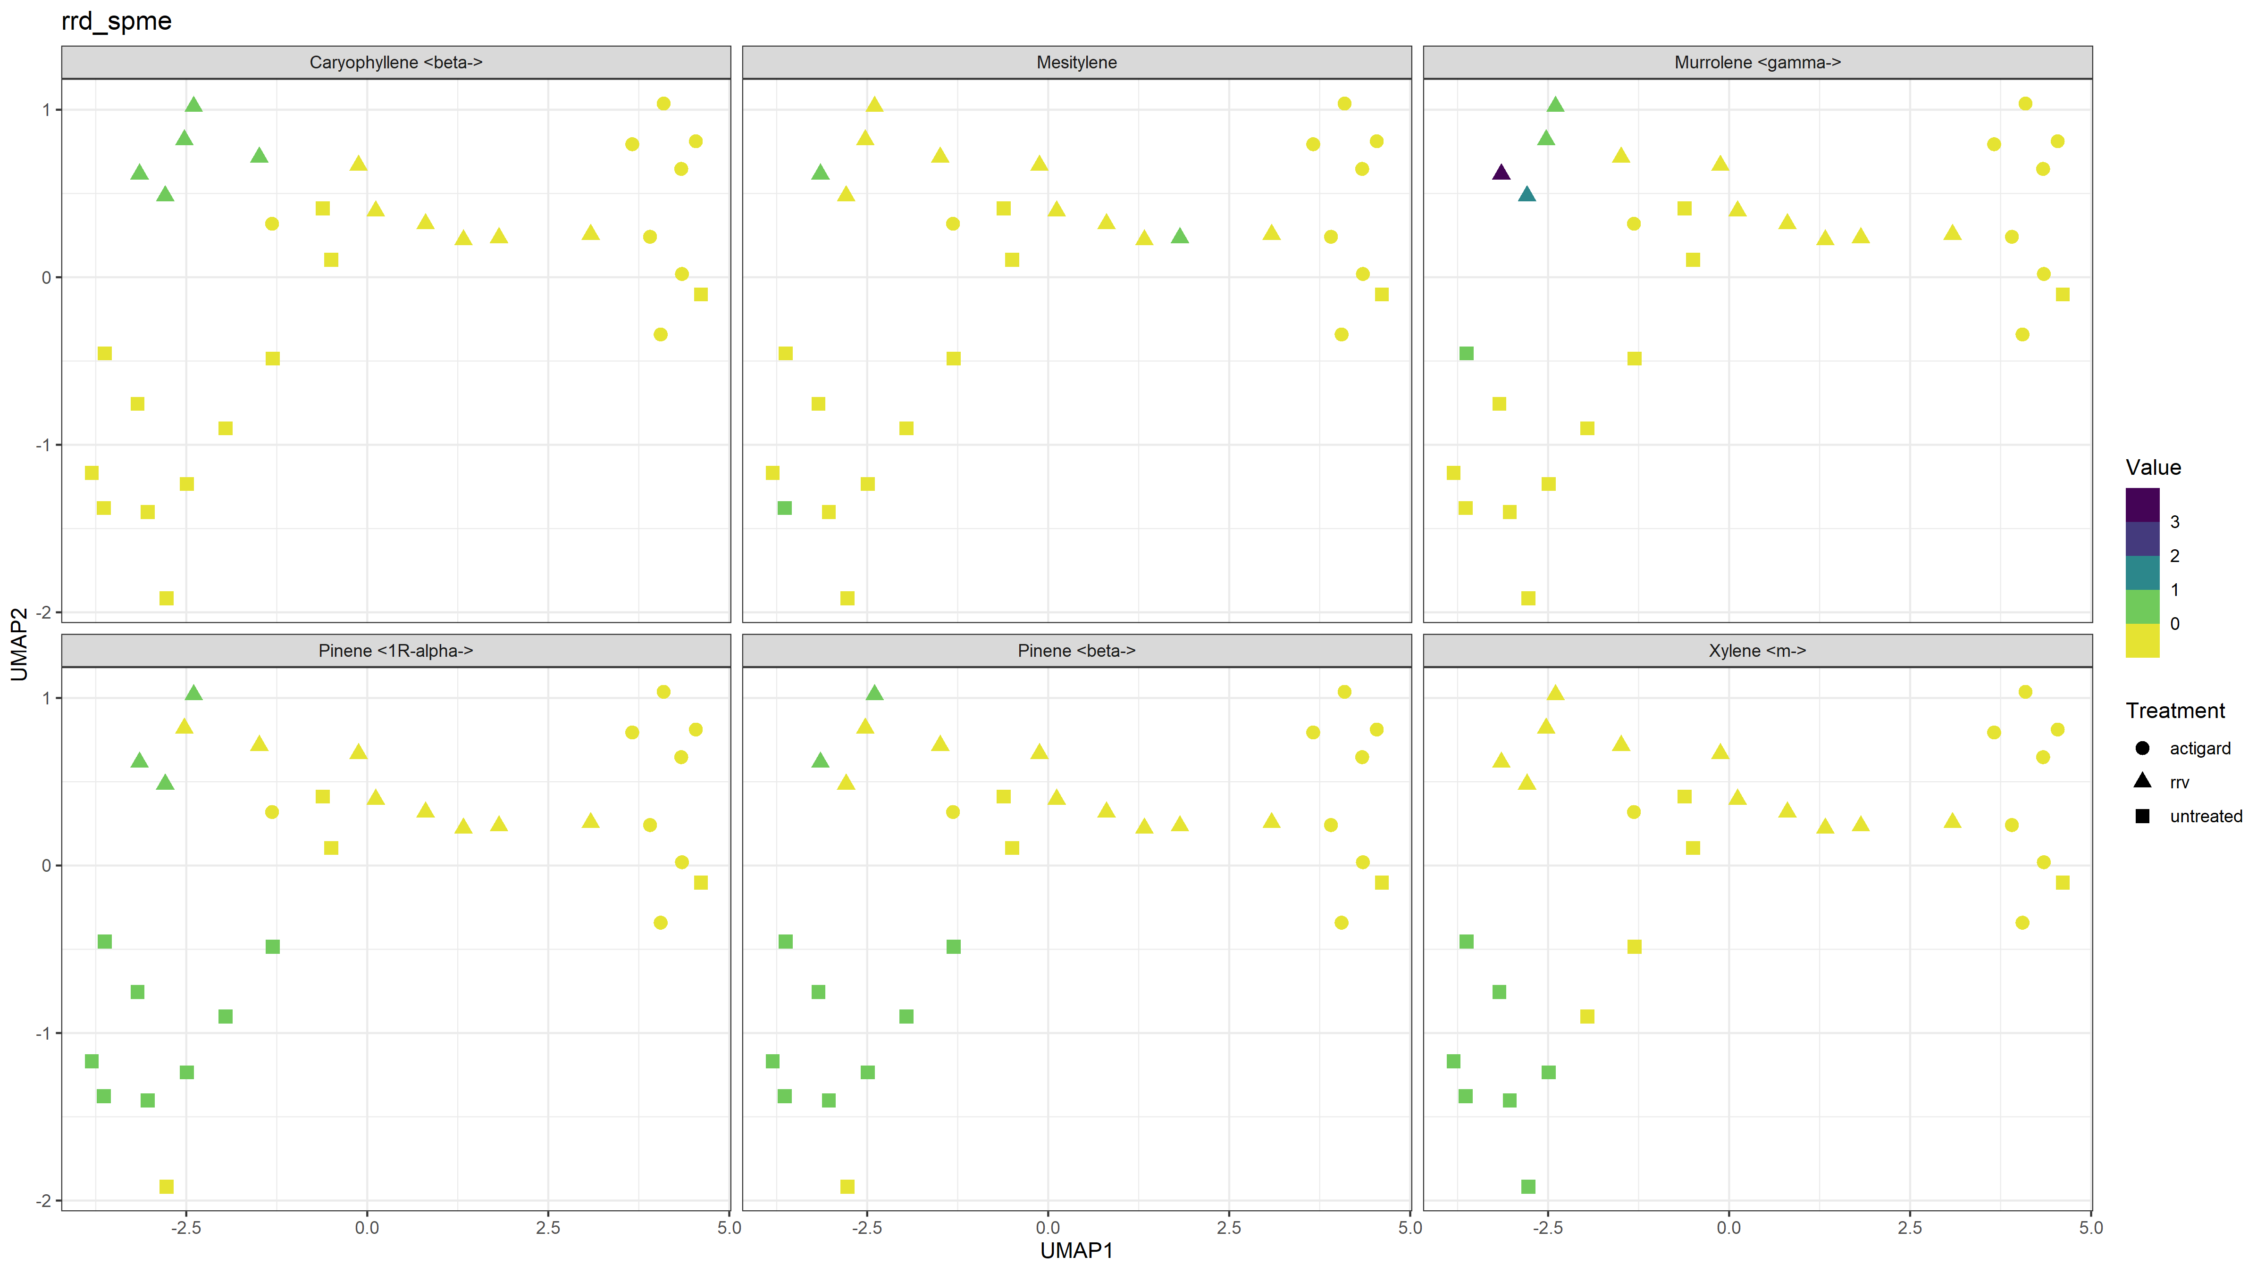

Figure 3.12: UMAP of SPME method’s six largest contributions to volatile compositions.

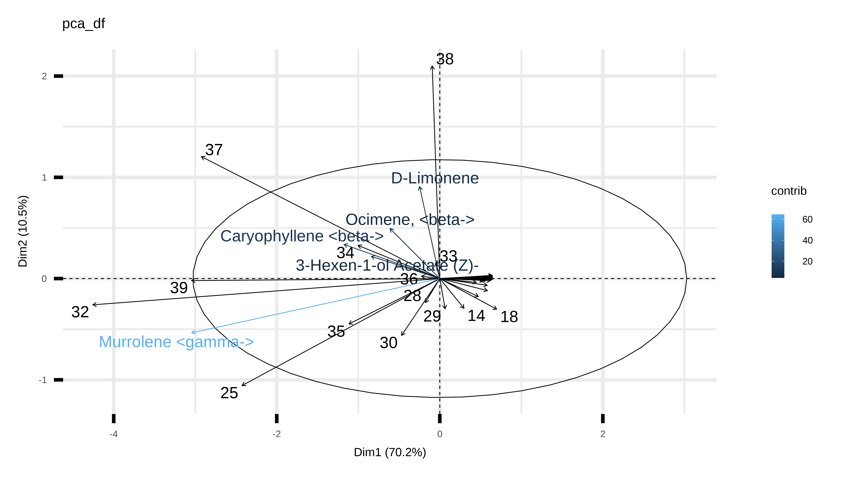

Figure 3.13: PCA biplot of volatiles collected with VCT+SPME methods.

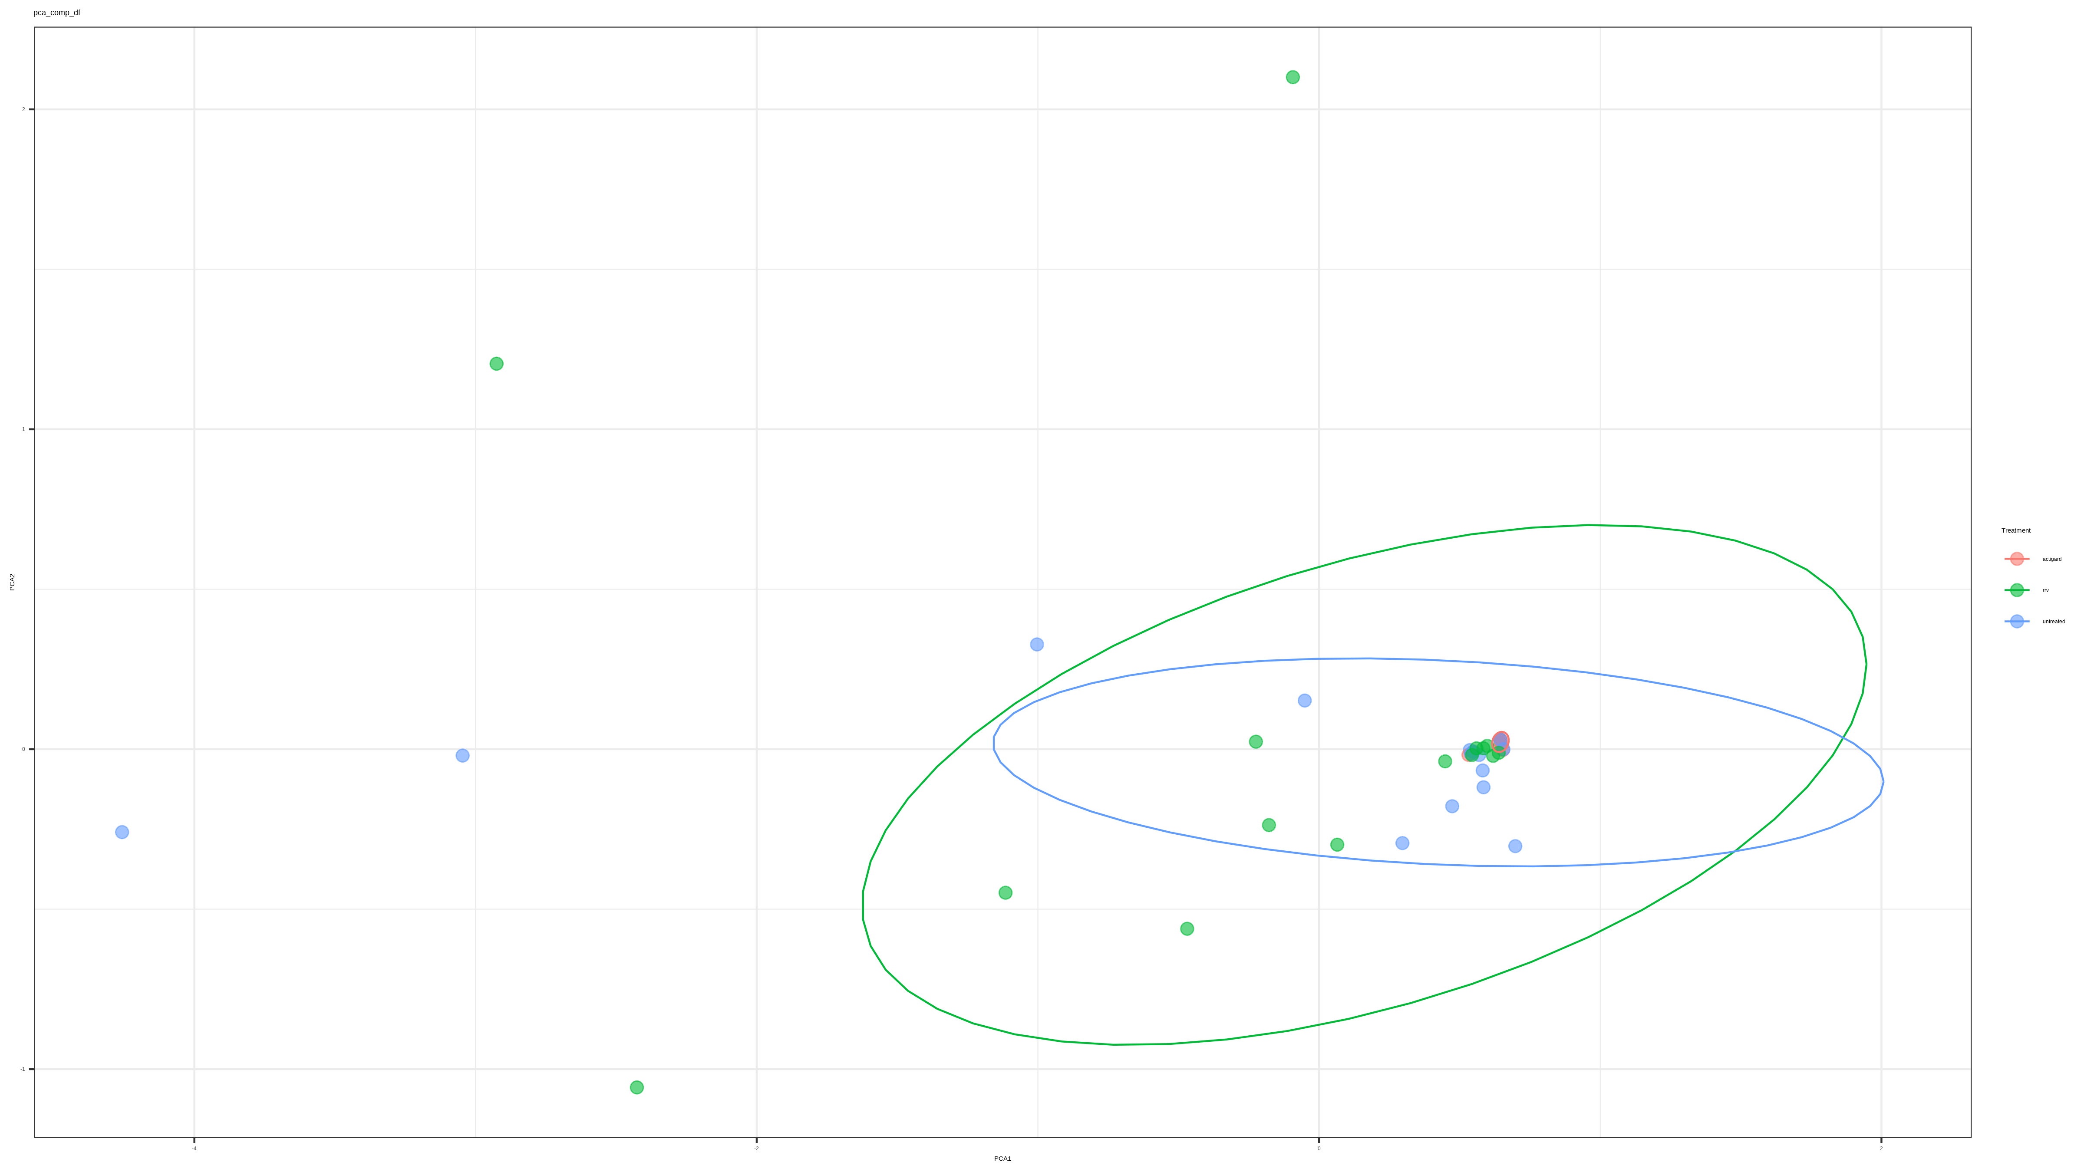

Figure 3.14: Comparison of VCT+SPME principal components. Ellipses represent 95% confidence intervals.

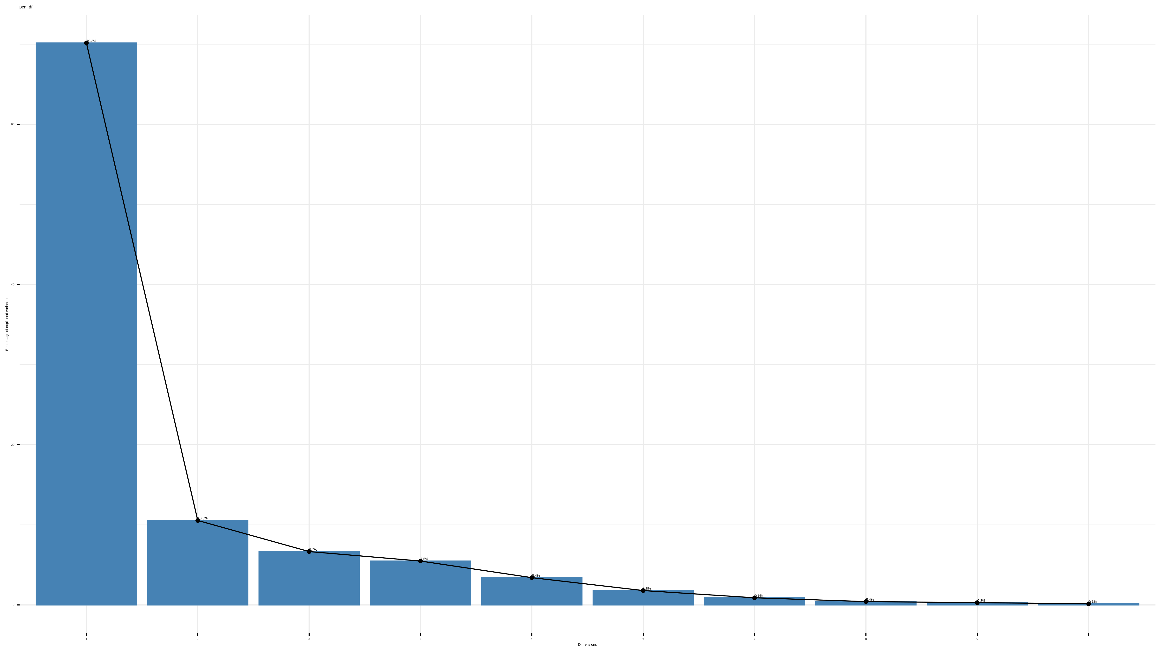

Figure 3.15: Scree plot of VCT+SPME principal components.

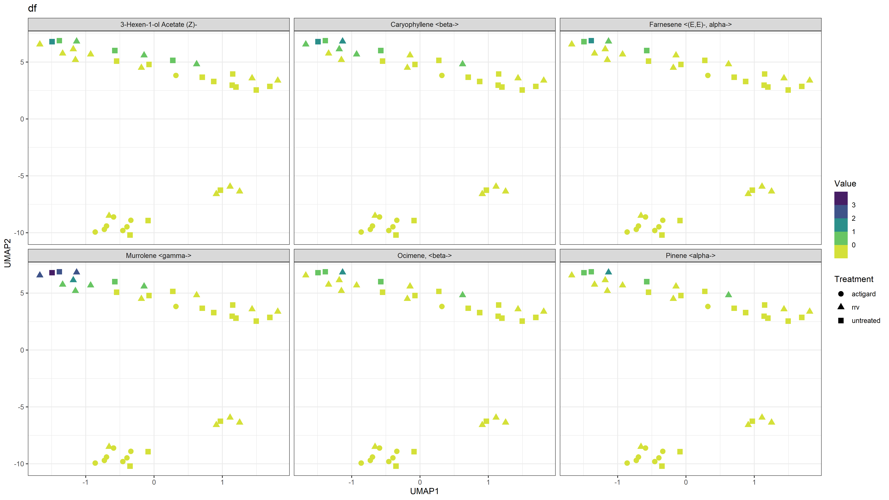

Figure 3.16: UMAP of all VCT+SPME volatiles.

### 3.3.2 *Amblyseius swirskii* were not affected by the VOCs tested

*A. swirskii* were not significantly selective for MeSA at the concentrations we used, but mites were significantly more likely to make choices when testing with roses. DL-Limonene created more choices than other treatments. (*3.18*). Choices for DL-Limonene vs. control and Filtered Air vs. Healthy Roses were not significantly different, but *A. swirskii* mites were significantly more attracted to RRV-infected roses.

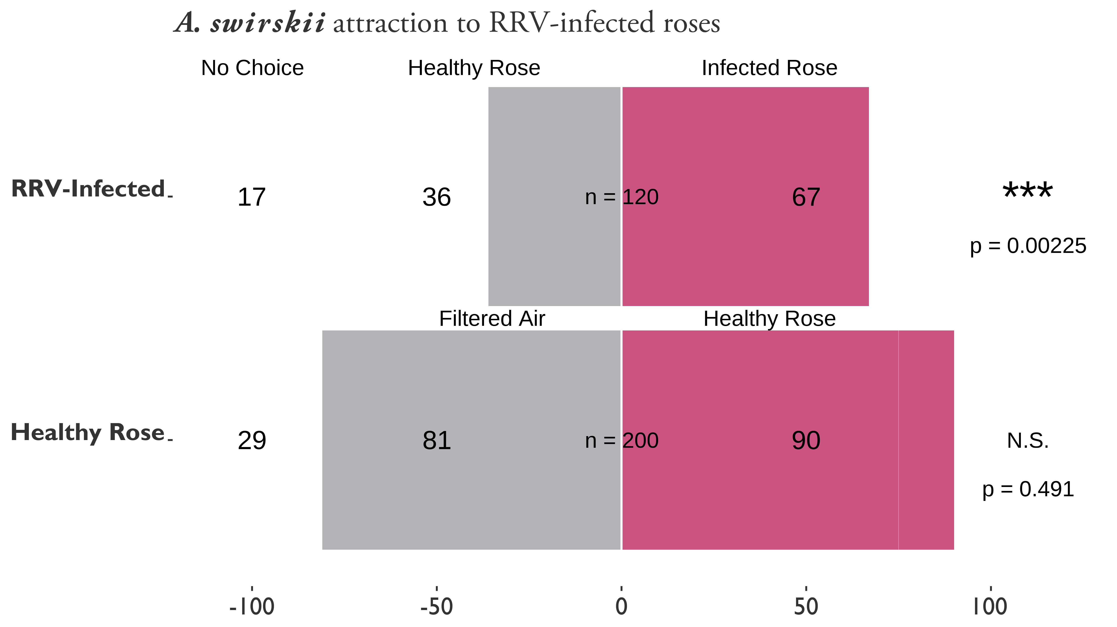

Figure 3.17: attraction to healthy and Rose Rosette Virus-infected Pink Double Knock Out® roses. Asterisks represent significant differences as calculated by $χ^{2}$ contingency table tests for given probabilities. N.S. = not significant. RRV-infected vs Healthy Rose: $χ^{2}=9.33$, $df=1$, $α=0.05$, $p−value=0.002$. Filtered Air vs Healthy Rose: $χ^{2}=0.47$, df $=$ 1, $α=0.05$, $p−value=0.4913$.

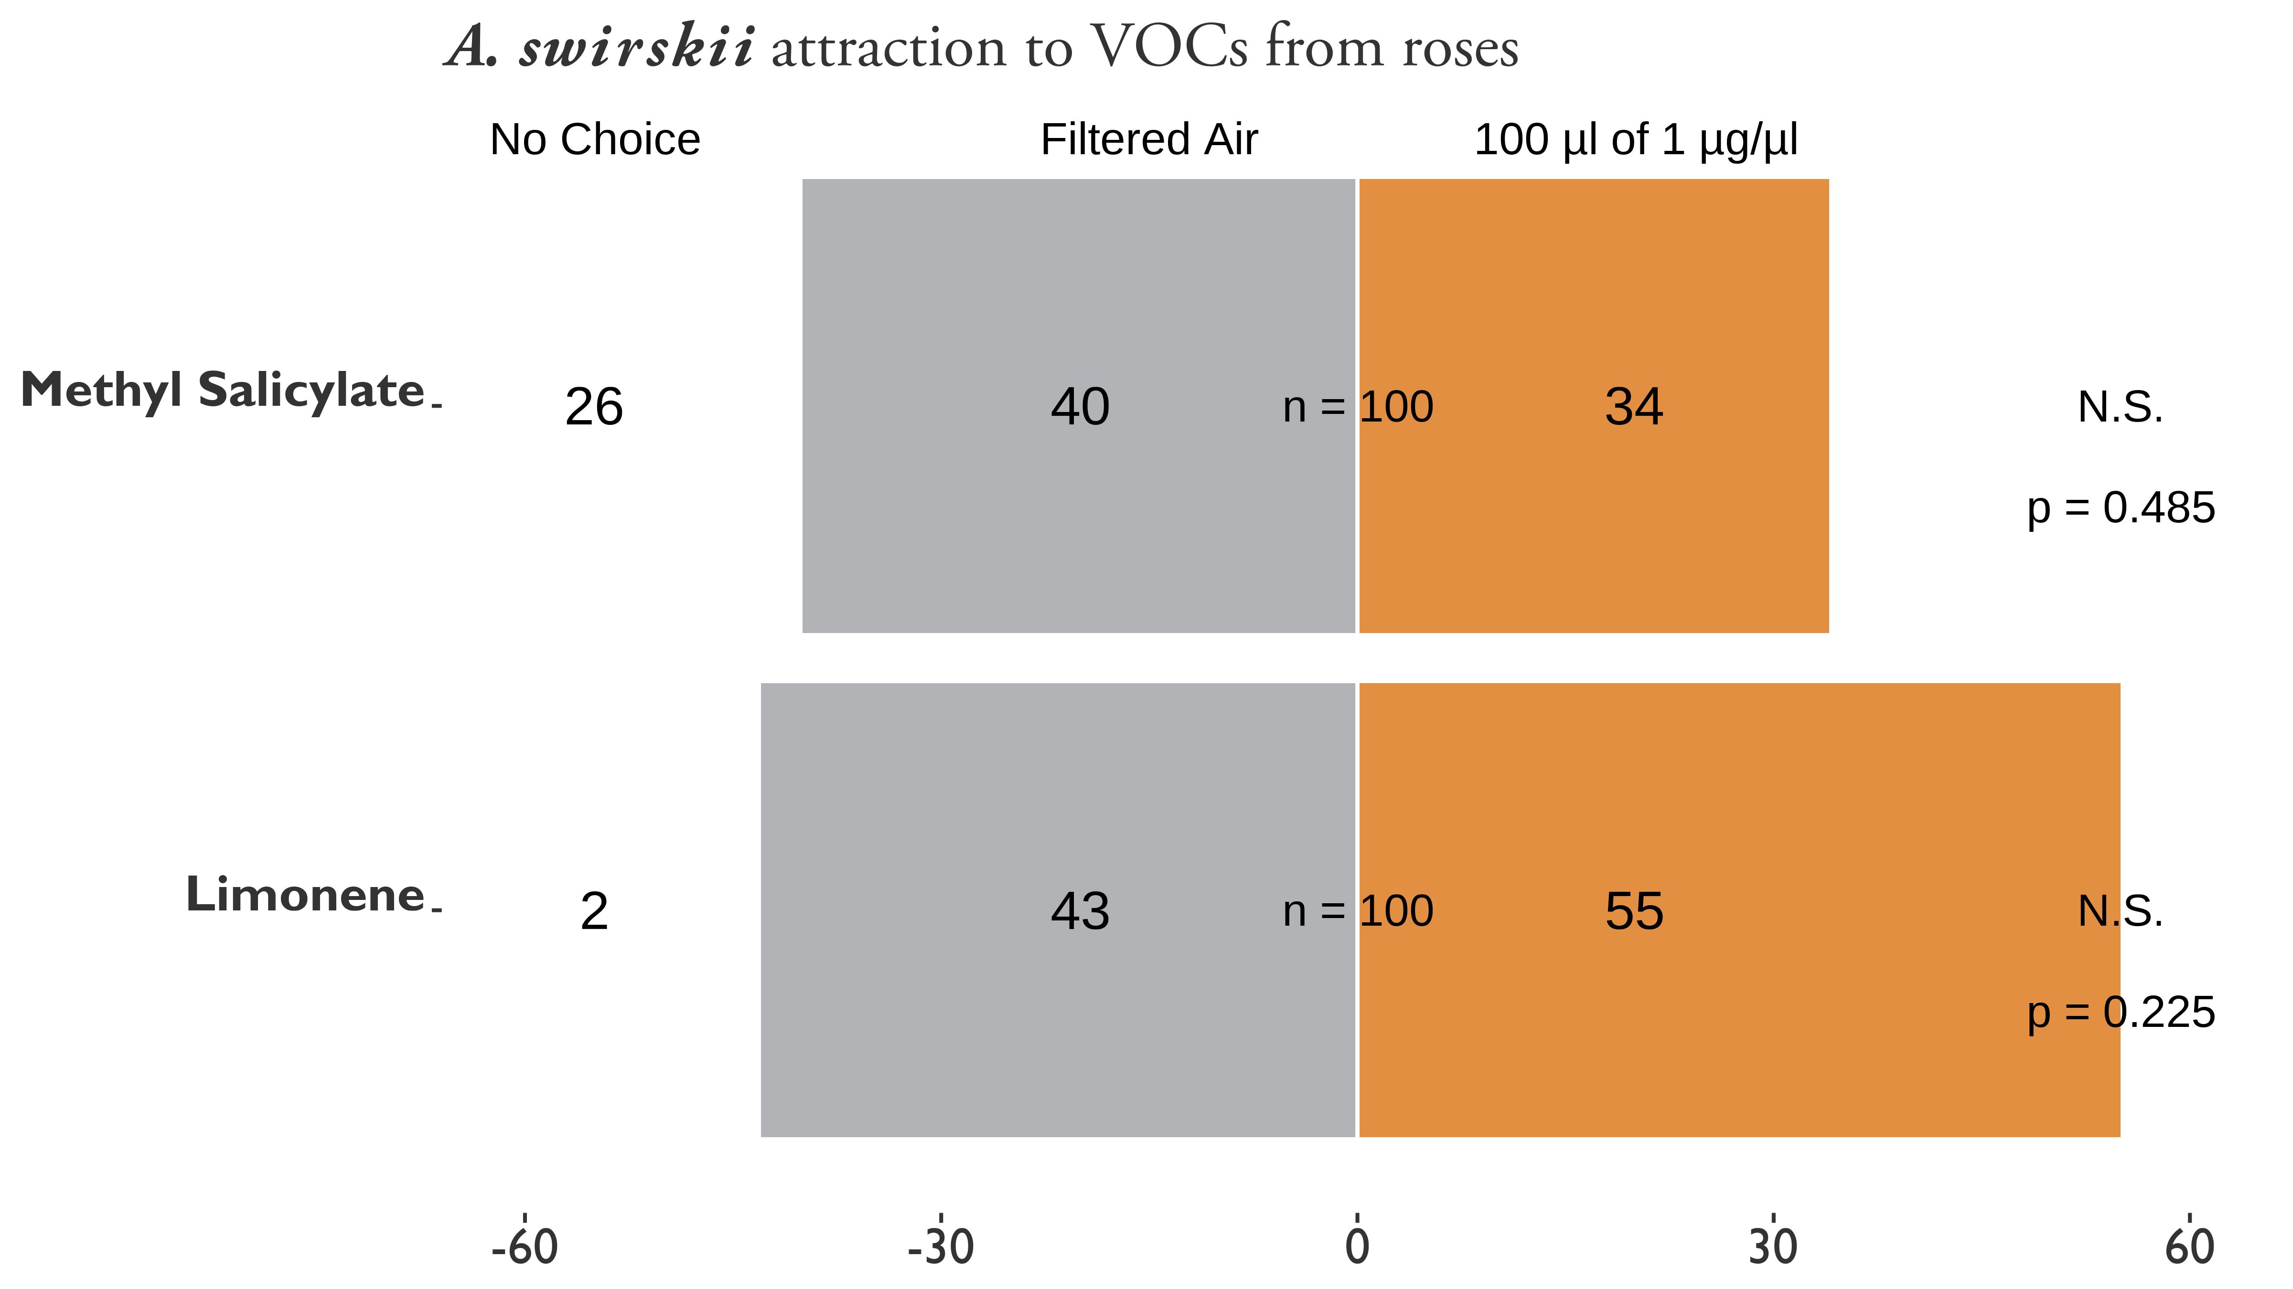

Figure 3.18: attraction to Methyl Salicylate (MeSA) and D-L Limonene vs filtered air at concentrations of 1 g/. 100 s of chemical was applied to 3 cm of dental wick inside of erlenmeyer flasks inline with the filtered air from the olfactometer. Asterisks represent significant differences as calculated by $χ^{2}$ contingency table tests for given probabilities. N.S. = not significant. MeSA vs Air: $χ^{2}=0.48649$, $df=1$, $α=0.05$, $p−value=0.4855$. D-L Limonene vs Air: $χ^{2}=0.94737$, $df=1$, $α=0.05$, $p−value=0.3304$.

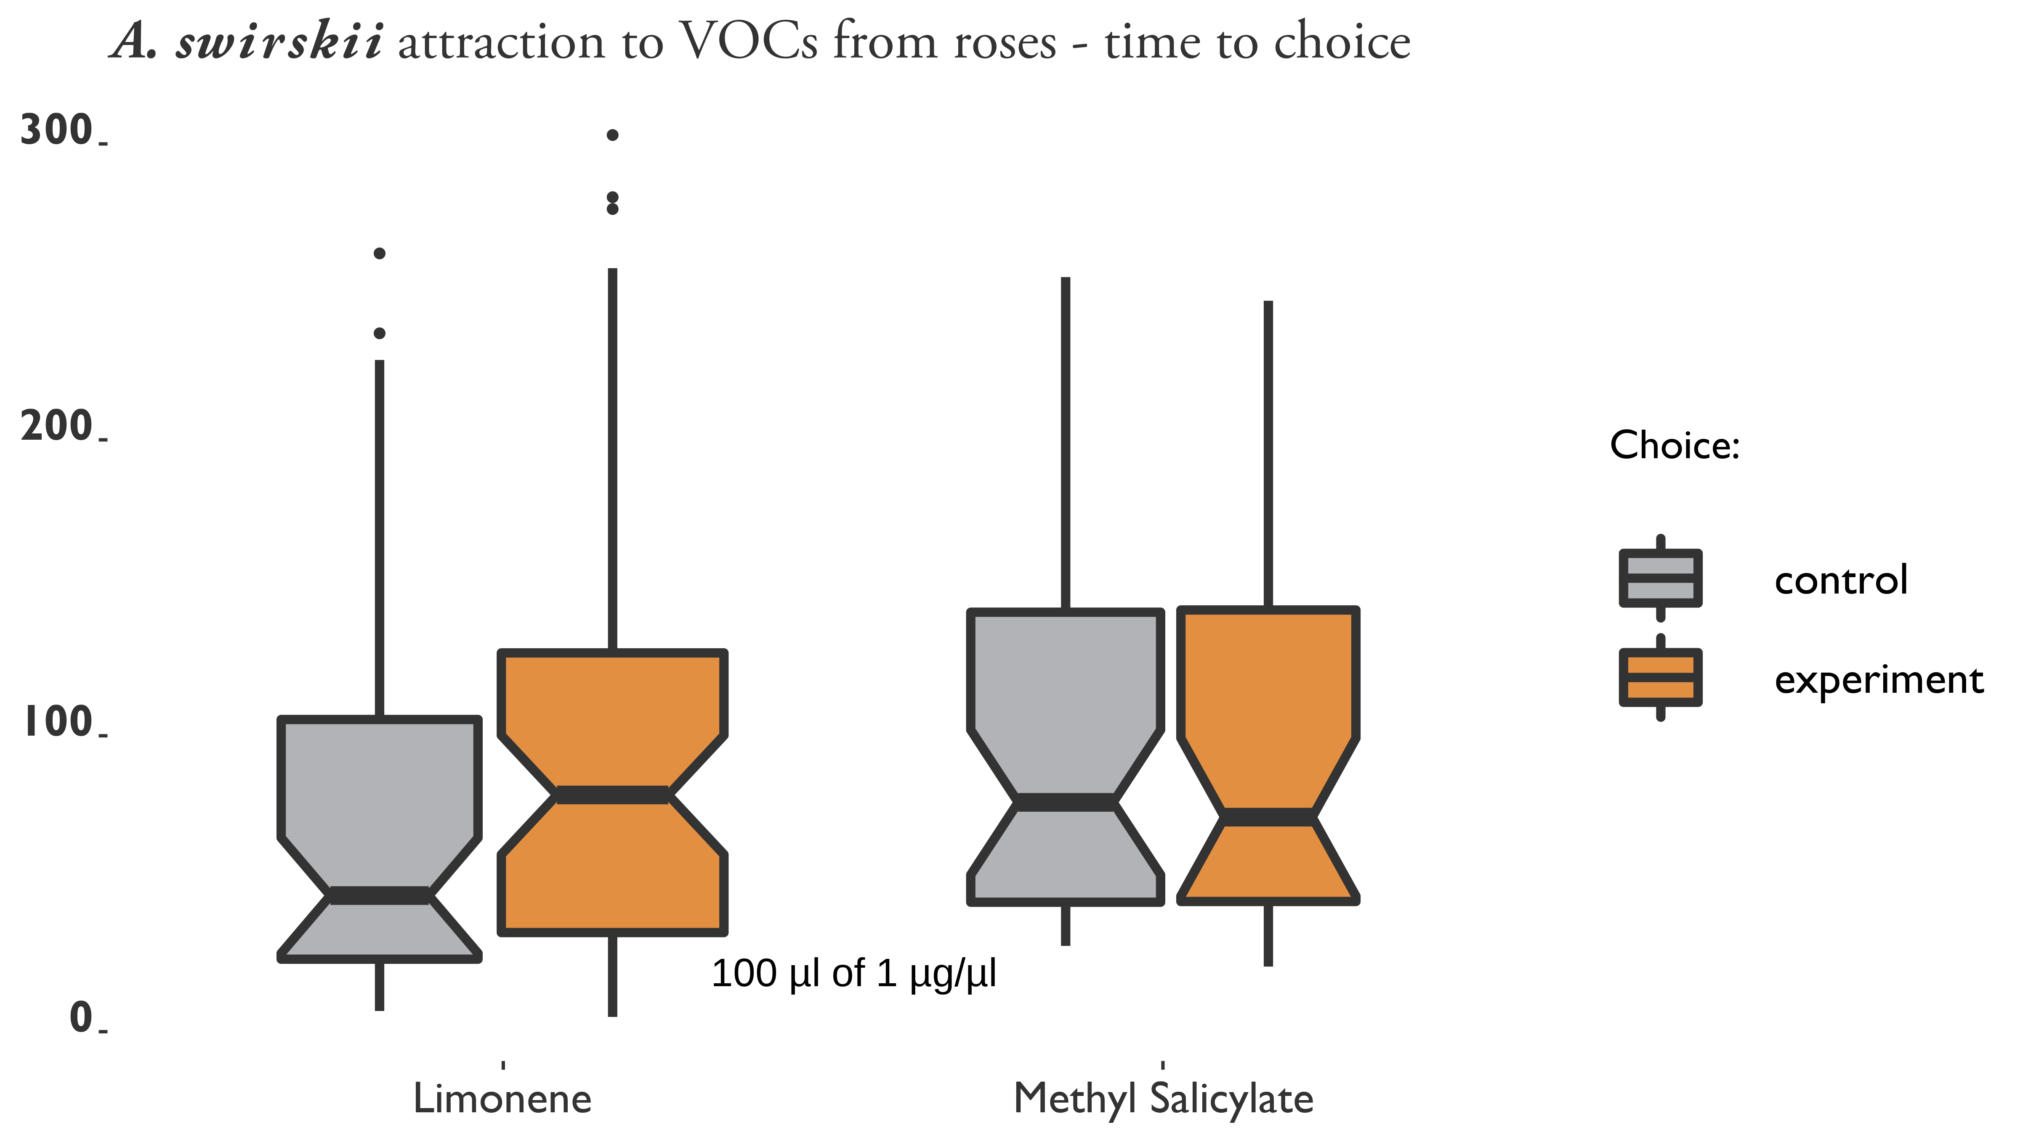

Figure 3.19: Time elapsed before choice of to MeSA and D-L Limonene vs filtered air at concentrations of 1 g/. 100 s of chemical was applied to 3 cm of dental wick inside of erlenmeyer flasks inline with the filtered air from the olfactometer.

## 3.4 Discussion

Plants play a large role in the lives of phytoseiid mites (Cortesero et al. 2000, Schmidt 2013): for example the trichome density of plants affects their dispersal (Loughner et al. 2010a, 2010b, Buitenhuis et al. 2013, Lopez et al. 2016), oviposition, (O’Dowd and Willson 1991, Walter 1992, 1996, Grostal and O’Dowd 1994, Agrawal and Karban 1997), performance as predators (Cédola et al. 2001, Seelmann et al. 2007, Buitenhuis et al. 2013) and their ability to avoid predation (Faraji et al. 2002). Therefore, it is not unusual to see a preference towards plant VOCs, but it is interesting to note their attraction to an infected rose (*3.17*). Future tests should try varying the concentrations of these chemicals, and testing the other chemicals detected from the volatile extractions. Olfactometers are considered a useful way to determine predatory mite attraction to different prey items (Janssen et al. 1990), so it is possible that infected roses release volatiles that *A. swirskii* would associate with prey. It is interesting to note that VCT methods found that levels of MeSA were lower for infected plants; SPME methods did not recover MeSA. It may be that SPME fibers were not exposed to VOCs long enough on infected roses to reach equilibrium, or MeSA is very low in severely infected plants. It is also peculiar to see that MeSA levels were not recovered from ASM-treated plants (*??, ??*). ASM induces SAR, again possibly that SPME fibers may not be adsorbing MeSA in our assays for some reason. Furthermore, ASM-treated plants had lower volatile activity overall, compared to other roses, which may explain the clustering we see in our figures (*3.9*, *3.16*). Another possibility is that the time of sampling affected the outcome. ASM-treated plants were sampled at the end of a 12-week application period, by which it may no longer be producing MeSA at high levels. This is an unfortunate side effect of sampling in the field at a remote site rather than in the lab. The SPME method is limited to short extractions, partially due to overheating of the inflator pumps. It is harder to have high confidence about results without VCT validation, due to the many variables and possible confounding effects such as plant age, measurement error, sample contamination, temperature, etc.. Sampling recently SAR-induced plants with VCT methods would give a good point of reference to resolve this discrepancy. If MeSA levels are truly low on infected roses, it may suggest that MeSA was not the primary chemical involved with attracting *A. swirskii* to roses. The most common VOCs extracted from roses were terpenes. -Murrolene and -Caryophyllene were the largest contributors to the VOC composition from the roses collected, so it would be worth testing these chemicals with *A. swirskii* to see if these chemicals play a role in *A. swirskii* attraction to infected roses. Mites were not more attracted to Limonene than filtered air in our preliminary trials, but there were differences in time to choice (*3.19*) and a significant difference between making a choice vs. no choice (*3.18*). On the contrary to the Limonene results, *A. swirskii* appeared to have random behaviors between choices and no-choice, and did not vary in their time to choice (*3.18*, *3.19*). We predict that reducing the concentrations of these synthetic VOCs may produce different responses, more experiments are warranted. In conclusion, we have found preliminary data about volatile changes in infected roses and SAR-induced roses, and their putative relationships with *A. swirskii*.

# 4 MANAGEMENT OF *PHYLLOCOPTES FRUCTIPHILUS* WITH SYSTEMIC ACQUIRED RESISTANCE

## 4.1 Introduction: *Phyllocoptes fructiphiulus* - An Increasingly Large Problem

*Phyllocoptes fructiphilus* Keifer (Trombidiformes: Eriophyidae) is a microscopic plant-feeding arachnid known as an eriophyid mite. *P. fructiphilus* is host specific, only feeding on plants in the genus *Rosa*, and normally cause little damage by itself. Unfortunately, *P. fructiphilus* has become infamous due to Rose Rosette Virus (RRV), a pathogen which the mite transmits while feeding. RRV infection creates the following symptoms: witches’ brooms/rosetting, deformed flowers, increased prickle density, elongated shoots, reddened leaves and stems, and increased die-back which ultimately kills the rose host (Allington et al. 1968, Tzanetakis et al. 2006, Laney et al. 2011). This disease is known as Rose Rosette Disease (RRD) and is widely considered the most serious disease of roses in the US. RRD and the mite have invaded the southeastern US as they followed the range expansion of the non-native *Rosa multiflora* (Thunb) towards the coast (Amrine Jr 1996, 2002, Otero-Colina et al. 2018). RRD afflicts a passionate group from different sectors of the US rose industry, including homeowners, commercial landscapers, nurseries, conservationists, and rosarians, all of whom stand to lose millions of dollars and many established roses plantings in the coming years Rwahnih et al. (2019). Florida, as the nation’s largest producer of roses, has a special interest developing methods to better control *P. fructiphilus* and RRD. There is a critical need to improve management of *P. fructiphilus* and RRD. Unfortunately, few commercially available roses have resistance to RRD (Di Bello et al. 2017, Byrne et al. 2018). Presently, growers are recommended to manage the *P. fructiphilus* by removing plants and spraying pesticides (Hong et al. 2012, Olson et al. 2017, “Control - rose rosette” 2018). However, pesticides have come under increased public scrutiny due to concerns about health, the environment, pest resistance, and harm to pollinators Vanbergen and Insect Pollinators Initiative (2013). Increased pesticide applications also decrease grower profits and reduce competitiveness with foreign markets. The lack of alternative or complementary management options exacerbates this issue: rose growers need more options for *P. fructiphilus* control, especially methods which can be integrated into existing management programs. In 2013, nursery workers in Quincy, Gadsden County, Florida, USA, detected unusual red growths, deformed stems and extra thorniness on 15 knockout roses which had been imported from out of state. Eight symptomatic plants were tested by our Plant Diagnostic Clinic at the University of Florida’s North Florida Research and Education Center in Quincy, FL, and found to be positive for RRD, but the *P. fructiphilus* mites were not detected at that time (Babu et al. 2014). On February 14, 2019, populations of *P. fructiphilius* were encountered on roses in Tallahassee, Leon County, Florida (Fife et al. 2020). The existence of *P. fructiphilus* in northern Florida increases the the possibility of introducing RRD from areas where the disease had become established, including the neighboring states of Georgia and Alabama (Solo 2018, Solo et al. 2020).

### 4.1.1 Integrating pest management: what are the effects of systemic acquired resistance on *Amblyseius swirskii* and *PPhyllocoptes fructiphilus*?

Integrated Pest Management (IPM) is the combination of science-informed best practices designed to keep the cost of pest control below the value of the crop damages which would occur without intervention (i.e. economic injury level) (Stern et al. 1959, Flint and Bosch 1981, USDA-ARS 2018). In practice, IPM is informed by an understanding of the pest’s biology and the judicious use of chemical controls, natural predators (biological controls), plant breeding, plant immune systems and physical (cultural) controls as needed to control pests as efficiently as possible (Bradley and Moore 2018). As part of the efforts to develop novel mite management methods, our lab has leveraged its experience with chemical ecology to conduct a series of preliminary two-choice maze (Y-tube olfactometer) trials with various species of commercially-available predatory mites. In these trials, mites can be exposed to chemical odorants which are correlated with the pest arthropod, such as samples droppings or sheds of the pest, a substrate which the pest has walked on, eggs of the pest, or plants which have been attacked by the pest. Attraction to these odorants is usually suggestive of predatory mite feeding preferences, and is a fast way to judge their potential for use in biological control (Janssen et al. 1990). While testing the compatibility of our rose system with various commercially-available predatory mites, we observed that *Amblyseius swirskii* Athias-Henriot (Mesostigmata: Phytoseiidae) mites were attracted towards roses which were infected with RRD (*see Chapter 3 - Results*). This was noteworthy because *A. swirskii* are generalist predators which feed on other common agricultural pests such as whiteflies (Bolckmans et al. 2005), spider mites (McMurtry et al. 1970), and thrips (Wimmer et al. 2008). *A. swirskii* can also persist on pollen (Loughner et al. 2011, Delisle et al. 2015) and other arthropods even when the pest of concern is absent (Janssen and Sabelis 2015). This may allow *A. swirskii* to be released as a preventative measure instead of reacting to an outbreak (Kutuk and Yigit 2011). Furthermore, phytoseiid mites integrate well into pest management programs and are compatible with certain pesticides (Trumble and Morse 1993, Nicetic et al. 2001, Fernández et al. 2017) and other bio-control agents (Midthassel et al. 2016). Although *A. swirksii* mites are likely too large to infiltrate into the tight spaces needed to feed on *P. fructiphilus*, and they are not typically used to control whiteflies or thrips on roses.

These results encouraged us to further investigate the differences between the chemical odorants (headspace volatiles) released from RRV-infected and uninfected roses using coupled Gas Chromatography-Mass Spectroscopy analysis (GC-MS). The GC-MS data suggested that RRV-infected roses had low levels of an important plant hormone known as Methyl Salicylate (MeSA) (*??*). MeSA typically increases during an immune response, such as when a plant is attacked by herbivores or pathogens (Shulaev et al. 1997, Park et al. 2007, Tieman et al. 2010). We expected high levels of MeSA in these infected roses, because they were in the middle of experiencing a pathogen attack, but contrary to this expectation, we found low levels of MeSA emitted from the RRV-infected roses. MeSA is also known to be an attractive odor to some many predatory mites, which use MeSA to locate their prey Boer and Dicke (2004a), and are often attracted to the Volatile Organic Compounds (VOCs) released when plants are injured by pests or infected with pathogens (Boer and Dicke 2004b). Our results suggest that either *A. swirski* are attracted to very low levels of MeSA, or perhaps this attraction is caused by other plant chemical cues besides MeSA. Either way, identification of these VOCs gives us insight into how RRD influences the prey-seeking behaviors of *A. swirksii*, which has implications for how effective predatory mite biocontrol might be. The most interesting part about low levels of MeSA is the role which this phytohormone typically plays in pathogen resistance Park et al. (2007). MeSA is derived from Salicylic Acid (SA) (Tieman et al. 2010), a chemical involved when inducing a plant’s immune response, known as Systemic Acquired Resistance (SAR) (Gaffney et al. 1993, Gozzo and Faoro 2013). SAR protects plants from fungi, bacteria and viral pathogens when induced and affects all tissues in the plant Ryals et al. (1994). Low levels of MeSA suggest that RRV interferes with the rose’s ability to defend itself against the pathogen. A possible way to avoid this negative feedback loop is to use SA to induce SAR *before* RRV infection, a procedure which would increase the rose’s resistance to pathogens before exposure Kalaivani et al. (2016). In light of this knowledge, we collaborated with the University of Georgia in to test how SAR-induction might protect roses from *P. fructiphilus* and/or RRD. acibenzolar-S-methyl (ASM) is a benzothiadiazole, a SAR-inducing chemical which works like Salicylic Acid to induce plant defenses against viruses and bacteria Ziadi et al. (2001). ASM is currently used by growers to protect plants from fungal infection (Ziadi et al. 2001, Tripathi et al. 2010, Jeschke 2015). ASM application also has shown chitinase activity in roses (Suo and Leung 2001), and reduces the severity of RRD infection (Babu et al. 2021). It is not known if this reduction in RRD severity and incidence is related to the effects of plant physiology on the virus, or due to reduced populations of *P. fructiphilus* when ASM is applied (Babu et al. 2021). Mites have an exoskeleton comprised of chitin (Nuzzaci and Alberti 1996), and some studies have shown that the hypersensitive response and SAR interfere with the ability of eriophyoid mites to feed or grow on induced plants (Bronner et al. 1991b, Westphal et al. 1991, 1992). A remaining concern is the effect that SAR-induction may have on predatory mite releases: although predatory mites do not feed directly on plants, they may still be harmed via direct and indirect effects of SAR-induction Pappas et al. (2017). We hypothesized that the systemic acaricide and ASM would reduce populations of *P. fructiphilus* and *T. urticae* more than the control, and that combined treatments of ASM with *A. swirskii* would reduce populations of *T. urticae* more than ASM alone. Furthermore, we hypothesized little harm to *A. swirskii* from either ASM or the acaricide, as *A. swirskii* are reportedly unharmed by spirotetramat-based products (Fernández et al. 2017). In order to test these hypotheses, we conducted a number of field studies from 2018-2021 to test the integration of predatory mites with SAR for control of herbivorous mites.

### 4.1.2 Phenology of populations of *Phyllocoptes fructiphilus* in northern Florida

*P.fructiphilus* were encountered on roses in Tallahassee, Leon County, Florida, on February 14, 2019 (Fife et al. 2020). Accordingly, the NFREC reported the find to the Florida Department of Agriculture and Consumer Services, who were able to confirm the mite species as *P. fructiphilius*. Researchers at the NFREC monitored the local populations of *P. fructiphilus* in that area from 2020-2021, before conducting the IPM field trial in Tallahassee.

## 4.2 Materials & Methods

### 4.2.1 Inducing systemic acquired resistance with acibenzolar-S-methyl to reduce populations of *Phyllocoptes fructiphilus*

We tested the efficacy of SAR-induction against mites in field trials during 12 weeks, from August to October at Griffin and Athens, GA. Griffin and Athens sites had low and high *P. fructiphilus* pest pressure, respectively.

***Phyllocoptes fructiphilus* Infestations** Potted plants were inoculated with putatively *P.fructiphilus*-infested canes from nearby RRD-infected roses in the landscape. Rose canes from infected roses were placed onto potted roses during the first and fifth weeks of the experiment.

**Roses** Field sites had 48 Pink Double Knock Out® Roses (Star Roses and Plants, West Grove, PA, USA) planted in 1 gallon buckets filled with potting soil and mixed with a granular slow-release fertilizer. Roses were placed on black plastic mulch with approximately 2 ft of space between pots. Plants were watered daily with overhead impact sprinklers. Plants in Griffin were placed alongside a plot of RRD-infected roses during 2018, and a second plot of RRD-infected roses was planted on the opposite side during 2019 (see *4.1* and *4.2*). Plots were designed with 12 roses total for each treatment, with 16 pots in 3 rows. 4 columns of 3 roses per block were assigned to the same treatment, and the same plants were rotated to new blocks of the same treatment during the second year (see *4.1* and *4.2*). Plants were monitored in a greenhouse to observe potential disease progress during the winter of 2018.

**Treatments** Actigard50WG® (Syngenta, Greensboro, NC, USA), (acibenzolar-S-methyl, ASM) was applied at two different rates: 50 / (Low rate) and 100 / (High rate) to observe the effects of inducing Systemic Acquired Resistance (SAR) on *P. fructiphilus*. A spirotetramat based miticide was applied at the label rate (Kontos® Miticide Insecticide, Bayer Corporation, Whippany, New Jersey, USA), and tap water was used as a control. Trials in Athens had the same treatments.

**Plot Design ASM Trials, Griffin - 2018** 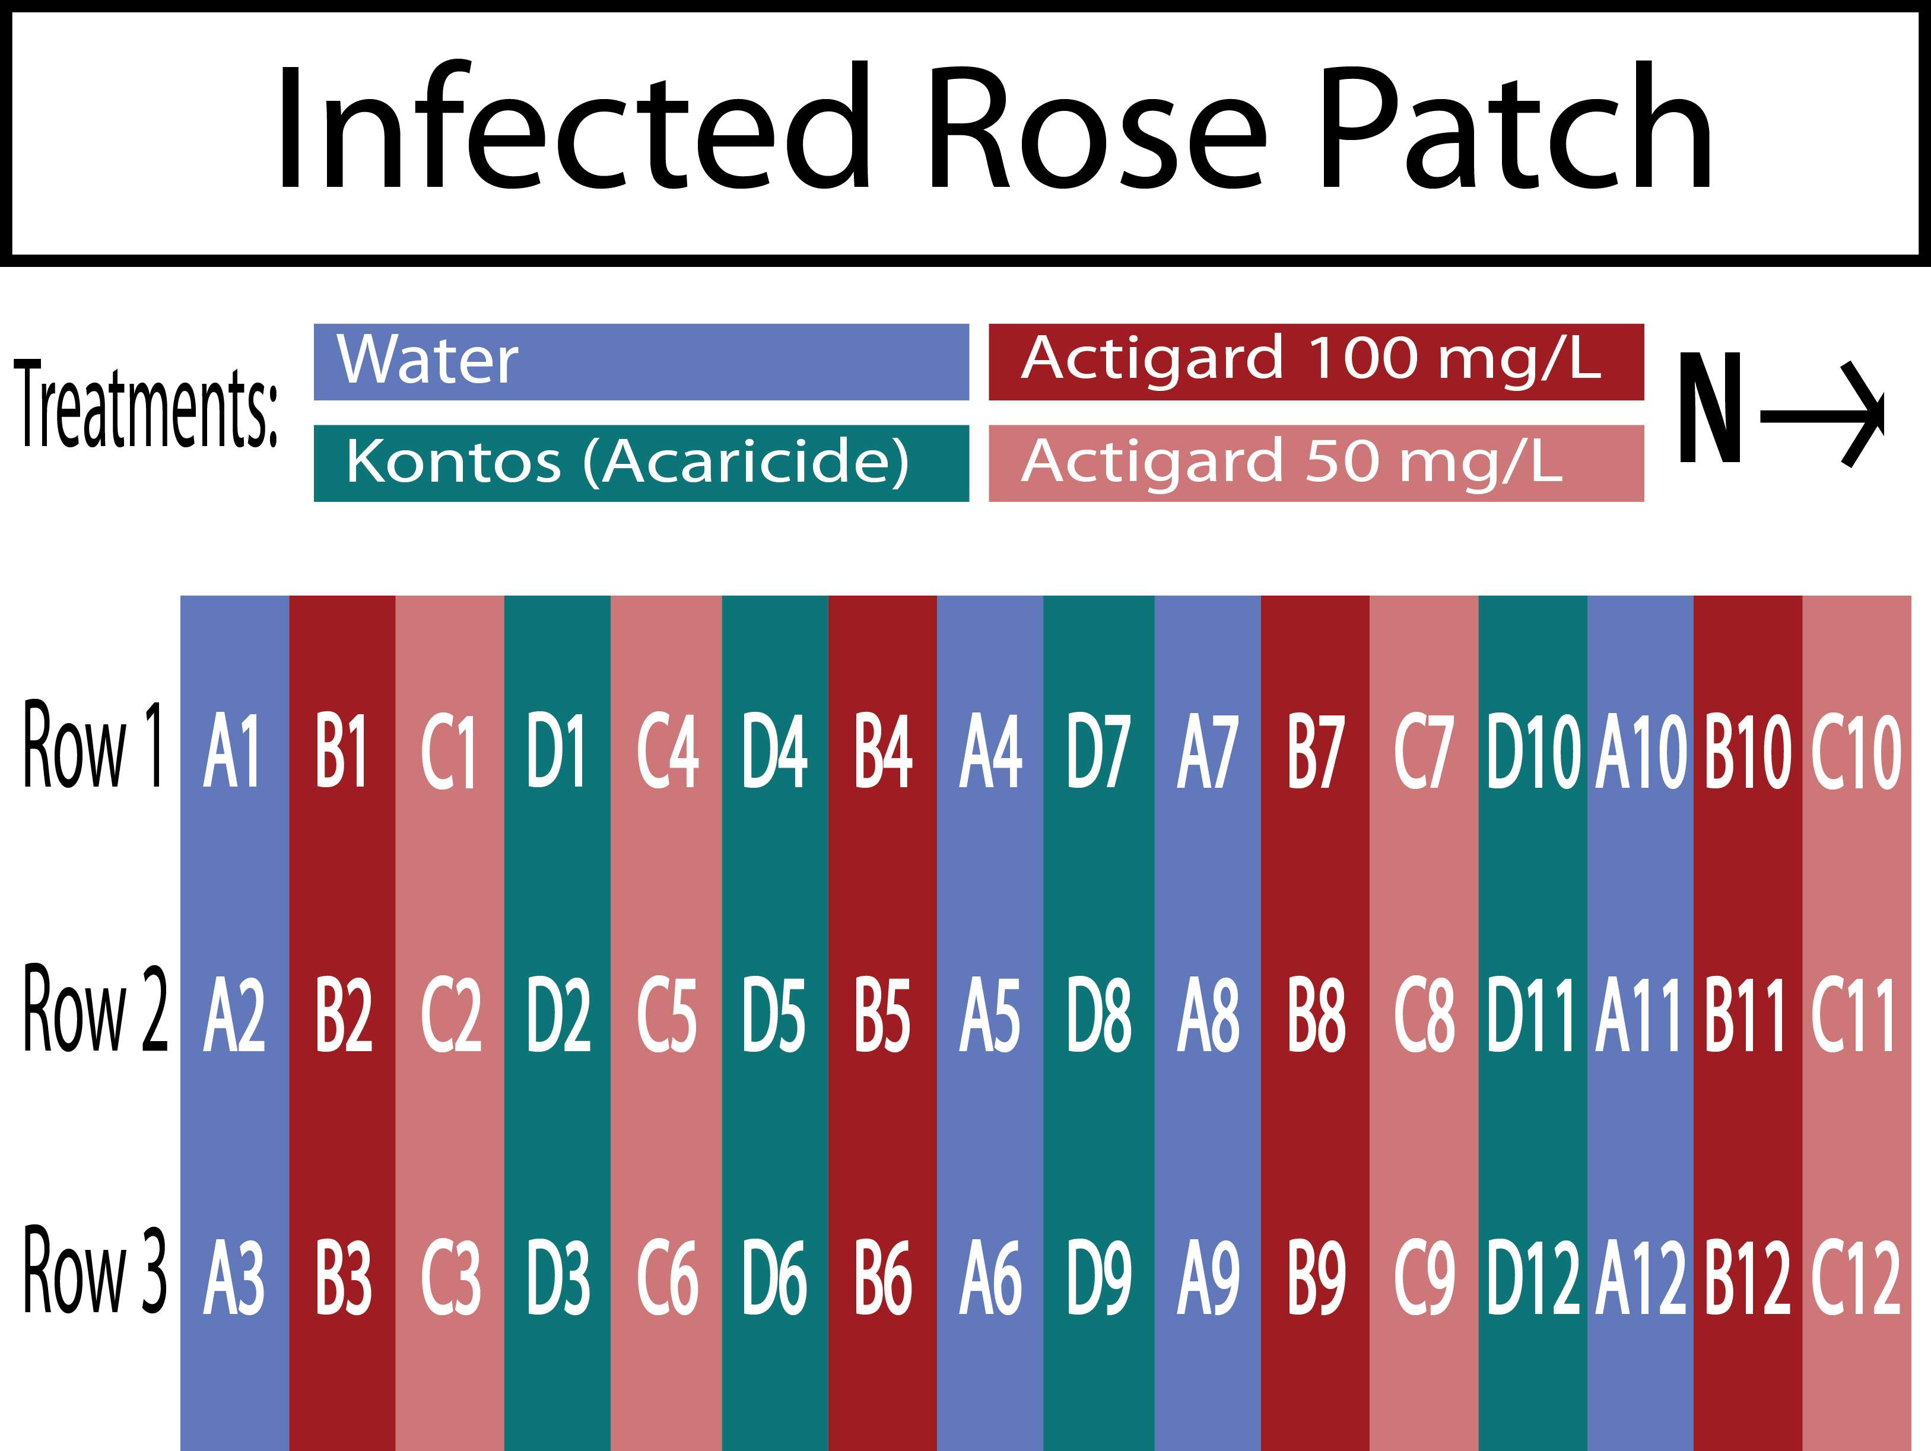

**Plot Design ASM Trials, Griffin - 2019** 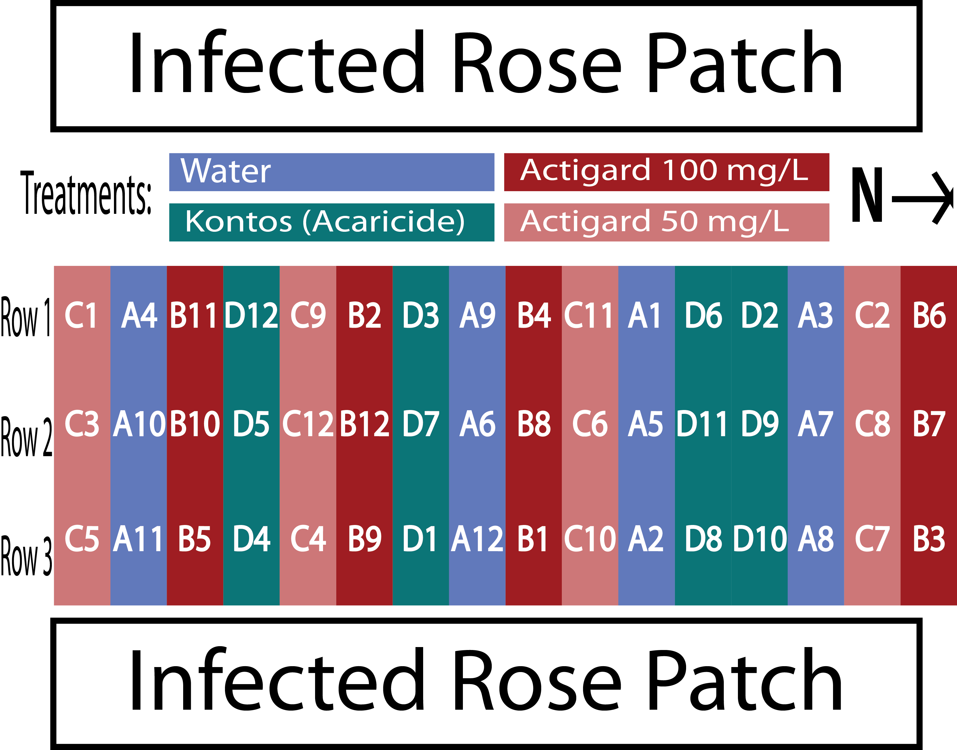

**Data Collection for ASM Trials** Rose/rosebud cuttings of about ~10 cm of cane were taken from each rose before the first treatments to determine the initial populations of *P. fructiphilus* on the roses. A stratified subset (one row across all blocks) of samples was taken from each rose treatment weekly, rotating samples until each rose plant has been sampled three times. Samples were collected from all roses at the end of the trial. The field trial was repeated for two seasons during the growing seasons of 2018 and 2019. Rose samples were placed in 50 mL centrifuge tubes and refrigerated or frozen until floral samples could be processed with 90% ethanol according to the methods of Monfreda et al. (2007). Eriophyoid mites and other mites collected were counted. Eriophyoid mites were identified after clearing and mounting in Hoyer’s iodine-modified medium as described by Faraji and Bakker (2008).

### 4.2.2 Integrating management options to control *Phyllocoptes fructiphilus*

During 2019 we conducted a second set of field trials in Griffin and Athens in addition to the ASM trials. We tested ASM alongside a different a SAR-inducer (SP2700, Trade name ‘Ninja’, SePro) and combined this SAR-inducer with predatory mites releases to observe if these two treatments would have greater reductions of *T. urticae* than either treatment on its own. We again tested a spirotetramat-based miticide and used water as a positive control (see *4.3* and *4.4*).

**Mite Infestation** *P. fructiphilus* are present in the landscape of Georgia. Cuttings of ~10 cm or rose cane were taken from roses showing symptoms of RRD in the landscape and placed in each rose pot on the 1st, 5th and 9th weeks of the experiment.

**Predatory mites** *Amblyseius swirskii* predatory mites were applied/released on the 1st, 5th and 9th week of the experiments. Mites were deployed from polyethylene fiber sachets (Ambly-S, Arbico Organics, Oro Valley, AZ, USA), containing live colonies of *A. swirskii* and a mite which they consume for food. There is a small hole at the bottom of these sachets which allowed the mites to be slowly released into the environment. The sachets were hung from rose canes in the center of each rose canopy to encourage successful mite release (Buitenhuis et al. 2014).

**Roses** The experiments were run for 12 weeks from August to October simultaneously in Griffin, GA and Athens, GA. Bare root roses were planted 2 months before the trials began to allow new flush to form. Rose planting media and environmental conditions were the same as previously described. The Athens site received and planted 96 Pink Double Knock Out® Roses (Star Roses and Plants, West Grove, PA, USA), while the Griffin site received 54 roses due to the smaller plot area available. The site at Athens had space for five blocks, while the site at Griffin, GA had space for three blocks. Each block was a 3 $×$ 6 plot with 18 plants, with three roses for each treatment. Flower cuttings were sampled from two rows each week, starting with the top rows of each block and rotating to the next row each week, continuing until all rows were sampled three times.

**Treatments** Actigard50WG® (Syngenta, Greensboro, NC, USA), (acibenzolar-S-methyl, ASM) was applied at 100 /, SP2700 (Trade name: Ninja, SePro, Carmel, IN, USA) was applied at its labeled rate, A spirotetramat based miticide was applied at the label rate (Kontos® Miticide Insecticide, Bayer Corporation, Whippany, New Jersey, USA), and tap water was used as a control. *A. swirskii* mites were deployed with one sachet per rose treated, and *A. swirskii* + Ninja treatments were applied with one sachet per rose treated, and SP2700 applied at its labelled rate. Treatments were done on the same day each week, weather permitting. Trials in Athens had the same treatments.

**Plot Design - Athens IPM 2019** 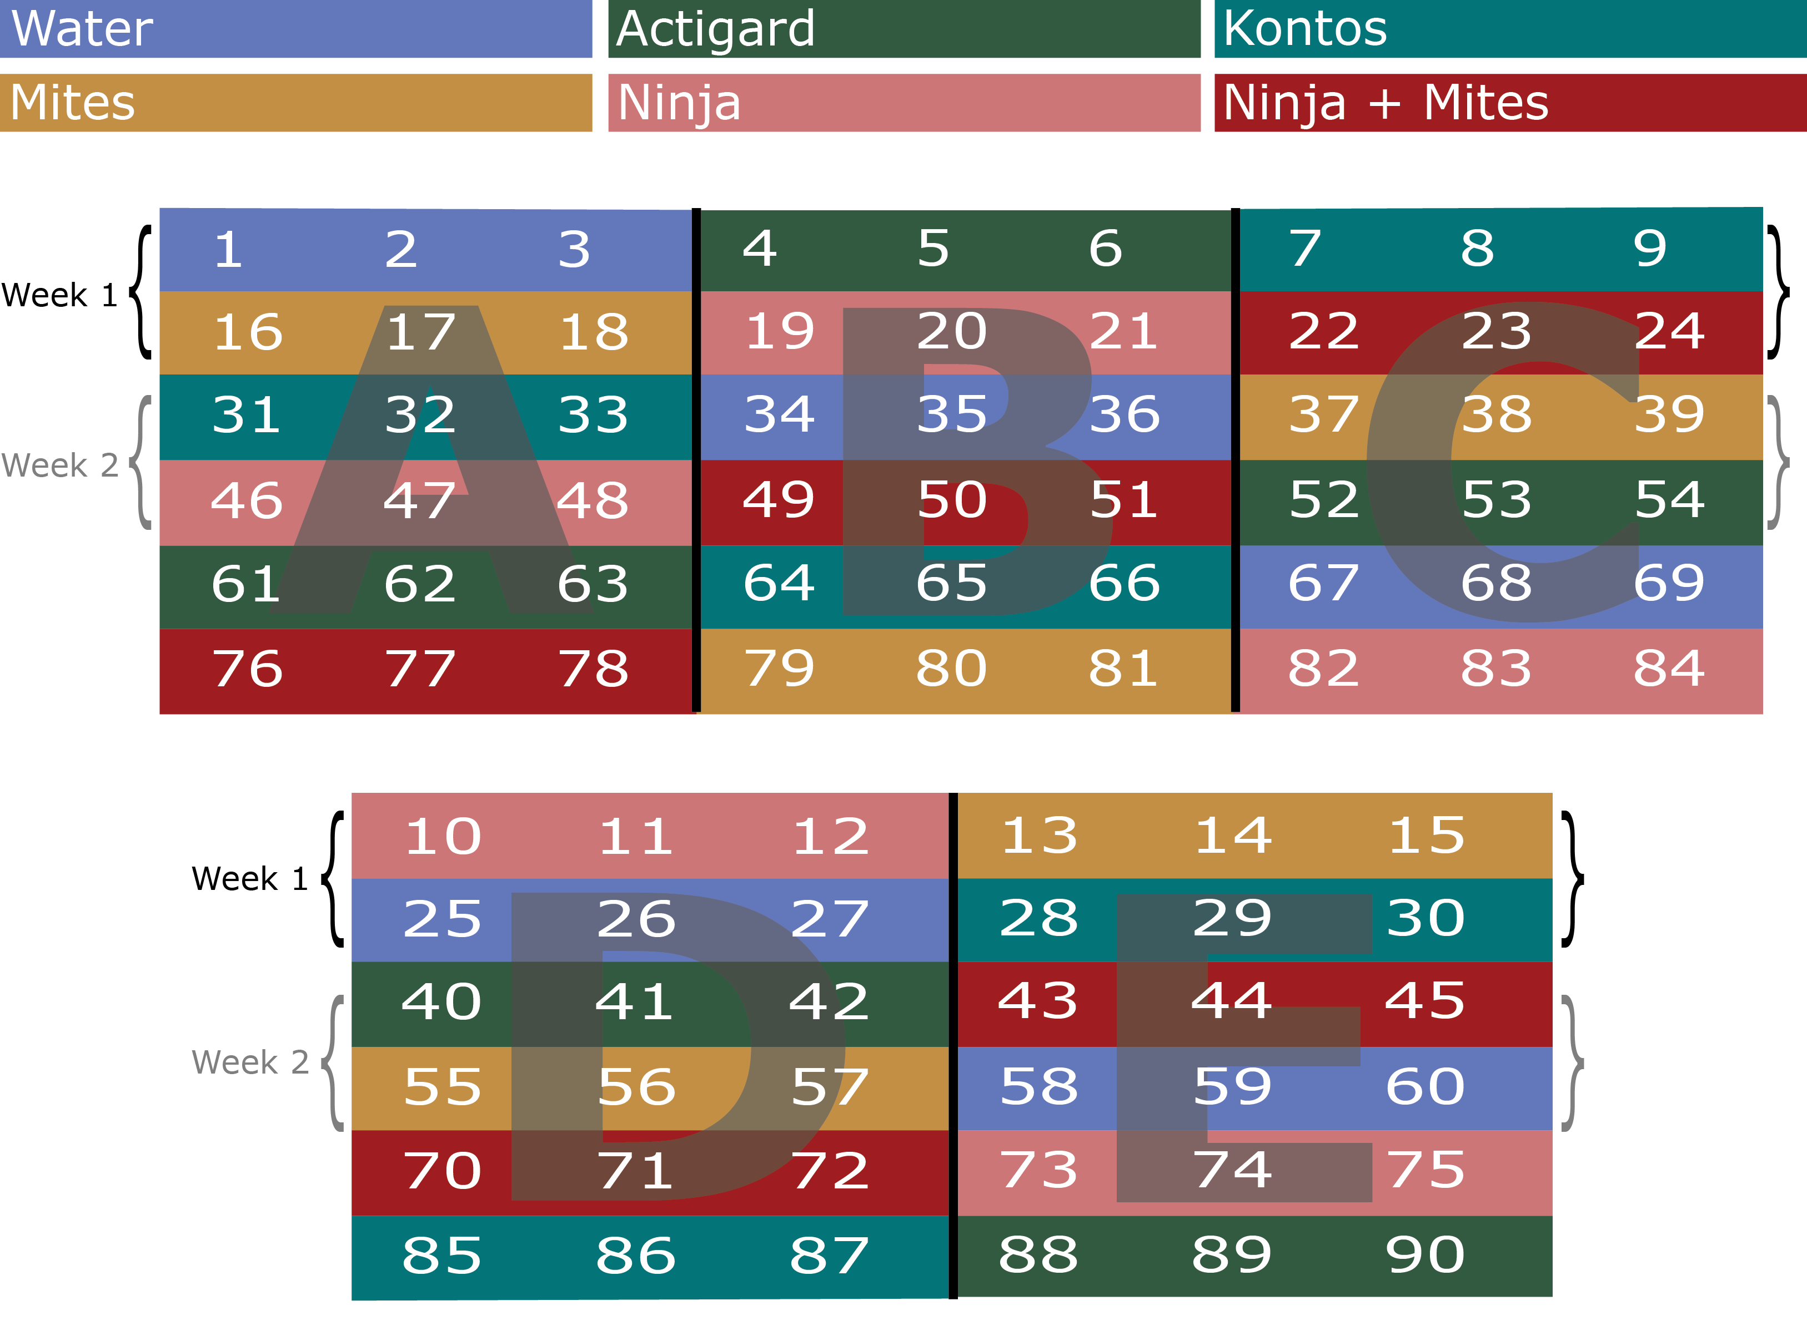

**Plot Design - Griffin IPM 2019** 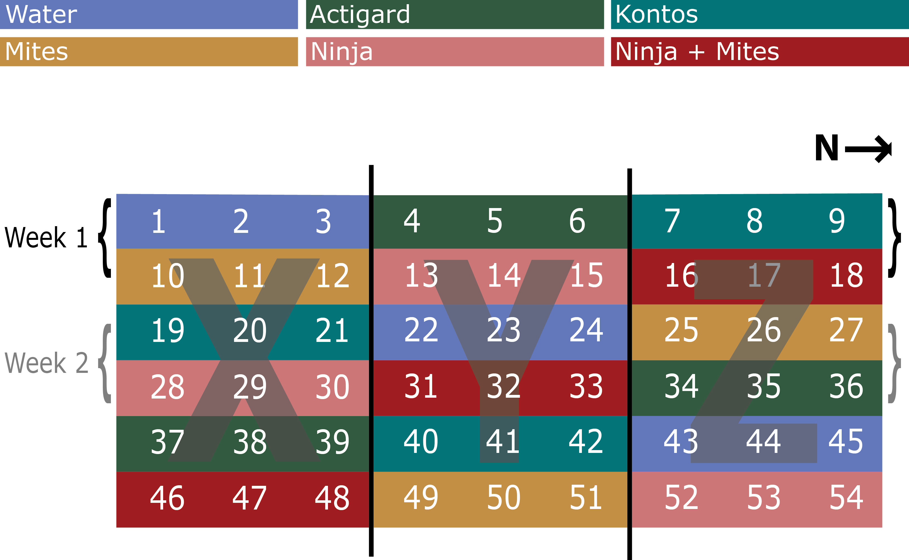

**Data Collection for Georgia IPM Trials** Flower samples were collected from all roses once before beginning the treatments on week 1 and once at the end of the experiment on week 12. For weeks 2 through 11, flower samples were collected weekly. starting from the top rows of each block, until each row was sampled three times (see *4.3* and *4.4*). Disease severity was recorded weekly according to the Horsfall-Barratt Scale (Horsfall 1945). Roses displaying symptoms of RRD had tissues sent to the Plant Disease Diagnostic Clinic at the North Florida Reasearch and Extension Center(PDC) for virus confirmation. Flower cuttings of about ~12 cm were taken and placed in 50 ml centrifuge tubes. Flowers were placed flower side down and submerged with 15 ml of 95% ethanol. Once the lid was secured, the the tube was shaken vigorously for a few seconds to help dislodge any mites. Samples were processed using the washing methods of Monfreda et al. (2007), eriophyoid mites were counted and identified as previously described.

### 4.2.3 Phenology field study

In order to be sure that a further series of IPM trials would be successful, we monitored a population of *P. fructiphilus* in Tallahassee which had mites but no RRD. Rose cuttings were collected periodically from four plots in the landscape of a church in Leon County, FL from 2020-2021: The site had two plantings of 2-3 years old Double Pink Knockout roses, with open sun exposure, ~0.3 spacing, and natural watering. Blocks were divided into 24 plots of ~3 $​^{2}$, with approximately 12 roses per plot. Samples were processed as previously described in ??. After washing, plant tissues were placed into in paper bags and put into a drying oven for ~48 hrs at 50 °C, after which dry weight was recorded. Mites were counted and recorded to track changes in the mite populations. Roses were pruned once on the beginning of July 2020 by a professional landscaping crew.

### 4.2.4 IPM field trials, Tallahassee 2021

A second trial of IPM was conducted in Tallahassee, FL. This site did not have RRD present, but had verified populations of *P. fructiphilus* present in the landscape (see APPENDIX). Spray applications were done weekly for 12 weeks from May to August 2021. Treatments were made on the same day each week, weather permitting.

**Roses** The site was divided into two blocks, with ten plots of roses in each block. Each plot was 3 $​^{2}$ with approximately 12 roses, the six roses at the center of the plot were treated, while the adjacent roses on either side was left as a buffer between plots to avoid treatment drift.

**Treatments** Five treatments were applied: tap water as a control, Actigard50WG® (acibenzolar-S-methyl, Syngenta, Greensboro, NC, USA) - 100 /, *Amblyseius swirskii* mini sachets with hooks (Ambly-S, Arbico Organics, Oro Valley, AZ, USA) - two sachets per rose in treated plots, and a combined treatment of Actigard50WG® - 100 / + *A. swirskii* - two sachets per rose in treated plots, and a spirotetramat miticide (Kontos® Miticide Insecticide, Bayer Corporation, Whippany, New Jersey, USA), (see *@(talla-ipm-2021)*).

**Mite Infestation** *P. fructiphilus* are present in the landscape of Tallahassee. Populations were present on the roses, as verified by the phenology experiments.

**Predatory mites** The two sachets of *A. swirskii* mites were applied to each of the six treated roses on the 1st, 5th and 9th week of the experiment, following the application instructions from the supplying company (Ambly-S, Arbico Organics, Oro Valley, AZ, USA). The sachets were hung from rose canes in the center of each rose. The *A. swirskii* plots were also treated with water weekly when the other plots were sprayed in order to keep conditions similar to other treatments.

**Data Collection for Tallahassee IPM Trials** Samples were collected and processed using similar methods as previously described in ??: Flower cuttings were taken weekly from from each of the six roses in the center of each plot. Three flowers (or buds if no flowers were present) were taken from each of the six central roses in each plot, for a total of 18 flowers/buds per bottle for each sampling bottle.The flowers/buds were placed into the ethanol-filled bottles and shaken vigorously for a few seconds to coat the rose tissue with ethanol and help dislodge any mites. Plant samples were processed according to the methods described in Monfreda et al. (2007). Plant tissues were retained after mites were washed off, and dried in kraft paper bags and put into the oven until dry (~48 hrs at 50 °C), after which the dry weight of the rose tissues was recorded.

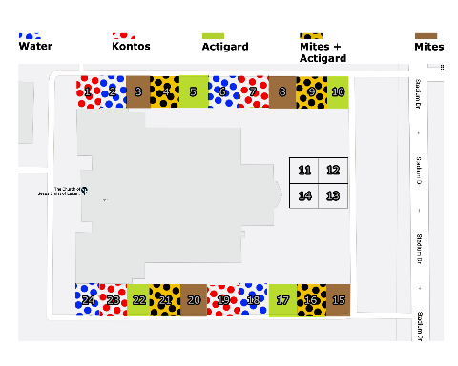

Figure 4.5: Field design for IPM trials on Pink Double Knock Out® roses to control in Tallahassee, FL with five treatments: Water, Actigard50WG®, Kontos®, predatory mite sachets, and + Actigard combined treatments. All products were applied at their label rates for 12 weeks. Flower cuttings were taken weekly to record numbers.

### 4.2.5 Analysis of field trial data

All data from all trials was processed and analyzed using R version 4.1.1 (R Core Team 2021). The data were all count data, so a Zero-Inflated Poisson Model (Zeileis et al. 2008) was required for the ASM data (Hothorn et al. 2008), while Generalized Linear Mixed Models (Bates et al. 2015) were used for all of the IPM and phenology trials. Estimated marginal means (least squares means) (Lenth 2021) and Tukey Contrasts Multiple Comparisons of Means were used to determine significant effects. In addition, about ~5% of early samples collected from the Tallahassee field trials were missing dry weights. Missing weight data was estimated and imputted using Multivariate Imputation by Chained Equations via the mice package (Buuren and Groothuis-Oudshoorn 2011).

## 4.3 Results

### 4.3.1 ASM trials

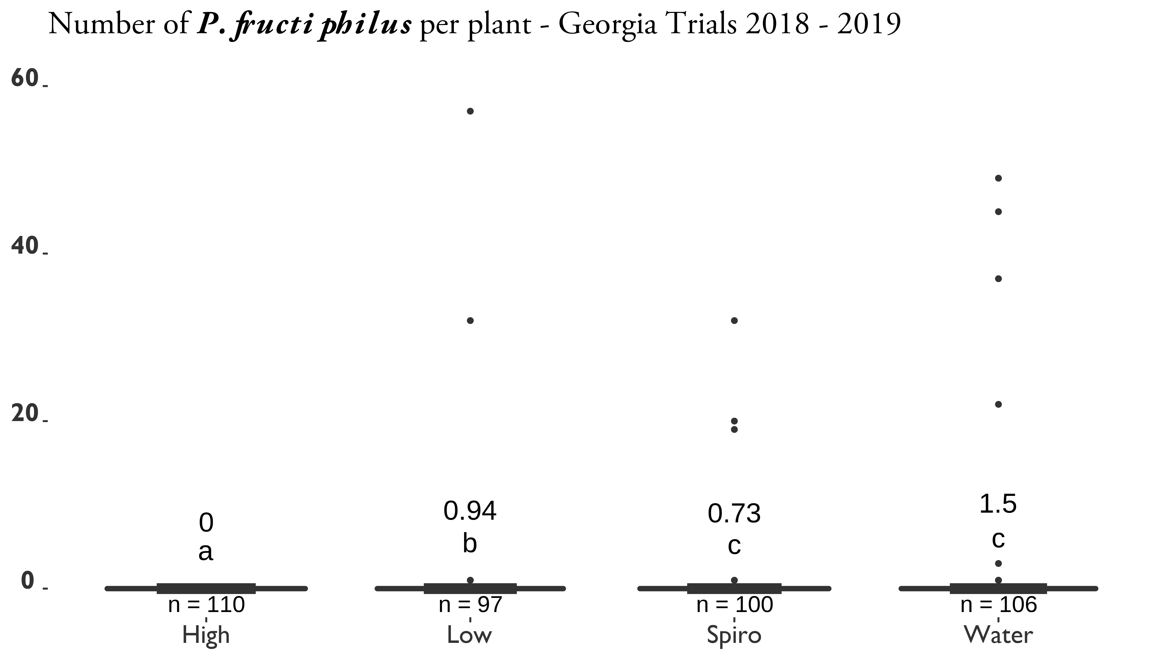

Figure 4.6: SAR-induction trials on Pink Double Knock Out® roses to control in Athens and Griffin, GA. Statistical significance was determined using Tukey contrasts for multiple Comparisons of means. Groups which share letters are not statistically different from one another. $α=0.05$. water = Water Control, High = 100 / Actigard50WG® (Syngenta, Greensboro, NC, USA) acibenzolar-S-methyl (ASM), low = 50 / Actigard50WG® (Syngenta, Greensboro, NC, USA) acibenzolar-S-methyl (ASM), Spiro = Kontos® Miticide Insecticide - Spirotetramat (Bayer Corporation, Whippany, New Jersey, USA), All products were applied for 12 weeks. Flower cuttings were taken weekly to record the numbers of herbivorous mites.

### 4.3.2 Phenology

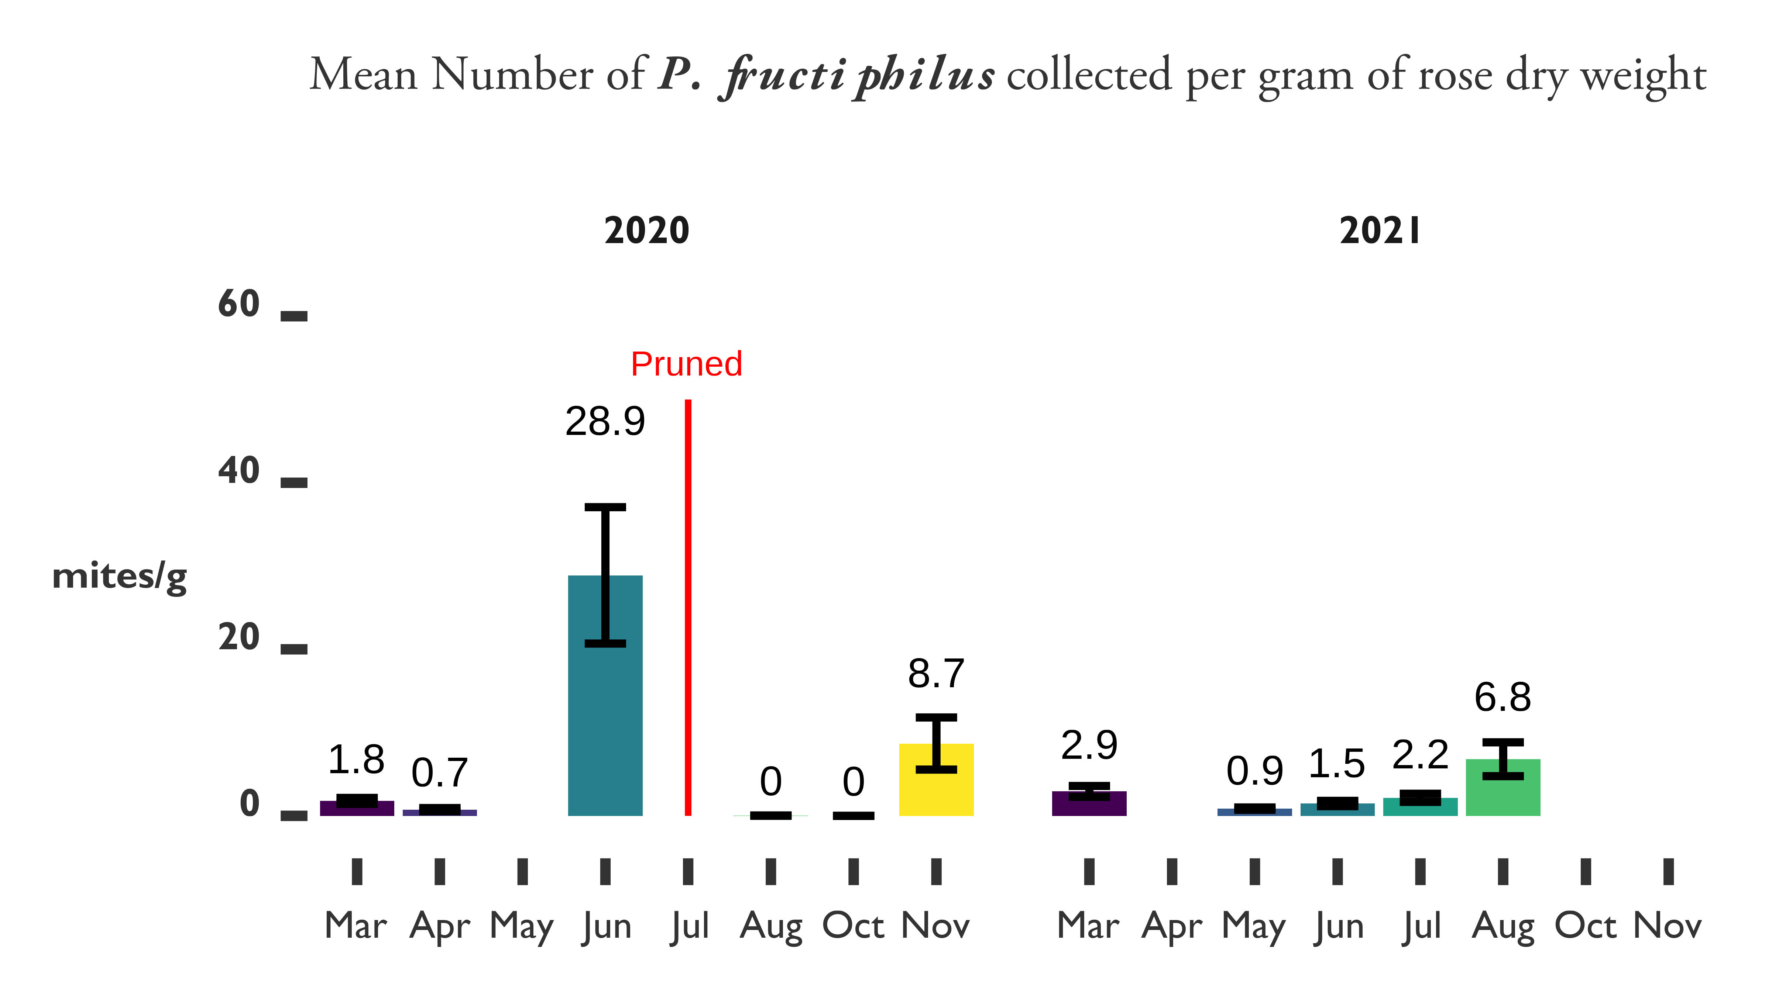

Figure 4.7: Phenology of mite populations on roses in Leon County, Florida 2020-2021. Roses were pruned back heavily on July 9, 2020.

### 4.3.3 IPM trials

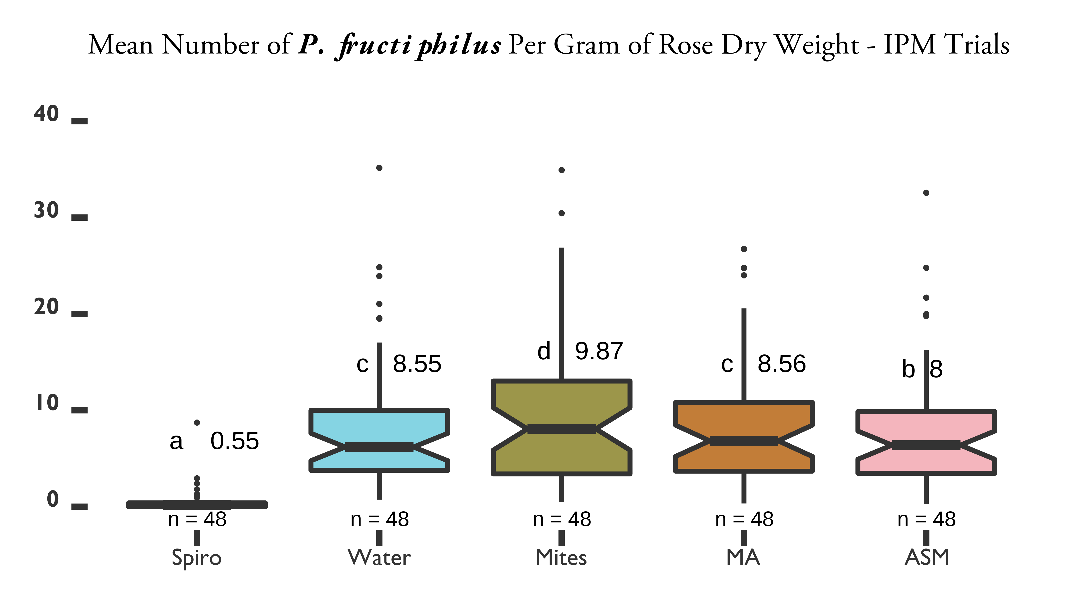

Figure 4.8: IPM trials on Pink Double Knock Out® roses to control in Tallahassee, FL with five treatments. Statistical significance was determined using Tukey contrasts for multiple Comparisons of means. Groups which share letters are not statistically different from one another. $α=0.05$. Water = Water Control, ASM = Actigard50WG® (Syngenta, Greensboro, NC, USA) acibenzolar-S-methyl (ASM), Spiro = Kontos® Miticide Insecticide - Spirotetramat (Bayer Corporation, Whippany, New Jersey, USA), Mites = predatory mite mini sachets on hooks (Ambly-S, Arbico Organics, Oro Valley, AZ, USA), MA = + Actigard combined treatments. All products were applied at their label rates for 12 weeks. Flower cuttings were taken weekly to record the numbers of and other herbivorous mites.

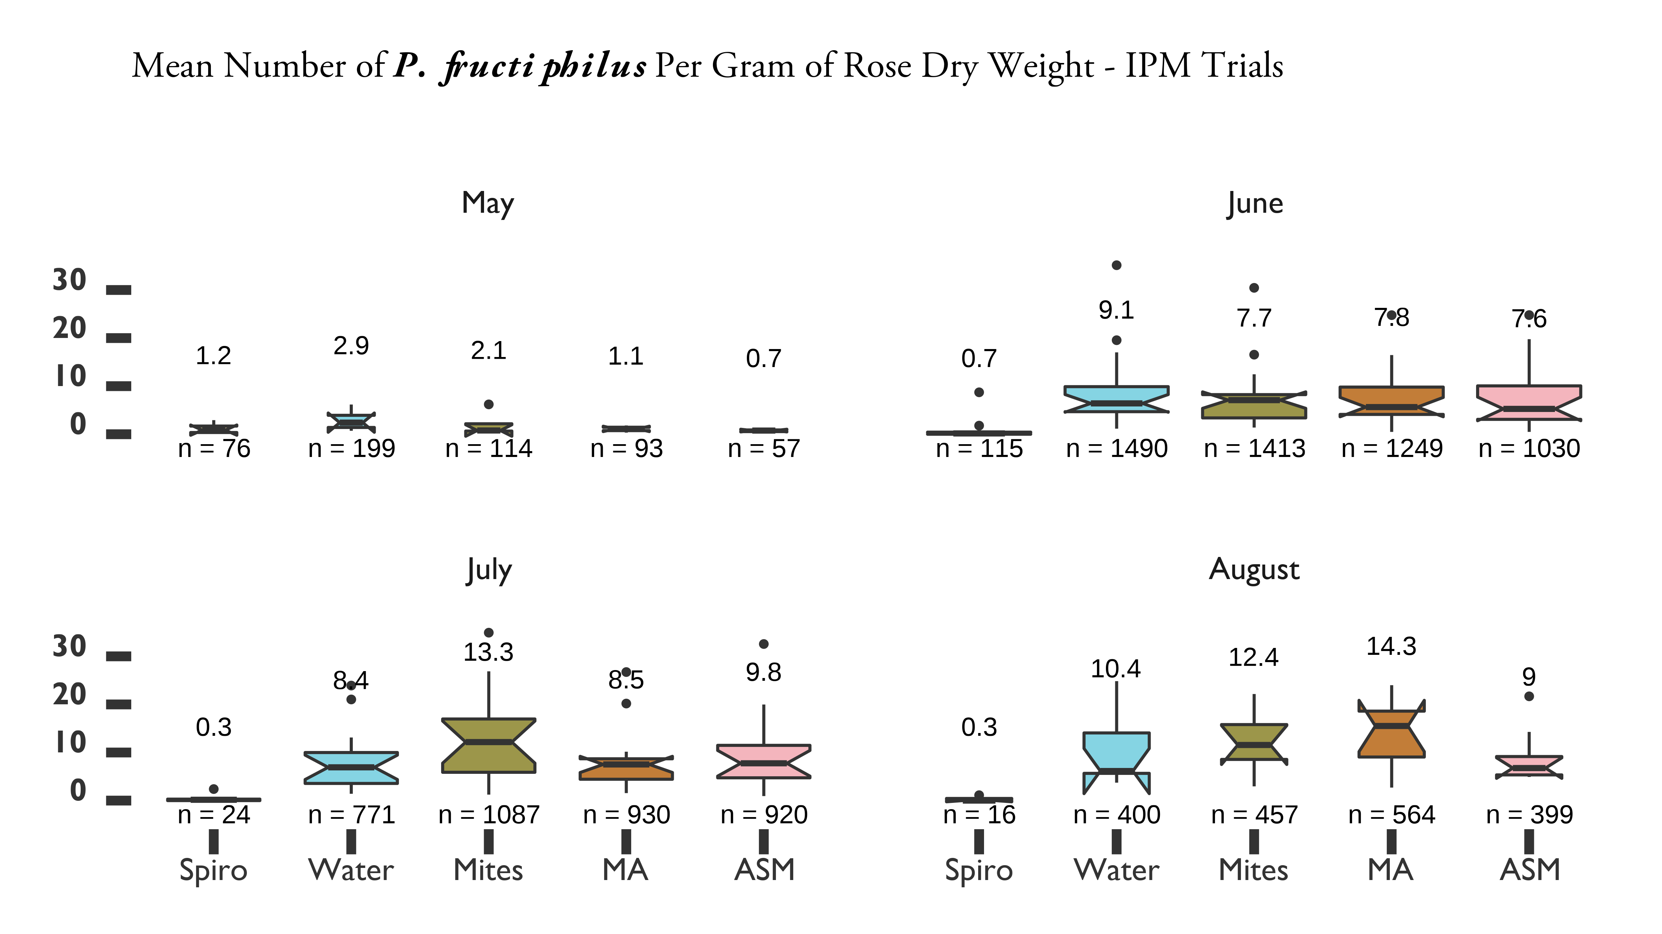

Figure 4.9: IPM trials on Pink Double Knock Out® roses to control in Tallahassee, FL with five treatments

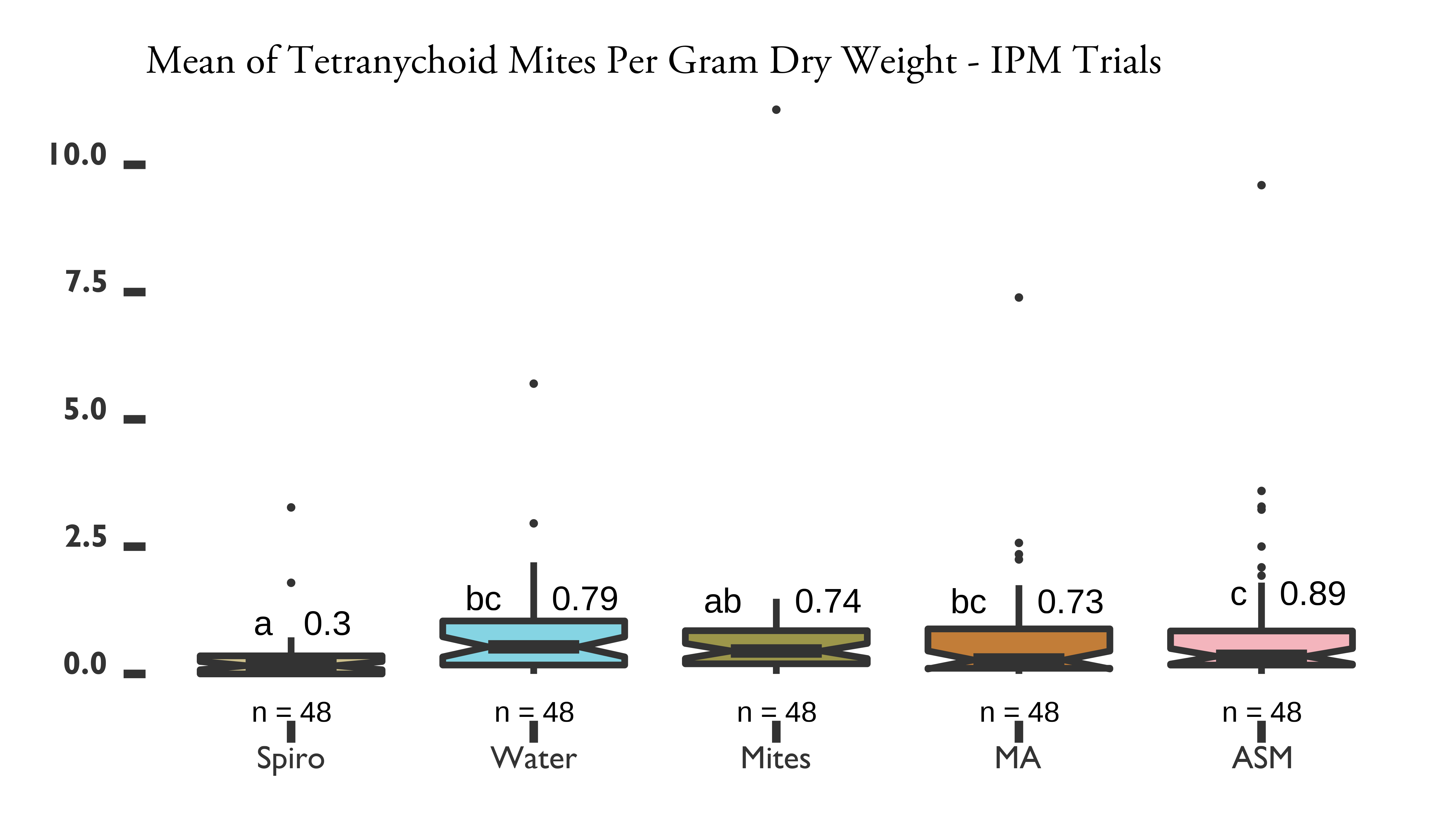

Figure 4.10: IPM trials on Pink Double Knock Out® roses to control in Tallahassee, FL with five treatments

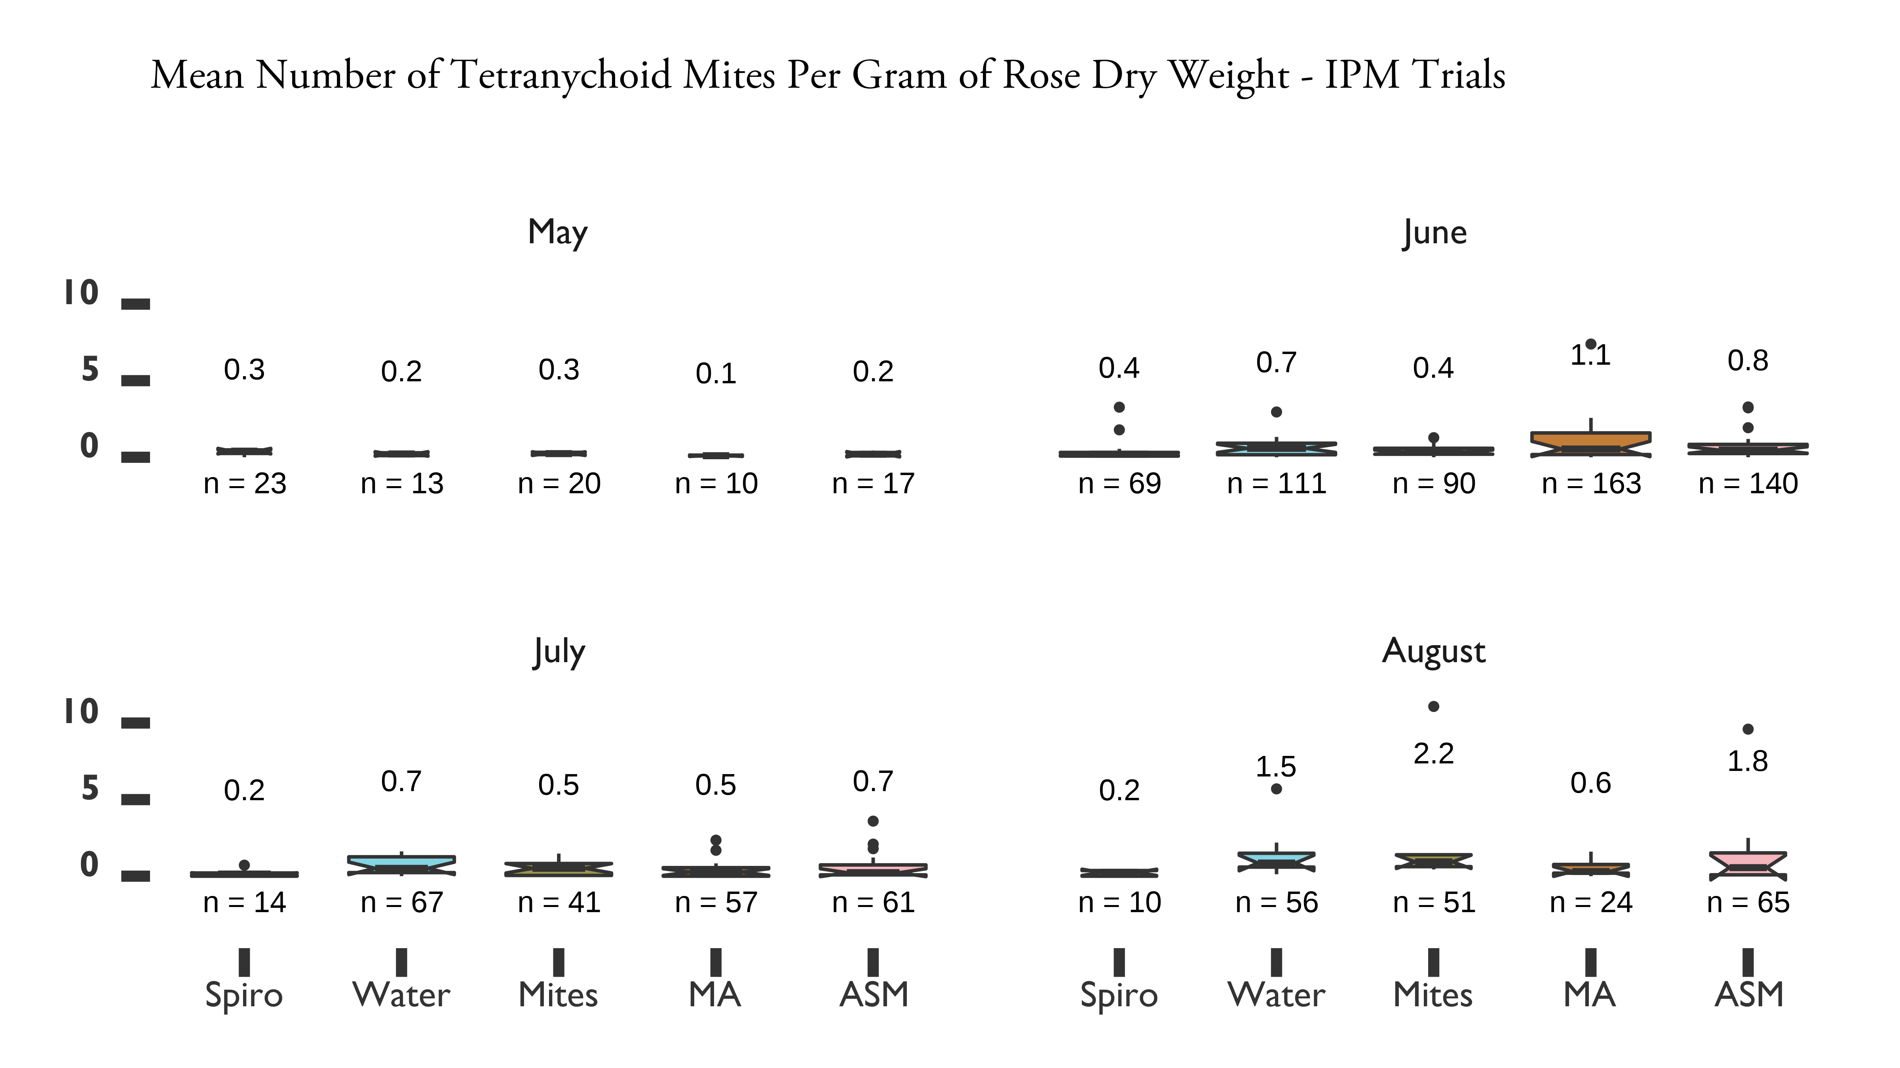

Figure 4.11: IPM trials on Pink Double Knock Out® roses to control in Tallahassee, FL with five treatments

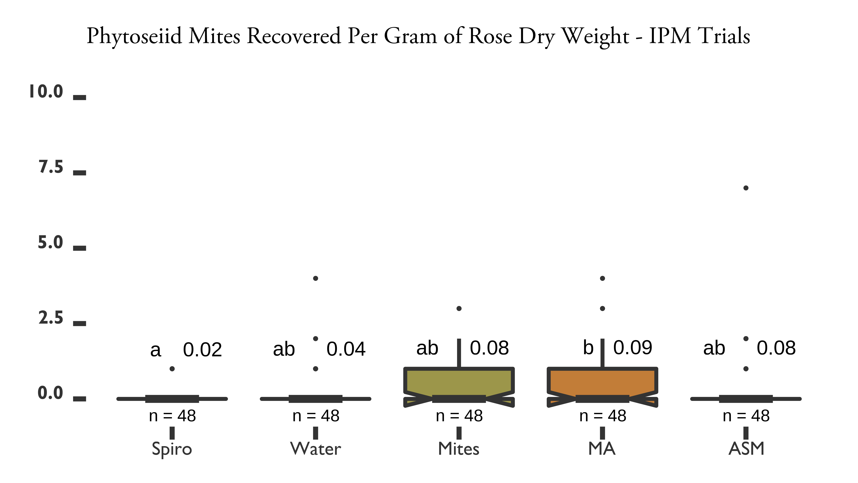

Figure 4.12: IPM trials on Pink Double Knock Out® roses to control in Tallahassee, FL with five treatments

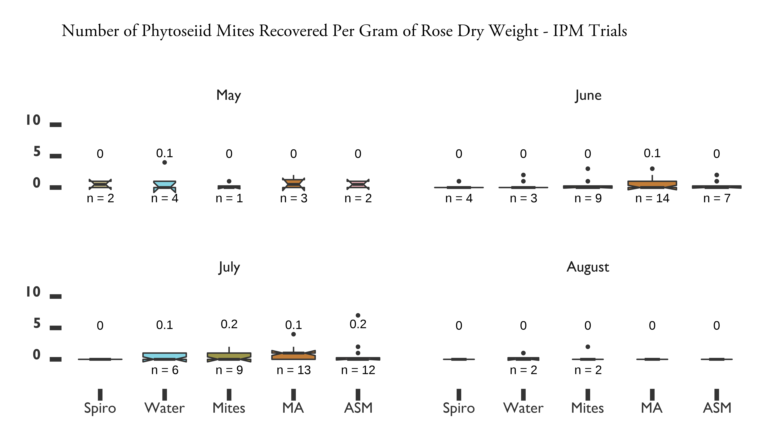

Figure 4.13: IPM trials on Pink Double Knock Out® roses to control in Tallahassee, FL with five treatments

## 4.4 Discussion

We had low recovery of *P. fructiphilus* for the ASM and IPM trials in Georgia. This lead us to the phenology study, to ensure that there had been adequate establishment of *P. fructiphilus* to create measurable effects. The phenology study was successful, and helped to inform the IPM trial in Tallahassee, which produced some meaningful data. Unfortunately, our results suggest that only applications of spirotetramat were able to significantly reduce populations of *P. fructiphilus*, an effect seen in all of the field trials conducted. SAR-induced plant defenses were unable to reduce mite numbers more than the control, even when combined with predatory mite releases (see *4.8*). The low recovery of *A. swirskii* makes it difficult to make claims about their efficacy as predators of *T. urticae* on roses. It is possible that *A. swirskii* simply dispersed to the point of leaving the rose plots: Buitenhuis et al. (2013) noted the ability of *A. swirskii* to move quickly on roses due to fewer trichomes, and recommended adjusting the release rates accordingly. This also emphasizes their lack of utility for feeding on *P. fructiphilus*: aside from being too large, *A. swirskii* predation was found to be negatively correlated with trichome density (Buitenhuis et al. 2013), suggesting that *A. swirskii* are unlikely to feed on *P. fructiphilus* hidden in the dense trichomes of rose sepals. Spirotetramat is known to be harmless to *A. swirskii* (Fernández et al. 2017), but no patterns emerged for either spirotetramat or ASM. Some evidence has been given that slow release mite sachets which are sheltered and provided with felt patches and/or moisture in the form of water-absorbant sodium polyacrylate gels had better releases of predators (Shimoda et al. 2018). In addition, other studies have struggled to recover phytoseiid mites generally, as evidenced by our mite surveys on roses. Fortunately, we did recover *A. swirskii* more often in the plots where they had been released, which is what we expected. We did not see an effect of *A. swirskii* release on the tetranychid mites which we found on the roses. Populations of *P. fructiphilius* showed seasonal fluctuations in mite numbers, with highest populations achieved during June 2020 and July 2021. Rose pruning in July 2020 reduced the numbers of *P, fructiphilus* collected for 3 months, populations began to recover that November. However, the number of *P.fructiphilus* collected was not significantly different between the years 2020 and 2021 for the phenology trials. Mite numbers remained relatively lower during 2021 compared to the previous year. None of the mite-infested roses have shown symptoms of RRD to date. Tracking populations for longer periods of time with additional climatic data could be used to determine the best times to prune and apply chemistry to reduce mite numbers. The large reductions of *P. fructiphilus* seen post pruning suggests its potential as a method of cultural mite control. The combination of pruning with acaricide treatments has been previously tested to control *P. fructiphilus*, with limited success (Windham et al. 2014), but these studies were conducted in areas of high pest pressure, with the presence of RRD. It is unlikely that acaricides or pruning are sufficient to prevent RRD infection: pruning does not remove the virus (Di Bello et al. 2017), and the inoculation access period for transmission of RRD is surprisingly short, with mites able to transmit the virus within an hour of plant feeding (Di Bello et al. 2017). Even so, the efficacy of combining pruning and acaricides has not been tested in areas with recent introductions of the mite without the virus. Combined management treatments may prove more effective in maintaining low populations of non-viruliferious *P. fruciphilus*, and should be investigated for preventing the spread of the mite, rather than preventing the disease proper.

# 5 *BREVIPALPUS*-TRANSMITTED *ORCHID FLECK DICHORHAVIRUS* INFECTING THREE NEW ORNAMENTAL HOSTS IN FLORIDA

Orchid fleck virus (OFV), is the type member for the genus *Dichorhavirus*, family *Rhabdoviridae*. The virus is a bacilliform, nuclear rhabdovirus composed of two segments of single-stranded, negative-sense RNA which infects plants (Dietzgen et al. 2014, Walker et al. 2018, Amarasinghe et al. 2019). Only Flat mites (Trombidiformes: Tenuipalpidae) from the genus *Brevipalpus* are known to transmit dichorhaviruses (Maeda 1998). Plants infected with OFV exhibit chlorotic and necrotic flecks on their leaves(Kubo et al. 2009b, Kubo et al. 2009a, Dietzgen et al. 2018b). The virus was first described as infecting *Cymbidium* orchids in Japan (Doi et al. 1977). There have been reports of OFV and OFV-like rhabdoviruses infecting orchids in Asia, Africa, North America, South America, Europe, and Oceania. The prevalence of OFV and its mite vector is thought to be associated with the movement of infected orchids (Dietzgen et al. 2018a). More than fifty species of Orchidaceae (Kitajima et al. 2010, Peng et al. 2013) can naturally become infected with OFV, as well as some Asparagaceae (Nolinoidaea) (Mei et al. 2016, Dietzgen et al. 2018b), and Rutaceae, where infection causes citrus leprosis-like symptoms (Roy et al. 2015, 2020, Cook et al. 2019, Olmedo-Velarde et al. 2021). Mechanical transmission of OFV is possible under laboratory conditions to the plant families Chenopodiaceae, Aizoaceae, Fabaceae, and Solanaceae (Chang et al. 1976, Kondo et al. 2003, Peng et al. 2013).

## 5.1 Virus Detection

During June 2020, chlorotic flecks and ringspot patterns of unknown etiology were observed on Giant Lilyturf *Liriope* spp., cv. ‘Gigantea’ in a landscape of Leon County, Florida (5.1). *Liriope* belong to a group of plants in the family Asparagaceae, subfamily Nolinoidaea, comprised of grass-like monocotyledonous liliod plants native to southeastern Asia (Chase et al. 2009, Meng et al. 2021). *Liriope* and the closely related *Ophiopogon* (Asparagaceae: Nolinoidaea) are considered the most important ground cover plant in the southeastern United States (Mcharo et al. 2003). Viral infections of suspected leaf samples were initially tested at the Plant Disease Diagnostic Clinic at the North Florida Research and Education Center (NFREC) in Quincy, FL. All the samples were tested with one step conventional RT-PCR, and were found negative for begomovirus, carlavirus, potyvirus, tospovirus, cucumber mosaic virus and tobacco mosaic virus. As initial diagnostics were inconclusive, samples were taken of putatively infected plants with ringspot symptoms during July and August of 2020. Leaves were taken from *Liriope* spp. and *Ophiopogon* spp., as well as the *Aspidistra elatior* Blume (Asparagaceae: Nolinoidaea), nearby, which appeared sickly and chlorotic (5.2). Plant materials were sent to the Florida Department of Agriculture and Consumer Services (FDACS) for identification. The FDACS determined that the pathogen was OFV using previously published primers and methods to conduct RT-PCR and Sanger sequencing (Kubo et al. 2009b, Kubo et al. 2009a, Ramos-González et al. 2015). The identity of the virus was verified as OFV Orchid strain 1, (OFV-Orc1), following the methods described in Kondo et al. (2017). Nucleotide sequencing shared 98% nucleotide identity with the OFV-isolates So (Accession No. AB244418) and Br (Accession No. MK522807), which belong to orchid subgroup I (Kondo et al. 2006, 2017). These samples from FDACS were subsequently retested by the USDA-APHIS-PPQ S&T Beltsville laboratory, in conjunction with tests of fresh samples from both Alachua and Leon counties. The USDA used RT-PCR, RT-qPCR, and High Throughput Sequencing (HTS) to reconfirm the presence of OFV. Conventional RT-PCR with Generic R2-Dicho-GF and R2-Dicho-GR primers amplified ~800 nt amplicons of the L-gene (RNA2) (Roy et al. 2020), to detect both OFV-Orc1 and OFV-Orc2 in *O. intermedius* and *A. elatior* from Leon County (Kondo et al. 2017) (GenBank Accession Numbers: MZ852004, MZ852005 MZ852006, and MZ852007). 99% nucleotide sequence identity is shared between OFV-Orc1 and OFV-Orc2 for the RNA2 genome, whereas 90% sequence identity was found between these two reassortment strains. The presence of OFV-Orc1 and OFV-Orc2 in Leon and Alachua counties was reaffirmed with HTS data (??): Analysis of HTS data from Leon County found that the symptomatic *L. muscari* were coinfected with both OFV-Orc1 and OFV-Orc2, while the symptomatic *A. elatior* were solely infected with OFV-Orc1. Sequence data of symptomatic *L. muscari* from Alachua County revealed infections with OFV-Orc2 (GenBank Accession MZ852006). After the initial identification by FDACS of OFV-Orc, mite samples were collected from symptomatic Asparagaceae in Leon County. Most mites collected were Tenuipalpid mites (flat mites or false spider mites), a pest of ornamental plants, some of which are known to act as vectors for plant viruses (Childers et al. 2003b, Childers and Rodrigues 2011).

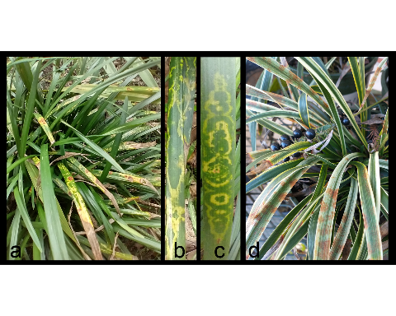

Figure 5.1: Variety of symptoms seen on spp. infected with Orchid Fleck Virus (OFV): (a) symptoms on cv. ‘Gigantea’ (b-c) Details of symptoms on cv. Gigantea (d) rust colored spots on

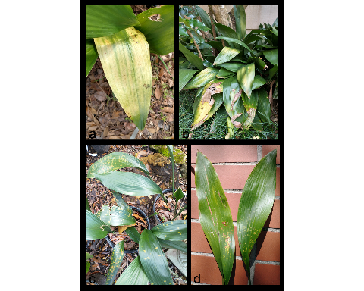

Figure 5.2: Symptoms seen on infected with OFV: (a) Detail of leaf chlorosis (b) Chlorosis appears similar to sun damage (c-d) Chlorotic flecks may indicate early symptoms of OFV

## 5.2 A Comment on the Status of *Brevipalpus* in Florida

Mite taxonomy is complicated by cryptic species complexes which occur in many plant-feeding groups of the Acari (Umina and Hoffmann 1999, Skoracka and Dabert 2010, Arthur et al. 2011, Skoracka et al. 2013), including tenuipalpid mites from the genus *Brevipalpus* (Navia et al. 2013). The commonly used phase-contrast microscopy is insufficient to detect some diagnostic characters for separation of cryptic species, instead best practices recommend the combination of Differential Interference Contrast (DIC) Microscopy and Scanning Electron Microscopy along with molecular methods to separate cryptic species (Beard et al. 2015). The flat mites collected were initially suspected to belong to *B. californicus* after inspection with phase contrast microscopy. Subsequent observation via DIC microscopy at FDACS agreed with this tentative identification. Unfortunately, the *B. californicus* s.l. species group, *sensu* Baker and Tuttle (1987) is suspected to contain cryptic species (Childers and Rodrigues 2011, Rodrigues and Childers 2013). New mite samples were collected from symptomatic liriopogons and *A. elatior* in Leon County and sent to USDA-ARS’s Electron and Confocal Microscopy Unit for analysis. Three mite species were recovered and examined under cryo-scanning electron microscopy (Cryo-SEM): *B. californicus* s.l. (5.3), *B. obovatus* Donnadieu and *B. confusus* Baker. The recent report of OFV in the US is thought to be Ko et al. (1985) which describes nuclear inclusions caused by an undescribed bacilliform rhabdovirus in *Brassia* orchids. The significance of this report is their description of the spoke-wheel configurations of the viral particles (Ko et al. 1985), a sign typically associated with OFV infection (Chang et al. 1976). Unfortunately, this article made no mention of mites or further investigations of the virus. The first report of OFV in the continental US was Bratsch et al. (2015), who confirmed the presence of OFV in *Phalaenopsis* hybrids using Transmission Electron Microscopy of ultrathin sections of plant tissue as well as molecular sequence analysis. They also discuss the association of OFV with *Brevipalpus* mites, but the authors did not make a conclusive species identification beyond suggesting that the mite vector belonged to the *B. californicus* group, referring to Kondo et al. (2003)’s publication (Bratsch et al. 2015). Later reports of OFV described OFV infecting a previously undescribed Nolinoidaea hosts in Australia (Mei et al. 2016, Dietzgen et al. 2018b), including *Liriope spicata* (Thunb.) Lour, a different species of liriopogon than those identified from the Florida sites. We are not aware of any reports of OFV infecting liriopogons, *A. elatior* nor other Nolinoidaea in the US. Although Peng et al. (2013) had mentioned an association between *B. californicus* and *A. elatior*, they never reported symptoms of OFV-Orc in this plant. We believe that our findings indicate the first report of OFV-Orc infecting ornamental Nolinoidaea in Florida, and possibly the US. This publication also marks the first reports of *A. elatior* and *Ophiopogon* spp. as natural hosts of OFV-Orc. There are two orchid strains of OFV (OFV-Orc1 and OFV-Orc2), and two citrus strains (OFV-Cit1 and OFV-Cit2) (Beltran-Beltran et al. 2020, Roy et al. 2020). The OFV strains detected in Florida are identical in genome sequence to the orchid strains of OFV infecting citrus in Hawaii, Mexico, Colombia, and South Africa (Beltran-Beltran et al. 2020, Roy et al. 2020). Both OFV-Orc1 and OFV-Orc2 infect citrus (Roy et al. 2020), but none of the citrus strains have been reported from any orchid species. The *Brevipalpus* mites collected from liriopogons and *A. elatior* in Leon County were abundant on OFV-infected plants very near to citrus trees, some plants even surrounding the trunk. *B. californicus* s. l. has been reported as a pest of citrus (Childers et al. 2003b) and are often collected from citrus fruits (Baker 1949, Baker and Tuttle 1987, Vacante 2010, 2016). The proximity of these mite vectors to citrus raises the question: why these trees are not currently infected with OFV-Orc? It is important to note the uncertainty surrounding the vector for OFV-Orc. There are three mite species which have been recovered from OFV-Orc infected plants: *B. obovatus*, and *B. confusus* and *B. californicus* s.l., but only *B. californicus* has been described as a vector of OFV. Even so, the *B. californicus* which we find on liriopogons and *A. elatior* may not be the same cryptic species as those found on citrus. Transmission of OFV from populations of *B. californicus* liriopogon/*A. elatior* to citrus may be limited by host preferences, vectorial capacity, viral propagation/circulation in the vector, viral acquisition times, or feeding times required for transmission to citrus. Even so, these types of questions require future study to determine the potential of nolinoidaea to citrus transmission. Best practices for integrated pest management have not been created for controlling *Brevipalpus* mites on these ornamentals, but methods designed to control *Brevipalpus* in other systems may be applicable. The most common method used to control *Bervipalpus* are synthetic acaricides such as spirodiclofen and cyflumetofen (Andrade et al. 2010, 2019, Leeuwen et al. 2015, Vechia et al. 2018). Unfortunately, some acaricides and their residues can harm beneficial predatory mites as well (Fernández et al. 2017), even at low doses (Havasi et al. 2021), and mixing different chemistries can be detrimental for mite control (Vechia et al. 2018). Furthermore, pesticide resistance has been reported in various *Brevipalpus* populations (Alves et al. 2000, Omoto et al. 2000, Campos and Omoto 2002, Rocha et al. 2021), due to exposure to pesticides used to control other arthropod pests (Vechia et al. 2021). In addition, phytoseiid predatory mites such as *Amblyseius largoensis* (Muma) and *Galendromus helveolus* (Chant) (Chen et al. 2006, Argolo et al. 2020), entomopathogenic fungi (Magalhães et al. 2005, Rossi-Zalaf et al. 2008, Peña et al. 2015, Revynthi et al. 2019) have shown promise for controlling other *Brevipalpus* mites. Moreover, it is often possible to integrate different control techniques for improved management, such as combining predatory mites with compatible acaricides and entomopathogenic fungi (Reddy 2001, Midthassel et al. 2016, Andrade et al. 2019). In conclusion, detecting OFV in Florida represents a concern for horticulturists who grow orchids, *Liriope*, *Ophiopogon*, or other susceptible Asparagaceae species which are commonly used in landscaping. Florida is also home to a plethora of native and naturalized orchid species, many of which are threatened, including cultivated *Vanilla* in southern Florida (Chambers et al. 2019) and the famous Ghost Orchid, [*Dendrophylax lindenii* (Lindl.) Benth. ex Rolfe]. Furthermore, Citrus leprosis was present in Florida during the 1860’s and almost eradicated by the mid-1960s (Knorr 1968, Knorr et al. 1968, Childers et al. 2003b). An examination of herbarium specimens of Florida citrus found that one strain of this historical virus, Citrus leprosis dichorhavirus-N0, is distantly related to the modern isolates of OFV (Kitajima et al. 2011, Hartung et al. 2015, Roy et al. 2020). The recent detection of OFV-Orc1 in South Africa (Cook et al. 2019) in *C. sinensis* (Navel and Valencia orange) and OFV-Orc2 in Hawaii (Olmedo-Velarde et al. 2021) in *C. reticulata* (mandarin) and *C. jambhiri* (rough lemon) associated with leprosis-like symptoms highlights the potential threat of different isolates of OFV on citrus, which will be a definite concern to the US multi-billion-dollar citrus industry already impacted by the Huanglongbing disease. *B. californicus*, *B. yothersi*, and *B. obovatus* are all present in Florida (Childers et al. 2003b, Akyazi et al. 2017), and are difficult to identify by non-experts, or without advanced methodologies. DNA barcoding (Armstrong and Ball 2005) or a similarly simple and accurate method for identification of these mite complexes is vital to identify mite populations which need to be monitored or controlled. By doing so, we can determine the risk OFV-Orc represents for the native plants, agriculture and the ornamental/landscaping industries of Florida and the surrounding regions.

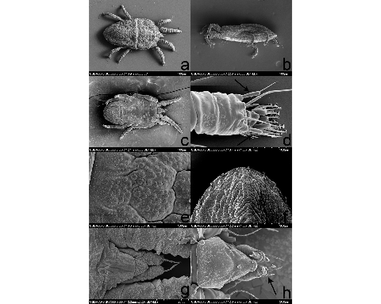

Figure 5.3: Cryo-SEM images of displaying various characters used for identification (Baker and Tuttle 1987, Beard et al. 2015) (a) Dorsum (b) Lateral view (c) Venter (d) Close up of distal end of leg 2, with arrows indicating paired solenidia, characteristic of the genus (e) Enlargement of the microplates of the mite cerotegument (f) Dorsal view of the distal portion of mite abdomen (g) Dorsal view of the mite rostrum (h) Ventral view of mite rostrum, observe 3 distal setae.

# 6 CONCLUSIONS: INVASIVE MITES ARE AN INCREASINGLY LARGE PROBLEM FOR FLORIDA

## 6.1 Invasive Species are a Problem in Florida

The aim of our research was to address the emerging problems caused by the recent invasions of mites and the plant viruses they vector to northern Florida. Florida is a hotspot for invasive species in the mainland US, due to a combination of its unique geography, climate, rapid development and a multitude of invasion pathways (Simberloff et al. 1997, Williams et al. 2007, Card et al. 2018). Invasive species are often harmful to ecosystem services and modify ecosystems to the detriment of native species (Gordon 1998). Efforts to manage invasive species costs the state of Florida ~$45M each year (Hiatt et al. 2019). Many Florida programs have been developed to raise public awareness about the threats of invasive species, as well as encouraging the reporting of invasive species by the public (Wallace et al. 2016). *Phyllocoptes fructiphilus*, Rose Rosette Disease, and Orchid Fleck Virus all represent yet another chapter in the story of Florida invasion ecology. These organisms have a high possibility of becoming established invasive species in Florida if preventative actions are not taken. Our research was designed to address two of the main issues of controlling *P. fructiphilus*: early detection and integrated pest management of the mite vector.

## 6.2 Main Findings

The principal findings of our experiments are:

1. *Phyllocoptes fructiphilus* is present in multiple cities in northern Florida
2. The predatory mite *Amblyseius swirskii* is attracted to roses infected with Rose Rosette Disease (RRD)
3. Infected roses have higher levels of defense-related terpenes, including -Muurolene, -Caryophyllene, and D-Limonene, some of which may be attractive to *A. swirskii*
4. ASM-treated plants had more similar profiles to one another than to the Volatile Organic Compounds (VOCs) released from healthy or RRD-infected plants
5. Systemic Acquired Resistance (SAR) via acibenzolar-S-methyl (ASM) does not appear to significantly reduce populations of *P. fructiphilus*
6. *P. fructiphilus* populations may be reduced by spirotetramat applications, or possibly heavy pruning
7. Orchid Fleck Virus (OFV) is present in ornamental groundcover plants in Florida. the vector of OFV (*Brevipalpus californicus*, *sensu lato*) is present as well

We encountered two invasive mite species associated with plant viruses in the last three years. This is likely an unfortunate byproduct of the plant trade and the (Chapman et al. 2017).

# REFERENCES

**Abou-Awad, B. A., and E. M. El-Banhawy**. **1985**. Susceptibility of the tomato russet mite, *Aculops lycopersici* (Acari: Eriophyidae), in Egypt to methamidophos, pyridaphenthion, cypermethrin, dicofol and fenarimol. Experimental & Applied Acarology. 1: 11–15, DOI:[10.1007/bf01262195](https://doi.org/10.1007/bf01262195).

**Achor, D. S., R. Ochoa, E. F. Erbe, H. Aguilar, W. P. Wergin, and C. C. Childers**. **2001**. Relative advantages of low temperature versus ambient temperature scanning electron microscopy in the study of mite morphology. International Journal of Acarology. 27: 3–12, DOI:[10.1080/01647950108684218](https://doi.org/10.1080/01647950108684218).

**Adler, F. R., and R. Karban**. **1994**. Defended fortresses or moving targets? Another model of inducible defenses inspired by military metaphors. The American Naturalist. 144: 813–832, DOI:[10.1086/285708](https://doi.org/10.1086/285708).

**Agrawal, A. A., and R. Karban**. **1997**. Domatia mediate plantarthropod mutualism. Nature. 387: 562–563, DOI:[10.1038/42384](https://doi.org/10.1038/42384).

**Agrawal, A. A., and R. Karban**. **1999**. Advantages of induced plant defenses, pp. 45–62. *In* Tollrain, R., Harvell, C.D. (eds.), The Ecology and Evolution of Inducible Defenses. Princeton University Press, Princeton, N.J.

**Agrios, G. N.** **2004**. [Plant pathology](https://www.ebook.de/de/product/3267675/george_n_agrios_plant_pathology.html). Academic Press.

**Agut, B., V. Pastor, J. Jaques, and V. Flors**. **2018**. Can plant defence mechanisms provide new approaches for the sustainable control of the two-spotted spider mite *Tetranychus urticae*? International Journal of Molecular Sciences. 19: 614, DOI:[10.3390/ijms19020614](https://doi.org/10.3390/ijms19020614).

**Akyazi, R., E. A. Ueckermann, and O. E. Liburd**. **2017**. New report of *Brevipalpus yothersi* (Prostigmata: Tenuipalpidae) on blueberry in Florida. Florida Entomologist. 100: 731–739, DOI:[10.1653/024.100.0420](https://doi.org/10.1653/024.100.0420).

**Alavanja, M. C. R., J. A. Hoppin, and F. Kamel**. **2004**. Health effects of chronic pesticide exposure: Cancer and neurotoxicity. Annual Review of Public Health. 25: 155–197, DOI:[10.1146/annurev.publhealth.25.101802.123020](https://doi.org/10.1146/annurev.publhealth.25.101802.123020).

**Alba, J. M., B. C. J. Schimmel, J. J. Glas, L. M. S. Ataide, M. L. Pappas, C. A. Villarroel, R. C. Schuurink, M. W. Sabelis, and M. R. Kant**. **2014**. Spider mites suppress tomato defenses downstream of jasmonate and salicylate independently of hormonal crosstalk. New Phytologist. 205: 828–840, DOI:[10.1111/nph.13075](https://doi.org/10.1111/nph.13075).

**Alcı́var, J., N. C. Mesa, and C. Vásquez**. **2020**. First report of *Raoiella indica* Hirst (Acari: Tenuipalpidae) in Province of Manabí, Ecuador. International Journal of Acarology. 46: 120–122, DOI:[10.1080/01647954.2020.1719195](https://doi.org/10.1080/01647954.2020.1719195).

**Alipour, Z., Y. Fathipour, and A. Farazmand**. **2016**. Age-stage predation capacity of *Phytoseiulus persimilis* and *Amblyseius swirskii* (Acari: Phytoseiidae) on susceptible and resistant rose cultivars. 42: 224–228, DOI:[10.1080/01647954.2016.1171797](https://doi.org/10.1080/01647954.2016.1171797).

**Alipour, Z., Y. Fathipour, A. Farazmand, and M. Khanamani**. **2019**. Resistant rose cultivar affects life table parameters of two-spotted spider mite and its predators *Phytoseiulus persimilis* and *Amblyseius swirskii* (Phytoseiidae). 24: 1620–1630, DOI:[10.11158/saa.24.9.4](https://doi.org/10.11158/saa.24.9.4).

**Allington, W. B., R. Staples, and G. Viehmeyer**. **1968**. Transmission of Rose rosette virus by the eriophyid mite *Phyllocoptes fructiphilus*. Journal of Economic Entomology. 61: 1137–1140, DOI:[10.1093/jee/61.5.1137](https://doi.org/10.1093/jee/61.5.1137).

**Alves, E. B., C. Omoto, and C. R. Franco**. **2000**. Resistência cruzada entre o dicofol e outros acaricidas em *Brevipalpus phoenicis* (Geijskes) (Acari: Tenuipalpidae). Anais da Sociedade Entomológica do Brasil. 29: 765–771, DOI:[10.1590/s0301-80592000000400017](https://doi.org/10.1590/s0301-80592000000400017).

**Amarasinghe, G. K., M. A. Ayllón, Y. Bào, C. F. Basler, S. Bavari, K. R. Blasdell, T. Briese, P. A. Brown, A. Bukreyev, A. Balkema-Buschmann, U. J. Buchholz, C. Chabi-Jesus, K. Chandran, C. Chiapponi, I. Crozier, R. L. de Swart, R. G. Dietzgen, O. Dolnik, J. F. Drexler, R. Dürrwald, W. G. Dundon, W. P. Duprex, J. M. Dye, A. J. Easton, A. R. Fooks, P. B. H. Formenty, R. A. M. Fouchier, J. Freitas-Astúa, A. Griffiths, R. Hewson, M. Horie, T. H. Hyndman, D. Jiāng, E. W. Kitajima, G. P. Kobinger, H. Kondō, G. Kurath, I. V. Kuzmin, R. A. Lamb, A. Lavazza, B. Lee, D. Lelli, E. M. Leroy, J. Lǐ, P. Maes, S.-Y. L. Marzano, A. Moreno, E. Mühlberger, S. V. Netesov, N. Nowotny, A. Nylund, A. L. Økland, G. Palacios, B. Pályi, J. T. Pawęska, S. L. Payne, A. Prosperi, P. L. Ramos-González, B. K. Rima, P. Rota, D. Rubbenstroth, M. Shı̄, P. Simmonds, S. J. Smither, E. Sozzi, K. Spann, M. D. Stenglein, D. M. Stone, A. Takada, R. B. Tesh, K. Tomonaga, N. Tordo, J. S. Towner, B. van den Hoogen, N. Vasilakis, V. Wahl, P. J. Walker, L.-F. Wang, A. E. Whitfield, J. V. Williams, F. M. Zerbini, T. Zhāng, Y.-Z. Zhang, and J. H. Kuhn**. **2019**. Taxonomy of the order Mononegavirales: Update 2019. Archives of Virology. 164: 1967–1980, DOI:[10.1007/s00705-019-04247-4](https://doi.org/10.1007/s00705-019-04247-4).

**Amaro, G., E. G. Fidelis, R. S. da Silva, and C. M. de Medeiros**. **2021**. Current and potential geographic distribution of red palm mite (*Raoiella indica* Hirst) in Brazil. Ecological Informatics. 65: 101396, DOI:[10.1016/j.ecoinf.2021.101396](https://doi.org/10.1016/j.ecoinf.2021.101396).

**Amrine, J. W., and T. A. Stasny**. **1994**. Catalog of the Eriophyoidea (Acarina: Prostigmata) of the world. Indira Publishing House.

**Amrine Jr, J. W.** **1996**. [*Phyllocoptes fructiphilus* and biological control of multiflora rose](https://doi.org/10.1016/s1572-4379(96)80050-9), pp. 741–749. *In* Helle, W., Lundquist, E.E., Sabelis, M.W., Bruin, J. (eds.), Eriophyoid Mites. Their Biology, Natural Enemies, and Control, World Crop Pests. Elsevier.

**Amrine Jr, J. W.** **2002**. *Rosa multiflora*. Biological control of invasive plants in the Eastern United States. 265–292.

**Andrade, D. J. de, C. A. L. de Oliveira, F. C. Pattaro, and D. S. Siqueira**. **2010**. Acaricidas utilizados na citricultura convencional e orgânica: Manejo da leprose e populações de ácaros fitoseídeos. Revista Brasileira de Fruticultura. 32: 1028–1037, DOI:[10.1590/s0100-29452011005000013](https://doi.org/10.1590/s0100-29452011005000013).

**Andrade, D. J. de, E. B. Ribeiro, M. R. de Morais, and O. Z. Zanardi**. **2019**. Bioactivity of an oxymatrine-based commercial formulation against *Brevipalpus yothersi* Baker and its effects on predatory mites in citrus groves. Ecotoxicology and Environmental Safety. 176: 339–345, DOI:[10.1016/j.ecoenv.2019.03.118](https://doi.org/10.1016/j.ecoenv.2019.03.118).

**Anguelova-Merhar, V. S., A. J. Westhuizen, and Z. A. Pretorius**. **2008**.,3-glucanase and chitinase activities and the resistance response of wheat to leaf rust. Journal of Phytopathology. 149: 381–384, DOI:[10.1111/j.1439-0434.2001.tb03866.x](https://doi.org/10.1111/j.1439-0434.2001.tb03866.x).

**Arena, G. D., P. L. Ramos-González, M. A. Nunes, M. Ribeiro-Alves, L. E. A. Camargo, E. W. Kitajima, M. A. Machado, and J. Freitas-Astúa**. **2016**. Citrus leprosis virus C infection results in hypersensitive-like response, suppression of the JA/ET plant defense pathway and promotion of the colonization of its mite vector. Frontiers in Plant Science. 7, DOI:[10.3389/fpls.2016.01757](https://doi.org/10.3389/fpls.2016.01757).

**Arena, G. D., P. L. Ramos-González, L. A. Rogerio, M. Ribeiro-Alves, C. L. Casteel, J. Freitas-Astúa, and M. A. Machado**. **2018**. Making a better home: Modulation of plant defensive response by *Brevipalpus* mites. Frontiers in Plant Science. 9, DOI:[10.3389/fpls.2018.01147](https://doi.org/10.3389/fpls.2018.01147).

**Argolo, P. S., A. M. Revynthi, M. A. Canon, M. M. Berto, D. J. Andrade, İ. Döker, A. Roda, and D. Carrillo**. **2020**. Potential of predatory mites for biological control of *Brevipalpus yothersi* (Acari: Tenuipalpidae). Biological Control. 149: 104330, DOI:[10.1016/j.biocontrol.2020.104330](https://doi.org/10.1016/j.biocontrol.2020.104330).

**Arimura, G.-I., R. Ozawa, and M. E. Maffei**. **2011**. Recent advances in plant early signaling in response to herbivory. International Journal of Molecular Sciences. 12: 3723–3739, DOI:[10.3390/ijms12063723](https://doi.org/10.3390/ijms12063723).

**Armstrong, K. F., and S. L. Ball**. **2005**. DNA barcodes for biosecurity: Invasive species identification. Philosophical Transactions of the Royal Society B: Biological Sciences. 360: 1813–1823, DOI:[10.1098/rstb.2005.1713](https://doi.org/10.1098/rstb.2005.1713).

**Arthur, A. L., A. D. Miller, and A. R. Weeks**. **2011**. Genetic markers indicate a new species complex of emerging pest mites in Australian grains. Annals of the Entomological Society of America. 104: 402–415, DOI:[10.1603/an10065](https://doi.org/10.1603/an10065).

**Arthurs, S., C. L. McKenzie, J. Chen, M. Dogramaci, M. Brennan, K. Houben, and L. Osborne**. **2009**. Evaluation of *Neoseiulus cucumeris* and *Amblyseius swirskii* (Acari: Phytoseiidae) as biological control agents of chilli thrips, *Scirtothrips dorsalis* (Thysanoptera: Thripidae) on pepper. 49: 91–96, DOI:[10.1016/j.biocontrol.2009.01.002](https://doi.org/10.1016/j.biocontrol.2009.01.002).

**Ataide, L. M. S., M. L. Pappas, B. C. J. Schimmel, A. Lopez-Orenes, J. M. Alba, M. V. A. Duarte, A. Pallini, R. C. Schuurink, and M. R. Kant**. **2016**. Induced plant-defenses suppress herbivore reproduction but also constrain predation of their offspring. Plant Science. 252: 300–310, DOI:[10.1016/j.plantsci.2016.08.004](https://doi.org/10.1016/j.plantsci.2016.08.004).

**Avellaneda, J., M. Dı́az, E. Coy-Barrera, D. Rodrı́guez, and C. Osorio**. **2019**. Rose volatile compounds allow the design of new control strategies for the Western flower thrips (*Frankliniella occidentalis*). Journal of Pest Science., DOI:[10.1007/s10340-019-01131-7](https://doi.org/10.1007/s10340-019-01131-7).

**Azevedo, L. H. de, R. D. C. Castilho, and G. J. de Moraes**. **2016**. Suitability of the litchi erineum mite, *Aceria litchii* (Keifer), as prey for the mite *Phytoseius intermedius* Evans & MacFarlane (Acari: Eriophyidae, Phytoseiidae). 21: 270, DOI:[10.11158/saa.21.3.2](https://doi.org/10.11158/saa.21.3.2).

**Babu, B., H. Dankers, E. Newberry, C. Baker, T. Schubert, G. Knox, and M. Paret**. **2014**. First report of Rose rosette virus associated with Rose rosette disease infecting knockout roses in Florida. Plant Disease. 98: 1449–1449, DOI:<https://doi.org/10.1094/PDIS-05-14-0501-PDN>.

**Babu, B., A. Jeyaprakash, D. Jones, T. S. Schubert, C. Baker, B. K. Washburn, S. H. Miller, K. Poduch, G. W. Knox, F. M. Ochoa-Corona, and M. L. Paret**. **2016**. Development of a rapid, sensitive TaqMan real-time RT-PCR assay for the detection of Rose rosette virus using multiple gene targets. Journal of Virological Methods. 235: 41–50, DOI:[10.1016/j.jviromet.2016.05.010](https://doi.org/10.1016/j.jviromet.2016.05.010).

**Babu, B., F. M. Ochoa-Corona, and M. L. Paret**. **2018**. Recombinase polymerase amplification applied to plant virus detection and potential implications. Analytical Biochemistry. 546: 72–77, DOI:[10.1016/j.ab.2018.01.021](https://doi.org/10.1016/j.ab.2018.01.021).

**Babu, B., M. L. Paret, X. Martini, G. Knox, B. Riddle, L. Ritchie, J. Aldrich, M. Kalischuk, and S. da Silva**. **2021**. Impact of foliar application of acibenzolar s-methyl on rose rosette disease and rose plant quality., DOI:[10.1094/pdis-01-21-0131-re](https://doi.org/10.1094/pdis-01-21-0131-re).

**Babu, B., B. K. Washburn, T. S. Ertek, S. H. Miller, C. B. Riddle, G. W. Knox, F. M. Ochoa-Corona, J. Olson, Y. Z. Katırcıoğlu, and M. L. Paret**. **2017a**. A field based detection method for Rose rosette virus using isothermal probe-based reverse transcription-recombinase polymerase amplification assay. Journal of Virological Methods. 247: 81–90, DOI:[10.1016/j.jviromet.2017.05.019](https://doi.org/10.1016/j.jviromet.2017.05.019).

**Babu, B., B. K. Washburn, S. H. Miller, K. Poduch, T. Sarigul, G. W. Knox, F. M. Ochoa-Corona, and M. L. Paret**. **2017b**. A rapid assay for detection of Rose rosette virus using reverse transcription-recombinase polymerase amplification using multiple gene targets. Journal of Virological Methods. 240: 78–84, DOI:[10.1016/j.jviromet.2016.11.014](https://doi.org/10.1016/j.jviromet.2016.11.014).

**Backus, E. A., W. B. Hunter, and C. N. Arne**. **1988**. Technique for staining leafhopper (Homoptera: Cicadellidae) salivary sheaths and eggs within unsectioned plant tissue. Journal of Economic Entomology. 81: 1819–1823, DOI:[10.1093/jee/81.6.1819](https://doi.org/10.1093/jee/81.6.1819).

**Baker, E. W.** **1949**. The genus *Brevipalpus* (Acarina: Pseudoleptidae). American Midland Naturalist. 42: 350, DOI:[10.2307/2422013](https://doi.org/10.2307/2422013).

**Baker, E. W., and D. M. Tuttle**. **1987**. The false spider mites of Mexico (Tenuipalpidae: Acari). (technical report No. 1706). The United States Department of Agriculture - Agricultural Research Service.

**Baker, R. T.** **1979**. Insecticide resistance in the peach silver mite *Aculus cornutus* (Banks) (Acari: Eriophyidae). New Zealand Journal of Experimental Agriculture. 7: 405–406, DOI:[10.1080/03015521.1979.10427117](https://doi.org/10.1080/03015521.1979.10427117).

**Baldwin, I. T., Z.-P. Zhang, N. Diab, T. E. Ohnmeiss, E. S. McCloud, G. Y. Lynds, and E. A. Schmelz**. **1997**. Quantification, correlations and manipulations of wound-induced changes in jasmonic acid and nicotine in *Nicotiana sylvestris*. Planta. 201: 397–404, DOI:[10.1007/s004250050082](https://doi.org/10.1007/s004250050082).

**Bastianel, M., V. M. Novelli, E. W. Kitajima, K. S. Kubo, R. B. Bassanezi, M. A. Machado, and J. Freitas-Astúa**. **2010**. Citrus leprosis: Centennial of an unusual mitevirus pathosystem. Plant Disease. 94: 284–292, DOI:[10.1094/pdis-94-3-0284](https://doi.org/10.1094/pdis-94-3-0284).

**Bates, D., M. Mächler, B. Bolker, and S. Walker**. **2015**. Fitting linear mixed-effects models using lme4. Journal of Statistical Software. 67: 1–48, DOI:[10.18637/jss.v067.i01](https://doi.org/10.18637/jss.v067.i01).

**Bauchan, G. B., G. Otero-Colina, J. Hammond, R. Jordan, and R. Ochoa**. **2019**. Rose rosette disease: It all started with a small mite. Acta Horticulturae. 227–232, DOI:[10.17660/actahortic.2019.1232.33](https://doi.org/10.17660/actahortic.2019.1232.33).

**Beard, J. J., R. Ochoa, R. Bauchan G., D. Trice M., J. Redford A., W. Walters T., and C. Mitter**. **2012**. Flat mites of the world edition 2. (<http://idtools.org/id/mites/flatmites/>).

**Beard, J. J., R. Ochoa, W. E. Braswell, and G. R. Bauchan**. **2015**. *Brevipalpus phoenicis* (Geijskes) species complex (Acari: Tenuipalpidae) a closer look. Zootaxa. 3944: 1, DOI:[10.11646/zootaxa.3944.1.1](https://doi.org/10.11646/zootaxa.3944.1.1).

**Begtrup, J.** **1972**. Structure of a bacilliform virus in *Dendrobium* as revealed by negative staining. Journal of Phytopathology. 75: 268–273, DOI:[10.1111/j.1439-0434.1972.tb02623.x](https://doi.org/10.1111/j.1439-0434.1972.tb02623.x).

**Belliure, B., M. W. Sabelis, and A. Janssen**. **2010**. Vector and virus induce plant responses that benefit a non-vector herbivore. Basic and Applied Ecology. 11: 162–169, DOI:[10.1016/j.baae.2009.09.004](https://doi.org/10.1016/j.baae.2009.09.004).

**Bello, P. L. D., T. Ho, and I. E. Tzanetakis**. **2015**. The evolution of emaraviruses is becoming more complex: Seven segments identified in the causal agent of Rose rosette disease. Virus Research. 210: 241–244, DOI:[10.1016/j.virusres.2015.08.009](https://doi.org/10.1016/j.virusres.2015.08.009).

**Beltran-Beltran, A. K., M. T. Santillán-Galicia, A. W. Guzmán-Franco, D. Teliz-Ortiz, M. A. Gutiérrez-Espinoza, F. Romero-Rosales, and P. L. Robles-Garcı́a**. **2020**. Incidence of Citrus leprosis virus C and *Orchid fleck dichorhavirus* citrus strain in mites of the genus *Brevipalpus* in Mexico. Journal of Economic Entomology. 113: 1576–1581, DOI:[10.1093/jee/toaa007](https://doi.org/10.1093/jee/toaa007).

**Bensoussan, N., M. E. Santamaria, V. Zhurov, I. Diaz, M. Grbić, and V. Grbić**. **2016**. Plant-herbivore interaction: Dissection of the cellular pattern of *Tetranychus urticae* feeding on the host plant. Frontiers in Plant Science. 7, DOI:[10.3389/fpls.2016.01105](https://doi.org/10.3389/fpls.2016.01105).

**Berenbaum, M. R., and A. R. Zangerl**. **1999**. The ecology and evolution of inducible defenses, pp. 10–32. *In* Tollrain, R., Harvell, C.D. (eds.),. Princeton University Press, Princeton, N.J.

**Bhardwaj, G., I. Ravi, S. Kumar, and V. Sharma**. **2021**. Induction of ,3-glucanase and chitinase activity, cloning and their characterization in the defense response of *Cuminum cyminum* plant against the fungal pathogen *Fusarium oxysporum*. Archives of Phytopathology and Plant Protection. 1–16, DOI:[10.1080/03235408.2021.1932016](https://doi.org/10.1080/03235408.2021.1932016).

**Bickford, D., D. J. Lohman, N. S. Sodhi, P. K. L. Ng, R. Meier, K. Winker, K. K. Ingram, and I. Das**. **2007**. Cryptic species as a window on diversity and conservation. Trends in Ecology & Evolution. 22: 148–155, DOI:[10.1016/j.tree.2006.11.004](https://doi.org/10.1016/j.tree.2006.11.004).

**Biere, A., and A. E. Bennett**. **2013**. Three-way interactions between plants, microbes and insects. Functional Ecology. 27: 567–573, DOI:[10.1111/1365-2435.12100](https://doi.org/10.1111/1365-2435.12100).

**Bischl, B., M. Lang, L. Kotthoff, J. Schiffner, J. Richter, E. Studerus, G. Casalicchio, and Z. M. Jones**. **2016**. [mlr: Machine learning in R](https://jmlr.org/papers/v17/15-066.html). Journal of Machine Learning Research. 17: 1–5.

**Blanchfield, A. L., A. M. Mackenzie, A. Gibbs, H. Kondo, T. Tamada, and C. R. Wilson**. **2001**. Identification of Orchid fleck virus by reverse transcriptase-polymerase chain reaction and analysis of isolate relationships. Journal of Phytopathology. 149: 713–718, DOI:[10.1046/j.1439-0434.2001.00702.x](https://doi.org/10.1046/j.1439-0434.2001.00702.x).

**Boer, J. G. de, and M. Dicke**. **2004a**. The role of methyl salicylate in prey searching behavior of the predatory mite *Phytoseiulus persimilis*. Journal of Chemical Ecology. 30: 255–271, DOI:[10.1023/b:joec.0000017976.60630.8c](https://doi.org/10.1023/b:joec.0000017976.60630.8c).

**Boer, J. G. de, and M. Dicke**. **2004b**. Experience with methyl salicylate affects behavioural responses of a predatory mite to blends of herbivore-induced plant volatiles. Entomologia Experimentalis et Applicata. 110: 181–189, DOI:[10.1111/j.0013-8703.2004.00133.x](https://doi.org/10.1111/j.0013-8703.2004.00133.x).

**Boer, J. G. de, and M. Dicke**. **2005**. Information use by the predatory mite *Phytoseiulus persimilis* (Acari: Phytoseiidae), a specialised natural enemy of herbivorous spider mites. Applied Entomology and Zoology. 40: 1–12, DOI:[10.1303/aez.2005.1](https://doi.org/10.1303/aez.2005.1).

**Bolckmans, K., Y. van Houten, and H. Hoogerbrugge**. **2005**. Biological control of whiteflies and western thrips in greenhouse sweet peppers with the phytoseiid predatory mite *Amblyseius swirskii* Athias-Henriot (Acari: Phytoseiidae), pp. 555–565. *In* Hoddle, M.S. (ed.), Second International Symposium on Biological Control of Arthropods. USDA Forest Service; USDA Forest Service Publication Forest Health Technology Enterprise Team.

**Boller, T., and G. Felix**. **2009**. A renaissance of elicitors: Perception of microbe-associated molecular patterns and danger signals by pattern-recognition receptors. Annual Review of Plant Biology. 60: 379–406, DOI:[10.1146/annurev.arplant.57.032905.105346](https://doi.org/10.1146/annurev.arplant.57.032905.105346).

**Bolton, S. J., G. R. Bauchan, P. E. Chetverikov, R. Ochoa, and H. Klompen**. **2018**. A rudimentary sheath for the smallest of "biting" chelicerae: The mouthparts of *Cunliffea* (Nematalycidae) and a new hypothesis on the origin of the stylet sheath of Eriophyoidea (Acariformes). International Journal of Acarology. 44: 374–381, DOI:[10.1080/01647954.2018.1488274](https://doi.org/10.1080/01647954.2018.1488274).

**Boom, C. E. M. V. D., T. A. V. Beek, M. A. Posthumus, A. D. Groot, and M. Dicke**. **2004**. Qualitative and quantitative variation among volatile profiles induced by *Tetranychus urticae* feeding on plants from various families. Journal of Chemical Ecology. 30: 69–89, DOI:[10.1023/b:joec.0000013183.72915.99](https://doi.org/10.1023/b:joec.0000013183.72915.99).

**Boom, C. E. M. van den, T. A. van Beek, and M. Dicke**. **2002**. Attraction of *Phytoseiulus persimilis* (Acari: Phytoseiidae) towards volatiles from various *Tetranychus urticae*-infested plant species. Bulletin of Entomological Research. 92, DOI:[10.1079/ber2002193](https://doi.org/10.1079/ber2002193).

**Bouagga, S., A. Urbaneja, and M. Pérez-Hedo**. **2018**. Combined use of predatory mirids with *Amblyseius swirskii* (Acari: Phytoseiidae) to enhance pest management in sweet pepper. Journal of Economic Entomology. 111: 1112–1120, DOI:[10.1093/jee/toy072](https://doi.org/10.1093/jee/toy072).

**Bratsch, S. A., B. E. Lockhart, and C. Ishimaru**. **2015**. Confirmation of first report of Orchid fleck virus in *Phalaenopsis* hybrid orchids in the USA. Plant Health Progress. 16: 146–148, DOI:[10.1094/php-br-15-0018](https://doi.org/10.1094/php-br-15-0018).

**Bronner, R., E. Westphal, and F. Dreger**. **1991a**. Enhanced peroxidase activity associated with the hypersensitive response of *Solanum dulcamara* to the gall mite *Aceria cladophthirus* (Acari: Eriophyoidea). Canadian Journal of Botany. 69: 2192–2196, DOI:[10.1139/b91-275](https://doi.org/10.1139/b91-275).

**Bronner, R., E. Westphal, and F. Dreger**. **1991b**. Pathogenesis-related proteins in *Solanum dulcamara* L. Resistant to the gall mite *Aceria cladophthirus* (Nalepa)(syn *Eriophyes cladophthirus* Nal.). Physiological and molecular plant pathology.

**Broussard, M. C.** **2007**. A horticultural study of *Liriope* and *Ophiopogon*: Nomenclature, morphology, and culture (PhD thesis). Louisiana State University, Department of Horticulture.

**Buitenhuis, R., E. Glemser, and A. Brommit**. **2014**. Practical placement improves the performance of slow release sachets of *Neoseiulus cucumeris*. Biocontrol Science and Technology. 24: 1153–1166, DOI:[10.1080/09583157.2014.930726](https://doi.org/10.1080/09583157.2014.930726).

**Buitenhuis, R., L. Shipp, C. Scott-Dupree, A. Brommit, and W. Lee**. **2013**. Host plant effects on the behaviour and performance of *Amblyseius swirskii* (Acari: Phytoseiidae). Experimental and Applied Acarology. 62: 171–180, DOI:[10.1007/s10493-013-9735-1](https://doi.org/10.1007/s10493-013-9735-1).

**Buuren, S. van, and K. Groothuis-Oudshoorn**. **2011**. [mice: Multivariate Imputation by Chained Equations in R](https://www.jstatsoft.org/v45/i03/). Journal of Statistical Software. 45: 1–67.

**Byrne, D. H., P. E. Klein, C. Hall, M. Windham, F. M. Ochoa-Corona, J. Olson, M. Paret, B. Babu, G. Knox, R. Jordan, J. Hammond, K. Ong, R. Ochoa, G. B. Bauchan, T. Evans, A. Windham, F. Hale, M. A. Palma, L. Ribera, and H. B. Pemberton**. **2019**. Combating Rose rosette disease US national project. Acta Horticulturae. 203–212, DOI:[10.17660/actahortic.2019.1232.30](https://doi.org/10.17660/actahortic.2019.1232.30).

**Byrne, D. H., P. Klein, M. Yan, E. Young, J. Lau, K. Ong, M. Shires, J. Olson, M. Windham, T. Evans, and D. Novick**. **2018**. Challenges of breeding Rose rosette-resistant roses. HortScience. 53: 604–608, DOI:[10.21273/hortsci12553-17](https://doi.org/10.21273/hortsci12553-17).

**Calvet, É. C., D. B. Lima, J. W. S. Melo, and M. G. C. G. Jr.** **2020**. Host plant discrimination through mobility parameters by eriophyoid mites. Systematic and Applied Acarology. 25: 1541–1551, DOI:[10.11158/saa.25.9.2](https://doi.org/10.11158/saa.25.9.2).

**Calvo, F. J., M. Knapp, Y. M. van Houten, H. Hoogerbrugge, and J. E. Belda**. **2014**. *Amblyseius swirskii*: What made this predatory mite such a successful biocontrol agent? Experimental and Applied Acarology. 65: 419–433, DOI:[10.1007/s10493-014-9873-0](https://doi.org/10.1007/s10493-014-9873-0).

**Campos, F. J., and C. Omoto**. **2002**. Resistance to hexythiazox in *Brevipalpus phoenicis* (Acari: Tenuipalpidae) from Brazilian citrus. Experimental and Applied Acarology. 26: 243–251, DOI:[10.1023/a:1021103209193](https://doi.org/10.1023/a:1021103209193).

**Card, D. C., B. W. Perry, R. H. Adams, D. R. Schield, A. S. Young, A. L. Andrew, T. Jezkova, G. I. M. Pasquesi, N. R. Hales, M. R. Walsh, M. R. Rochford, F. J. Mazzotti, K. M. Hart, M. E. Hunter, and T. A. Castoe**. **2018**. Novel ecological and climatic conditions drive rapid adaptation in invasive Florida Burmese pythons. 27: 4744–4757, DOI:[10.1111/mec.14885](https://doi.org/10.1111/mec.14885).

**Carrillo, D., J. H. Frank, J. C. V. Rodrigues, and J. E. Peña**. **2011a**. A review of the natural enemies of the red palm mite, *Raoiella indica* (Acari: Tenuipalpidae). Experimental and Applied Acarology. 57: 347–360, DOI:[10.1007/s10493-011-9499-4](https://doi.org/10.1007/s10493-011-9499-4).

**Carrillo, D., D. Navia, F. Ferragut, and J. E. Peña**. **2011b**. First report of *Raoiella indica* (Acari: Tenuipalpidae) in Colombia. Florida Entomologist. 94: 370–371, DOI:[10.1653/024.094.0241](https://doi.org/10.1653/024.094.0241).

**Carrillo, D., and J. E. Peña**. **2011**. Prey-stage preferences and functional and numerical responses of *Amblyseius largoensis* (Acari: Phytoseiidae) to *Raoiella indica* (Acari: Tenuipalpidae). Experimental and Applied Acarology. 57: 361–372, DOI:[10.1007/s10493-011-9488-7](https://doi.org/10.1007/s10493-011-9488-7).

**Cédola, C. V., N. E. Sánchez, and G. G. Liljesthröm**. **2001**. Effect of tomato leaf hairiness on functional and numerical response of *Neoseiulus californicus* (Acari: Phytoseiidae). Experimental and Applied Acarology. 25: 819–831, DOI:[10.1023/a:1020499624661](https://doi.org/10.1023/a:1020499624661).

**Chabi-Jesus, C., P. L. Ramos-González, A. D. Tassi, O. Guerra-Peraza, E. W. Kitajima, R. Harakava, J. E. A. Beserra, R. B. Salaroli, and J. Freitas-Astúa**. **2018**. Identification and characterization of Citrus Chlorotic Spot Virus, a new *Dichorhavirus* associated with Citrus leprosis-like symptoms. Plant Disease. 102: 1588–1598, DOI:[10.1094/pdis-09-17-1425-re](https://doi.org/10.1094/pdis-09-17-1425-re).

**Chagas, C. M., E. W. Kitajima, and J. C. V. Rodrigues**. **2003**. Coffee ringspot virus vectored by *Brevipalpus phoenicis* (Acari: Tenuipalpidae) in coffee. Experimental and Applied Acarology. 30: 203–213, DOI:[10.1023/b:appa.0000006549.87310.41](https://doi.org/10.1023/b:appa.0000006549.87310.41).

**Chambers, A. H., P. Moon, V. Edmond, and E. Bassil**. **2019**. Vanilla cultivation in southern Florida. EDIS. 2019: 7, DOI:[10.32473/edis-hs1348-2019](https://doi.org/10.32473/edis-hs1348-2019).

**Chang, M. U., Arai. Kei, Doi. Yoji, and Yora. Kiyoshi**. **1976**. Morphology and intracellular appearance of Orchid fleck virus. Japanese Journal of Phytopathology. 42: 156–157, DOI:[10.3186/jjphytopath.42.156](https://doi.org/10.3186/jjphytopath.42.156).

**Chang, W.** **2019**. [webshot: Take screenshots of web pages](https://CRAN.R-project.org/package=webshot).

**Chapman, D., B. V. Purse, H. E. Roy, and J. M. Bullock**. **2017**. Global trade networks determine the distribution of invasive non-native species. Global Ecology and Biogeography. 26: 907–917, DOI:[10.1111/geb.12599](https://doi.org/10.1111/geb.12599).

**Chase, Mark. W., James. L. Reveal, and M. F. Fay**. **2009**. A subfamilial classification for the expanded asparagalean families Amaryllidaceae, Asparagaceae and Xanthorrhoeaceae. Botanical Journal of the Linnean Society. 161: 132–136, DOI:[10.1111/j.1095-8339.2009.00999.x](https://doi.org/10.1111/j.1095-8339.2009.00999.x).

**Chen, T.-Y., J. V. French, T.-X. Liu, and J. V. da Graça**. **2006**. Predation of *Galendromus helveolus* (Acari: Phytoseiidae) on *Brevipalpus californicus* (Acari: Tenuipalpidae). Biocontrol Science and Technology. 16: 753–759, DOI:[10.1080/09583150600700172](https://doi.org/10.1080/09583150600700172).

**Chetverikov, P. E.** **2012**. Confocal laser scanning microscopy technique for the study of internal genitalia and external morphology of eriophyoid mites (Acari: Eriophyoidea). Zootaxa. 3453: 56–68.

**Chetverikov, P. E., F. Beaulieu, T. Cvrković, B. Vidović, and R. Petanović**. **2012**. *Oziella sibirica* (Acari: Eriophyoidea: Phytoptidae), a new eriophyoid mite species described using confocal microscopy, COI barcoding and 3D surface reconstruction. Zootaxa. 3560: 41–60.

**Chigira, A., and K. Miura**. **2005**. Detection of “*Candidatus* Cardinium” bacteria from the haploid host *Brevipalpus californicus* (Acari: Tenuipalpidae) and effect on the host. Experimental and Applied Acarology. 37: 107–116, DOI:[10.1007/s10493-005-0592-4](https://doi.org/10.1007/s10493-005-0592-4).

**Childers, C. C.** **1994**. Feeding injury to ’Robinson’ tangerine leaves by *Brevipalpus* mites (Acari: Tenuipalpidae) in Florida and evaluation of chemical control on citrus. Florida Entomologist. 77: 265–271.

**Childers, C. C., and K. S. Derrick**. **2003**. *Brevipalpus* mites as vectors of unassigned Rhabdoviruses in various crops. Experimental and Applied Acarology. 30: 1–3, DOI:[10.1023/b:appa.0000006542.96404.63](https://doi.org/10.1023/b:appa.0000006542.96404.63).

**Childers, C. C., J. V. French, and J. C. V. Rodrigues**. **2003a**. *Brevipalpus californicus*, *B. obovatus*, *B. phoenicis*, and *B. lewisi* (Acari: Tenuipalpidae): A review of their biology, feeding injury and economic importance. Experimental and Applied Acarology. 30: 5–28, DOI:[10.1023/b:appa.0000006543.34042.b4](https://doi.org/10.1023/b:appa.0000006543.34042.b4).

**Childers, C. C., and J. C. V. Rodrigues**. **2011**. An overview of *Brevipalpus* (Acari: Tenuipalpidae) and the plant viruses they transmit. Zoosymposia. 6: 180–192, DOI:[10.11646/zoosymposia.6.1.28](https://doi.org/10.11646/zoosymposia.6.1.28).

**Childers, C. C., J. C. V. Rodrigues, K. S. Derrick, D. S. Achor, J. V. French, W. C. Welbourn, R. Ochoa, and E. W. Kitajima**. **2003b**. Citrus leprosis and its status in Florida and Texas: Past and present. Experimental and Applied Acarology. 30: 181–202, DOI:[10.1023/b:appa.0000006548.01625.72](https://doi.org/10.1023/b:appa.0000006548.01625.72).

**Childers, C. C., J. C. V. Rodrigues, and W. C. Welbourn**. **2003c**. Host plants of *Brevipalpus californicus*, *B. obovatus*, and *B. phoenicis* (Acari: Tenuipalpidae) and their potential involvement in the spread of viral diseases vectored by these mites. Experimental and Applied Acarology. 30: 29–105, DOI:[10.1023/b:appa.0000006544.10072.01](https://doi.org/10.1023/b:appa.0000006544.10072.01).

**Chisholm, S. T., G. Coaker, B. Day, and B. J. Staskawicz**. **2006**. Host-microbe interactions: Shaping the evolution of the plant immune response. Cell. 124: 803–814, DOI:[10.1016/j.cell.2006.02.008](https://doi.org/10.1016/j.cell.2006.02.008).

**Chow, A., A. Chau, and K. M. Heinz**. **2010**. Compatibility of *Amblyseius (Typhlodromips) swirskii* (Athias-Henriot) (Acari: Phytoseiidae) and *Orius insidiosus* (Hemiptera: Anthocoridae) for biological control of *Frankliniella occidentalis* (Thysanoptera: Thripidae) on roses. Biological Control. 53: 188–196, DOI:[10.1016/j.biocontrol.2009.12.008](https://doi.org/10.1016/j.biocontrol.2009.12.008).

**Cole, D. L.** **1999**. The efficacy of acibenzolar-S-methyl, an inducer of systemic acquired resistance, against bacterial and fungal diseases of tobacco. Crop Protection. 18: 267–273, DOI:[10.1016/s0261-2194(99)00026-5](https://doi.org/10.1016/s0261-2194(99)00026-5).

**Conners, L.** **1941**. Twentieth annual report of the Canadian plant report survey 1940. Dominion Can. Dept. Agr. Sci. Serv.

**Conrath, U., G. J. M. Beckers, V. Flors, P. Garcı́a-Agustı́n, G. Jakab, F. Mauch, M.-A. Newman, C. M. J. Pieterse, B. Poinssot, M. J. Pozo, A. Pugin, U. Schaffrath, J. Ton, D. Wendehenne, L. Zimmerli, and B. Mauch-Mani**. **2006**. Priming: Getting ready for battle. Molecular Plant-Microbe Interactions. 19: 1062–1071, DOI:[10.1094/mpmi-19-1062](https://doi.org/10.1094/mpmi-19-1062).

**(**[**Control - rose rosette**](https://roserosette.org/control/)**) University of Georgia - Center for Invasive Species and Ecosystem Health**. **2018**. [Control - rose rosette](https://roserosette.org/control/).

**Cook, G., W. Kirkman, R. Clase, C. Steyn, E. Basson, P. H. Fourie, S. D. Moore, T. G. Grout, E. Carstens, and V. Hattingh**. **2019**. Orchid fleck virus associated with the first case of Citrus leprosis-N in South Africa. European Journal of Plant Pathology. 155: 1373–1379, DOI:[10.1007/s10658-019-01854-4](https://doi.org/10.1007/s10658-019-01854-4).

**Cook, S. M., Z. R. Khan, and J. A. Pickett**. **2007**. The use of push-pull strategies in integrated pest management. 52: 375–400, DOI:[10.1146/annurev.ento.52.110405.091407](https://doi.org/10.1146/annurev.ento.52.110405.091407).

**Cortesero, A. M., J. O. Stapel, and W. J. Lewis**. **2000**. Understanding and manipulating plant attributes to enhance biological control. Biological Control. 17: 35–49, DOI:[10.1006/bcon.1999.0777](https://doi.org/10.1006/bcon.1999.0777).

**Couto, D., and C. Zipfel**. **2016**. Regulation of pattern recognition receptor signalling in plants. Nature Reviews Immunology. 16: 537–552, DOI:[10.1038/nri.2016.77](https://doi.org/10.1038/nri.2016.77).

**Croft, B. A., and H. E. V. D. Baan**. **1988**. Ecological and genetic factors influencing evolution of pesticide resistance in tetranychid and phytoseiid mites. Experimental & Applied Acarology. 4: 277–300, DOI:[10.1007/bf01196191](https://doi.org/10.1007/bf01196191).

**Crowe, F. J.** **1983**. Witches’ broom of rose: A new outbreak in several central states. Plant Disease. 67: 544, DOI:[10.1094/pd-67-544](https://doi.org/10.1094/pd-67-544).

**Daly, C., M. P. Widrlechner, M. D. Halbleib, J. I. Smith, and W. P. Gibson**. **2012**. Development of a new USDA plant hardiness zone map for the United States. 51: 242–264, DOI:[10.1175/2010jamc2536.1](https://doi.org/10.1175/2010jamc2536.1).

**Darolt, J. C., C. G. Fassini, N. A. Wulff, and R. M. D. Piero**. **2020**. Gene expression of salicylic acid and jasmonic acid pathways and photosynthesis parameters of sweet orange trees in response to acibenzolar-S-methyl. Tropical Plant Pathology., DOI:[10.1007/s40858-020-00373-6](https://doi.org/10.1007/s40858-020-00373-6).

**Dasch, G. A., A. Ramaiah, Z. C. Holmes, M. L. Zambrano, and T. B. Shirey**. **2019**. [Use of the ion torrent PGM for determining the genomic sequences of *Francisella* and *Coxiella*-like endosymbionts and *Rickettsia* directly from hard ticks](https://doi.org/10.1007/978-3-030-17265-7_1), pp. 1–35. *In* Contemporary Acarology. Springer International Publishing.

**Delisle, J. F., L. Shipp, and J. Brodeur**. **2015**. Apple pollen as a supplemental food source for the control of Western flower thrips by two predatory mites, *Amblyseius swirskii* and *Neoseiulus cucumeris* (Acari: Phytoseiidae), on potted chrysanthemum. Experimental and Applied Acarology. 65: 495–509.

**Demard, E. P., I. Döker, and J. A. Qureshi**. **2021**. Re-description of seven predatory mite species of family Phytoseiidae (Acari: Mesostigmata) sourced from Florida citrus groves. PLOS ONE. 16: e0255455, DOI:[10.1371/journal.pone.0255455](https://doi.org/10.1371/journal.pone.0255455).

**Dent, D.** **2000**. Insect pest management. CABI Pub, Wallingford, Oxon, UK New York, NY, USA.

**Di Bello, P. L., T. Thekke-Veetil, T. Druciarek, and I. E. Tzanetakis**. **2017**. Transmission attributes and resistance to Rose rosette virus. Plant Pathology. 67: 499–504, DOI:[10.1111/ppa.12738](https://doi.org/10.1111/ppa.12738).

**Dietzgen, R. G., J. Freitas-Astúa, C. Chabi-Jesus, P. L. Ramos-González, M. M. Goodin, H. Kondo, A. D. Tassi, and E. W. Kitajima**. **2018a**. [Dichorhaviruses in their host plants and mite vectors](https://doi.org/10.1016/bs.aivir.2018.06.001). Elsevier.

**Dietzgen, R. G., J. H. Kuhn, A. N. Clawson, J. Freitas-Astúa, M. M. Goodin, E. W. Kitajima, H. Kondo, T. Wetzel, and A. E. Whitfield**. **2014**. *Dichorhavirus*: A proposed new genus for *Brevipalpus* mite-transmitted, nuclear, bacilliform, bipartite, negative-strand RNA plant viruses. Archives of Virology. 159: 607–619, DOI:[10.1007/s00705-013-1834-0](https://doi.org/10.1007/s00705-013-1834-0).

**Dietzgen, R. G., A. D. Tassi, J. Freitas-Astúa, and E. W. Kitajima**. **2018b**. First report of Orchid fleck virus and its mite vector on Green cordyline. Australasian Plant Disease Notes. 13, DOI:[10.1007/s13314-018-0295-4](https://doi.org/10.1007/s13314-018-0295-4).

**Dobhal, S., J. D. Olson, M. Arif, J. A. G. Suarez, and F. M. Ochoa-Corona**. **2016**. A simplified strategy for sensitive detection of Rose rosette virus compatible with three RT-PCR chemistries. Journal of Virological Methods. 232: 47–56, DOI:[10.1016/j.jviromet.2016.01.013](https://doi.org/10.1016/j.jviromet.2016.01.013).

**Doğramaci, M., S. P. Arthurs, J. Chen, C. McKenzie, F. Irrizary, and L. Osborne**. **2011**. Management of chilli thrips *Scirtothrips dorsalis* (Thysanoptera: Thripidae) on peppers by *Amblyseius swirskii* (Acari: Phytoseiidae) and *Orius insidiosus* (Hemiptera: Anthocoridae). 59: 340–347, DOI:[10.1016/j.biocontrol.2011.09.008](https://doi.org/10.1016/j.biocontrol.2011.09.008).

**Doi, Y., M. U. Chang, and K. Yora**. **1977**. Orchid fleck virus. CMI/AAB descriptions of plant viruses.

**Doudrick, R. L., W. R. Enns, M. F. Brown, D. F. Millikan, and others**. **1986**. Characteristics and role of the mite, *Phyllocoptes* fructiphilus (Acari: Eriophyidae) in the etiology of Rose rosette. Entomological News. 97: 163–168.

**Doudrick, R. L., J. A. White, and D. F. Millikan**. **1987**. Graft and mechanical transmission of the Rose rosette agent. Transactions of the Missouri academy of science (USA).

**Dowling, A. P. G., R. Ochoa, J. J. Beard, W. C. Welbourn, and E. A. Ueckermann**. **2011**. Phylogenetic investigation of the genus *Raoiella* (Prostigmata: Tenuipalpidae): Diversity, distribution, and world invasions. Experimental and Applied Acarology. 57: 257–269, DOI:[10.1007/s10493-011-9483-z](https://doi.org/10.1007/s10493-011-9483-z).

**Driesche, R. G. van, M. S. Hoddle, and T. D. Center**. **2007**. Control de plagas y malezas por enemigos naturales. United States department of agriculture - forest service forest health technology enterprise team.

**Driesche, R. G. V., R. I. Carruthers, T. Center, M. S. Hoddle, J. Hough-Goldstein, L. Morin, L. Smith, D. L. Wagner, B. Blossey, V. Brancatini, R. Casagrande, C. E. Causton, J. A. Coetzee, J. Cuda, J. Ding, S. V. Fowler, J. H. Frank, R. Fuester, J. Goolsby, M. Grodowitz, T. A. Heard, M. P. Hill, J. H. Hoffmann, J. Huber, M. Julien, M. T. K. Kairo, M. Kenis, P. Mason, J. Medal, R. Messing, R. Miller, A. Moore, P. Neuenschwander, R. Newman, H. Norambuena, W. A. Palmer, R. Pemberton, A. P. Panduro, P. D. Pratt, M. Rayamajhi, S. Salom, D. Sands, S. Schooler, M. Schwarzländer, A. Sheppard, R. Shaw, P. W. Tipping, and R. D. van Klinken**. **2010**. Classical biological control for the protection of natural ecosystems. Biological Control. 54: S2–S33, DOI:[10.1016/j.biocontrol.2010.03.003](https://doi.org/10.1016/j.biocontrol.2010.03.003).

**Dunlop, J. A., S. Wirth, D. Penney, A. McNeil, R. S. Bradley, P. J. Withers, and R. F. Preziosi**. **2011**. A minute fossil phoretic mite recovered by phase-contrast X-ray computed tomography. Biology Letters. 8: 457–460, DOI:[10.1098/rsbl.2011.0923](https://doi.org/10.1098/rsbl.2011.0923).

**Dutcher, J. D.** **2007**. [General concepts in integrated pest and disease management](https://www.ebook.de/de/product/6740472/general_concepts_in_integrated_pest_and_disease_management.html), pp. 26–43. *In* Ciancio, A., Mukerji, K.G. (eds.),. Springer Netherlands.

**Eddelbuettel, D., and J. J. Balamuta**. **2018**. Extending *R* with *C++*: A Brief Introduction to *Rcpp*. The American Statistician. 72: 28–36, DOI:[10.1080/00031305.2017.1375990](https://doi.org/10.1080/00031305.2017.1375990).

**Edelstein-Keshet, L., and M. D. Rausher**. **1989**. The effects of inducible plant defenses on herbivore populations. 1. Mobile herbivores in continuous time. The American Naturalist. 133: 787–810, DOI:[10.1086/284953](https://doi.org/10.1086/284953).

**Ehrlich, P. R., and P. H. Raven**. **1964**. Butterflies and plants: A study in coevolution. Evolution. 18: 586, DOI:[10.2307/2406212](https://doi.org/10.2307/2406212).

**Epstein, A. H., and J. H. Hill**. **1995**. The biology of Rose rosette disease: A mite-associated disease of uncertain aetiology. Journal of Phytopathology. 143: 353–360, DOI:[10.1111/j.1439-0434.1995.tb00275.x](https://doi.org/10.1111/j.1439-0434.1995.tb00275.x).

**Epstein, A. H., and J. H. Hill**. **1999**. Status of Rose rosette disease as a biological control for Multiflora rose. Plant disease. 83: 92–101.

**(Eriophyoid mites. Their biology, natural enemies, and control)** . **1996**. Eriophyoid mites. Their biology, natural enemies, and control, World crop pests. Elsevier.

**Ersin, F., İ. Döker, and F. Turanli**. **2020**. Toxicity of sulfoxaflor and four modern fungicides on various stages of a non-target predatory mite, *Amblyseius swirskii* (Acari: Phytoseiidae). 25: 1531–1540, DOI:[10.11158/saa.25.9.1](https://doi.org/10.11158/saa.25.9.1).

**Escobar-Garcia, H. A., and D. J. Andrade**. **2020**. First report of *Raoiella indica* (Acari: Tenuipalpidae) in Peru. Systematic and Applied Acarology. 25: 1729–1732, DOI:[10.11158/saa.25.10.1](https://doi.org/10.11158/saa.25.10.1).

**Etienne, J., and C. H. W. Flechtmann**. **2006**. First record of *Raoiella indica* (Hirst, 1924) (Acari: Tenuipalpidae) in Guadeloupe and Saint Martin, West Indies. International Journal of Acarology. 32: 331–332, DOI:[10.1080/01647950608684476](https://doi.org/10.1080/01647950608684476).

**Facchini, E., L. Nalon, M. E. Andreis, M. D. Giancamillo, R. Rizzi, and M. Mortarino**. **2019**. Honeybee pupal length assessed by CT-scan technique: Effects of *Varroa* infestation, developmental stage and spatial position within the brood comb. Scientific Reports. 9, DOI:[10.1038/s41598-019-46474-4](https://doi.org/10.1038/s41598-019-46474-4).

**Fantz, P. R.** **2008**. Species of *Liriope* cultivated in the southeastern United States. HortTechnology. 18: 343–348, DOI:[10.21273/horttech.18.3.343](https://doi.org/10.21273/horttech.18.3.343).

**Fantz, P. R.** **2009**. Names and species of *Ophiopogon* cultivated in the southeastern United States. HortTechnology. 19: 385–394, DOI:[10.21273/hortsci.19.2.385](https://doi.org/10.21273/hortsci.19.2.385).

**Fantz, P. R., D. Carey, T. Avent, and J. Lattier**. **2015**. Inventory, descriptions, and keys to segregation and identification of liriopogons cultivated in the southeastern United States. HortScience. 50: 957–993, DOI:[10.21273/hortsci.50.7.957](https://doi.org/10.21273/hortsci.50.7.957).

**Faraji, F., and F. Bakker**. **2008**. A modified method for clearing, staining and mounting plant-inhabiting mites. European Journal of Entomology. 105: 793–795, DOI:[10.14411/eje.2008.105](https://doi.org/10.14411/eje.2008.105).

**Faraji, F., A. Janssen, and M. W. Sabelis**. **2002**. Oviposition patterns in a predatory mite reduce the risk of egg predation caused by prey. Ecological Entomology. 27: 660–664, DOI:[10.1046/j.1365-2311.2002.00456.x](https://doi.org/10.1046/j.1365-2311.2002.00456.x).

**Farber, C., M. Shires, K. Ong, D. Byrne, and D. Kurouski**. **2019**. Raman spectroscopy as an early detection tool for Rose rosette infection. Planta. 250: 1247–1254, DOI:[10.1007/s00425-019-03216-0](https://doi.org/10.1007/s00425-019-03216-0).

**Farmer, E. E.** **2016**. [Leaf defence](https://www.ebook.de/de/product/28782938/edward_e_farmer_leaf_defence.html). Oxford University Press.

**Farmer, E. E., E. Alméras, and V. Krishnamurthy**. **2003**. Jasmonates and related oxylipins in plant responses to pathogenesis and herbivory. Current Opinion in Plant Biology. 6: 372–378, DOI:[10.1016/s1369-5266(03)00045-1](https://doi.org/10.1016/s1369-5266(03)00045-1).

**Farragut, F., I. P. Moreno, V. M. I. Calvo, and L. A. E. Colomar**. **2010**. Ácaros depredadores de la familia Phytoseiidae en las plantas cultivadas. Ediciones Agrotécnicas, Madrid.

**Favaro, R., J. T. V. Resende, A. Gabriel, A. R. Zeist, E. C. N. Cordeiro, and J. L. F. Júnior**. **2019**. Salicylic acid: Resistance inducer to two-spotted spider mite in strawberry crop. Horticultura Brasileira. 37: 60–64, DOI:[10.1590/s0102-053620190109](https://doi.org/10.1590/s0102-053620190109).

**Feinerer, I., K. Hornik, and D. Meyer**. **2008**. [Text mining infrastructure in R](https://www.jstatsoft.org/v25/i05/). Journal of Statistical Software. 25: 1–54.

**Fenner, K., S. Canonica, L. P. Wackett, and M. Elsner**. **2013**. Evaluating pesticide degradation in the environment: Blind spots and emerging opportunities. Science. 341: 752–758, DOI:[10.1126/science.1236281](https://doi.org/10.1126/science.1236281).

**Fernández, M. M., P. Medina, A. Wanumen, P. Del Estal, G. Smagghe, and E. Viñuela**. **2017**. Compatibility of sulfoxaflor and other modern pesticides with adults of the predatory mite *Amblyseius swirskii*. Residual contact and persistence studies. BioControl. 62: 197–208, DOI:[10.1007/s10526-017-9784-1](https://doi.org/10.1007/s10526-017-9784-1).

**Fife, A., S. Bolton, J. L. Griesheimer, M. Paret, and X. Martini**. **2020**. First report of *Phyllocoptes fructiphilus* Keifer (Eriophyidae), the vector of the Rose rosette virus, in Florida, USA. Florida Entomologist. 103.

**Flint, M. L., and R. van den Bosch**. **1981**. [Introduction to integrated pest management](https://doi.org/10.1007/978-1-4615-9212-9). Springer US.

**Fox, J., and S. Weisberg**. **2019**. [An R companion to applied regression](https://socialsciences.mcmaster.ca/jfox/Books/Companion/), Third. ed. Sage, Thousand Oaks CA.

**Francl, L. J.** **2001**. The disease triangle: A plant pathological paradigm revisited. The Plant Health Instructor., DOI:[10.1094/phi-t-2001-0517-01](https://doi.org/10.1094/phi-t-2001-0517-01).

**Freitas, G. S. de, V. de Araújo Lira, L. O. V. Jumbo, F. J. dos Santos, A. S. Rêgo, and A. V. Teodoro**. **2021**. The potential of *Beauveria bassiana* to control *Raoiella indica* (Acari: Tenuipalpidae) and its compatibility with predatory mites. Crop Protection. 149: 105776, DOI:[10.1016/j.cropro.2021.105776](https://doi.org/10.1016/j.cropro.2021.105776).

**Freitas-Astúa, J., L. Moreira, C. Rivera, C. M. Rodrı́guez, and E. W. Kitajima**. **2002**. First report of Orchid fleck virus in Costa Rica. Plant Disease. 86: 1402–1402, DOI:[10.1094/pdis.2002.86.12.1402d](https://doi.org/10.1094/pdis.2002.86.12.1402d).

**Gadino, A. N., V. M. Walton, and J. C. Lee**. **2011**. Olfactory response of *Typhlodromus pyri* (Acari: Phytoseiidae) to synthetic methyl salicylate in laboratory bioassays. Journal of Applied Entomology. 136: 476–480, DOI:[10.1111/j.1439-0418.2011.01670.x](https://doi.org/10.1111/j.1439-0418.2011.01670.x).

**Gadino, A. N., V. M. Walton, and J. C. Lee**. **2012**. Evaluation of methyl salicylate lures on populations of *Typhlodromus pyri* (Acari: Phytoseiidae) and other natural enemies in western Oregon vineyards. Biological Control. 63: 48–55, DOI:[10.1016/j.biocontrol.2012.06.006](https://doi.org/10.1016/j.biocontrol.2012.06.006).

**Gaffney, T., L. Friedrich, B. Vernooij, D. Negrotto, G. Nye, S. Uknes, E. Ward, H. Kessmann, and J. Ryals**. **1993**. Requirement of salicylic acid for the induction of systemic acquired resistance. Science. 261: 754–756, DOI:[10.1126/science.261.5122.754](https://doi.org/10.1126/science.261.5122.754).

**Galvão, A. S., J. W. S. Melo, V. B. Monteiro, D. B. Lima, G. J. D. Moraes, and M. G. C. Gondim**. **2012**. Dispersal strategies of *Aceria guerreronis* (Acari: Eriophyidae), a coconut pest. Experimental and Applied Acarology. 57: 1–13, DOI:[10.1007/s10493-012-9527-z](https://doi.org/10.1007/s10493-012-9527-z).

**García-Escamilla, P., Y. Duran-Trujillo, G. Otero-Colina, G. Valdovinos-Ponce, Ma. T. Santillán-Galicia, C. F. Ortiz-Garcı́a, J. J. Velázquez-Monreal, and S. Sánchez-Soto**. **2018**. Transmission of viruses associated with cytoplasmic and nuclear leprosis symptoms by *Brevipalpus yothersi* and *B. californicus*. Tropical Plant Pathology. 43: 69–77, DOI:[10.1007/s40858-017-0195-8](https://doi.org/10.1007/s40858-017-0195-8).

**Gäumann, E. A.** **1950**. Principles of plant infection : A text-book of general plant pathology for biologists, agriculturists, foresters and plant breeders. Hafner Publishing Company, New York.

**(**[**General concepts in integrated pest and disease management**](https://www.ebook.de/de/product/6740472/general_concepts_in_integrated_pest_and_disease_management.html)**)** . **2007**. [General concepts in integrated pest and disease management](https://www.ebook.de/de/product/6740472/general_concepts_in_integrated_pest_and_disease_management.html). Springer Netherlands.

**Gerson, U.** **1971**. [Mites of the genus *ledermuelleria* (Prostigmata: Stigmaeidae) associated with mosses in Canada](http://www1.montpellier.inra.fr/CBGP/acarologia/article.php?id=3368). Acarologia. 13: 319–343.

**Gerson, U.** **2008**. The Tenuipalpidae: An under-explored family of plant-feeding mites. Systematic and Applied Acarology. 13: 83, DOI:[10.11158/saa.13.2.1](https://doi.org/10.11158/saa.13.2.1).

**Gerson, U.** **2014**. Pest control by mites (Acari): Present and future. Acarologia. 54: 371–394, DOI:[10.1051/acarologia/20142144](https://doi.org/10.1051/acarologia/20142144).

**Gerson, U., and E. Cohen**. **1989**. Resurgences of spider mites (Acari: Tetranychidae) induced by synthetic pyrethroids. Experimental and Applied Acarology. 6: 29–46, DOI:[10.1007/bf01193231](https://doi.org/10.1007/bf01193231).

**Gerson, U., R. L. Smiley, and R. Ochoa**. **2003**. [Mites (Acari) for pest control](https://doi.org/10.1002/9780470750995). John Wiley & Sons.

**Ghasemzadeh, S., A. Leman, and G. J. Messelink**. **2017**. Biological control of *Echinothrips americanus* by phytoseiid predatory mites and the effect of pollen as supplemental food. 73: 209–221, DOI:[10.1007/s10493-017-0191-1](https://doi.org/10.1007/s10493-017-0191-1).

**Giangrande, A.** **2003**. Biodiversity, conservation, and the ’taxonomic impediment’. Aquatic Conservation: Marine and Freshwater Ecosystems. 13: 451–459, DOI:[10.1002/aqc.584](https://doi.org/10.1002/aqc.584).

**Gibbs, A.** **2000**. Viruses of orchids in Australia; their identification, biology and control. The Australian Orchid Rev. 65: 10–21.

**Giribet, G.** **2018**. Current views on chelicerate phylogenya tribute to Peter Weygoldt. Zoologischer Anzeiger. 273: 7–13, DOI:[10.1016/j.jcz.2018.01.004](https://doi.org/10.1016/j.jcz.2018.01.004).

**Glas, J. J., J. M. Alba, S. Simoni, C. A. Villarroel, M. Stoops, B. C. J. Schimmel, R. C. Schuurink, M. W. Sabelis, and M. R. Kant**. **2014**. Defense suppression benefits herbivores that have a monopoly on their feeding site but can backfire within natural communities. BMC Biology. 12, DOI:[10.1186/s12915-014-0098-9](https://doi.org/10.1186/s12915-014-0098-9).

**Glazebrook, J.** **2005**. Contrasting mechanisms of defense against biotrophic and necrotrophic pathogens. Annual Review of Phytopathology. 43: 205–227, DOI:[10.1146/annurev.phyto.43.040204.135923](https://doi.org/10.1146/annurev.phyto.43.040204.135923).

**Gnanvossou, D., R. Hanna, and M. Dicke**. **2003**. Infochemical-mediated intraguild interactions among three predatory mites on cassava plants. Oecologia. 135: 84–90, DOI:[10.1007/s00442-002-1120-4](https://doi.org/10.1007/s00442-002-1120-4).

**Goodman, R. N., and A. J. Novacky**. **1994**. The hypersensitive reaction in plants to pathogens : A resistance phenomenon. APS Press, St. Paul, Minn.

**Gordon, D. R.** **1998**. Effects of invasive, non-indigenous plant species on ecosystem processes: Lessons from Florida. Ecological Applications. 8: 975–989, DOI:[10.1890/1051-0761(1998)008[0975:eoinip]2.0.co;2](https://doi.org/10.1890/1051-0761(1998)008[0975:eoinip]2.0.co;2).

**Goy, P. A., G. Felix, J. P. Métraux, and F. Meins**. **1992**. Resistance to disease in the hybrid *Nicotiana glutinosa* x *Nicotiana debneyi* is associated with high constitutive levels of ,3-glucanase, chitinase, peroxidase and polyphenoloxidase. Physiological and Molecular Plant Pathology. 41: 11–21, DOI:[10.1016/0885-5765(92)90045-w](https://doi.org/10.1016/0885-5765(92)90045-w).

**Gozzo, F., and F. Faoro**. **2013**. Systemic acquired resistance (50 years after discovery): Moving from the lab to the field. Journal of Agricultural and Food Chemistry. 61: 12473–12491, DOI:[10.1021/jf404156x](https://doi.org/10.1021/jf404156x).

**Gradish, A. E., C. D. Scott-Dupree, L. Shipp, C. R. Harris, and G. Ferguson**. **2010**. Effect of reduced risk pesticides on greenhouse vegetable arthropod biological control agents. 67: 82–86, DOI:[10.1002/ps.2036](https://doi.org/10.1002/ps.2036).

**Granillo, C. R., and S. H. Smith**. **1974**. Tobacco and tomato ringspot viruses and their relationships with *Tetranychus urticae*. Phytopathology. 64: 494, DOI:[10.1094/phyto-64-494](https://doi.org/10.1094/phyto-64-494).

**Grodsky, S. M., R. B. Iglay, C. E. Sorenson, and C. E. Moorman**. **2015**. Should invertebrates receive greater inclusion in wildlife research journals? The Journal of Wildlife Management. 79: 529–536, DOI:[10.1002/jwmg.875](https://doi.org/10.1002/jwmg.875).

**Grolemund, G., and H. Wickham**. **2011**. [Dates and times made easy with lubridate](https://www.jstatsoft.org/v40/i03/). Journal of Statistical Software. 40: 1–25.

**Groot, T. V. M., and J. A. J. Breeuwer**. **2006**. *Cardinium* symbionts induce haploid thelytoky in most clones of three closely related *Brevipalpus* species. Experimental and Applied Acarology. 39: 257–271, DOI:[10.1007/s10493-006-9019-0](https://doi.org/10.1007/s10493-006-9019-0).

**Groot, T. V. M., A. Janssen, A. Pallini, and J. A. J. Breeuwer**. **2005**. Adaptation in the asexual false spider mite *Brevipalpus phoenicis*: Evidence for frozen niche variation. Experimental and Applied Acarology. 36: 165–176, DOI:[10.1007/s10493-005-3360-6](https://doi.org/10.1007/s10493-005-3360-6).

**Grostal, R., and D. J. O’Dowd**. **1994**. Plants, mites and mutualism: Leaf domatia and the abundance and reproduction of mites on *Viburnum tinus* (Caprifoliaceae). Oecologia. 97: 308–315, DOI:[10.1007/bf00317319](https://doi.org/10.1007/bf00317319).

**Guo, H., and J. R. Ecker**. **2004**. The ethylene signaling pathway: New insights. Current Opinion in Plant Biology. 7: 40–49, DOI:[10.1016/j.pbi.2003.11.011](https://doi.org/10.1016/j.pbi.2003.11.011).

**Hajek, A. E., and J. Eilenberg**. **2019**. [Natural enemies](https://www.ebook.de/de/product/31183605/ann_e_hajek_joergen_eilenberg_natural_enemies.html). Cambridge University Press.

**Halitschke, R., J. A. Stenberg, D. Kessler, A. Kessler, and I. T. Baldwin**. **2007**. Shared signals “alarm calls” from plants increase apparency to herbivores and their enemies in nature. Ecology Letters. 1: 24–34, DOI:[10.1111/j.1461-0248.2007.01123.x](https://doi.org/10.1111/j.1461-0248.2007.01123.x).

**Hartung, J. S., A. Roy, S. Fu, J. Shao, W. L. Schneider, and R. H. Brlansky**. **2015**. History and diversity of Citrus leprosis virus recorded in herbarium specimens. Phytopathology. 105: 1277–1284, DOI:[10.1094/phyto-03-15-0064-r](https://doi.org/10.1094/phyto-03-15-0064-r).

**Havasi, M., A. Alsendi, N. S. S. Bozhgani, K. Kheradmand, and R. Sadeghi**. **2021**. The effects of bifenazate on life history traits and population growth of *Amblyseius swirskii* Athias-Henriot (Acari: Phytoseiidae). Systematic and Applied Acarology. 26: 610–623, DOI:[10.11158/saa.26.3.10](https://doi.org/10.11158/saa.26.3.10).

**Heger, T., and J. M. Jeschke**. **2014**. The enemy release hypothesis as a hierarchy of hypotheses. Oikos. 123: 741–750, DOI:[10.1111/j.1600-0706.2013.01263.x](https://doi.org/10.1111/j.1600-0706.2013.01263.x).

**Heimpel, G. E., and N. J. Mills**. **2017**. [Biological control: Ecology and applications](https://www.ebook.de/de/product/28005981/george_e_heimpel_nicholas_j_mills_biological_control_ecology_and_applications.html). Cambridge.

**Helle, W., and M. Wysoki**. **1996**. [Arrhenotokous parthenogenesis](https://doi.org/10.1016/s1572-4379(96)80050-9), pp. 741–749. *In* Helle, W., Lundquist, E.E., Sabelis, M.W., Bruin, J. (eds.), Eriophyoid Mites. Their Biology, Natural Enemies, and Control, World Crop Pests. Elsevier.

**Henry, L., and H. Wickham**. **2021**. [tidyselect: Select from a set of strings](https://CRAN.R-project.org/package=tidyselect).

**Hiatt, D., K. Serbesoff-King, D. Lieurance, D. R. Gordon, and S. L. Flory**. **2019**. Allocation of invasive plant management expenditures for conservation: Lessons from Florida, USA. 1, DOI:[10.1111/csp2.51](https://doi.org/10.1111/csp2.51).

**Hindal, D. F., J. W. Amrine, R. L. Williams, and T. A. Stasny**. **1988**. Rose rosette disease on Multiflora rose (*Rosa multiflora*) in Indiana and Kentucky. Weed Technology. 2: 442–444, DOI:[10.1017/s0890037x00032243](https://doi.org/10.1017/s0890037x00032243).

**Hong, C., M. A. Hansen, and E. Day**. **2012**. Rose rosette disease (technical report No. 450-620). Virginia Cooperative Extension.

**Hoogerbrugge, H., Y. van Houten, M. Knapp, K. Bolckmans, and others**. **2011**. [Biological control of greenhouse whitefly on roses with phytoseiid mites.](http://www.iobc-wprs.org/pub/bulletins/bulletin_2011_68_table_of_contents_abstracts.pdf) IOBC/WPRS Bulletin. 68: 59–63.

**Hoogerbrugge, H., K. O. Lenferink, Y. van Houten, K. Bolckmans, and others**. **2014**. [Screening of three phytoseiid mite species as biocontrol agents of *Echinothrips americanus*.](http://www.iobc-wprs.org/pub/bulletins/bulletin_2014_102_table_of_contents_abstracts.pdf) IOBC/WPRS Bulletin. 102: 97–101.

**Horsfall, J. G.** **1945**. An improved grading system for measuring plant diseases. Phytopathology. 35: 655.

**Hothorn, T., F. Bretz, and P. Westfall**. **2008**. Simultaneous inference in general parametric models. Biometrical Journal. 50: 346–363.

**Houten, Y. M. V., H. Hoogerbrugge, K. O. Lenferink, M. Knapp, and K. J. F. Bolckmans**. **2016**. Evaluation of *Euseius gallicus* as a biological control agent of western flower thrips and greenhouse whitefly in rose. 25: S147–S159, DOI:[10.2300/acari.25.suppl_147](https://doi.org/10.2300/acari.25.suppl_147).

**Howard, F. W., and E. A. Rodriguez**. **1991**. Tightness of the perianth of cococuts in relation to infestation by coconut mites. 74: 358, DOI:[10.2307/3495319](https://doi.org/10.2307/3495319).

**Howe, G. A., and G. Jander**. **2008**. Plant immunity to insect herbivores. Annual Review of Plant Biology. 59: 41–66, DOI:[10.1146/annurev.arplant.59.032607.092825](https://doi.org/10.1146/annurev.arplant.59.032607.092825).

**Hoy, M.** **2011**. Agricultural acarology : Introduction to integrated mite management. CRC Press, Boca Raton.

**Jackman, S.** **2020**. [pscl: Classes and methods for R developed in the political science computational laboratory](https://github.com/atahk/pscl/). United States Studies Centre, University of Sydney, Sydney, New South Wales, Australia.

**James, D. G., and T. S. Price**. **2004**. Field-testing of methyl salicylate for recruitment and retention of beneficial insects in grapes and hops. Journal of chemical ecology. 30: 1613–1628.

**Janssen, A., C. D. Hofker, A. R. Braun, N. Mesa, M. W. Sabelis, and A. C. Bellotti**. **1990**. Preselecting predatory mites for biological control: The use of an olfactometer. Bulletin of Entomological Research. 80: 177–181, DOI:[10.1017/s0007485300013390](https://doi.org/10.1017/s0007485300013390).

**Janssen, A., and M. W. Sabelis**. **2015**. Alternative food and biological control by generalist predatory mites: The case of *Amblyseius swirskii*. Experimental and Applied Acarology.

**Järemo, J., J. Tuomi, and P. Nilsson**. **1999**. The ecology and evolution of inducible defenses, pp. 33–44. *In* Tollrain, R., Harvell, C.D. (eds.),. Princeton University Press, Princeton, N.J.

**Jeppson, L. R., H. H. Kiefer, and E. W. Baker**. **1975**. Mites injurious to economic plants. University of California Press, Berkeley.

**Jeschke, P.** **2015**. Propesticides and their use as agrochemicals. 72: 210–225, DOI:[10.1002/ps.4170](https://doi.org/10.1002/ps.4170).

**Jesse, L. C., K. A. Moloney, and J. J. Obrycki**. **2006**. Abundance of arthropods on the branch tips of the invasive plant, *Rosa multiflora* (Rosaceae). Weed Biology and Management. 6: 204–211, DOI:[10.1111/j.1445-6664.2006.00222.x](https://doi.org/10.1111/j.1445-6664.2006.00222.x).

**Jones, J. D. G., and J. L. Dangl**. **2006**. The plant immune system. Nature. 444: 323–329, DOI:[10.1038/nature05286](https://doi.org/10.1038/nature05286).

**Jung, C., and B. A. Croft**. **2000**. Survival and plant-prey finding by *Neoseiulus fallacis* *Neoseiulus fallacis* (Acari: Phytoseiidae) on soil substrates after aerial dispersal. Experimental and Applied Acarology. 24: 579–596, DOI:[10.1023/a:1026593907917](https://doi.org/10.1023/a:1026593907917).

**Kachroo, A., and G. P. Robin**. **2013**. Systemic signaling during plant defense. Current Opinion in Plant Biology. 16: 527–533, DOI:[10.1016/j.pbi.2013.06.019](https://doi.org/10.1016/j.pbi.2013.06.019).

**Kalaivani, K., M. M. Kalaiselvi, and S. Senthil-Nathan**. **2016**. Effect of methyl salicylate (MeSA), an elicitor on growth, physiology and pathology of resistant and susceptible rice varieties. Scientific reports. 6: 34498.

**Kane, E. C., R. Ochoa, G. Mathurin, E. F. Erbe, and J. J. Beard**. **2012**. *Raoiella indica* (Acari: Tenuipalpidae): An exploding mite pest in the neotropics. Experimental and Applied Acarology. 57: 215–225, DOI:[10.1007/s10493-012-9541-1](https://doi.org/10.1007/s10493-012-9541-1).

**Kant, M. R., W. Jonckheere, B. Knegt, F. Lemos, J. Liu, B. C. J. Schimmel, C. A. Villarroel, L. M. S. Ataide, W. Dermauw, J. J. Glas, M. Egas, A. Janssen, T. V. Leeuwen, R. C. Schuurink, M. W. Sabelis, and J. M. Alba**. **2015**. Mechanisms and ecological consequences of plant defence induction and suppression in herbivore communities. Annals of Botany. 115: 1015–1051, DOI:[10.1093/aob/mcv054](https://doi.org/10.1093/aob/mcv054).

**Kant, M. R., M. W. Sabelis, M. A. Haring, and R. C. Schuurink**. **2007**. Intraspecific variation in a generalist herbivore accounts for differential induction and impact of host plant defences. Proceedings of the Royal Society B: Biological Sciences. 275: 443–452, DOI:[10.1098/rspb.2007.1277](https://doi.org/10.1098/rspb.2007.1277).

**Karban, R., and J. H. Myers**. **1989**. Induced plant responses to herbivory. Annual review of ecology and systematics. 20: 331–348.

**Kassambara, A., and F. Mundt**. **2020**. [factoextra: Extract and visualize the results of multivariate data analyses](https://CRAN.R-project.org/package=factoextra).

**Kassar, A., and J. W. Amrine Jr**. **1990**. Rearing and development of *Phyllocoptes fructiphilus* (Acari: Eriophyidae). Entomological News. 276–282.

**Katsiani, A., D. Stainton, K. Lamour, and I. E. Tzanetakis**. **2020**. The population structure of Rose rosette virus in the USA. Journal of General Virology. 101: 676–684, DOI:[10.1099/jgv.0.001418](https://doi.org/10.1099/jgv.0.001418).

**Kessler, A., and I. T. Baldwin**. **2001**. Defensive function of herbivore-induced plant volatile emissions in nature. Science. 291: 2141–2144, DOI:[10.1126/science.291.5511.2141](https://doi.org/10.1126/science.291.5511.2141).

**Kessler, A., A. Halitschke, and I. T. Baldwin**. **2004**. Silencing the jasmonate cascade: Induced plant defenses and insect populations. Science. 305: 665–668, DOI:[10.1126/science.1096931](https://doi.org/10.1126/science.1096931).

**Khederi, S. J., M. Khanjani, M. Gholami, and E. D. Lillo**. **2018a**. Sources of resistance to the erineum strain of *Colomerus vitis* (Acari: Eriophyidae) in grapevine cultivars. Systematic and Applied Acarology. 23: 405, DOI:[10.11158/saa.23.3.1](https://doi.org/10.11158/saa.23.3.1).

**Khederi, S. J., M. Khanjani, M. Gholami, and E. de Lillo**. **2018b**. Impact of the erineum strain of *Colomerus vitis* (Acari: Eriophyidae) on the development of plants of grapevine cultivars of Iran. Experimental and Applied Acarology. 74: 347–363, DOI:[10.1007/s10493-018-0245-z](https://doi.org/10.1007/s10493-018-0245-z).

**Kitajima, E. W., A. Blumenschein, and A. S. Costa**. **1974**. Rodlike particles associated with ringspot symptoms in several orchid species in Brazil. Journal of Phytopathology. 81: 280–286, DOI:[10.1111/j.1439-0434.1974.tb02801.x](https://doi.org/10.1111/j.1439-0434.1974.tb02801.x).

**Kitajima, E. W., C. M. Chagas, R. Harakava, R. F. Calegario, J. Freitas-Astúa, J. C. V. Rodrigues, and C. C. Childers**. **2011**. Citrus leprosis in Florida, USA, appears to have been caused by the nuclear type of Citrus leprosis virus (CilLV-N). Virus Reviews & Research. 16, DOI:[10.17525/vrr.v16i1-2.51](https://doi.org/10.17525/vrr.v16i1-2.51).

**Kitajima, E. W., H. Kondo, A. Mackenzie, J. A. M. Rezende, R. Gioria, A. Gibbs, and T. Tamada**. **2001**. Comparative cytopathology and immunocytochemistry of Japanese, Australian and Brazilian isolates of Orchid fleck virus. Journal of General Plant Pathology. 67: 231–237, DOI:[10.1007/pl00013018](https://doi.org/10.1007/pl00013018).

**Kitajima, E. W., K. S. Kubo, P. de Tarso Oliveira Ferreira, B. K. de Alcântara, A. J. Boari, R. T. Gomes, J. Freitas-Astua, J. A. M. Rezende, G. J. de Morais, and R. B. Salaroli**. **2008**. Chlorotic spots on *Clerodendrum*, a disease caused by a nuclear type of *Brevipalpus* (Acari: Tenuipalpidae) transmitted virus. Scientia Agricola. 65: 36–49, DOI:[10.1590/s0103-90162008000100006](https://doi.org/10.1590/s0103-90162008000100006).

**Kitajima, E. W., J. A. M. Rezende, and J. C. V. Rodrigues**. **2003**. Passion fruit green spot virus vectored by *Brevipalpus phoenicis* (Acari: Tenuipalpidae) on passion fruit in Brazil. Experimental and Applied Acarology. 30: 225–231, DOI:[10.1023/b:appa.0000006551.74604.84](https://doi.org/10.1023/b:appa.0000006551.74604.84).

**Kitajima, E. W., J. C. V. Rodrigues, and J. Freitas-Astua**. **2010**. An annotated list of ornamentals naturally found infected by *Brevipalpus* mite-transmitted viruses. Scientia Agricola. 67: 348–371, DOI:[10.1590/s0103-90162010000300014](https://doi.org/10.1590/s0103-90162010000300014).

**Knapp, M., Y. van Houten, E. van Baal, and T. Groot**. **2018**. Use of predatory mites in commercial biocontrol: Current status and future prospects. Acarologia. 58: 72–82, DOI:[10.24349/acarologia/20184275](https://doi.org/10.24349/acarologia/20184275).

**Knorr, L. C.** **1968**. [Studies on the etiology of leprosis in citrus](https://doi.org/10.5070/C526w4x67c). *In* International Organization of Citrus Virologists Conference Proceedings.

**Knorr, L. C., H. A. Denmark, and H. C. Burnett**. **1968**. Occurrence of *Brevipalpus* mites, leprosis, and false leprosis on citrus in Florida. The Florida Entomologist. 51: 11, DOI:[10.2307/3493667](https://doi.org/10.2307/3493667).

**Ko, N.-J., F. W. Zettler, J. R. Edwardson, and R. G. Christie**. **1985**. Light microscopic techniques for detecting orchid viruses. Acta Horticulturae. 241–254, DOI:[10.17660/actahortic.1985.164.27](https://doi.org/10.17660/actahortic.1985.164.27).

**Kondo, H., K. Hirota, K. Maruyama, I. B. Andika, and N. Suzuki**. **2017**. A possible occurrence of genome reassortment among bipartite rhabdoviruses. Virology. 508: 18–25, DOI:[10.1016/j.virol.2017.04.027](https://doi.org/10.1016/j.virol.2017.04.027).

**Kondo, H., T. Maeda, Y. Shirako, and T. Tamada**. **2006**. Orchid fleck virus is a rhabdovirus with an unusual bipartite genome. Journal of General Virology. 87: 2413–2421, DOI:[10.1099/vir.0.81811-0](https://doi.org/10.1099/vir.0.81811-0).

**Kondo, H., T. Maeda, and T. Tamada**. **2003**. Orchid fleck virus: *Brevipalpus californicus* mite transmission, biological properties and genome structure. Experimental and Applied Acarology. 30: 215–223, DOI:[10.1023/b:appa.0000006550.88615.10](https://doi.org/10.1023/b:appa.0000006550.88615.10).

**Konopka, T.** **2020**. [umap: Uniform manifold approximation and projection](https://CRAN.R-project.org/package=umap).

**Krantz, G. W.** **2009**. A manual of acarology. Texas Tech University Press, Lubbock, Tex.

**Krantz, G. W., and E. E. Lindquist**. **1979**. Evolution of phytophagous mites (Acari). Annual Review of Entomology. 24: 121–158.

**Kubo, K. S., J. Freitas-Astúa, M. A. Machado, and E. W. Kitajima**. **2009a**. Orchid fleck symptoms may be caused naturally by two different viruses transmitted by *Brevipalpus*. Journal of General Plant Pathology. 75: 250–255, DOI:[10.1007/s10327-009-0167-z](https://doi.org/10.1007/s10327-009-0167-z).

**Kubo, K. S., R. M. Stuart, J. Freitas-Astúa, R. Antonioli-Luizon, E. C. Locali-Fabris, H. D. Coletta-Filho, M. A. Machado, and E. W. Kitajima**. **2009b**. Evaluation of the genetic variability of Orchid fleck virus by single-strand conformational polymorphism analysis and nucleotide sequencing of a fragment from the nucleocapsid gene. Archives of Virology. 154: 1009–1014, DOI:[10.1007/s00705-009-0395-8](https://doi.org/10.1007/s00705-009-0395-8).

**Kuczyński, L., A. Radwańska, K. Karpicka-Ignatowska, A. Laska, M. Lewandowski, B. G. Rector, A. Majer, J. Raubic, and A. Skoracka**. **2020**. A comprehensive and cost-effective approach for investigating passive dispersal in minute invertebrates with case studies of phytophagous eriophyid mites. Experimental and Applied Acarology. 82: 17–31, DOI:[10.1007/s10493-020-00532-z](https://doi.org/10.1007/s10493-020-00532-z).

**Kumar, V., Y. Xiao, C. L. McKenzie, and L. S. Osborne**. **2015**. Early establishment of the phytoseiid mite *Amblyseius swirskii* (Acari: Phytoseiidae) on pepper seedlings in a predator-in-first approach. Experimental and Applied Acarology. 65: 465–481, DOI:[10.1007/s10493-015-9895-2](https://doi.org/10.1007/s10493-015-9895-2).

**Kutuk, H., and A. Yigit**. **2011**. Pre-establishment of *Amblyseius swirskii* (Athias-Henriot) (Acari: Phytoseiidae) using *Pinus brutia* (Ten.) (Pinales: Pinaceae) pollen for thrips (Thysanoptera: Thripidae) control in greenhouse peppers. International Journal of Acarology. 37: 95–101, DOI:[10.1080/01647954.2010.540081](https://doi.org/10.1080/01647954.2010.540081).

**Laney, A. G., K. E. Keller, R. R. Martin, and I. E. Tzanetakis**. **2011**. A discovery 70 years in the making: Characterization of the Rose rosette virus. Journal of General Virology. 92: 1727–1732, DOI:[10.1099/vir.0.031146-0](https://doi.org/10.1099/vir.0.031146-0).

**Lawson-Balagbo, L. M., M. G. C. Gondim, G. J. de Moraes, R. Hanna, and P. Schausberger**. **2007a**. Life history of the predatory mites *Neoseiulus* *paspalivorus* and *Proctolaelaps* *bickleyi*, candidates for biological control of *Aceria* *guerreronis*. Experimental and Applied Acarology. 43, DOI:[10.1007/s10493-007-9101-2](https://doi.org/10.1007/s10493-007-9101-2).

**Lawson-Balagbo, L. M., M. G. C. Gondim, G. J. de Moraes, R. Hanna, and P. Schausberger**. **2007c**. Refuge use by the Coconut mite *Aceria guerreronis*: Fine scale distribution and association with other mites under the perianth. Biological Control. 43: 102–110, DOI:[10.1016/j.biocontrol.2007.05.010](https://doi.org/10.1016/j.biocontrol.2007.05.010).

**Lawson-Balagbo, L. M., M. G. C. Gondim, G. J. de Moraes, R. Hanna, and P. Schausberger**. **2007b**. Exploration of the acarine fauna on coconut palm in Brazil with emphasis on *Aceria guerreronis* (Acari: Eriophyidae) and its natural enemies. Bulletin of Entomological Research. 98: 83–96, DOI:[10.1017/s0007485307005421](https://doi.org/10.1017/s0007485307005421).

**Leeuwen, T. V., L. Tirry, A. Yamamoto, R. Nauen, and W. Dermauw**. **2015**. The economic importance of acaricides in the control of phytophagous mites and an update on recent acaricide mode of action research. Pesticide Biochemistry and Physiology. 121: 12–21, DOI:[10.1016/j.pestbp.2014.12.009](https://doi.org/10.1016/j.pestbp.2014.12.009).

**Leeuwen, T. V., J. Witters, R. Nauen, C. Duso, and L. Tirry**. **2009**. The control of eriophyoid mites: State of the art and future challenges. Experimental and Applied Acarology. 51: 205–224, DOI:[10.1007/s10493-009-9312-9](https://doi.org/10.1007/s10493-009-9312-9).

**Lenth, R. V.** **2021**. [emmeans: Estimated marginal means, aka least-squares means](https://CRAN.R-project.org/package=emmeans).

**Lesemann, D., and J. Begtrup**. **1971**. Elektronenmikroskopischer nachweis eines bazilliformen virus in *Phalaenopsis*. Journal of Phytopathology. 71: 257–269, DOI:[10.1111/j.1439-0434.1971.tb03162.x](https://doi.org/10.1111/j.1439-0434.1971.tb03162.x).

**Lesemann, D., and S. Doraiswamy**. **1975**. Bullet-shaped virus-like particles in chlorotic and necrotic leaf lesions of orchids. Journal of Phytopathology. 83: 27–39, DOI:[10.1111/j.1439-0434.1975.tb03510.x](https://doi.org/10.1111/j.1439-0434.1975.tb03510.x).

**Lesna, I., F. R. da Silva, Y. Sato, M. W. Sabelis, and S. T. E. Lommen**. **2014**. *Neoseiulus paspalivorus*, a predator from coconut, as a candidate for controlling dry bulb mites infesting stored tulip bulbs. Exp Appl Acarol., DOI:[10.1007/s10493-014-9775-1](https://doi.org/10.1007/s10493-014-9775-1).

**Li, J., S. Liu, K. Guo, F. Zhang, H. Qiao, J. Chen, M. Yang, X. Zhu, R. Xu, C. Xu, and J. Chen**. **2018**. Plant-mediated competition facilitates a phoretic association between a gall mite and a psyllid vector. Experimental and Applied Acarology. 76: 325–337, DOI:[10.1007/s10493-018-0315-2](https://doi.org/10.1007/s10493-018-0315-2).

**Lillo, E. de, A. Pozzebon, D. Valenzano, and C. Duso**. **2018**. An intimate relationship between eriophyoid mites and their host plants - a review. Frontier in Plant Science. 9, DOI:[10.3389/fpls.2018.01786](https://doi.org/10.3389/fpls.2018.01786).

**Lindquist, E. E.** **1996**. [External anatomy and notation of structures](https://doi.org/10.1016/s1572-4379(96)80006-6), pp. 101–150. *In* Helle, W., Lundquist, E.E., Sabelis, M.W., Bruin, J. (eds.), Eriophyoid Mites. Their Biology, Natural Enemies, and Control, World Crop Pests. Elsevier.

**Lindquist, E. E.** **1999**. [Evolution of phytophagy in trombidiform mites](https://doi.org/10.1007/978-94-017-1343-6_4), pp. 73–88. *In* Ecology and Evolution of the Acari. Springer Netherlands.

**Liu, H., and P. Stiling**. **2006**. Testing the enemy release hypothesis: A review and meta-analysis. Biological Invasions. 8: 1535–1545, DOI:[10.1007/s10530-005-5845-y](https://doi.org/10.1007/s10530-005-5845-y).

**Lopez, L., and H. A. Smith**. **2016**. Quality assessment of the commercially available predator *Amblyseius swirskii* (Acari: Phytoseiidae). Plant Health Progress. 17: 206–210, DOI:[10.1094/php-rs-16-0040](https://doi.org/10.1094/php-rs-16-0040).

**Lopez, L., H. A. Smith, M. A. Hoy, and R. D. Cave**. **2016**. Dispersal of *Amblyseius swirskii* (Acari: Phytoseiidae) on high-tunnel bell peppers in presence or absence of *Polyphagotarsonemus latus* (Acari: Tarsonemidae). Journal of Insect Science. 17: 6, DOI:[10.1093/jisesa/iew095](https://doi.org/10.1093/jisesa/iew095).

**Loughner, R., J. Nyrop, K. Wentworth, J. Sanderson, and others**. **2011**. Towards enhancing biocontrol of thrips: Effects of supplemental pollen and fibers on foliar abundance of *Amblyseius swirskii*, pp. 105–109. *In* Towards Enhancing Biocontrol of Thrips: Effects of Supplemental Pollen and Fibers on Foliar Abundance of *Amblyseius Swirskii*. International Organization for Biological; Integrated Control of Noxious Animals; Plants.

**Loughner, R., K. Wentworth, G. Loeb, and J. Nyrop**. **2010a**. Influence of leaf trichomes on predatory mite density and distribution in plant assemblages and implications for biological control. Biological Control. 54: 255–262, DOI:[10.1016/j.biocontrol.2010.05.017](https://doi.org/10.1016/j.biocontrol.2010.05.017).

**Loughner, R., K. Wentworth, G. Loeb, and J. Nyrop**. **2010b**. Leaf trichomes influence predatory mite densities through dispersal behavior. Entomologia Experimentalis et Applicata. 134: 78–88, DOI:[10.1111/j.1570-7458.2009.00939.x](https://doi.org/10.1111/j.1570-7458.2009.00939.x).

**Maeda, T.** **1998**. Evidence that Orchid fleck virus is efficiently transmitted in a persistent manner by the mite *Brevipalpus californicus*. Abstr., 7th Int. Cong. Plant Pathol. 3.

**Maeda, T., and Y. Liu**. **2006**. Intraspecific variation in the olfactory response of the predatory mite *Neoseiulus womersleyi* Schicha (Acari: Phytoseiidae) to different amount of spider mite-infested plant volatiles. Applied Entomology and Zoology. 41: 209–215, DOI:[10.1303/aez.2006.209](https://doi.org/10.1303/aez.2006.209).

**Maeda, T., and J. Takabayashi**. **2001**. Production of herbivore-induced plant volatiles and their attractiveness to *Phytoseius persimilis* (Acari: Phytoseiidae) with changes of *Tetranychus urticae* (Acari: Tetranychidae) density on a plant. Applied Entomology and Zoology. 36: 47–52, DOI:[10.1303/aez.2001.47](https://doi.org/10.1303/aez.2001.47).

**Magalhães, B. P., J. C. V. Rodrigues, D. G. Boucias, and C. C. Childers**. **2005**. Pathogenicity of *Metarhizium anisopliae* var. Acridum to the false spider mite *Brevipalpus phoenicis* (Acari: Tenuipalpidae). Florida Entomologist. 88: 195–198, DOI:[10.1653/0015-4040(2005)088[0195:pomava]2.0.co;2](https://doi.org/10.1653/0015-4040(2005)088[0195:pomava]2.0.co;2).

**Magalhães, S., M. R. Forbes, A. Skoracka, M. Osakabe, C. Chevillon, and K. D. McCoy**. **2007**. Host race formation in the Acari. Experimental and Applied Acarology. 42: 225–238, DOI:[10.1007/s10493-007-9091-0](https://doi.org/10.1007/s10493-007-9091-0).

**Manson, D. C. M., and G. N. Oldfield**. **1996**. [Life forms, deuterogyny, diapause and seasonal development](https://doi.org/10.1016/s1572-4379(96)80050-9), pp. 741–749. *In* Helle, W., Lundquist, E.E., Sabelis, M.W., Bruin, J. (eds.), Eriophyoid Mites. Their Biology, Natural Enemies, and Control, World Crop Pests. Elsevier.

**Marquina, J. C. T., and F. C. Ferre**. **2010**. Organismos para el control de patógenos en los cultivos protegidos : Prácticas culturales para una agricultura sostenible, pp. 15–43. *In* Marquina, J.C.T., Camacho-Ferre, F., Torres-Vila, L.M. (eds.),. Fundación Cajamar, Almería.

**Masiero, E., D. Banik, J. Abson, P. Greene, A. Slater, and T. Sgamma**. **2020**. Molecular verification of the UK national collection of cultivated *Liriope* and *Ophiopogon* plants. Plants. 9: 558, DOI:[10.3390/plants9050558](https://doi.org/10.3390/plants9050558).

**Mauck, K., N. A. Bosque-Pérez, S. D. Eigenbrode, C. M. D. Moraes, and M. C. Mescher**. **2012**. Transmission mechanisms shape pathogen effects on host-vector interactions: Evidence from plant viruses. Functional Ecology. 26: 1162–1175, DOI:[10.1111/j.1365-2435.2012.02026.x](https://doi.org/10.1111/j.1365-2435.2012.02026.x).

**McCoy, C. W., and L. G. Albrigo**. **1996**. Eriophyoid mites. Their biology, natural enemies, and control, pp. 513–526. *In* Lindquist, E.E., Bruin, J., Sabelis, M.W. (eds.), World Crop Pests. Elsevier.

**Mcharo, M., E. Bush, D. L. Bonte, C. Broussard, and L. Urbatsch**. **2003**. Molecular and morphological investigation of ornamental liriopogons. Journal of the American Society for Horticultural Science. 128: 575–577, DOI:[10.21273/jashs.128.4.0575](https://doi.org/10.21273/jashs.128.4.0575).

**McMurtry, J. A., and B. A. Croft**. **1997**. Life-styles of Phytoseiid mites and their roles in biological control. Annual Review of Entomology. 42: 291–321, DOI:[10.1146/annurev.ento.42.1.291](https://doi.org/10.1146/annurev.ento.42.1.291).

**McMurtry, J. A., C. B. Huffaker, and M. van de Vrie**. **1970**. Ecology of tetranychid mites and their natural enemies: A review: I. Tetranychid enemies: Their biological characters and the impact of spray practices. Hilgardia. 40: 331–390, DOI:[10.3733/hilg.v40n11p331](https://doi.org/10.3733/hilg.v40n11p331).

**McNew, G. L.** **1960**. Plant pathology, an advanced treatise, pp. 19–69. *In* Dimond, A.E., Horsfall, J.G. (eds.),. Academic Press, New York.

**Mei, Y., N. Bejerman, K. S. Crew, N. McCaffrey, and R. G. Dietzgen**. **2016**. First report of Orchid fleck virus in lilyturf (*Liriope spicata*) in Australia. Plant Disease. 100: 1028–1028, DOI:[10.1094/pdis-10-15-1205-pdn](https://doi.org/10.1094/pdis-10-15-1205-pdn).

**Melzer, M. J., N. Simbajon, J. Carillo, W. B. Borth, J. Freitas-Astúa, E. W. Kitajima, K. R. Neupane, and J. S. Hu**. **2013**. A cilevirus infects ornamental hibiscus in Hawaii. Archives of Virology. 158: 2421–2424, DOI:[10.1007/s00705-013-1745-0](https://doi.org/10.1007/s00705-013-1745-0).

**Meng, R., L.-Y. Luo, J.-Y. Zhang, D.-G. Zhang, Z.-L. Nie, and Y. Meng**. **2021**. The deep evolutionary relationships of the morphologically heterogeneous Nolinoideae (Asparagaceae) revealed by transcriptome data. Frontiers in Plant Science. 11, DOI:[10.3389/fpls.2020.584981](https://doi.org/10.3389/fpls.2020.584981).

**Messing, R. H., and B. A. Croft**. **1996**. [Chemical control of eriophyoid mites](https://doi.org/10.1016/s1572-4379(96)80006-6), pp. 695–726. *In* Helle, W., Lundquist, E.E., Sabelis, M.W., Bruin, J. (eds.), Eriophyoid Mites. Their Biology, Natural Enemies, and Control, World Crop Pests. Elsevier.

**Michalska, K., A. Skoracka, D. Navia, and J. W. Amrine**. **2009**. Behavioural studies on eriophyoid mites: An overview. Experimental and Applied Acarology. 51: 31–59, DOI:[10.1007/s10493-009-9319-2](https://doi.org/10.1007/s10493-009-9319-2).

**Midthassel, A., S. R. Leather, D. J. Wright, and I. H. Baxter**. **2016**. Compatibility of *Amblyseius swirskii* with *Beauveria bassiana*: Two potentially complimentary biocontrol agents. Biocontrol. 61: 437–447, DOI:[10.1007/s10526-016-9718-3](https://doi.org/10.1007/s10526-016-9718-3).

**Mithöfer, A., and W. Boland**. **2008**. Recognition of herbivory-associated molecular patterns. Plant Physiology. 146: 825–831, DOI:[10.1104/pp.107.113118](https://doi.org/10.1104/pp.107.113118).

**Monfreda, R., G. Nuzzaci, and E. De Lillo**. **2007**. Detection, extraction, and collection of eriophyoid mites. Zootaxa. 1662: 35–43.

**Monterrosa, A., F. B. Iriarte, M. L. Paret, and S. V. Joseph**. **2021**. Effects of relative humidity on the vector of rose rosette disease, *Phyllocoptes fructiphilus* (eriophyidae), and incidence of disease symptoms. 104, DOI:[10.1653/024.104.0305](https://doi.org/10.1653/024.104.0305).

**Moraes, C. M. D., M. C. Mescher, and J. H. Tumlinson**. **2001**. Caterpillar-induced nocturnal plant volatiles repel conspecific females. Nature. 410: 577–580, DOI:[10.1038/35069058](https://doi.org/10.1038/35069058).

**Müller, K., and H. Wickham**. **2021**. [tibble: Simple data frames](https://CRAN.R-project.org/package=tibble).

**Mullin, C. A.** **1986**. Molecular aspects of insect-plant associations, pp. 175–209. *In* Brattsten, L., Ahmad, S. (eds.),. Plenum Press, New York.

**Muma, M. H., and H. A. Denmark**. **1970**. [Arthropods of Florida and neighboring land areas, volume 6, Phytoseiidae of Florida](https://ufdc.ufl.edu/AA00000576/00001). Florida department of agriculture; consumer services.

**Narusaka, Y., M. Narusaka, T. Horio, and H. Ishii**. **1999**. Comparison of local and systemic induction of acquired disease resistance in cucumber plants treated with benzothiadiazoles or salicylic acid. Plant and Cell Physiology. 40: 388–395, DOI:[10.1093/oxfordjournals.pcp.a029554](https://doi.org/10.1093/oxfordjournals.pcp.a029554).

**Navia, D., R. S. de Mendonça, A. Skoracka, W. Szydło, D. Knihinicki, G. L. Hein, P. R. V. da Silva Pereira, G. Truol, and D. Lau**. **2012**. Wheat curl mite, *Aceria tosichella*, and transmitted viruses: An expanding pest complex affecting cereal crops. Experimental and Applied Acarology. 59: 95–143, DOI:[10.1007/s10493-012-9633-y](https://doi.org/10.1007/s10493-012-9633-y).

**Navia, D., R. S. Mendonça, F. Ferragut, L. C. Miranda, R. C. Trincado, J. Michaux, and M. Navajas**. **2013**. Cryptic diversity in *Brevipalpus* mites (Tenuipalpidae). Zoologica Scripta. 42: 406–426, DOI:[10.1111/zsc.12013](https://doi.org/10.1111/zsc.12013).

**Navia, D., R. Ochoa, C. Welbourn, and F. Ferragut**. **2009**. Adventive eriophyoid mites: A global review of their impact, pathways, prevention and challenges. Experimental and Applied Acarology. 51: 225–255, DOI:[10.1007/s10493-009-9327-2](https://doi.org/10.1007/s10493-009-9327-2).

**Negloh, K., R. Hanna, and P. Schausberger**. **2011**. The coconut mite, *Aceria guerreronis*, in Benin and Tanzania: Occurrence, damage and associated acarine fauna. Exp Appl Acarol. 55: 361–374, DOI:[10.1007/s10493-011-9474-0](https://doi.org/10.1007/s10493-011-9474-0).

**Nelson, M. F., and C. E. Bone**. **2015**. Effectiveness of dynamic quarantines against pathogen spread in models of the horticultural trade network. Ecological Complexity. 24: 14–28, DOI:[10.1016/j.ecocom.2015.07.002](https://doi.org/10.1016/j.ecocom.2015.07.002).

**Neuwirth, E.** **2014**. [RColorBrewer: Colorbrewer palettes](https://CRAN.R-project.org/package=RColorBrewer).

**Nguyen, D. T., D. Vangansbeke, and P. D. Clercq**. **2013**. Artificial and factitious foods support the development and reproduction of the predatory mite *Amblyseius swirskii*. Experimental and Applied Acarology. 62: 181–194, DOI:[10.1007/s10493-013-9749-8](https://doi.org/10.1007/s10493-013-9749-8).

**Nicetic, O., D. M. Watson, G. A. C. Beattie, A. Meats, and J. Zheng**. **2001**. Integrated pest management of two-spotted mite *Tetranychus urticae* on greenhouse roses using petroleum spray oil and the predatory mite *phytoseiulus persimilis*. Experimental and applied acarology. 25: 37–53.

**Nomikou, M., R. Meng, R. Schraag, M. W. Sabelis, and A. Janssen**. **2005**. How predatory mites find plants with whitefly prey. Experimental and Applied Acarology. 36: 263–275, DOI:[10.1007/s10493-005-6650-0](https://doi.org/10.1007/s10493-005-6650-0).

**(**[**North Carolina extension gardener handbook**](https://www.ebook.de/de/product/32731736/north_carolina_extension_gardener_handbook.html)**)** . **2018**. [North Carolina extension gardener handbook](https://www.ebook.de/de/product/32731736/north_carolina_extension_gardener_handbook.html). University of North Carolina press.

**Nuzzaci, G., and G. Alberti**. **1996**. [Internal anatomy and physiology](https://doi.org/10.1016/s1572-4379(96)80006-6), pp. 101–150. *In* Helle, W., Lundquist, E.E., Sabelis, M.W., Bruin, J. (eds.), Eriophyoid Mites. Their Biology, Natural Enemies, and Control, World Crop Pests. Elsevier.

**Nuzzaci, G., and E. de Lillo**. **1996**. Perspectives on eriophyoid mite research. Entomologica. 30: 73–91, DOI:[10.15162/0425-1016/673](https://doi.org/10.15162/0425-1016/673).

**O’Dowd, D. J., and M. F. Willson**. **1991**. Associations between mites and leaf domatia. Trends in Ecology & Evolution. 6: 179–182, DOI:[10.1016/0169-5347(91)90209-g](https://doi.org/10.1016/0169-5347(91)90209-g).

**Ocenar, J.** **2020**. [New pest advisory - orchid fleck virus (ofv)](https://hdoa.hawaii.gov/pi/files/2020/08/NPA-20-02-Orchid-fleck-virus.pdf) (technical report No. 20-02). Hawaiʻi department of agriculture - plant pest control branch.

**Oldfield, G. N.** **1996a**. [Eriophyoid mites. Their biology, natural enemies, and control](https://doi.org/10.1016/s1572-4379(96)80015-7), pp. 243–250. *In* Lindquist, E.E., Bruin, J., Sabelis, M.W. (eds.), World Crop Pests. Elsevier.

**Oldfield, G. N.** **1996b**. Diversity and host plant specificity. *In* Helle, W., Lundquist, E.E., Sabelis, M.W., Bruin, J. (eds.), Eriophyoid Mites. Their Biology, Natural Enemies, and Control, World Crop Pests. Elsevier.

**Oldfield, G. N.** **2005**. Biology, ecology, and evolution of gall-inducing arthropods, pp. 35–57. *In* Raman, A., Schaefer, C.W., Withers, T.M. (eds.),. Science Publishers Enfield.

**Oldfield, G. N., and K. Michalska**. **1996**. [Spermatophore deposition, mating behavior and population mating structure](https://doi.org/10.1016/s1572-4379(96)80050-9), pp. 741–749. *In* Helle, W., Lundquist, E.E., Sabelis, M.W., Bruin, J. (eds.), Eriophyoid Mites. Their Biology, Natural Enemies, and Control, World Crop Pests. Elsevier.

**Oldfield, G. N., and G. Proeseler**. **1996**. Eriophyoid mites as vectors of plant pathogens. *In* Helle, W., Lundquist, E.E., Sabelis, M.W., Bruin, J. (eds.), Eriophyoid Mites. Their Biology, Natural Enemies, and Control, World Crop Pests. Elsevier.

**Oliver, J. H.** **1971**. Parthenogenesis in mites and ticks (Arachnida: Acari). American Zoologist. 11: 283–299, DOI:[10.1093/icb/11.2.283](https://doi.org/10.1093/icb/11.2.283).

**Olmedo-Velarde, A., A. Roy, C. Padmanabhan, S. Nunziata, M. K. Nakhla, and M. Melzer**. **2021**. First report of Orchid fleck virus associated with Citrus leprosis symptoms in rough lemon (*Citrus jambhiri*) and mandarin (*C. reticulata*) the United States. Plant Disease., DOI:[10.1094/PDIS-12-20-2736-PDN](https://doi.org/10.1094/PDIS-12-20-2736-PDN).

**Olson, J., E. J. Rebek, M. A. Schnelle, and others**. **2017**. Rose rosette disease.

**Omoto, C., E. B. Alves, and P. C. Ribeiro**. **2000**. Detecção e monitoramento da resistência de *Brevipalpus phoenicis* (Geijskes) (Acari: Tenuipalpidae) do dicofol. Anais da Sociedade Entomológica do Brasil. 29: 757–764, DOI:[10.1590/s0301-80592000000400016](https://doi.org/10.1590/s0301-80592000000400016).

**Omoto, C., T. J. Dennehy, C. W. McCoy, S. E. Crane, and J. W. Long**. **1994**. Detection and characterization of the interpopulation variation of citrus rust mite (Acari: Eriophyidae) resistance to dicofol in Florida citrus. Journal of Economic Entomology. 87: 566–572, DOI:[10.1093/jee/87.3.566](https://doi.org/10.1093/jee/87.3.566).

**Omoto, C., T. J. Dennehy, C. W. McCoy, S. E. Crane, and J. W. Long**. **1995**. Interface between citrus rust mite (Acari: Eriophyidae) and dicofol: Implications for resistance management. Journal of Economic Entomology. 88: 1129–1137, DOI:[10.1093/jee/88.5.1129](https://doi.org/10.1093/jee/88.5.1129).

**Otero-Colina, G., R. Ochoa, J. W. Amrine Jr, J. Hammond, R. Jordan, and G. R. Bauchan**. **2018**. Eriophyoid mites found on healthy and Rose rosette diseased roses in the United States. Journal of Environmental Horticulture. 36: 146–153, DOI:[10.24266/0738-2898-36.4.146](https://doi.org/10.24266/0738-2898-36.4.146).

**Ottolinger, P.** **2019**. [bib2df: Parse a BibTeX file to a data frame](https://CRAN.R-project.org/package=bib2df).

**Pappas, M. L., C. Broekgaarden, G. D. Broufas, M. R. Kant, G. J. Messelink, A. Steppuhn, F. Wäckers, and N. M. van Dam**. **2017**. Induced plant defences in biological control of arthropod pests: A double-edged sword. Pest Management Science. 73: 1780–1788, DOI:[10.1002/ps.4587](https://doi.org/10.1002/ps.4587).

**Park, H.-H., L. Shipp, and R. Buitenhuis**. **2010**. Predation, development, and oviposition by the predatory mite *Amblyseius swirkii* (Acari: Phytoseiidae) on Tomato russet mite (Acari: Eriophyidae). Journal of Economic Entomology. 103: 563–569, DOI:[10.1603/ec09161](https://doi.org/10.1603/ec09161).

**Park, H.-H., L. Shipp, R. Buitenhuis, and J. J. Ahn**. **2011**. Life history parameters of a commercially available *Amblyseius swirskii* (Acari: Phytoseiidae) fed on cattail (*Typha latifolia*) pollen and tomato russet mite (*Aculops lycopersici*). Journal of Asia-Pacific Entomology. 14: 497–501, DOI:[10.1016/j.aspen.2011.07.010](https://doi.org/10.1016/j.aspen.2011.07.010).

**Park, S.-W., E. Kaimoyo, D. Kumar, S. Mosher, and D. F. Klessig**. **2007**. Methyl salicylate is a critical mobile signal for plant systemic acquired resistance. Science. 318: 113–116, DOI:[10.1126/science.1147113](https://doi.org/10.1126/science.1147113).

**Pearson, M. N., G. V. H. Jackson, S. P. Pone, and R. L. J. Howitt**. **1993**. Vanilla viruses in the South Pacific. Plant Pathology. 42: 127–131, DOI:[10.1111/j.1365-3059.1993.tb01479.x](https://doi.org/10.1111/j.1365-3059.1993.tb01479.x).

**Peña, J. E., J. Bruin, and M. W. Sabelis**. **2012**. Biology and control of the red palm mite, *Raoiella indica*: An introduction. Experimental and Applied Acarology. 57: 211–213, DOI:[10.1007/s10493-012-9569-2](https://doi.org/10.1007/s10493-012-9569-2).

**Peña, J. E., K. Santos, I. Baez, and D. Carrillo**. **2015**. Physical post-harvest techniques as potential quarantine treatments against *Brevipalpus yothersi* (Acarina: Tenuipalpidae). The Florida Entomologist. 98: 1169–1174, DOI:[10.1653/024.098.0422](https://doi.org/10.1653/024.098.0422).

**Peng, D. W., G. H. Zheng, Q. X. Tong, Z. Z. Zheng, and Y. L. Ming**. **2017**. First report of *Orchid fleck dichorhavirus* from *Cymbidium* sp. In China. Plant Disease. 101: 514–514, DOI:[10.1094/pdis-09-16-1305-pdn](https://doi.org/10.1094/pdis-09-16-1305-pdn).

**Peng, D. W., G. H. Zheng, Z. Z. Zheng, Q. X. Tong, and Y. L. Ming**. **2013**. Orchid fleck virus: An unclassified bipartite, negative-sense RNA plant virus. Archives of Virology. 158: 313–323, DOI:[10.1007/s00705-012-1506-5](https://doi.org/10.1007/s00705-012-1506-5).

**Petanović, R., and M. Kielkiewicz**. **2010a**. [Planteriophyoid mite interactions: Cellular biochemistry and metabolic responses induced in mite-injured plants. Part I](https://doi.org/10.1007/978-90-481-9562-6_4), pp. 61–80. *In* Eriophyoid Mites: Progress and Prognoses. Springer Netherlands.

**Petanović, R., and M. Kielkiewicz**. **2010b**. [Planteriophyoid mite interactions: Specific and unspecific morphological alterations. Part II](https://doi.org/10.1007/978-90-481-9562-6_5), pp. 81–91. *In* Eriophyoid Mites: Progress and Prognoses. Springer Netherlands.

**Petzold, H.** **1971**. Der elektronenmikroskopische nachweis eines bacilliformen virus an blattfleckenkranken *Dendrobien*. Journal of Phytopathology. 70: 43–52, DOI:[10.1111/j.1439-0434.1971.tb03461.x](https://doi.org/10.1111/j.1439-0434.1971.tb03461.x).

**Picoli, P. R. F., M. R. Vieira, E. A. da Silva, and M. S. de Oliveira da Mota**. **2010**. Ácaros predadores associados ao ácaro-da-erinose da lichia. 45: 1246–1252, DOI:[10.1590/s0100-204x2010001100003](https://doi.org/10.1590/s0100-204x2010001100003).

**(Plant pathology, an advanced treatise)** . **1960**. Plant pathology, an advanced treatise, pp. 357–429. *In* Dimond, A.E., Horsfall, J.G. (eds.),. Academic Press, New York.

**(**[**Prospects for biological control of plant feeding mites and other harmful organisms**](https://www.ebook.de/de/product/25040570/prospects_for_biological_control_of_plant_feeding_mites_and_other_harmful_organisms.html)**)** . **2015**. [Prospects for biological control of plant feeding mites and other harmful organisms](https://www.ebook.de/de/product/25040570/prospects_for_biological_control_of_plant_feeding_mites_and_other_harmful_organisms.html). Springer-Verlag GmbH.

**Qualley, A. V., and N. Dudareva**. **2008**. [Aromatic volatiles and their involvement in plant defense](https://doi.org/10.1007/978-1-4020-8182-8_3), pp. 409–432. *In* Schaller, A. (ed.), Induced Plant Resistance to Herbivory. Springer Netherlands.

**R Core Team**. **2021**. [R: A language and environment for statistical computing](https://www.R-project.org/). R Foundation for Statistical Computing, Vienna, Austria.

**Rajninec, M., M. Fratrikova, E. Boszoradova, M. Jopcik, M. Bauer, and J. Libantova**. **2021**. Basic ,3-glucanase from textitDrosera binata exhibits antifungal potential in transgenic tobacco plants. Plants. 10: 1747, DOI:[10.3390/plants10081747](https://doi.org/10.3390/plants10081747).

**Ramı́rez, M. B., H. J. Sarubbi, O. Arias, L. H. de Azevedo, and C. H. W. Flechtmann**. **2020**. First report of *Raoiella indica* Hirst (Acari: Tenuipalpidae) in Paraguay. Journal of Plant Diseases and Protection. 127: 715–717, DOI:[10.1007/s41348-020-00312-2](https://doi.org/10.1007/s41348-020-00312-2).

**Ramos-González, P. L., C. Chabi-Jesus, O. Guerra-Peraza, A. D. Tassi, E. W. Kitajima, R. Harakava, R. B. Salaroli, and J. Freitas-Astúa**. **2017**. Citrus leprosis virus N: A new dichorhavirus causing Citrus leprosis disease. Phytopathology. 107: 963–976, DOI:[10.1094/phyto-02-17-0042-r](https://doi.org/10.1094/phyto-02-17-0042-r).

**Ramos-González, P. L., H. Sarubbi-Orue, L. Gonzales-Segnana, C. Chabi-Jesus, J. Freitas-Astúa, and E. W. Kitajima**. **2015**. Orchid fleck virus infecting orchids in Paraguay: First report and use of degenerate primers for its detection. Journal of Phytopathology. 164: 342–347, DOI:[10.1111/jph.12420](https://doi.org/10.1111/jph.12420).

**Rancic, D., B. Stevanovic, R. Petanović, B. Magud, I. Tosevski, and A. Gassmann**. **2006**. Anatomical injury induced by the eriophyid mite *Aceria anthocoptes* on the leaves of *Cirsium arvense*. Experimental and Applied Acarology. 38: 243–253, DOI:[10.1007/s10493-006-0013-3](https://doi.org/10.1007/s10493-006-0013-3).

**Reddy, G. V. P.** **2001**. Comparative effectiveness of an integrated pest management system and other control tactics for managing the spider mite *Tetranychus ludeni* (Acari: Tetranychidae) on eggplant. Experimental and Applied Acarology. 25: 985–992, DOI:[10.1023/a:1020661215827](https://doi.org/10.1023/a:1020661215827).

**Revynthi, A. M., J. E. Peña, J. M. Moreno, A. L. Beam, C. Mannion, W. D. Bailey, and D. Carrillo**. **2019**. Effectiveness of hot-water immersion against *Brevipalpus yothersi* (Acari: Tenuipalpidae) as a postharvest treatment for lemons. Journal of Economic Entomology., DOI:[10.1093/jee/toz258](https://doi.org/10.1093/jee/toz258).

**Robertson, N. L., and T. W. Carroll**. **1988**. Virus-like particles and a spider mite intimately associated with a new disease of barley. Science. 240: 1188–1190, DOI:[10.1126/science.240.4856.1188](https://doi.org/10.1126/science.240.4856.1188).

**Rocha, C., J. D. Vechia, P. Savi, C. Omoto, and D. Andrade**. **2021**. Resistance to spirodiclofen in *Brevipalpus yothersi* (Acari: Tenuipalpidae) from brazilian citrus groves: Detection, monitoring, and population performance. Pest Management Science., DOI:[10.1002/ps.6341](https://doi.org/10.1002/ps.6341).

**Roda, A., A. Dowling, C. Welbourn, J. Pena, J. C. V. Rodrigues, M. A. Hoy, R. Ochoa, R. A. Duncan, and W. D. Chi**. **2008**. Red palm mite situation in the Caribbean and Florida. Proceedings of the Caribbean Food Crops Society. 44: 80–174.

**Rodrigues, J. C. V., and C. C. Childers**. **2013**. *Brevipalpus* mites (Acari: Tenuipalpidae): Vectors of invasive, non-systemic cytoplasmic and nuclear viruses in plants. Experimental and Applied Acarology. 59: 165–175, DOI:[10.1007/s10493-012-9632-z](https://doi.org/10.1007/s10493-012-9632-z).

**Rodrigues, J. C. V., M. H. Cosh, E. R. Hunt, G. J. de Moraes, G. Barroso, W. A. White, and R. Ochoa**. **2020**. Tracking red palm mite damage in the western hemisphere invasion with landsat remote sensing data. Insects. 11: 627, DOI:[10.3390/insects11090627](https://doi.org/10.3390/insects11090627).

**Rodrigues, J. C. V., E. W. Kitajima, and C. M. Chagas**. **2003**. *Brevipalpus*-transmitted plant virus and virus-like diseases: Cytopathology and some recent cases. Experimental and Applied Acarology. 30: 135–160, DOI:[10.1023/b:appa.0000006546.55305.e3](https://doi.org/10.1023/b:appa.0000006546.55305.e3).

**Rodrigues, J. C. V., R. Ochoa, and E. C. Kane**. **2007**. First report of *Raoiella indica* Hirst (Acari: Tenuipalpidae) and its damage to coconut palms in Puerto Rico and Culebra Island. International Journal of Acarology. 33: 3–5, DOI:[10.1080/01647950708684493](https://doi.org/10.1080/01647950708684493).

**Rosenthal, M. F., M. Gertler, A. D. Hamilton, S. Prasad, and M. C. B. Andrade**. **2017**. Taxonomic bias in animal behaviour publications. Animal Behaviour. 127: 83–89, DOI:[10.1016/j.anbehav.2017.02.017](https://doi.org/10.1016/j.anbehav.2017.02.017).

**Rossi-Zalaf, L. S., and S. B. Alves**. **2006**. Susceptibility of *Brevipalpus phoenicis* to entomopathogenic fungi. Experimental and Applied Acarology. 40: 37–47, DOI:[10.1007/s10493-006-9024-3](https://doi.org/10.1007/s10493-006-9024-3).

**Rossi-Zalaf, L. S., S. B. Alves, and S. A. Vieira**. **2008**. Efeito de meios de cultura na virulência de *Hirsutella thompsonii* (Fischer) (Deuteromycetes) para o controle *Brevipalpus phoenicis* (Geijskes) (Acari: Tenuipalpidae). Neotropical Entomology. 37: 312–320, DOI:[10.1590/s1519-566x2008000300011](https://doi.org/10.1590/s1519-566x2008000300011).

**Roy, A., A. L. Stone, G. Otero-Colina, G. Wei, R. H. Brlansky, R. Ochoa, G. Bauchan, W. L. Schneider, M. K. Nakhla, and J. S. Hartung**. **2020**. Reassortment of genome segments creates stable lineages among strains of Orchid fleck virus infecting citrus in Mexico. Phytopathology. 110: 106–120, DOI:[10.1094/phyto-07-19-0253-fi](https://doi.org/10.1094/phyto-07-19-0253-fi).

**Roy, A., A. L. Stone, J. Shao, G. Otero-Colina, G. Wei, N. Choudhary, D. Achor, L. Levy, M. K. Nakhla, J. S. Hartung, W. L. Schneider, and R. H. Brlansky**. **2015**. Identification and molecular characterization of nuclear Citrus leprosis virus, a member of the proposed dichorhavirus genus infecting multiple citrus species in Mexico. Phytopathology. 105: 564–575, DOI:[10.1094/phyto-09-14-0245-r](https://doi.org/10.1094/phyto-09-14-0245-r).

**Roy, A., A. Stone, G. Otero-Colina, G. Wei, N. Choudhary, D. Achor, J. Shao, L. Levy, M. K. Nakhla, C. R. Hollingsworth, J. S. Hartung, W. L. Schneider, and R. H. Brlansky**. **2013**. Genome assembly of Citrus leprosis virus nuclear type reveals a close association with Orchid fleck virus. Genome Announcements. 1, DOI:[10.1128/genomea.00519-13](https://doi.org/10.1128/genomea.00519-13).

**Rwahnih, M. A., J. Karlik, A. Diaz-Lara, K. Ong, D. Mollov, D. Haviland, and D. Golino**. **2019**. First report of Rose rosette virus associated with Rose rosette disease affecting roses in California. Plant Disease. 103: 380–380, DOI:[10.1094/pdis-07-18-1203-pdn](https://doi.org/10.1094/pdis-07-18-1203-pdn).

**Ryals, J., S. Uknes, and E. Ward**. **1994**. Systemic acquired resistance. Plant Physiology. 104: 1109–1112, DOI:[10.1104/pp.104.4.1109](https://doi.org/10.1104/pp.104.4.1109).

**Sabelis, M. W., and J. Bruin**. **1996**. [Evolutionary ecology: Life history patterns, food plant choice and dispersal](https://doi.org/10.1016/s1572-4379(96)80050-9), pp. 741–749. *In* Helle, W., Lundquist, E.E., Sabelis, M.W., Bruin, J. (eds.), Eriophyoid Mites. Their Biology, Natural Enemies, and Control, World Crop Pests. Elsevier.

**Sabelis, M., A. Janssen, A. Pallini, M. Venzon, J. Bruin, B. Drukker, and P. Scutareanu**. **1999**. Behavioral responses of predatory and herbivorous arthropods to induced plant volatiles: From evolutionary ecology to agricultural applications, pp. 269–296. *In* Agrawal, A.A., Tuzun, S., Bent, E. (eds.), Induced Plant Defenses Against Pathogens and Herbivores : Biochemistry, Ecology, and Agriculture. APS Press, St. Paul, Minn.

**Sarmento, R. A., F. Lemos, P. M. Bleeker, R. C. Schuurink, A. Pallini, M. G. A. Oliveira, E. R. Lima, M. Kant, M. W. Sabelis, and A. Janssen**. **2011**. A herbivore that manipulates plant defence. Ecology Letters. 14: 229–236, DOI:[10.1111/j.1461-0248.2010.01575.x](https://doi.org/10.1111/j.1461-0248.2010.01575.x).

**Sarwar, M.** **2017**. [Predatory mites (Acari: Phytoseiidae) culturing for their releasing](https://www.ebook.de/de/product/29856502/muhammad_sarwar_predatory_mites_{Acari}_{Phytoseiidae}_culturing_for_their_releasing.html). LAP Lambert Academic Publishing.

**Sauvêtre, P., E. Veniant, G. Croq, A. D. Tassi, E. W. Kitajima, C. Chabi-Jesus, P. L. Ramos-González, J. Freitas-Astúa, and D. Navia**. **2018**. First report of Orchid fleck virus in the orchid collection of Jardin du Luxembourg, Paris, France. Plant Disease. 102: 2670–2670, DOI:[10.1094/pdis-02-18-0371-pdn](https://doi.org/10.1094/pdis-02-18-0371-pdn).

**Savory, T.** **1964**. Arachnida. Academic Press, London,New York.

**Schloerke, B., D. Cook, J. Larmarange, F. Briatte, M. Marbach, E. Thoen, A. Elberg, and J. Crowley**. **2021**. [GGally: Extension to ’ggplot2’](https://CRAN.R-project.org/package=GGally).

**Schmidt, R. A.** **2013**. Leaf structures affect predatory mites (Acari: Phytoseiidae) and biological control: A review. Experimental and Applied Acarology. 62: 1–17, DOI:[10.1007/s10493-013-9730-6](https://doi.org/10.1007/s10493-013-9730-6).

**Schoeller, E. N., C. L. McKenzie, and L. S. Osborne**. **2020**. Comparison of the phytoseiid mites *Amblyseius swirskii* and *Amblydromalus limonicus* for biological control of chilli thrips, *Scirtothrips dorsalis* (Thysanoptera: Thripidae). 82: 309–318, DOI:[10.1007/s10493-020-00556-5](https://doi.org/10.1007/s10493-020-00556-5).

**Scholthof, K.-B. G.** **2006**. The disease triangle: Pathogens, the environment and society. Nature Reviews Microbiology. 5: 152–156, DOI:[10.1038/nrmicro1596](https://doi.org/10.1038/nrmicro1596).

**Schoonhoven, L. M., J. J. A. van Loon, and M. Dicke**. **2005**. Insect-plant biology. Oxford University Press, Oxford New York.

**Seelmann, L., A. Auer, D. Hoffmann, and P. Schausberger**. **2007**. Leaf pubescence mediates intraguild predation between predatory mites. Oikos. 116: 807–817, DOI:[10.1111/j.0030-1299.2007.15895.x](https://doi.org/10.1111/j.0030-1299.2007.15895.x).

**Shimoda, T., Y. Kagawa, H. Yoshizawa, A. Nakano, K. Matsuhira, H. Yanagita, M. Shimomoto, T. Adachi-Hagimori, K. Mori, N. Hinomoto, T. Hiraoka, and T. Nakajima**. **2018**. Moisturized sheltered sachets are potentially useful for the efficient release of selected predators in a wide range of humidity environments. BioControl. 64: 65–75, DOI:[10.1007/s10526-018-09920-2](https://doi.org/10.1007/s10526-018-09920-2).

**Shulaev, V., P. Silverman, and I. Raskin**. **1997**. Airborne signalling by methyl salicylate in plant pathogen resistance. Nature. 385: 718–721, DOI:[10.1038/385718a0](https://doi.org/10.1038/385718a0).

**Silva, F. R. da**. **2016**. [Small is superior: Plant-provided prey refuges, predator-prey dynamics and biological control](https://hdl.handle.net/11245/1.536208) (PhD thesis).

**Skoracka, A., and M. Dabert**. **2010**. The Cereal rust mite *Abacarus hystrix* (Acari: Eriophyoidea) is a complex of species: Evidence from mitochondrial and nuclear DNA sequences. Bulletin of Entomological Research. 100: 263–272, DOI:[10.1017/s0007485309990216](https://doi.org/10.1017/s0007485309990216).

**Skoracka, A., L. Kuczyński, W. Szydło, and B. Rector**. **2013**. The wheat curl mite *Aceria tosichella* (Acari: Eriophyoidea) is a complex of cryptic lineages with divergent host ranges: Evidence from molecular and plant bioassay data. Biological Journal of the Linnean Society. 109: 165–180, DOI:[10.1111/bij.12024](https://doi.org/10.1111/bij.12024).

**Skoracka, A., S. Magalhães, B. G. Rector, and L. Kuczyński**. **2015**. Cryptic speciation in the Acari: A function of species lifestyles or our ability to separate species? Experimental and Applied Acarology. 67: 165–182, DOI:[10.1007/s10493-015-9954-8](https://doi.org/10.1007/s10493-015-9954-8).

**Skoracka, A., L. Smith, G. Oldfield, M. Cristofaro, and J. W. Amrine**. **2009**. Host-plant specificity and specialization in eriophyoid mites and their importance for the use of eriophyoid mites as biocontrol agents of weeds. Experimental and Applied Acarology. 51: 93–113, DOI:[10.1007/s10493-009-9323-6](https://doi.org/10.1007/s10493-009-9323-6).

**Slykhuis, J. T.** **1965**. [Mite transmission of plant viruses](https://doi.org/10.1016/s0065-3527(08)60544-8), pp. 97–137. *In* Advances in Virus Research Volume 11. Elsevier.

**Solo, K. M.** **2018**. Rose eriophyid mites: An ecological study of *Phyllocoptes fructiphilus* Keifer (Acari: Eriophyidea), vector of Rose rosette virus, and its relationship with *Rosa* species (Master’s thesis).

**Solo, K. M., S. B. Collins, M. K. Shires, R. Ochoa, G. R. Bauchan, L. G. Schneider, A. Henn, J. C. Jacobi, J. L. Williams-Woodward, M. R. Hajimorad, F. A. Hale, J. B. Wilkerson, A. S. Windham, K. L. Ong, M. L. Paret, X. Martini, D. H. Byrne, and M. T. Windham**. **2020**. A survey of Rose rosette virus and eriophyid mites associated with roses in the southeastern United States. HortScience. 1–7, DOI:[10.21273/hortsci14653-20](https://doi.org/10.21273/hortsci14653-20).

**Steppuhn, A., and I. T. Baldwin**. **2008**. [Induced defenses and the cost-benefit paradigm](https://doi.org/10.1007/978-1-4020-8182-8_3), pp. 61–83. *In* Schaller, A. (ed.), Induced Plant Resistance to Herbivory. Springer Netherlands.

**Stern, V. M., R. F. Smith, R. van den Bosch, and K. S. Hagen**. **1959**. The integration of chemical and biological control of the spotted alfalfa aphid: The integrated control concept. Hilgardia. 29: 81–101, DOI:[10.3733/hilg.v29n02p081](https://doi.org/10.3733/hilg.v29n02p081).

**(Strangers in paradise )** . **1997**. Strangers in paradise. Island Press, Washington, D.C.

**Suo, Y., and D. W. M. Leung**. **2001**. Elevation of extracellular ,3-glucanase and chitinase activities in rose in response to treatment with acibenzolar-S-methyl and infection by *D. rosae*. Journal of Plant Physiology. 158: 971–976, DOI:[10.1078/0176-1617-00300](https://doi.org/10.1078/0176-1617-00300).

**Takeshita, M., M. Okuda, S. Okuda, A. Hyodo, K. Hamano, N. Furuya, and K. Tsuchiya**. **2013**. Induction of antiviral responses by acibenzolar-S-methyl against Cucurbit chlorotic yellows virus in melon. Phytopathology. 103: 960–965, DOI:[10.1094/phyto-08-12-0188-r](https://doi.org/10.1094/phyto-08-12-0188-r).

**Tennekes, M.** **2018**. tmap: Thematic maps in R. Journal of Statistical Software. 84: 1–39, DOI:[10.18637/jss.v084.i06](https://doi.org/10.18637/jss.v084.i06).

**Thaler, J. S., P. T. Humphrey, and N. K. Whiteman**. **2012**. Evolution of jasmonate and salicylate signal crosstalk. Trends in Plant Science. 17: 260–270, DOI:[10.1016/j.tplants.2012.02.010](https://doi.org/10.1016/j.tplants.2012.02.010).

**Thaler, J. S., M. J. Stout, R. Karban, and S. S. Duffey**. **2001**. Jasmonate-mediated induced plant resistance affects a community of herbivores. Ecological Entomology. 26: 312–324, DOI:[10.1046/j.1365-2311.2001.00324.x](https://doi.org/10.1046/j.1365-2311.2001.00324.x).

**(The ecology and evolution of inducible defenses)** . **1999**. The ecology and evolution of inducible defenses. Princeton University Press, Princeton, N.J.

**Tieman, D., M. Zeigler, E. Schmelz, M. G. Taylor, S. Rushing, J. B. Jones, and H. J. Klee**. **2010**. Functional analysis of a tomato salicylic acid methyl transferase and its role in synthesis of the flavor volatile methyl salicylate. The Plant Journal. 62: 113–123, DOI:[10.1111/j.1365-313x.2010.04128.x](https://doi.org/10.1111/j.1365-313x.2010.04128.x).

**Tierney, N., D. Cook, M. McBain, and C. Fay**. **2021**. [Naniar: Data structures, summaries, and visualisations for missing data](https://CRAN.R-project.org/package=naniar).

**Tipping, P. W., and A. B. Sindermann**. **2000**. Natural and augmented spread of Rose rosette disease of multiflora rose in Maryland. Plant Disease. 84: 1344–1344, DOI:[10.1094/pdis.2000.84.12.1344c](https://doi.org/10.1094/pdis.2000.84.12.1344c).

**Titley, M. A., J. L. Snaddon, and E. C. Turner**. **2017**. Scientific research on animal biodiversity is systematically biased towards vertebrates and temperate regions. PLOS ONE. 12: e0189577, DOI:[10.1371/journal.pone.0189577](https://doi.org/10.1371/journal.pone.0189577).

**Tripathi, D., Y.-L. Jiang, and D. Kumar**. **2010**. SABP2, a methyl salicylate esterase is required for the systemic acquired resistance induced by acibenzolar-S-methyl in plants. FEBS Letters. 584: 3458–3463, DOI:[10.1016/j.febslet.2010.06.046](https://doi.org/10.1016/j.febslet.2010.06.046).

**Trumble, J. T., and J. P. Morse**. **1993**. Economics of integrating the predaceous mite *Phytoseiulus persimilis* (Acari: Phytoseiidae) with pesticides in strawberries. Journal of Economic Entomology. 86: 879–885, DOI:[10.1093/jee/86.3.879](https://doi.org/10.1093/jee/86.3.879).

**Tzanetakis, I. E., R. C. Gergerich, and R. R. Martin**. **2006**. A new *Ilarvirus* found in rose. Plant Pathology. 55: 568–568, DOI:[10.1111/j.1365-3059.2006.01410.x](https://doi.org/10.1111/j.1365-3059.2006.01410.x).

**Umina, P. A., and A. A. Hoffmann**. **1999**. Tolerance of cryptic species of blue oat mites (*Penthaleus* spp.) And the redlegged earth mite (*Halotydeus destructor*) to pesticides. Australian Journal of Experimental Agriculture. 39: 621, DOI:[10.1071/ea99028](https://doi.org/10.1071/ea99028).

**USDA-ARS**. **2018**. A national road map for integrated pest managment. United States Department of Agriculture-Agricultural Research Service.

**Vacante, V.** **2010**. [Citrus mites: Identification, bionomy and control](https://www.ebook.de/de/product/8907013/vincenzo_vacante_citrus_mites_identification_bionomy_and_control.html). CABI.

**Vacante, V.** **2016**. [Handbook of mites of economic plants: Identification, bio-ecology and control](https://www.ebook.de/de/product/24216869/vincenzo_vacante_handbook_of_mites_of_economic_plants_identification_bio_ecology_and_control.html). CABI.

**Vanbergen, A. J., and the Insect Pollinators Initiative**. **2013**. Threats to an ecosystem service: Pressures on pollinators. Frontiers in Ecology and the Environment. 11: 251–259, DOI:[10.1890/120126](https://doi.org/10.1890/120126).

**Vancanneyt, G., C. Sanz, T. Farmaki, M. Paneque, F. Ortego, P. Castanera, and J. J. Sanchez-Serrano**. **2001**. Hydroperoxide lyase depletion in transgenic potato plants leads to an increase in aphid performance. Proceedings of the National Academy of Sciences. 98: 8139–8144, DOI:[10.1073/pnas.141079498](https://doi.org/10.1073/pnas.141079498).

**Vásquez, C., G. de Magally Quirós, O. Aponte, and D. M. F. Sandoval**. **2008**. First report of *Raoiella indica* Hirst (Acari: Tenuipalpidae) in South America. Neotropical Entomology. 37: 739–740, DOI:[10.1590/s1519-566x2008000600019](https://doi.org/10.1590/s1519-566x2008000600019).

**Vechia, J. F. D., M. C. Ferreira, and D. J. Andrade**. **2018**. Interaction of spirodiclofen with insecticides for the control of *Brevipalpus yothersii* in citrus. Pest Management Science. 74: 2438–2443, DOI:[10.1002/ps.4918](https://doi.org/10.1002/ps.4918).

**Vechia, J. F. D., T. V. Leeuwen, G. D. Rossi, and D. J. Andrade**. **2021**. The role of detoxification enzymes in the susceptibility of *Brevipalpus californicus* exposed to acaricide and insecticide mixtures. Pesticide Biochemistry and Physiology. 175: 104855, DOI:[10.1016/j.pestbp.2021.104855](https://doi.org/10.1016/j.pestbp.2021.104855).

**Vincent, T. R., M. Avramova, J. Canham, P. Higgins, N. Bilkey, S. T. Mugford, M. Pitino, M. Toyota, S. Gilroy, A. J. Miller, S. A. Hogenhout, and D. Sanders**. **2017**. Interplay of plasma membrane and vacuolar ion channels, together with BAK1, elicits rapid cytosolic calcium elevations in *Arabidopsis* during aphid feeding. The Plant Cell. 29: 1460–1479, DOI:[10.1105/tpc.17.00136](https://doi.org/10.1105/tpc.17.00136).

**Vlot, A. C., D. A. Dempsey, and D. F. Klessig**. **2009**. Salicylic acid, a multifaceted hormone to combat disease. Annual Review of Phytopathology. 47: 177–206, DOI:[10.1146/annurev.phyto.050908.135202](https://doi.org/10.1146/annurev.phyto.050908.135202).

**Walker, P. J., K. R. Blasdell, C. H. Calisher, R. G. Dietzgen, H. Kondo, G. Kurath, B. Longdon, D. M. Stone, R. B. Tesh, N. Tordo, N. Vasilakis, and A. E. Whitfield**. **2018**. ICTV virus taxonomy profile: *Rhabdoviridae*. Journal of General Virology. 99: 447–448, DOI:[10.1099/jgv.0.001020](https://doi.org/10.1099/jgv.0.001020).

**Wallace, R. D., C. T. Bargeron, D. J. Moorhead, and J. H. LaForest**. **2016**. IveGot1: Reporting and tracking invasive species in Florida. 15: 51–62, DOI:[10.1656/058.015.sp805](https://doi.org/10.1656/058.015.sp805).

**Walling, L. L.** **2000**. The myriad plant responses to herbivores. Journal of Plant Growth Regulation. 19: 195–216, DOI:[10.1007/s003440000026](https://doi.org/10.1007/s003440000026).

**Walter, D. E.** **1992**. Leaf surface-structure and the distribution of *Phytoseius* mites (Acarina, Phytoseiidae) in south-eastern Australian forests. Australian Journal of Zoology. 40: 593, DOI:[10.1071/zo9920593](https://doi.org/10.1071/zo9920593).

**Walter, D. E.** **1996**. Living on leaves: Mites, tomenta, and leaf domatia. Annual Review of Entomology. 41: 101–114, DOI:[10.1146/annurev.en.41.010196.000533](https://doi.org/10.1146/annurev.en.41.010196.000533).

**Walter, D. E., and H. C. Proctor**. **2013**. [Mites: Ecology, evolution & behaviour](https://www.ebook.de/de/product/20725813/david_evans_walter_heather_c_proctor_mites_ecology_evolution_behaviour.html). Springer-Verlag GmbH.

**Wang, G.-Y., Y. Meng, J.-L. Huang, and Y.-P. Yang**. **2014**. Molecular phylogeny of *Ophiopogon* (Asparagaceae) inferred from nuclear and plastid DNA sequences. Systematic Botany. 39: 776–784, DOI:[10.1600/036364414x682201](https://doi.org/10.1600/036364414x682201).

**Warabieda, W., M. Markiewicz, and D. Wójcik**. **2020**. Mutual relations between jasmonic acid and acibenzolar-S-methyl in the induction of resistance to the two-spotted spider mite (*Tetranychus urticae*) in apple trees. Experimental and Applied Acarology. 82: 59–79, DOI:[10.1007/s10493-020-00539-6](https://doi.org/10.1007/s10493-020-00539-6).

**Ward, E. R., G. B. Payne, M. B. Moyer, S. C. Williams, S. S. Dincher, K. C. Sharkey, J. J. Beck, H. T. Taylor, P. Ahl-Goy, F. Meins, and J. A. Ryals**. **1991**. Differential regulation of ,3-glucanase messenger RNAs in response to pathogen infection. Plant Physiology. 96: 390–397, DOI:[10.1104/pp.96.2.390](https://doi.org/10.1104/pp.96.2.390).

**Welbourn, W. C., R. Ochoa, E. C. Kane, and E. F. Erbe**. **2003**. Morphological observations on *Brevipalpus phoenicis* (Acari: Tenuipalpidae) including comparisons with *B. Californicus* and *b. Obovatus*. Experimental and Applied Acarology. 30: 107–133, DOI:[10.1023/b:appa.0000006545.40017.a0](https://doi.org/10.1023/b:appa.0000006545.40017.a0).

**Wergin, W. P., R. Ochoa, E. F. Erbe, C. Craemer, and A. K. Raina**. **2006**. Use of low-temperature field emission scanning electron microscopy to examine mites. Scanning. 22: 145–155, DOI:[10.1002/sca.4950220301](https://doi.org/10.1002/sca.4950220301).

**Westphal, E., F. Dreger, and R. Bronner**. **1991**. Induced resistance in *Solanum dulcamara* triggered by the gall mite *Aceria cladophthirus* (Acari: Eriophyoidea). Experimental & Applied Acarology. 12: 111–118, DOI:[10.1007/bf01204404](https://doi.org/10.1007/bf01204404).

**Westphal, E., and D. C. M. Manson**. **1996**. Eriophyoid mites. Their biology, natural enemies, and control, pp. 231–250. *In* Lindquist, E.E., Bruin, J., Sabelis, M.W. (eds.), World Crop Pests. Elsevier.

**Westphal, E., M. J. Perrot-Minnot, S. Kreiter, and J. Gutierrez**. **1992**. Hypersensitive reaction of *Solanum dulcamara* to the gall mite *Aceria cladophthirus* causes an increased susceptibility to *Tetranychus urticae*. Experimental & Applied Acarology. 15: 15–26, DOI:[10.1007/bf01193964](https://doi.org/10.1007/bf01193964).

**Wickham, H.** **2019**. [stringr: Simple, consistent wrappers for common string operations](https://CRAN.R-project.org/package=stringr).

**Wickham, H., J. Hester, and W. Chang**. **2021**. [devtools: Tools to make developing R packages easier](https://CRAN.R-project.org/package=devtools).

**Williams, D. A., E. Muchugu, W. A. Overholt, and J. P. Cuda**. **2007**. Colonization patterns of the invasive Brazilian peppertree, *Schinus terebinthifolius*, in Florida. 98: 284–293, DOI:[10.1038/sj.hdy.6800936](https://doi.org/10.1038/sj.hdy.6800936).

**Wimmer, D., D. Hoffmann, and P. Schausberger**. **2008**. Prey suitability of Western flower thrips, *Frankliniella occidentalis*, and Onion thrips, *Thrips tabaci*, for the predatory mite *Amblyseius swirskii*. Biocontrol Science and Technology. 18: 533–542, DOI:[10.1080/09583150802029784](https://doi.org/10.1080/09583150802029784).

**Windham, M., A. Windham, F. Hale, and J. Jr. Amrine**. **2014**. Observations on Rose rosette disease. Amercian Rose. 56–62.

**Xiao, Y., P. Avery, J. Chen, C. McKenzie, and L. Osborne**. **2012**. Ornamental pepper as banker plants for establishment of *Amblyseius swirskii* (Acari: Phytoseiidae) for biological control of multiple pests in greenhouse vegetable production. Biological Control. 63: 279–286, DOI:[10.1016/j.biocontrol.2012.09.007](https://doi.org/10.1016/j.biocontrol.2012.09.007).

**Xue, L., P. M. Charest, and S. H. Jabaji-Hare**. **1998**. Systemic induction of peroxidases, 1,3--glucanases, chitinases, and resistance in bean plants by binucleate *Rhizoctonia* species. Phytopathology. 88: 359–365, DOI:[10.1094/phyto.1998.88.4.359](https://doi.org/10.1094/phyto.1998.88.4.359).

**Zarate, S. I., L. A. Kempema, and L. L. Walling**. **2006**. Silverleaf whitefly induces salicylic acid defenses and suppresses effectual jasmonic acid defenses. Plant Physiology. 143: 866–875, DOI:[10.1104/pp.106.090035](https://doi.org/10.1104/pp.106.090035).

**Zeileis, A., C. Kleiber, and S. Jackman**. **2008**. [Regression models for count data in R](http://www.jstatsoft.org/v27/i08/). Journal of Statistical Software. 27.

**Zhang, J., X. Du, Q. Wang, X. Chen, D. Lv, K. Xu, S. Qu, and Z. Zhang**. **2010**. Expression of pathogenesis related genes in response to salicylic acid, methyl jasmonate and 1-aminocyclopropane-1-carboxylic acid in *Malus hupehensis* (Pamp.) Rehd. BMC Research Notes. 3, DOI:[10.1186/1756-0500-3-208](https://doi.org/10.1186/1756-0500-3-208).

**Zhang, P.-J., S.-J. Zheng, J. J. A. van Loon, W. Boland, A. David, R. Mumm, and M. Dicke**. **2009**. Whiteflies interfere with indirect plant defense against spider mites in lima bean. Proceedings of the National Academy of Sciences. 106: 21202–21207, DOI:[10.1073/pnas.0907890106](https://doi.org/10.1073/pnas.0907890106).

**Zhao, S., and J. W. Amrine**. **1997**. Investigation of snowborne mites (Acari) and relevancy to dispersal. International Journal of Acarology. 23: 209–213, DOI:[10.1080/01647959708683565](https://doi.org/10.1080/01647959708683565).

**Zhao, S., and J. W. A. James**. **1997**. A new method for studying aerial dispersal behaviour of eriophyoid mites (Acari: Eriophyoidea). Systematic and Applied Acarology. 2: 107, DOI:[10.11158/saa.2.1.14](https://doi.org/10.11158/saa.2.1.14).

**Zheng, D.-R., G.-H. Liu, R.-J. Zhang, A. G. S. Cuthbertson, and B.-L. Qiu**. **2012**. Evaluation of the predatory mite *Amblyseius hainanensis* (Acari: Phytoseiidae) and artificial rainfall for the management of *Brevipalpus obovatus* (Acari: Tenuipalpidae). Experimental and Applied Acarology. 58: 121–131, DOI:[10.1007/s10493-012-9555-8](https://doi.org/10.1007/s10493-012-9555-8).

**Ziadi, S., P. Poupard, M. Brisset, J.-P. Paulin, and P. Simoneau**. **2001**. Characterization in apple leaves of two subclasses of PR-10 transcripts inducible by acibenzolar-S-methyl, a functional analogue of salicylic acid. Physiological and Molecular Plant Pathology. 59: 33–43, DOI:[10.1006/pmpp.2001.0343](https://doi.org/10.1006/pmpp.2001.0343).